Marie Curie Final Report: IIF proposal 331985

Rapid progress in the field of optomechanics has undergone a paradigm shift in the last 5 years. It is now possible to use light to prepare and sense the quantum ground state of a nanomechanical oscillator. Alongside parallel developments in electromechanics, this success marks the emergence of a third wave of quantum technology based on mechanical systems, following in the footsteps of atomic physics in the 1970s and solid state spin ca. 15 years ago. The new field of quantum optomechanics faces key challenges on several fronts, including execution of protocols for preparation and readout of nontrivial quantum states, mitigation of fundamental sources of mechanical decoherence, and the search for robust and field-distributable architectures. IIF proposal 331985 (“Quantum coherence and decoherence in cavity optomechanics”) takes aim at this new threshold, exploring fundamental and practical aspects of coherence in a mechanical system optomechanically-cooled to near the quantum ground state. The project builds upon the capabilities of a state-of-the-art optomechanical system developed by the host group of T. J. Kippenberg at EPFL, consisting of a cryogenically-cooled silica microcavity with strongly coupled, high-Q optical and mechanical resonances. Using the recent development of quantum-coherent optomechanical coupling, it is proposed to demonstrate, for the first time, quantum-coherent state transfer between a nanomechanical oscillator and an optical field. Second, exploiting the tools of cryogenic optomechanics, it is proposed to observe and control resonant coupling between a nanomechanical oscillator and a two-level-fluctuator for the first time. Third, building upon developments in the integration of ultra-high-Q SiN nanobeams and silica microdisk cavities, it is proposed to engineer a robust chipscale optomechanical system suitable for ground-state cooling using a simple table-top cryo-cooler.
Early in the development of project, objective 3 was found to be highly promising and to offer surprising connections to objective 1. The project thus evolved in an alternative fashion, with development of the nanobeam-microdisk system at the forefront. The motivation behind this shift pertains to the realization that this system could be used to realized ultra-efficient position measurements of the nanobeam’s motion, with imprecision much smaller than the zero-point (ground state) motion of its fundamental string-like vibration, and with the minimal disturbance allowed by the Heisenberg uncertainty principle. This capability offers an alternative route to quantum coherent control based on measurement-based feedback. The fellow and colleagues managed to achieve the requisite sensitivity by developing a novel fabrication technique that allows the nanobeam to be placed within 25 nm of the surface of a microdisk, where it experiences a peculiarly strong optomechanical coupling due to gradient-dipole forces. Using the microdisk as an interferometer to readout the displacement of the nanobeam, the fellow and his colleagues demonstrated a sensitivity four orders of magnitude smaller than the beam’s zero-point motion, and with a disturbance within a factor of 5 of the Heisenberg uncertainty limit. At the time of reporting [1], the sensitivity achieved represented a 100-fold improvement over previously reported linear position measurements (Fig. 1). Deploying the system in a 4 K cryostat, it was found that the measurement was precise enough to resolve a single phonon of displacement (on average) on the timescale over which a single phonon enters from the thermal environment. In this regime of quantum coherent measurement, it becomes possible to actively stabilize an oscillator in its quantum ground state, in a paradigm known as feedback cooling. The fellow and colleagues thus demonstrated feedback cooling of the beam’s vibration to a phonon number of 5, corresponding to a ground state probability of 16% and an effective temperature 0.001 degrees above absolute zero. To date, this remains the highest fidelity cooling of a mechanical oscillator by measurement-based feedback, over a mass scale ranging 30 orders of magnitude, from a trapped ion (10^-26 kg) to a kg test mass in a gravitational wave interferometer (Fig. 2).
The above results, obtained in the first year of the fellowship, produced four satellite projects that were pursued during the second year of the fellowship. Highlights of these ongoing projects include: (1) first observation of “motional sideband asymmetry” in a feedback-cooled mechanical oscillator (the effect by which a mechanical oscillator cooled to its ground state can absorb, but not emit energy) [4], (2) development of the first nanobeam oscillator with a mechanical frequency larger than its thermal decoherence rate at room temperature (a basic prerequisite for quantum coherent operation) [5], (3) a comprehensive upgrade of the nanobeam-microdisk system, including a demonstration of room temperature nanomechanical position measurement with a state-of-the-art efficiency compared to the Heisenberg uncertainty limit [3], and (4) engineering of an electrically functionalized version of the nanobeam-microdisk system, for application towards quantum coherent conversion of electrical signals into optical signals [2].
Results of the project are impactful two principle ways. First, they highlight a remarkable trend (Fig. 1) in optomechanics towards near ideal weak position measurements of mechanical motion --- with imprecisions many orders of magnitude below the `standard quantum limit’ (corresponding to zero-point motion), and with measurement back-action beginning to dominate all forces experienced by the mechanical element. This advance has the potential to open a new era of measurement-based quantum control of solid-state mechanical devices. With minor improvements to read-out efficiency, theoretical proposals for feedback-based ground-state preparation , squeezing, and entanglement of mechanical motion now seem within reach in the next 5 years. Second, they address an important and central challenge in optomechanics, which is to identify techniques to monolithically integrate mechanical and optical materials with high power capacity, high optical quality, and high mechanical quality. The fabrication technique used to develop the nanobeam-microdisk system is readily extended to complex micro-patterning and alternative materials, such as metallized or crystalline films. Thus the device is envisioned as a platform for electrical- or atom/defect-based “hybrid” optomechanical systems, with applications ranging from precision charge/force/mass sensing to basic quantum optics and atomic physics research. Such systems offer intriguing long term perspectives, particularly in conjunction with low entropy mechanical states generated by quantum feedback.
Finally, the fellow feels compelled to point out that precision measurement is at the historical core of the field of optomechanics, beginning with the conceptualization of gravitational wave detectors in the 1960s, which predicted that Heisenberg’s uncertainty principle would pose practical limits on the interferometric position readout of a ~kg test mirror. Only recently, after decades of progressive miniaturization of mechanical and optical resonators, has this limit come within reach. Our results represent the cutting edge, and have the proud distinction of occurring in the year of the (rumored, but bravo!) first detection of a gravitational wave at the Laser Interferometer Gravitational Wave Observatory (LIGO).
Figure 1. Displacement sensitivity of opto- and electromechanical systems over the last decade. Sensitivity is expressed in units relative to the zero-point fluctuations of the vibrating test mass.
Figure 2. Survey: cooling of mechanical oscillators using measurement-based feedback (blue) and autonomous feedback (red) based on parametric coupling to optical/microwave cavities.

Manuscripts/Preprints:
[1] D. J. Wilson, V. Sudhir, N. Piro, R. Schilling,, A. Ghadimi, & T. J. Kippenberg. “Measurement-based control of a mechanical oscillator at its thermal decoherence rate”. Nature, 524(7565), 325-329 (2015).
[2] H. Okamoto, R. Schilling, H. Schütz, V. Sudhir, D. J. Wilson, H. Yamaguchi, & T. J. Kippenberg. “A strongly-coupled $\ Lambda $-type micromechanical system”. arXiv preprint arXiv:1601.05623 (2016).
[3] R. Schilling, H. Schütz, A. Ghadimi, V. Sudhir, D. J. Wilson, & T. J. Kippenberg. “Near-field integration of a SiN nanobeam and a SiO$_2$ microdisk for Heisenberg-limited displacement sensing”. arXiv preprint arXiv:1601.06745 (2016).
In preparation:
[4] V. Sudhir, D. J. Wilson, , R. Schilling,, H. Schütz, A. Ghadimi, & T. J. Kippenberg. “Appearance and disappearance of quantum correlations in measurement-based feedback” (in preparation).
[5] A. Ghadimi, D. J. Wilson, & T. J. Kippenberg. “Dissipation engineering of high stress SiN nanobeams” (in preparation).
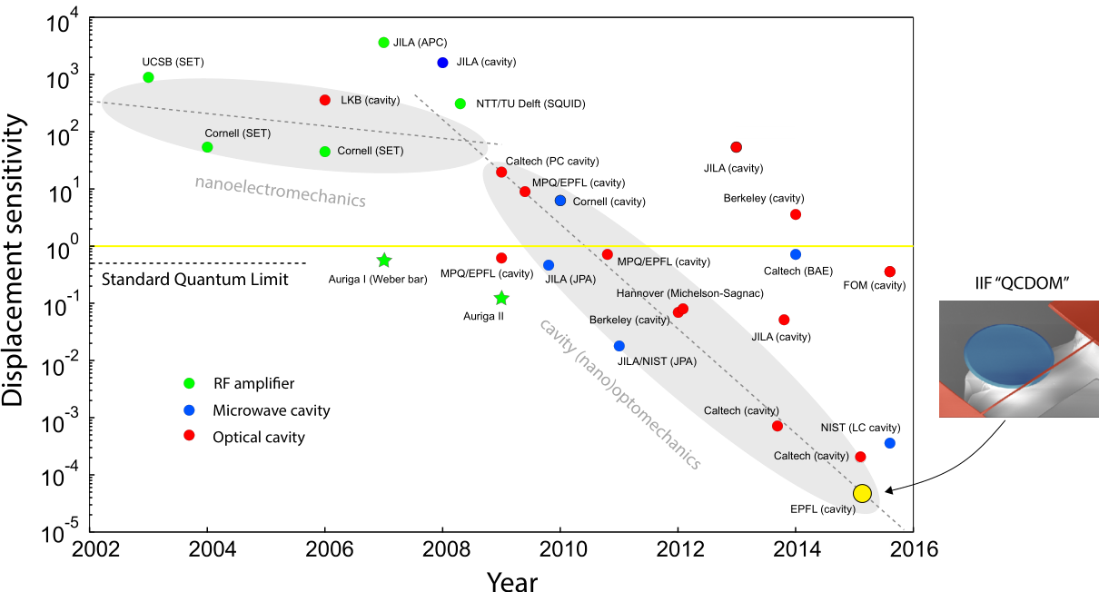
Figure 1. Displacement sensitivity of opto- and electromechanical systems over the last decade. Sensitivity is expressed in units relative to the zero-point fluctuations of the vibrating test mass.

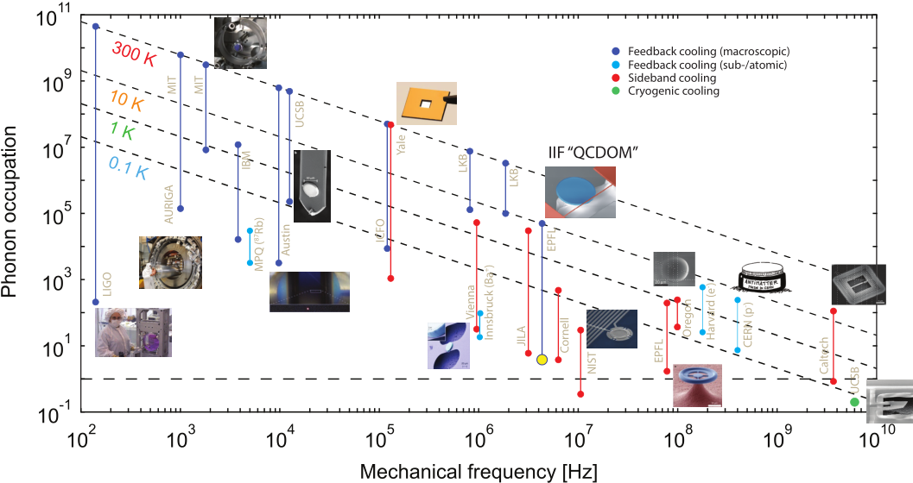
Figure 2. Survey: cooling of mechanical oscillators using measurement-based feedback (blue) and autonomous feedback (red) based on parametric coupling to optical/microwave cavities.

