Figure 1 The primary archaeological sites of interest in the Tembo project are shown as white circles.

Figure 2 An example of a ZooMS spectra, separating elephant and hippopotamus ivory.

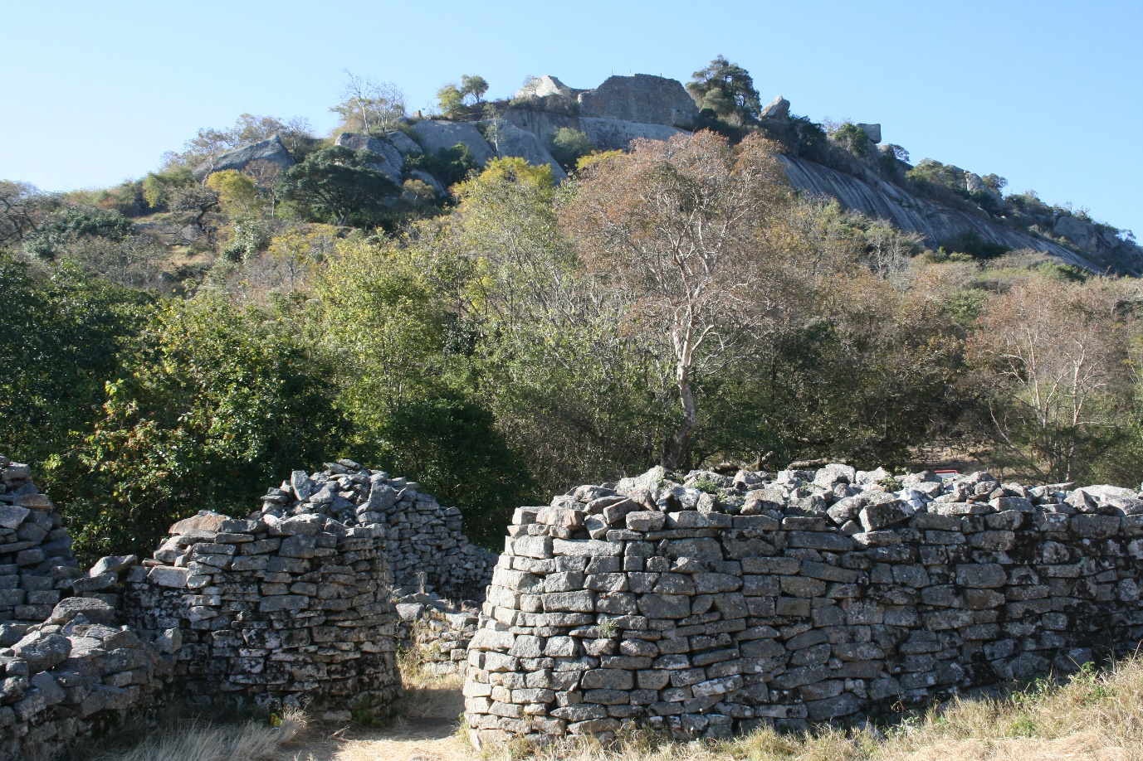

Figure 3 The approach to the great stone walled settlement of Great Zimbabwe.

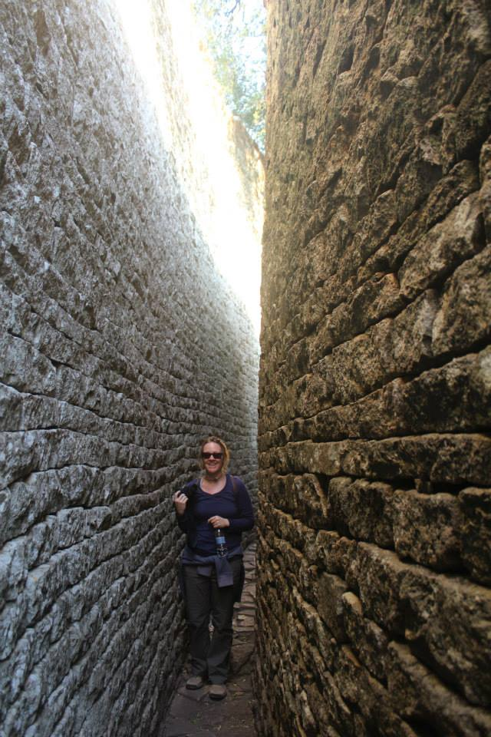

Figure 4 Tembo fellow Ashley Coutu within the stone walls of the archaeological site of Great Zimbabwe on a field excursion with colleagues from the University of Cape Town who were excavating at the site.
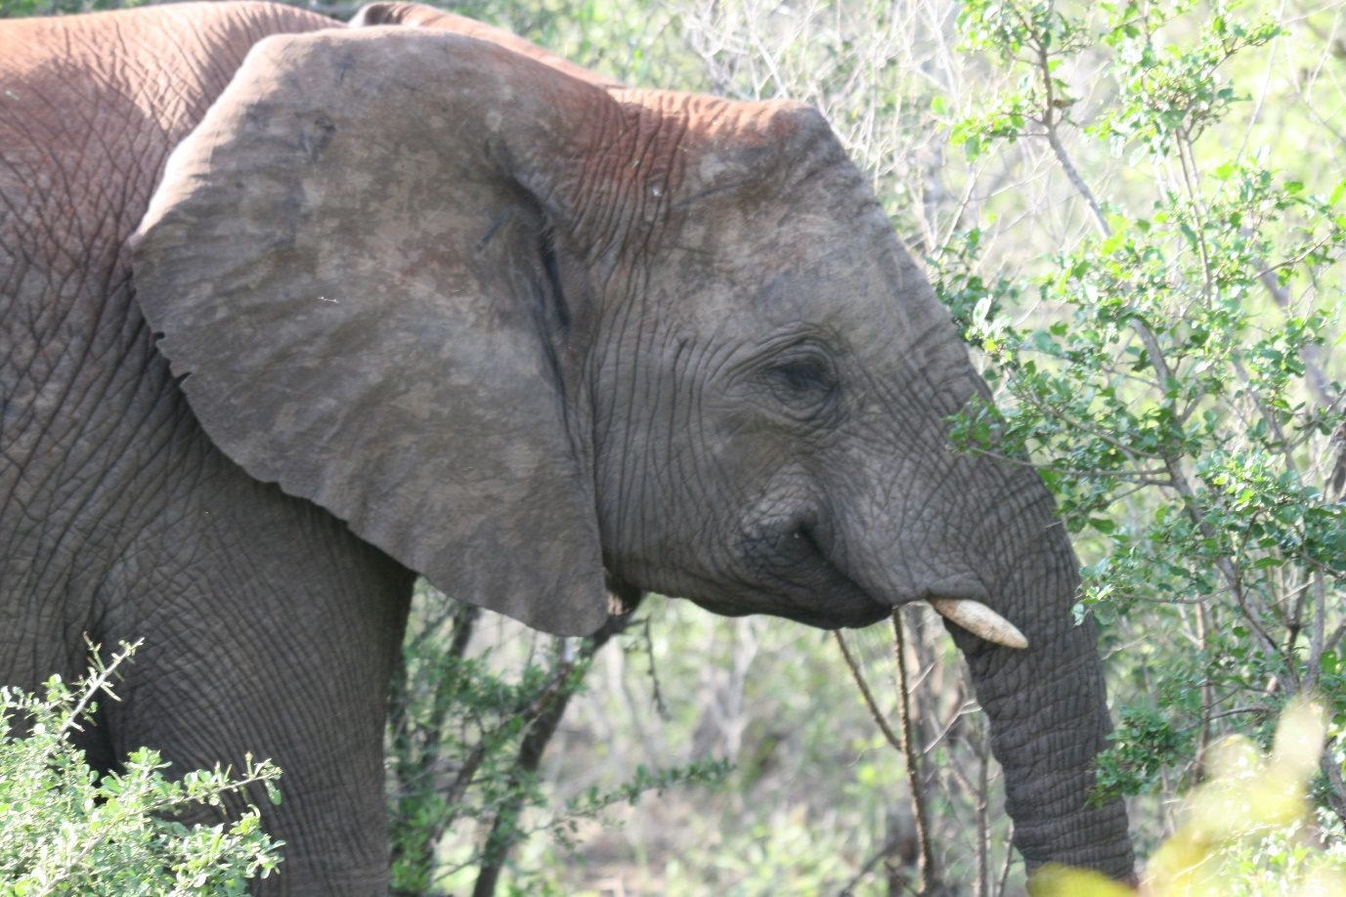

Figure 5 Elephant in Hluhluwe-Imfolozi game reserve, KwaZulu-Natal, South Africa.

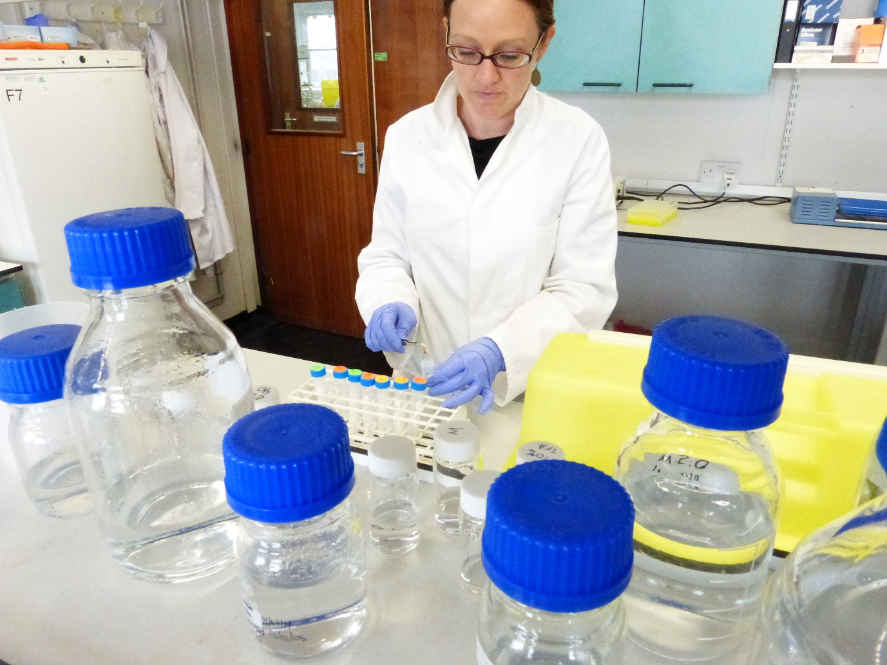

Figure 6 Tembo fellow Ashley Coutu in the BioArCh laboratories at the University of York putting an archaeological bone sample into acidic solution.

