1  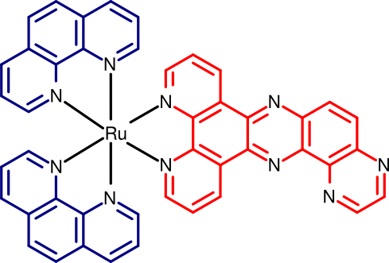 | 3  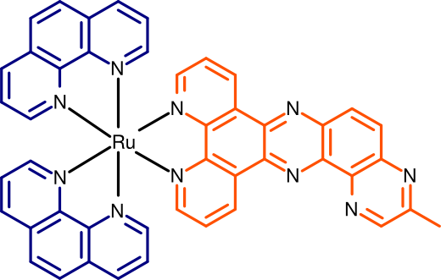 | 5  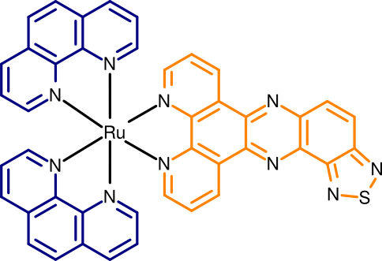
2  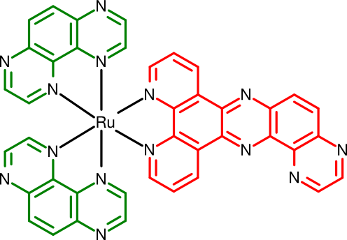 | 4  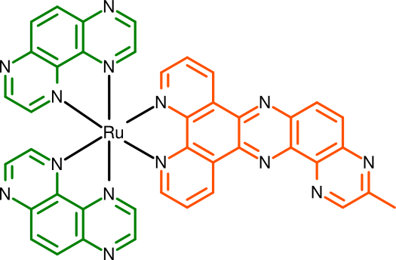 | 6  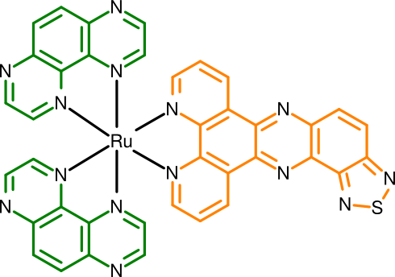
Figure 1: New polypyridyl derivatives. (1-2) phen and tap ruthenium complexes with pyrazino [2,3-h] dipyrido[3,2-a: 20,30-c] phenazine (pdppz). (3-4) phen and tap ruthenium complexes with 3- methylpyrazino [2,3-h]dipyrido[3,2-a:2’,3’-c]phenazine (mpdppz) (5-6) phen and tap ruthenium complexes with dipyrido [3,2-a:2’,3’-c] [1,2,5] thiadiazolo [3,4-4,3] phenazine (dtp).

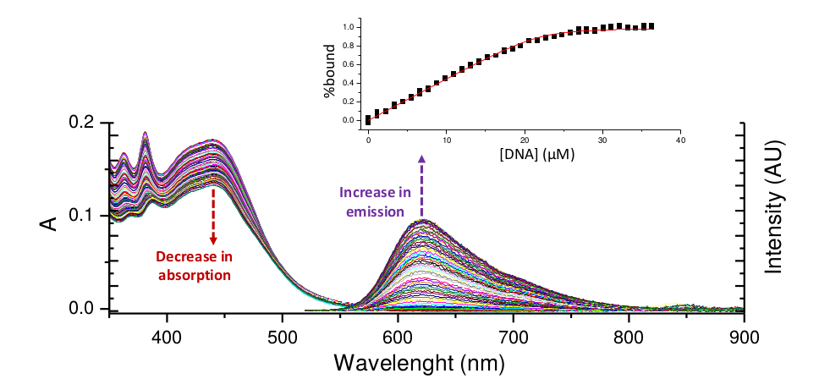
Figure 2: The changes in the UV/Vis absorption and emission spectra of compound 3∙2Cl (9.1 μM) with increasing concentration of st-DNA (0-100 μM) at pH 7.4 (10 mM PBS).

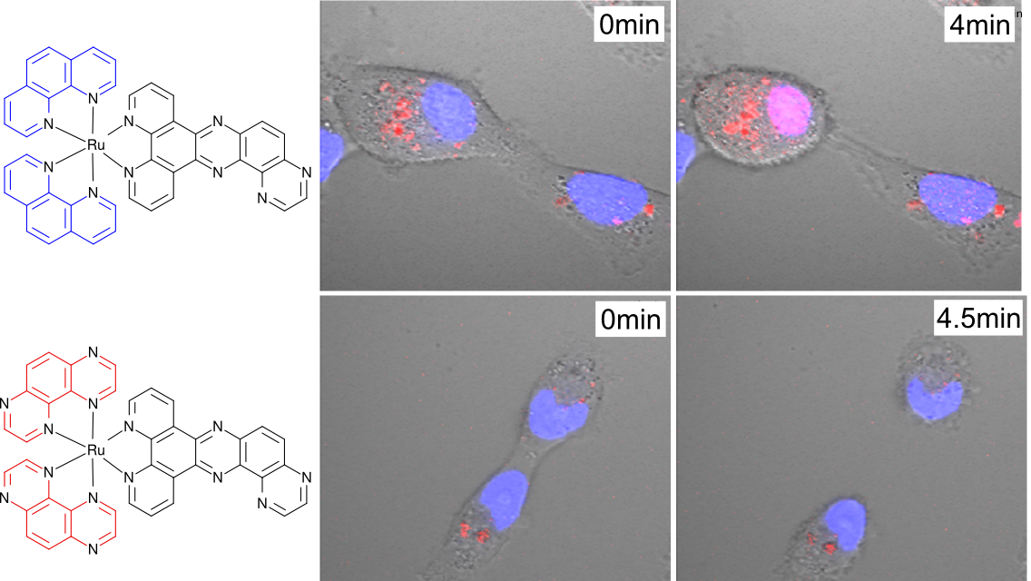
Figure 3: Light-induced cell death in HeLa cells. Blue color are the nuclei stained with commercial dye DAPI and red color is the Ruthenium complex
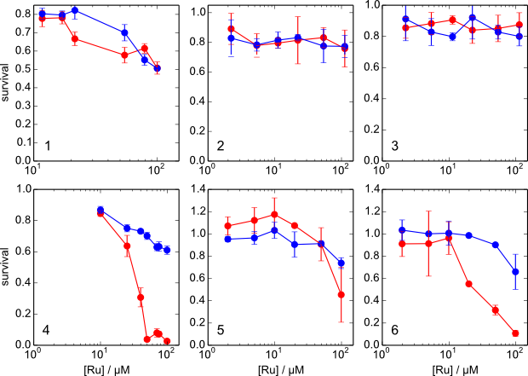
Figure 4: Cell viability assay for RPCs 1 to 6 either upon illumination (red stroke) or in darkness (blue stroke).

