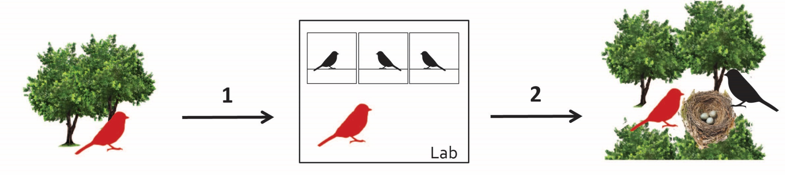

Fig. 1 - Project schematic. Wild birds are brought into the lab for mate preference testing, and then followed breeding in the wild the following year.

