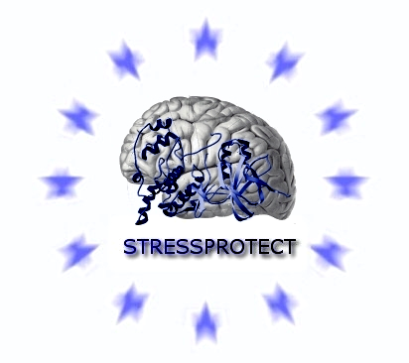

Project no. 005310

Project acronym: STRESSPROTECT

Targeting of stress kinase signalling as therapeutic strategy against
excitotoxicity

Instrument: Priority 1 - STP

Thematic Priority: Life sciences, genomics and biotechnology for health

Final Activity Report

Period covered: from 1. January 2005 to 30. June 2008
Date of preparation: 30. July 2008

Start date of project: 1. January 2005
Duration: 3,5 years (42 months)

Project coordinator name: Thomas Herdegen
Project coordinator organisation name: University of Kiel, Germany

Revision:

Publishable final activity report

STRESSPROTECT was created to elucidate the intraneuronal mechanisms underlying excitotoxicity on several levels of physiological, molecular-genetic and biochemical analysis. At the end of the funding period, STRESSPROTECT has contributed to our current knowledge of excitotoxicity and treatment of neurological disorders at several levels.
(1) Characterisation of the use of the TAT-fused JNK inhibitor D-JNKI1 (XG-102)
- Detailed characterisation of its pharmacokinetic and pharmacodynamic properties.
- Demonstration that D-JNKI1 is targeted selectively into the neurons that need it by an endocytic mechanism.
- Significant protective and beneficial neuroprotection in various in vitro and in vivo models including excitotoxicity models such as ischemia (neonatal and adult) and seizures; apoptosis following axotomy and trophic deprivation; Alzheimer, traumatic hearing loss.
- Elucidation of novel death-mediating mechanisms downstream of JNK inhibition including autophagy.
- Combination of D-JNKI1 and hyperbaric oxygenation (HBO) several hours after transient cerebral ischemia reduced the infarct area by 83% and 62% in the cortical areas of the penumbra and in the ischemic core, respectively.
- Post-ischemic application of D-JNKI1 resulted in a lasting improvement of neurological scores and behavior in an adult stroke model.
(2) Development of novel TAT-fused peptide inhibitors against
- JNK3
- p38δ
- PSD95-domains
(3) Analysis of calcium-triggered MAPK activation
- Mainly due to its binding to NMDA-receptors, glutamate provoked the activation of calcium-fluxes underlying excitotoxicity.
- Blockade of mitochondrial calcium uptake impaired signaling via JNK but not via p38, which required calcium in its immediate proximity to the NR2-PDZ interaction domain.
- Also, p38 activation could be blocked by novel peptide inhibitors that prevented the PSD95-mediated anchoring of enzymes close to NMDA receptors.
(4) The p38 and JNK kinases are considered major player in excitotoxicity.
- STRESSPROTECT characterized their distribution within neuronal compartments and organelles. It is the localization rather than the individual isoform properties that determines the physiological (cytoplasmic presence) versus the pathological (nuclear presence) actions of JNK in neuroplasticity and excitotoxicity.
- We provided novel tools for dissecting the MAPK activities such as gene silencing of JNK isoforms, generation of plasmids with nuclear import- and export-sequences or inhibitor sequence plasmids.
- Proteomics identified more than 10 new JNK and p38 substrates.
(5) The PSD complex translates the NMDA-receptor signals into pathophysiological executions. STRESSPROTECT identified novel protein-protein interactions responsible for ECX which could be blocked by novel developed inhibitors.

These achievements have been published in internationally respected journals including Nature Neuroscience, Journal of Cell Biology, Journal of Neuroscience, Molecular and Cellular Neuroscience and have been reviewed in Nature Neuroscience Reviews and in Trends in Pharmacological Sciences. Moreover, STRESSPROTECT presented data and strategies during several international conferences including FENS (lectures and symposia). This scientific success could only be achieved by intense collaboration and frank exchange of information within the STRESSPROTECT network funded by the 6th FP.

