
CREATION

Project no.: 502259 (INCO)

Project acronym: CREATION

Project full name: Connecting Russian and European Technologies and Innovation Systems

Instrument: Specific Support Action

Thematic Priority: FP6 INCO (FP6-2002-INCO-Russia+NIS/SSA-4)

Final Activity Report

Period covered: 01/01/2005 to 31/12/2005 Date of preparation: 30/01/2006

Start date of project: 01/01/2005 Duration: 12 months

Project coordinator name: Prof. Leonid Gokhberg
Project coordinator organisation name: Centre for Science and Education Programmes
(Moscow, Russia)

Table of Contents

Publishable executive summary 3
Section 1 – Project objectives and major achievements during the reporting period………….. 5
Section 2 – Workpackage progress of the period 7
WP 1 - Development and maintenance of an English–language database "Russian RTD Units & Innovative SMEs" 7
WP 2 - Creation of web services and design of periodical digests for dissemination of data on research findings and technologies obtained within EU programmes to Russian high-tech SMEs 13
WP 3 - Establishment of regional information, assistance and consultancy services in Russia 17
WP 4 - Development of Russian–language FP6 web services and periodical publishing and disseminating CORDIS-based information bulletins 31
WP 5 - Consortium management activities, including dissemination of the project results 35
Table 1: Deliverables List 37
Table 2: Milestones List 38
Section 3 – Consortium management 50
Table 3: Workpackages – Plan and Status Barchart 51
Section 4 – Other issues 54
Appendix 1 - Plan for using and disseminating the knowledge 55
Section 1 - Exploitable knowledge and its Use 55
Section 2 - Dissemination of knowledge 56
Overview table 61
Section 3 -Publishable results 65
Annex 1 - Digests on EU RTD results and new technologies
Annex 2 - Lists of the workshops participants and presentations made at the workshops in Moscow and St. Petersburg
Annex 3 – CORDIS-based information briefs
Annex 4 – Project results dissemination: Websites and Publications

CREATION

Publishable executive summary
In the globalised world, research and development are moving forward to the ever freer and faster exchange of scientific results, information and research personnel between countries.
SMEs contribute to a more innovation friendly environment in Europe, improved conditions for the diffusion of new technologies, the emergence of new economic activities and fostering the innovation culture. The technology-based SMEs are the principle creators of future economic growth and employment. New and dynamic entrepreneurial initiatives are important for competitiveness and job-creating potential. All this can now be fully attributed to the developing sector of Russian innovative units and SMEs.
Funded under the FP6 INCO SSA programme, project CREATION (Connecting Russian and EuropeAn Technologies and InnovatiON Systems) was focused on development of an efficient and sustainable infrastructure for information support to Russia’s SMEs participation in FP6 and EU stakeholders interested in international co-operation with Russian RTD units and innovative SMEs, thus compensating the deficiency of information sources both in Russia and in the EU.
The project was targeted at the following objectives:
- To inform EU stakeholders on innovative SMEs in Russia and their activities, assist European RTD teams in the search for Russian partners and consortium building.
- To promote involvement of Russian high-tech SMEs into innovation processes both in Russia and the EU.
- To facilitate participation of Russian S&T community and high-tech SMEs in FP6.
- To increase Russian stakeholders’ awareness of FP6 and emerging ERA related issues.
The international project consortium involved five organisations from Russia and Austria: Centre for Science and Education Programmes (CESEP, Russia) - co-ordinator; Centre for Science Research and Statistics (CSRS, Russia); Austrian Research Promotion Agency (FFG, Austria); St.-Petersburg State University (SPbSU, Russia) and State University – Higher School of Economics (HSE, Russia). The consortium was co-ordinated by Prof. Leonid Gokhberg (20, Myasnitskaya, Moscow, Russia. Tel: +7 495 6212873, fax: +7 495 6250367, e-mail: Lgokhberg@hse.ru).
The key aspects of the project were two-way EU-Russia information flow and services. The services generated opportunities for encouraging international SMEs and research organisations partnership. The Internet accessible partner search tool "Russian RTD Units & Innovative SMEs" with classification of the presented institutions by FP6 thematic priorities, as well as the published Directory of the same name made it easy to get contact details of high-tech SMEs and research centres in Russia.
The tailor-made website, regularly issued information digests, assistance and consultancy services on all aspects of participation in FP6 established in Moscow and St.-Petersburg have facilitated the participation of Russian SMEs and research institutions in FP6.
Two international training workshops “Participation of Russian RTD Organisations and Small and Medium Enterprises in the Sixth Framework Programme and Innovation Activities” were carried out by the project partner Austrian Research Promotion Agency in Moscow and St.-Petersburg. The workshop collected more than 200 representatives of Russian research organisations and SMEs, authorities from the Ministry for Education and Science of the Russian Federation, the European Commission DG for Research and INTAS.
Russian-language web services and regular information digests presented to Russian audience results of the EU RTD programmes and technology offers, consequently introducing new technological opportunities for Russian SMEs, raising their awareness of external new technology resources and promoting international co-operation in the innovation field.
Thus, the CREATION project objectives and activities targeting Russia's integration to ERA noticeably contributed to the general objective of international co-operation activities carried out under the FP6 to help open up the ERA to the rest of the world.
The project provided European SMEs and research organisations with access to knowledge and expertise available in Russia and facilitated participation of Russian RTD units and SMEs in the INCO and the broader Priority Thematic Areas in the context of the FP6 new instruments.
For further information, please, visit: http://www.fp6-creation.ru/

Activity report

Section 1 – Project objectives and major achievements during the reporting period
A general project's objective was to develop an efficient and sustainable infrastructure for information support to Russia’s participation in FP6 and the ERA, and involvement of Russian enterprises into innovation process via establishing links with EU partners. The measures proposed by the project targeted the following immediate objectives:
- To inform EU stakeholders on innovative SMEs in Russia and their activities, assist European RTD teams in the search for Russian partners and consortium building.
- To promote involvement of Russian high-tech SMEs into innovation processes both in Russia and the EU.
- To facilitate participation of Russian S&T community and high-tech SMEs in FP6.
- To increase Russian stakeholders’ awareness of FP6 and emerging ERA related issues.
Under realisation of the defined goals the following major achievements were obtained during the reporting period:
- The English–language database "Russian RTD Units & Innovative SMEs" was elaborated with classification of its records by existing EU S&T priorities and user-friendly Internet search tool.
- The Directory "Russian RTD Units & Innovative SMEs" was published in English.
- The project website http://www.fp6-creation.ru was created, including the Russian and English versions. The Russian version http://www.fp6-creation.ru/index.htm presents information on FP6 and opportunities for SMEs participation in the thematic priorities and the specific SMEs programme. Special sections were designed within the Russian version of the website for overview of data on research findings and technologies obtained under EU programmes. The series of the CORDIS-based express-information briefs on FP6 and other RTD international EU programmes were placed on the Russian-language website pages. The English version http://www.fp6-creation.ru/eindex.htm presents: a review of the SME sector in Russia; Partner Search Service on Russian RTD Units & Innovative SMEs; ‘expressions of interest’ section presenting questionnaires filled in by Russian innovative SMEs, research organizations and universities interested in RTD international collaboration and participation in the EU Framework programmes.
- There were established FP6 information, assistance and consultancy services in Moscow and St.–Petersburg.
- Russian-language CORDIS-based express-information briefs on EU RTD programmes were periodically issued and disseminated, as well as digests on research findings and technologies obtained under EU programmes.
- International training workshops “Participation of Russian RTD Organisations and Small and Medium Enterprises in the Sixth Framework Programme and Innovation Activities” were organized in Moscow and St.–Petersburg.

Section 2 – Workpackage progress of the period

WP 1 - Development and maintenance of an English–language database "Russian RTD Units & Innovative SMEs"
The objective of Workpackage 1 was to

- inform EU stakeholders on innovative SMEs in Russia and their activities, assist European RTD teams in the search for Russian partners and consortium building

Deliverables planned:

- Internet accessible English–language database on Russian RTD Units and Innovative SMEs
- Publication of Directory "Russian RTD Units and Innovative SMEs"

Deliverables achieved:

- Internet accessible English–language database on Russian RTD Units and Innovative SMEs http://www.fp6-creation.ru/win/partnersearch.php
- Published English-language Directory "Russian RTD Units and Innovative SMEs"

Milestones planned:

- The database "Russian RTD Units & Innovative SMEs"
- User-friendly Internet accessible English–language database on Russian RTD Units and Innovative SMEs with records classification by existing European S&T priorities
- Directory "Russian RTD Units and Innovative SMEs"

Milestones and achieved results:

- English-language database "Russian RTD Units & Innovative SMEs" was formed in March 2005
- User-friendly Internet accessible English–language database on Russian RTD Units and Innovative SMEs with records classification by existing European S&T priorities was launched in June 2005
- Directory "Russian RTD Units and Innovative SMEs" was published in December 2005

The objective of the WP1 was achieved by development and maintenance of an English–language database "Russian RTD Units & Innovative SMEs" with classification of its records by existing EU S&T priorities.
With the aim to inform the European community on Russian SMEs that have capacities to implement research results, in particular, those dealing with high-tech, there was created a database "Russian RTD Units & Innovative SMEs". The project partners – CESEP, CSRS and ISEK/HSE organised the database development process from the starting stage of collectiing initial data to the final stage of launching the user-friendly Internet accessible database and Directory publication. The major sources of data were CESEP, CSRS and ISEK/HSE databases and custom-made surveys targeting RTD units and innovative SMEs. All sorts of sources for information collection, including a data collection exercise aimed at newly organised RTD units, were utilized in this regard. The information for the database relating to the “Innovative SMEs” was collected in close collaboration with the Russian Foundation for Assistance to Small Innovative Enterprises (FASIE) http://www.fasie.ru/. For specification and updating of the initial data, two types of bilingual Russian-English questionnaires corresponding to research organisations or SMEs were elaborated. These questionnaires supplied with instructions and briefs about FP6 were disseminated to a wide range of research organisations and SMEs in Russia. The access to the questionnaires for on-line infill was also provided via project’s website http://www.fp6-creation.ru/win/quest.html.

Questionnaire 1.
Confidentiality is guaranteed by the recipient of information
R&D Institution of the Register of Legal Entities (form to fill in)
Full name  of the institution  (according to the Charter);  short name of the institution | Full postal address  (legal and actual) | Phone  (specify area code) | Fax  (specify area code) | E-mail;  Internet | Institution  head  (full name) | Main areas of research  (six-digit code by GRNTI)*
Year of establishment

Size of employment

* The State Inventory of Science and Technology Information (GRNTI) is available on the CSRS Website: http://www.csrs.ru/activity/reestr.htm
If the institution has no Internet access and GRNTI codes are unknown, it is necessary to provide a description of the areas of research.

Questionnaire 2.
АНКЕТА
QUESTIONNAIRE

Заполните, пожалуйста, анкету и вышлите ее Анне Пикаловой: apikalova@hse.ru
Please, fill in the Questionnaire and return it to Anna Pikalova: apikalova@hse.ru

Поля, помеченные (*) , обязательны для заполнения
(*) – mandatory fields
Информация об организации  Details about organisation | На русском языке  in Russian | На английском языке  in English
* Полное наименование организации
Organisation name
Сокращенное название организации
Organisation acronym
* Тип организации (НИИ, ВУЗ, МСП – малое/среднее предприятие, ПП - промышленное предприятие, другое)
Organisation Activity Type (RES - Research, HE - University, SME - Small and Medium Enterprise, IND - Industry, OTH - Other)
* Направления научной, технологической и инновационной деятельности организации
Organisation’s research, technology or innovation areas
* Руководитель организации (ФИО)
Head of organisation (first name, family name)
* Почтовый индекс
Post сode
* Область
Region
* Город
City
* Улица, дом
Street, House
* Телефон организации (с указанием кода города)
Telephone (+city code) of organisation
* Факс организации
Fax of organisation
* Электронная почта организации
E-mail of organisation
* Интернет сайт организации
Website of organisation

Контактная информация  Contact Information | * На русском языке  in Russian | * На английском языке  in English
* Контактное лицо (ФИО полностью)
Contact person (first name, family name)
* Должность
Position
* Почтовый адрес (дом, улица, город, индекс, область)
Post address (house, street, city, code, region)
* Телефон контактного лица
Telephone
* Факс контактного лица
Fax
* E-mail контактного лица
E-mail

* Отметьте, пожалуйста, знаком «Х» научную (-ые) область (-ти)  Please, use “X” to indicate the scientific area/s | x
CHEMISTRY
SOCIAL AND HUMAN SCIENCES
ECONOMICS
ENGINEERING
ENVIRONMENT AND GEOSCIENCES
INFORMATION TECHNOLOGIES
LIFE SCIENCES
MATHEMATICS
PHYSICS
OTHER (Please indicate the area)

 | ДА  YES | НЕТ  NO
Согласны на размещение в Интернете заполненной анкеты (ДА / НЕТ)
I agree with the publication of my data (YES / NO)
Дата заполнения анкеты
Date
The collected data and filled in questionnaires were analysed, processed, translated into English and organised as a database.
To assist RTD units and SMEs from the EU Member States and Associated Countries in the search for Russian partners and consortium building, an access to the database was provided through the Internet http://www.fp6-creation.ru/win/partnersearch.php. With this aim, proper software and a user-friendly interface were developed. "Russian RTD Units & Innovative SMEs " is an English-language database on Russian RTD organisations (research institutes, universities, designing bureaux, etc.) & small and medium enterprises covering in their activities the whole range of FP6 thematic areas. This database covers about 6,000 organisations across Russia and contains detailed information about each organisation, such as its post address, phone and fax numbers, e-mail, website address, name of the institution head and fields of S&T activity.
In order to create efficient procedures of partner search a tailor-made concordance key between the FP6 thematic priority activities and relevant positions of the Russian Rubricator of S&T activities has been developed for the search service. At the first step, a user can select a FP6 thematic priority activity he is interested in. At the second step, the user chooses one or more relevant positions from the Russian Rubricator. The search results present detailed data on RTD Units & Innovative SMEs engaged in the selected S&T areas.
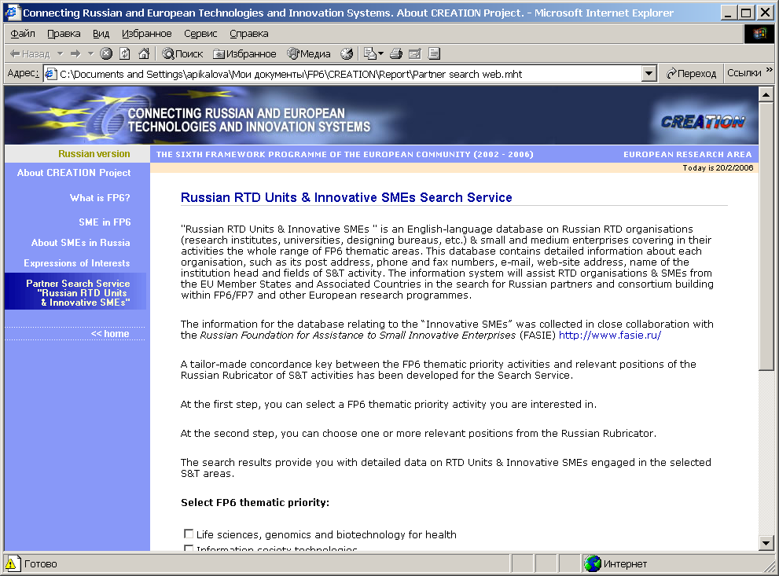

The information system provides assistance to RTD organisations & SMEs from the EU Member States and Associated Countries in the search for Russian partners and consortium building within FP6/FP7 and other European research programmes.
All information collected in the project framework was either taken from open publicly available sources or provided by particular RTD units or enterprises on a voluntary basis.
The database is accessible for any INCO and INTAS initiatives and is used by participants and targeted audience of RUSERA, TECHBRID and other INCO projects.
The cross-references, information links and access to the database from the RTC North and ZENIT Internet websites with relevant announcement and instructions for European users were provided.
A Directory “Russian RTD Units and Innovative SMEs” was published at the CSRS printing shop. A copy of the Directory is enclosed with the present report.
The Directory "Russian RTD Units & Innovative SMEs" is to be widely disseminated among all the parties concerned. It will increase research co-operation between enterprises and the public science.
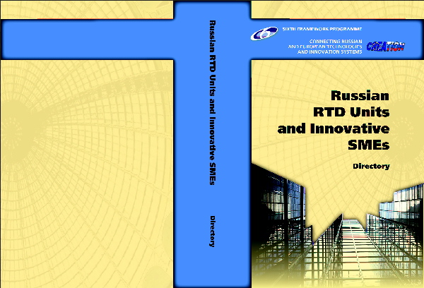

It will promote new technological opportunities for Russian SMEs. The Database and Directory provide stakeholders from the EU Member States and Associated Countries with access to knowledge and expertise available in Russian RTD entities and SMEs, enable EU RTD teams with an efficient tool for search of Russian partners and consortium building, facilitate Russia’s participation in FP6 projects. It will contribute to forming new and strengthening existing mutually beneficial partnerships and development of EU – Russia S&T co-operation, e.g. via building networks related to particular RTD problems addressed by FP6.

WP 2 - Creation of web services and design of periodical digests for dissemination of data on research findings and technologies obtained within EU programmes to Russian high-tech SMEs

The objective of Workpackage 2 was to

- promote involvement of Russian high-tech SMEs into innovation processes both in Russia and the EU.

Deliverables planned:

- Special section on the website for presentation of EU RTD programmes results and technology offers
- Russian–language digests on EU RTD results and new technologies

Deliverables achieved:

- Special section on the website for presentation of EU RTD programmes results and technology offers
- Russian–language digests on EU RTD results and new technologies

Milestones planned:

- The first issue of Russian–language digest on EU RTD results and new technologies
- A special section on website for presentation of EU RTD programmes results and technology offers

Milestones and achieved results:

- Monthly issued Russian–language digests on EU RTD results and new technologies from June 2005 to the end of the project
- A special section on the website for presentation of EU RTD programmes results and technology offers was launched in August 2005 http://www.fp6-creation.ru/win/results.html
The objective of the WP2 was achieved by creation of Russian-language web pages http://www.fp6-creation.ru/win/results.html and design of periodical digests for dissemination of data on research findings and technologies obtained under EU programmes to Russian high-tech SMEs.
During the project implementation the CREATION website was elaborated. The website includes the particular service for presentation of relevant information in Russian, based on CORDIS Technology Marketplace, CORDIS FOCUS RTD Results Supplement and other information sources.

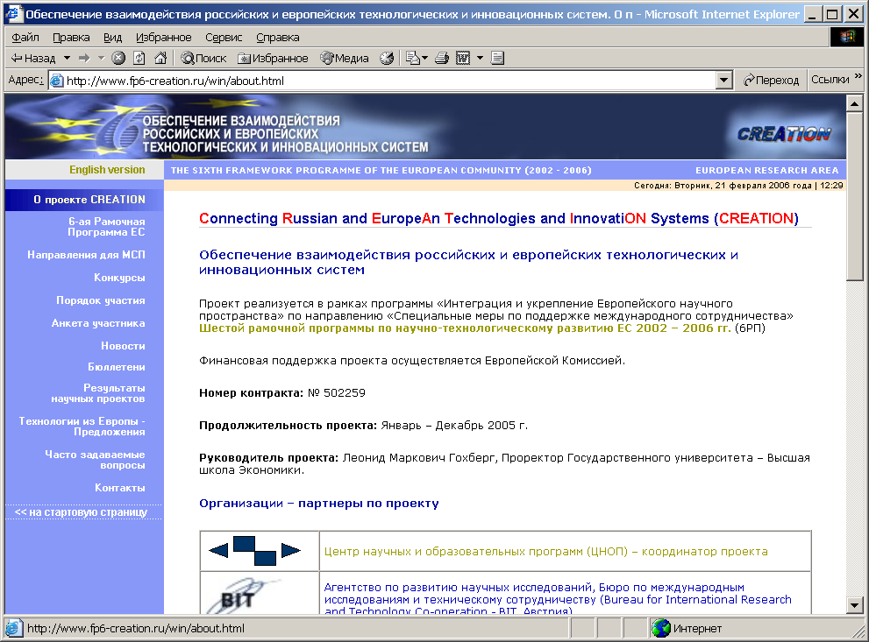
Periodical digests providing relevant information on RTD results and new technologies were designed and monthly issued. The project group selected the relevant information from the EU sources, translated it into Russian and prepared regularly on this basis information materials for the project website and digests.
The digests were distributed among Russian SMEs and research ogranisations (more than 3,000 e-mails) in electronic form free of charge. The on-line subscription on the digests was provided from the website. The information web pages are available to a wide range of Russian innovative enterprises that have capacities to implement research results obtained under the EU RTD programmes. The information on new technologies and innovation initiatives existing in RTC North (UK) and ZENIT GmbH (Germany) was also distributed in Russia by means of digests issues.
The created information services – web pages and digests introduced new technological opportunities for Russian SMEs and raised their awareness of external new technology resources.
The digests issued during the project implementation are presented in Annex 1.
An example of the designed digest is below.
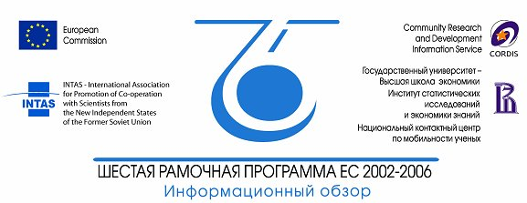
Connecting Russian and EuropeAn Technologies and InnovatiON Systems

Обеспечение взаимодействия российских и европейских технологических и инновационных систем
CREATION

Проекты
- Рождение нового сектора промышленности – ведущие европейские компании организовали технологическую платформу для сетевых и электронных средств вещания (NEM)
Ведущие европейские компании в области телекоммуникаций, электроники, аудиовизуальной продукции и электронных средств вещания объединили свои усилия в реализации инициативы, способствующей развитию новых аудиовизуальных и мультимедийных широкополосных передач. Эта инициатива, возглавляемая фирмой Thomson, получила название NEM (Networked and Electronic Media – Сетевые и электронные средства вещания). NEM как одна из первых Технологических платформ ЕС была открыта 29 июня в Брюсселе.
http://dbs.cordis.lu/cordis-сgi/srchidadb?ACTION=D&SESSION=&DOC=1&TBL=EN_RTDN&RCN=EN_RCN_ID:3210&CALLER=CORDISwire

Защита воздушных судов от атак террористов
Проект SAFEE (Security of Aircraft in the Future European Environment) предполагает развитие системы безопасности нового уровня для защиты самолетов и пассажиров во время угрозы захвата самолета. Цель проекта - создание широкого спектра систем специальных сенсорных датчиков, а также адекватных ответных действий против физических или электронных вторжений. В проекте участвует 31 организация из 13 стран, координирует проект компания SAGEM, Франция.
http://dbs.cordis.lu/fep-cgi/srchidadb?ACTION=D&SESSION=&DOC=1&TBL=EN_PROJ&RCN=EP_RCN:72832&CALLER=FP6_PROJ
Рынок инноваций
- Новые сетевые решения для автоматизированных приложений
Проект разрабатывает новые информационные системы обработки данных и сетевого контроля для автоматизированного оборудования на промышленных предприятиях. В рамках проекта создана ‘интегрированная информационная система для автоматизированных систем', ее программное обеспечение позволяет проводить более точные работы и в тоже время способно брать на себя больше функций аппаратных средств, чем предыдущие системы. Такая самообучающаяся система может проводить мониторинг, классифицировать и реагировать на дефекты, обнаруженные посредством сети. Итальянские координаторы проекта ищут партнеров для сотрудничества в виде создания совместных предприятий, совместного маркетинга, производства и партнерства с государственными организациями и бизнес-структурами.
http://dbs.cordis.lu/fep-cgi/srchidadb?ACTION=D&SESSION=&TBL=EN_OFFR&RCN=EN_RCN:2047&CALLER=OFFR_O_BUSI_EN
- Система многократного мониторинга контура
Распознавание контура - важное требование в промышленности, чтобы гарантировать качество продукта, требования безопасности и оптимальные эксплуатационные характеристики. МСП из Германии предлагает новую устойчивую систему для распознавания контура, которая может быть интегрирована в имеющиеся системы производства продукции и контроля качества. Система включает программное обеспечение и работает с камерами.
http://dbs.cordis.lu/fep-cgi/srchidadb?ACTION=D&SESSION=&DOC=1&RCN=EN_RCN:2031&CALLER=OFFR_TM_EN&TBL=EN_OFFR
- Компьютерные схемы без кремния
Развитие интегральных схем в течение многих лет осуществлялось на основе использования продуктов на основе кремния. ЕС в настоящее время ищет альтернативные материалы, и, кажется, вероятный кандидат был идентифицирован. Проект NICE (Швеция), исследующий потенциал базирующихся на фуллеренах технологий, сумел создать оптимальные условия для производства эндопроизводных фуллеренов и также пропустить высоко очищенный материал через ряд хроматографических шагов. Полученные знания являются ключевыми к дальнейшему приложению фуллеренов для изготовления интегральных схем, независимых от кремния. Возможное сотрудничество: дальнейшие исследования или развитие проекта; консультирование.
http://dbs.cordis.lu/fep-cgi/srchidadb?ACTION=D&SESSION=&DOC=1&RCN=EN_RCN:2076&CALLER=OFFR_TM_EN&TBL=EN_OFFR
Поиск партнеров
Итальянское МСП Microbo Biosensori ищет партнеров для дальнейшей работы по усовершенствованию устройства для быстрого обнаружения и выборочного подсчета бактерий в воде, пищевых продуктах и любой другой жидкой или твердой среде. Нужны также партнеры для коммерциализации этого устройства в области контроля безопасности пищевых продуктов и/или мониторинга качества воды.
http://dbs.cordis.lu/fep-cgi/srchidadb?ACTION=D&SESSION=&DOC=1&TBL=EN_PART&RCN=EN_RCN:60748&CALLER=EN_PARTNERS
Конференции
- Innovact-2005, Франция, 4-5 октября
Innovact, европейский форум для растущих инновационных компаний состоится в Реймсе, Франция, с 4 по 5 октября 2005 г. В 10-й юбилейной конференции ожидается участие около 4000 представителей от более чем 200 европейских начинающих компаний, будут вручены специальные призы и пройдет до 40 различных мероприятий. Программа форума будет включать вопросы, связанные с инновациями и предпринимательством, а также устойчивым развитием и новыми материалами.
http://www.innovact.com/index_gb.php3

Конкурс по отбору Центров коммерциализации результатов научных исследований
Консорциум компаний Inno, "АЕА Текнолоджи", "TNO" приглашает к участию в конкурсе по отбору Центров коммерциализации результатов научных исследований. Конкурс проводится в рамках реализации проекта "Наука и коммерциализация технологий" ("Science and Technology Commercialisation", EuropeAid/115381/C/SV/RU - далее Проект), финансируемого Европейской Комиссией в рамках программы технического содействия EuropeAid, подпрограмма "Поддержка частного сектора и содействие экономическому развитию". Партнером Проекта является Российская Академия Наук. Общей целью конкурса является развитие и создание пилотных Центров коммерциализации результатов научных исследований. Сроки представления заявок с 23 июля по 8 сентября 2005 года включительно.
Конкурсная документация http://ras-stc.ru/files/centers/call_for_proposal.zip, формы заявок и критерии отбора представлены на сайте «Наука и коммерциализация технологий» http://www.ras-stc.ru/news/view/36.
Поддержка со стороны проекта позволит пилотным центрам коммерциализации создать возможности для обеспечения организационных, технических, юридических, финансовых и маркетинговых аспектов коммерциализации научно-технических результатов. Эта поддержка будет включать в себя, например:
- консультации по развитию бизнеса с учетом индивидуальных запросов от каждого конкретного центра;
- обеспечение связи с потенциальными клиентами на национальном и международном уровнях, содействие в установлении коммерческих связей;
- интеграция в европейские и/или российские сети трансфера технологий;
- обучение персонала (включая учебные туры и стажировки) в России и в Европейском Сообществе;
- содействие в интеграции в международные научно-исследовательские консорциумы;
- улучшение представления во внешней среде, в частности через сайт проекта и другие Интернет-ресурсы;
- информационная поддержка;
- обмен опытом с центрами коммерциализации, решающими сходные вопросы;
- разработка систем мониторинга.
По всем вопросам, возникающим при подготовке заявок, просьба обращаться в службу поддержки по адресу: info@ras-stc.ru . Материалы по итогам конкурса будут опубликованы в газете "Поиск" и на сайте Проекта.
При подготовке обзора использованы материалы информационной системы Европейского Сообщества CORDIS http://www.cordis.lu
© ГУ-ВШЭ, Институт статистических исследований и экономики знаний, 2005. При использовании информации ссылка обязательна http://www.fp6-creation.ru.

WP 3 - Establishment of regional information, assistance and consultancy services in Russia
The objective of Workpackage 3 was to

- to facilitate participation of Russian S&T community and high-tech SMEs in FP6

Deliverables planned:

- Workshop on Russian SMEs participation in FP6 and innovation activities foreseen under FP6 thematic priorities
- Assisting and consultancy services in Moscow
- Assisting and consultancy services in St.-Petersburg

Deliverables achieved:

- International Workshop on Russian SMEs participation in FP6 and innovation activities foreseen under FP6 thematic priorities in Moscow, 08-09 June 2005 - with 123 participants
- International Workshop on Russian SMEs participation in FP6 and innovation activities foreseen under FP6 thematic priorities in St. Petersburg, 14 June 2005 - with 39 participants
- Assisting and consultancy services in Moscow
- Assisting and consultancy services in St.-Petersburg

Milestones planned:

- Workshop on Russian SMEs participation in FP6 and innovation activities foreseen under FP6 thematic priorities in March 2005
- Announcement about start of assisting and consultancy services in Moscow in April 2005
- Announcement about start of assisting and consultancy services in St.-Petersburg in May 2005

Milestones and achieved results:

- International Workshop on Russian SMEs participation in FP6 and innovation activities foreseen under FP6 thematic priorities in Moscow, 08-09 June 2005 - with 123 participants
- International Workshop on Russian SMEs participation in FP6 and innovation activities foreseen under FP6 thematic priorities in St. Petersburg, 14 June 2005 - with 39 participants
- Functioning of the assisting and consultancy services on SMEs participation under FP6 at the State University - Higher School of Economics (Moscow) from January 2005
- Functioning of the assisting and consultancy services on SMEs participation under FP6 at the St.-Petersburg State University from March 2005

One of the objectives of WP 3 was to increase the awareness of Russian SMEs on special SMEs activities in FP6 and the promotion of the participation of Russian SMEs in FP6 and innovation activities foreseen under the FP6 thematic priorities.
For this purpose the consortium partner organisations – FFG/EIP in its capacity as Austrian FP6 National Contact Point Organistaion, HSE and ICAPE in close collaboration with the Russian Foundation for Assistance to Small Innovative Enterprises, nominated as SMEs NCP for Russia, developed and carried out the workshop programme, including training in Moscow and St.-Petersburg on specific FP6 issues, which are of relevance for potential Russian FP6 project proposers and respective project partners in EU-Russia consortia.
Two international workshops “Participation of Russian RTD Organisations and Small and Medium Enterprises in the Sixth Framework Programme and Innovation Activities” were conducted in:
- Moscow, 08-09 June 2005
State University – Higher School of Economics

- St. Petersburg, 14 June 2005
Saint-Petersburg State University

The main objectives of the workshop were to facilitate participation of the Russian S&T community and high-tech SMEs in the FP6; to promote the involvement of Russian RTD organisations and SMEs in EU innovation activities envisaged under FP6 thematic priorities and INTAS activities.
The audience of the workshops represented over 160 participants, among whom Mr. Dmitry Livanov, Head of the Department for S&T and Innovation Policy, Ministry of Education and Science of the Russian Federation, Mr. Ivan Bortnik, Head of the Russian Foundation for Assistance to Small Innovative Enterprises, Mr. Richard Burger, Deputy Executive Secretary of INTAS, authorities of the EC Directorate M - Investment in Research and Links with Other Policies, Research and Small & Medium Enterprises Unit, representatives of Russian research organisations, innovative SMEs and universities. The invitation to take part in the workshops was provided to Mr. Enrique Playan, CREATION project manager from the EC INCO Directorate.
The first day of the workshop was devoted to the presentation of opportunities for Russian RTD organisations and SMEs under Community research programmes. During the second day of the workshop the Austrian Research Promotion Agency, Division for International Research and Technology Cooperation, organised training on practical issues of participation in FP6 for Russian RTD organisations and innovative SMEs, including FP6 instruments, cost models, legal and financial issues, writing, submission and evaluation of a project proposal, contract negotiations, project management, practical exercise in preparing a financial statement, CORDIS website and partner search tools. FFG/EIP was represented by two highly qualified FP6 experts:
- Marcus BIDMON
→ FP6 National Contact Point for SME
→ Deputy Head, Department Industrial Technologies and Transport
(NMP Priority Area)
→ Project officer for CRAFT (Co-operative Research Action for Technology)
→ FFG/EIP project manager of the FP6 SSA projects:
- NanoRoadSME
- PLASTeam
- NAoMITec
- WOODISM
- http://www.ffg.at/index.php?cid=694

- Ralf KÖNIG
→ FP6 National Contact Point for INCO, NEST & INTAS
→ Head of Department; Department International Cooperation (INCO & INTAS)
→ Project officer for CRAFT (Co-operative Research Action for Technology)
→ FFG/EIP project manager of the FP6 SSA and INTAS projects:
- CREATION
- RUSERA
- INTAS ININ NIP Continuing Advice for Russia
- http://www.ffg.at/index.php?cid=827
- http://www.bit.ac.at/inco/bitincoprojects.htm

The workshop participants in Moscow and in St.-Petersburg were trained by the project partner FFG/EIP intensively on the following FP6 issues:

- FP6 National Contact Point System & Organisations:
- Austrian Research Promotion Agency
- FP6 at a glance:
- Structuring ERA
- FP6 overview
- Thematic priorities
- Strengthening the foundations of the ERA
- Rules for participation,
- Minimum participation requirements
- International Cooperation
- Marie Curie Actions
- FP6 Instruments:
- IP
- NoE
- STREP
- CA
- SSA
- Legal and Financial Issues
- Cost models and overheads
- AC - additional cost
- FC - full cost
- FCF - full cost with flat rate
- Applicability, use of and maximum reimbursement rates per cost model and per activity type
- Activity types
- Management
- Research
- Demonstration
- Training
- Funding Opportunities for SMEs within FP6:
- CRAFT
- Collective Research
- SME participation in FP6 Thematic Priorities (IPs, STREPs)
- Austrian Case Study
- CRAFT SME Success Story
- Project Proposal: Preparation & Writing
- How to write a successful project proposal
- work programme
- call for proposals
- guide for proposers
- A1, A2, A3 forms
- Proposal Part B (structure and content)
- Project Proposal: Submission and Evaluation Procedure
- Submission procedures & options
- Electronic submission
- Risks
- Evaluation by independent experts
- Evaluation criteria
- Evaluation procedures
- Experts Management Module for FP6
- Calls for experts
- Project Proposal: Contract Negotiations with the European Commission:
- CPFs & CPF editors
- Contract negotiation
- Consortium agreement
- Intelectual Property Rights
- Liabilities
- Financing
- Access rights
- Implementation of the project
- Signature, entry into force
- Completion of contract
- Project Consortium:
- Role of coordinator
- Contractor
- Partner
- Workpackage leader
- Subcontractor
- EC project/scientific/financial officers
- Project Management:
- Project management tools
- EC project reporting (period, final reports)
- External financial audit (audit certificate)
- Partner Search
- Tools
- Websites
- Databases
- CORDIS Website
- Features
- Practical Exercise:
- Preparing a financial statement (cost models, activity types)

Presentations and information about the CREATION FP6 training workshops in Moscow and St.-Petersburg can be found on the following websites:
in Russian http://www.hse.ru/temp/2005/06_08-09_seminar.shtml
in English http://www.bit.ac.at/inco/va_moscow&stpetersburg_index.htm

Presentations are given in Annex 2.

The workshops photos

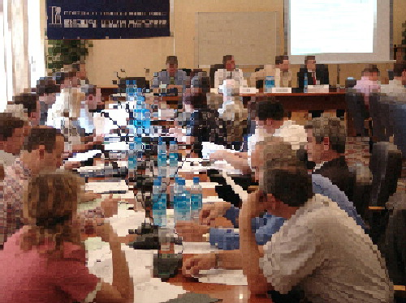 | 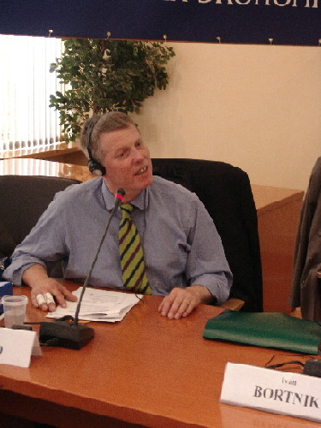
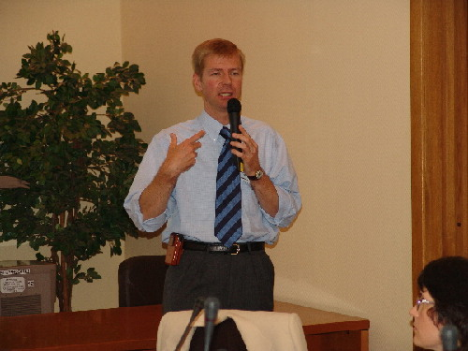 | 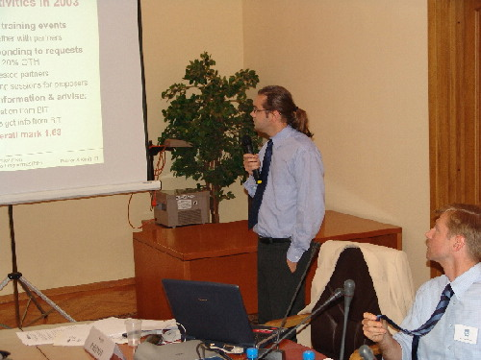
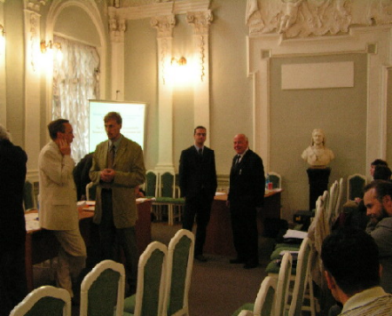 | 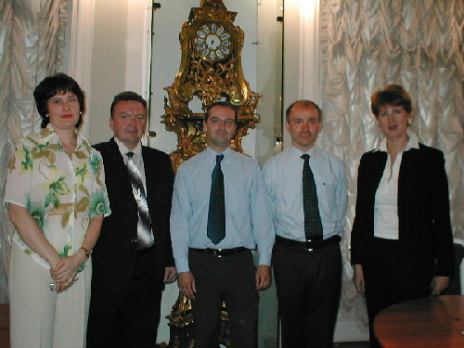

CREATION FP6 SME training workshop websites

http://www.bit.ac.at/inco/va_moscow&stpetersburg_index.htm  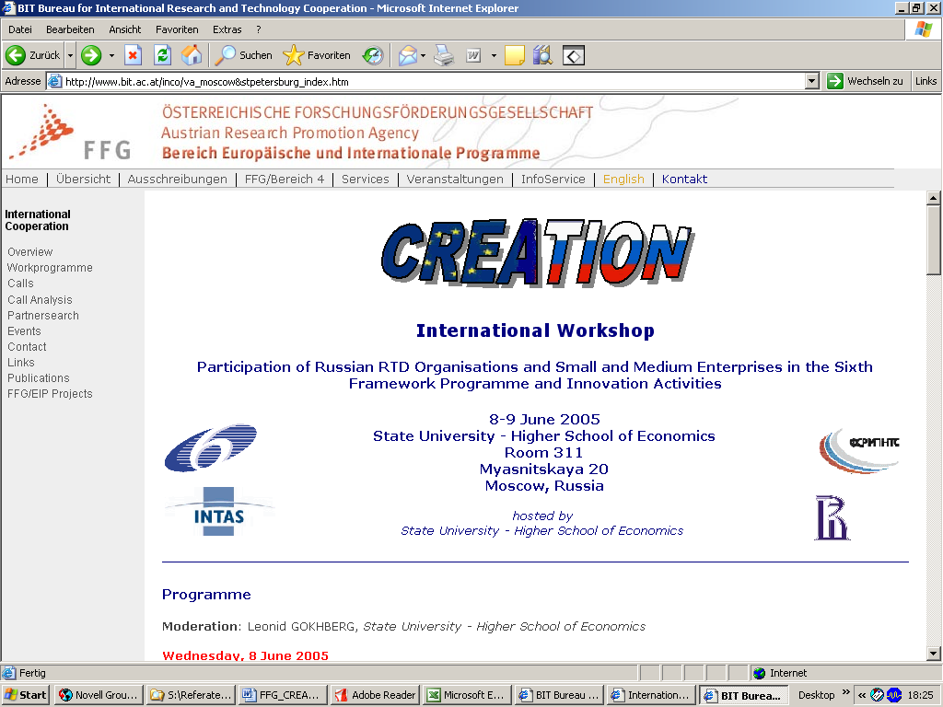 | http://www.hse.ru/temp/2005/06_08-09_seminar.shtml  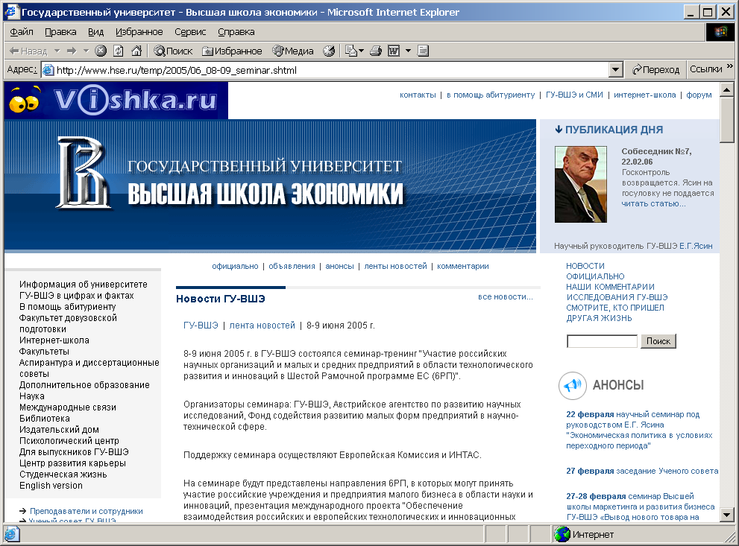

Programme of the CREATION FP6 SME training workshop in Moscow

CREATION | International Workshop | 
     | Participation of Russian RTD Organisations and Small and Medium Enterprises in the Sixth Framework Programme and Innovation Activities
 | 08-09 June 2005  State University - Higher School of Economics  Room 311  Myasnitskaya 20  Moscow, Russia

Programme

Moderation: Dr. Leonid Gokhberg
State University – Higher School of Economics

Day One
- Wednesday, 8th June 2005 -

09:30 – 10:00 | Registration and Welcome Coffee
10:00 – 10:30 | Opening and Brief Introduction  Leonid GOKHBERG  State University - Higher School of Economics, Russia  Nikolay BULAEV  Chairman of the Committee of Science and Education, The State Duma of the Russian Federation  Dmitry LIVANOV  Head of the Department for S&T and Innovation Policy, Ministry of Education and Science of the Russian Federation
10:30 – 11:00 | The Foundation for Assistance to Small Innovative Enterprises  Ivan Bortnik  The Foundation for Assistance to Small Innovative Enterprises (FASIE), Russian Federation
11:00 – 11:15 | Opportunities for Russian RTD Organisations and SMEs in Community Research Programmes  Thomas Arnold  European Commission, DG Research, Directorate M - Investment in Research and Links with Other Policies, Research and SMEs Unit
11:15 – 11:45 | Coffee Break
11:45 – 12:15 | Scientific Cooperation between EU and the Russian Federation  Jean-Louis Lavroff  Counsellor for Science and Technology, Delegation of the European Commission in Russia
12:15 – 12:45 | The FP6-INCO Project “CREATION”  Anna Pikalova  State University – Higher School of Economics, Russia
12:45 – 13:00 | The FP6 Small & Medium Enterprises National Contact Point for Russia  Mikhail Shubin  FP6 Small & Medium Enterprises National Contact Point  The Foundation for Assistance to Small Innovative Enterprises (FASIE), Russia
13:00 – 13:15 | The Austrian Research Promotion Agency - FP6 National Contact Point Organisation  Marcus BIDMON  Austrian Research Promotion Agency (FFG), Division European and International Programmes (EIP), Austria
13:15 – 13:45 | Europe – New Independent States: Science & Technology Cooperation through INTAS  Richard BURGER  INTAS - International Association for the promotion of co-operation with scientists from the New Independent States of the former Soviet Union
13:45 – 14:45 | Lunch Break
14:45 – 15:30 | FP6 at a glance  FP6 overview (thematic priorities, structuring ERA, strengthening the foundations of the ERA), rules for participation, minimum participation requirements, INCO  Ralf Koenig  Austrian Research Promotion Agency (FFG), Division European and International Programmes (EIP), Austria
15:30 – 16:00 | Russian RTD Organisations and SMEs in FP6: How to apply? What type of support? Examples of cooperation  Bernd VERACHTERT  European Commission, DG Research, Directorate M - Investment in Research and Links with Other Policies, Research and SMEs Unit Sector for Collective Research and Promoting SMEs Participation
16:00 – 16:30 | Coffee Break
16:30 – 17:30 | FP6 Instruments, Cost Models, Legal and Financial Issues  - Instruments, project types (IP, NoE, STREP, CA, SSA)  Cost models and overheads (AC - additional cost, FC - full cost, FCF - full cost with flat rate)  applicability, use of and maximum reimbursement rates per cost model and per activity type  - Activity type  Specific, management, demonstration and training activities  Ralf Koenig  Austrian Research Promotion Agency (FFG), Division European and International Programmes (EIP), Austria
17:30 – 18:10 | Project Success Stories: Russian SMEs in FP6  Anatoliy KOVALEV  Research, Technology and Venture Enterprise “Poverkhnost”  Sergey PARINOV  State University – Higher School of Economics
18:10 – 18:30 | Questions & Discussion
18:30 | End of Day One

Day Two
- Thursday, 09th June 2005 -

09:00 – 09:30 | Gathering of Participants, Coffee
09:30 – 09:45 | Euro Innovation  Ms. Nina LEVCHENKO  FP6 Small & Medium Enterprises National Contact Point  The Foundation for Assistance to Small Innovative Enterprises, Russia
09:45 – 10:30 | Funding Opportunities for SMEs within FP6  CRAFT, Collective Research, SME participation in FP6 Thematic Priorities (IPs, STREPs), Austrian Case Studies  Marcus Bidmon  FFG - Austrian Research Promotion Agency, Division European and International Programmes (EIP), Austria
10:30 – 11:30 | Project Proposal: Preparation & Writing  How to write a successful project proposal  Marcus Bidmon  FFG - Austrian Research Promotion Agency, Division European and International Programmes (EIP), Austria
11:30 – 12:00 | Coffee Break
12:00 – 12:30 | Project Proposal: Submission and Evaluation Procedure  Submission procedures, submission options, electronic submission, risks, evaluation criteria and procedures  Ralf Koenig  FFG - Austrian Research Promotion Agency, Division European and International Programmes (EIP), Austria
12:30 – 13:00 | Project Proposal: Contract Negotiations with the European Commission  CPFs, CPF editors, liabilities, financing, access rights, implementation of the project  Ralf Koenig  FFG - Austrian Research Promotion Agency, Division European and International Programmes (EIP), Austria
13:00 – 14:00 | Lunch Break
14:00 – 14:30 | Project Consortium  Role of coordinator, contractor/partner, workpackage leader, subcontractor, EC project/scientific/financial officer  Ralf Koenig  FFG - Austrian Research Promotion Agency, Division of European and International Programmes (EIP)
14:30 – 15:00 | Project Administration  Project management tools, EC project reporting, external financial audit  Ralf Koenig  FFG - Austrian Research Promotion Agency, Division of European and International Programmes (EIP)
15:00 – 15:30 | Coffee Break
15:30 – 17:00 | Practical Exercise  Preparing a financial statement (cost models, activity types)  Ralf Koenig & Marcus BIDMOn  FFG - Austrian Research Promotion Agency, Division European and International Programmes (EIP), Austria
17:00 – 17:20 | CORDIS Website  Ralf Koenig  FFG - Austrian Research Promotion Agency, Division European and International Programmes (EIP), Austria
17:20 – 17:40 | Partner Search (Tools)  Ralf Koenig  FFG - Austrian Research Promotion Agency, Division European and International Programmes (EIP), Austria
17:40 – 18:00 | Questions & Discussion
18:00 | End of Day Two
18:00 | End of Workshop

Programme of the CREATION FP6 SME training workshop in St. Petersburg

CREATION | International Workshop
 | Participation of Russian RTD Organisations and Small and Medium Enterprises in the Sixth Framework Programme and Innovation Activities
14 June 2005
St. Petersburg State University
Petrosky Hall
7/9 Universitetskaya nab.,
St. Petersburg, Russia

Programme

Moderation: Dr. Anna Pikalova
State University – Higher School of Economics

Tuesday, 14th June 2005

09:00 – 09:30 | Registration
09:30 – 9:45 | Opening and Brief Introduction
9:45 – 10:00 | The FP6 Small & Medium Enterprises National Contact Point for Russia  Nina LEVCHENKO  FP6 Small & Medium Enterprises National Contact Point for Russia, The Foundation for Assistance to Small Innovative Enterprises, Russia
10:15 – 10:30 | The Austrian Research Promotion Agency - FP6 National Contact Points  Marcus BIDMON  Austrian Research Promotion Agency (FFG), Division of European and International Programmes (EIP), Austria
10:30 – 10:45 | The FP6-INCO “CREATION” Project  Anna Pikalova  State University – Higher School of Economics, Russia Division of European and International Programmes (EIP), Austria
10:45 – 11:30 | Funding Opportunities for SMEs within FP6  CRAFT, Collective Research, SMEs participation in the FP6 Thematic Priorities (IPs, STREPs), Austrian Case Studies  Marcus Bidmon  Austrian Research Promotion Agency (FFG), Division of European and International Programmes (EIP), Austria
11:30 – 12:00 | Coffee Break
12:00 – 13:00 | FP6 Instruments, Cost Models, Legal and Financial Issues  - Instruments, project types (IP, NoE, STREP, CA, SSA)  - Cost models and overheads (AC - additional costs, FC - full costs, FCF - full costs with flat rate)  - Activity types (research, management, demonstration, training)  Ralf Koenig  Austrian Research Promotion Agency (FFG), Division of European and International Programmes (EIP), Austria
13:00 – 14:00 | Lunch Break
14:00 – 15:00 | Project Proposal: Preparation & Writing  How to write a successful project proposal  Marcus Bidmon  Austrian Research Promotion Agency (FFG), Division of European and International Programmes (EIP), Austria
15:00 – 15:30 | Project Proposal: Submission and Evaluation  Submission procedures, submission options, electronic submission, risks, evaluation procedures  Ralf Koenig  Austrian Research Promotion Agency (FFG), Division of European and International Programmes (EIP), Austria
15:30 – 16:00 | Contract Negotiations with the European Commission  Contract Preparation Forms (CPF), CPF Editor, liabilities, financing, access rights, implementation of the project  Ralf Koenig  Austrian Research Promotion Agency (FFG), Division of European and International Programmes (EIP), Austria
16:00 – 16:30 | Coffee Break
16:30 – 17:00 | Project Consortium  Role of coordinator, contractor/partner, workpackage leader, subcontractor, EC project/scientific/financial officer  Ralf Koenig  Austrian Research Promotion Agency (FFG), Division of European and International Programmes (EIP), Austria
17:00 – 17:20 | CORDIS Website  Ralf Koenig  Austrian Research Promotion Agency (FFG), Division of European and International Programmes (EIP), Austria
17:20 – 17:40 | Partner Search Tools  Ralf Koenig  Austrian Research Promotion Agency (FFG), Division of European and International Programmes (EIP), Austria
17:40 – 18:00 | Questions & Discussion
18:00 | End of Workshop

The workshops presentations and lists of participants are given in Annex 2.

Creation of the information, assistance and consultancy services in Moscow and St.- Petersburg contributed significantly to the achievement of the WP3 main objective: to facilitate participation of Russian S&T community and high-tech SMEs in FP6.
Assisting and consultancy service in Moscow was organised at the State University – Higher School of Economics. Relevant information concerning SMEs participation in FP6 was studied and translated into Russian. This information covers the SME specific programmes, participation rules for SMEs, calls for proposals, partner search facilities, proposal preparation, financial rules, contract negotiations and reporting, intellectual property rights, etc. Specially trained staff provided assistance and consultations on the whole range of SME participation issues for Russian potential participants in the Central region of Russia.
In the Northwest region of Russia, assisting and consultancy service was organised at the St.-Petersburg State University. With this aim, the ICAPE staff was preliminarily trained by experts from CESEP and HSE. Providing assistance and consultations for SME applicants in the Northwest region, the ICAPE staff worked in close collaboration with the Moscow service and had access to the comprehensive information materials in Russian on SME participation in FP6 including the SME specific programmes, participation rules for SME, calls for proposals, partner search facilities, proposal preparation, financial rules, contract negotiations and reporting, intellectual property rights, etc. ICAPE disseminated information materials and express-information briefs to a wide range of all interested parties in the electronic forms throughout the Northwest region. Various information dissemination activities, such as regional seminars and infodays, were used by ICAPE for information spreading.
The information materials were placed on the CREATION website. Assistance and consultations were provided daily by HSE and ICAPE staff for representatives of Russian SMEs and research organisations via e-mail, by phone and at individual meetings. A special section “Frequently Asked Questions” was opened on the website. It includes various questions and answers about FP6 in general, participation conditions for SMEs from third countries, partnership building and recommendations for procedures of searching for a suitable partner for joint projects, projects evaluation, etc. Very many questions were asked on financial issues of preparing proposals and reporting.

WP 4 - Development of Russian–language FP6 web services and periodical publishing and disseminating CORDIS-based information bulletins
The objective of Workpackage 4 was to

- increase Russian stakeholders awareness of FP6 and emerging ERA related issues

Deliverables planned:

- CORDIS-based express-information briefs on EU RTD programmes
- Russian-language website with detailed information on FP6 thematic priorities and SME's specific programmes

Deliverables achieved:

- 23 CORDIS-based express-information briefs on EU RTD programmes issued and disseminated throughout Russia from 15 January 2005
- Russian-English website with detailed information on FP6 thematic priorities and SME's specific programmes at the Russian part and Russian partners search services at the English part

Milestones planned:

- The first CORDIS-based express-information brief on EU RTD programmes issued by month 1 from the project starting date
- Russian-language website with detailed information on FP6 thematic priorities and SME's specific programmes

Milestones and achieved results:

- 23 Russian-language CORDIS-based express-information briefs on EU RTD programmes were issued and disseminated throughout Russia from January to December 2005
- Russian-English website with detailed information on FP6 thematic priorities and SME's specific programmes at the Russian part (from April 2005) and Russian partners search services at the English part (from June 2005)
To achieve the objective of the WP4, the main documents about ERA, FP6 and INTAS were translated into Russian by the project partners CESEP and HSE. The translated documents particularly covered Regulation (EC) No 2321/2002 of the European Parliament and of the Council of 16 December, 2002 concerning the rules for the participation, official presentation of the FP6, detailed description of the instruments of implementation of FP6 (Integrated Projects, Networks of Excellence and others) and thematic areas - Life Sciences, Information Society Technologies and Marie Curie Actions. The access to these documents was provided on the Russian websites of the CREATION project http://www.fp6-creation.ru/, Mobility NCP http://fp6.hse.ru, Knowledge Society NCP http://fp6.csrs.ru, SMEs NCP http://www.fasie.ru/index.php?pid=51, Information Internet Channel “Science and Innovation” http://www.rsci.ru, Portal of Information Support for Innovation and Business http://www.innovbusiness.ru and others. Translations always mentioned sources of information and where to find the full original text.
HSE designed the Russian-language CORDIS-based express-information briefs. Rrelevant information on EU RTD programmes was regularly selected on CORDIS and INTAS websites, translated into Russian and information materials for the briefs were prepared on this basis. Starting from the first month from the contract date, the fortnightly issued briefs offered information on FP6 and INTAS programmes, schemes, opportunities and calls opened for participation of Russian researchers and SMEs. Some issues were devoted to the Seventh Framework Programme with special attention paid to the creation of the ERA and Russian participation in it. These briefs were published in the electronic form on the website http://www.fp6-creation.ru/win/builit.html and in hard copy for distribution among workshops participants (WP3). They were distributed free of charge to more than 3,000 electronic addresses across Russia including research organisations, universities, innovative SMEs and individual researchers. The briefs were disseminated among participants of the workshops on 8-9 June (Moscow) and 14 June (St.-Petersburg).
Subscription to the briefs was organised by mail and at the website http://www.fp6-creation.ru/win/subscribetobuilit.html. The briefs got positive response by numerous readers who subscribed to it.
The Russian-English website was started by the CREATION consortium in April 2005. It contains general information on FP6 and more detailed description of specific programme for SMEs in Russian. To establish an effective information exchange between the EU and Russia within FP6, the website consists of two major parts targeting Russian and European research communities (in Russian and English respectively) providing a wide range of two-way information flows both for Russian and EU researchers.
The Russian part contains detailed information on opportunities for SMEs participation in FP6, updated calls for proposals, projects results and technology offers from the EU. The Russian part also provides regular CORDIS- and INTAS-based briefs in Russian, which offer information on the FP6, FP7 issues, events and calls open for participation of Russian researchers and SMEs. The project partners also developed easy-to-use facilities for electronic subscribing to the briefs via the website. The “Frequently Asked Questions” section was launched in the Russian part of the website. Interactive access was provided to the questionnaire for Russian potential participants of the FP6.
The website is supplemented with an English-language part. The English part consists of actual information about the SME sector in Russia http://www.fp6-creation.ru/win/smeinrussia.html, provides access to the data on Russian enterprises and research organisations interested in participation in FP6 – ‘Expressions of interests’ section http://www.fp6-creation.ru/win/exprofinter.html. To assist RTD units and SMEs from the EU Member States and Associated Countries in the search for Russian partners and consortium building, a Partner Search Service “Russian RTD Units & Innovative SMEs” was established at the CREATION website http://www.fp6-creation.ru/win/partnersearch.php. A special review of the SME sector in Russia was prepared for the English part of the website http://www.fp6-creation.ru/win/smeinrussia.html.
The website was registered in the most popular Russian Internet search systems and indices such as Yandex.ru, Rambler.ru, Aport.ru; it was registered in the Internet statistical system SPYLOG for accounting of the website attendance. Linkages to the website were placed at other Russian Internet sites related to science, technology and innovation and international co-operation.
The project partners carried constant monitoring of information for the website. Many materials were translated or rendered into Russian, they always contain linkages to full versions of the most important documents and articles in English.
CORDIS-based express-information briefs are presented at Annex 3.
CREATION website, Russian version http://www.fp6-creation.ru/index.htm
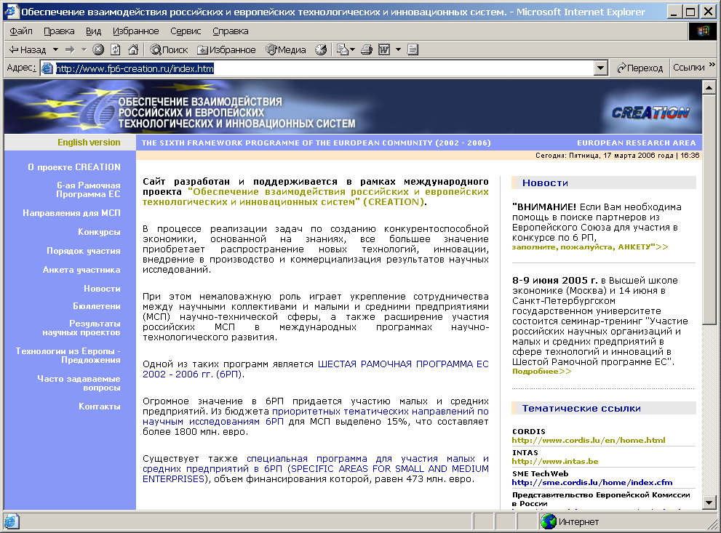

CREATION website, English version http://www.fp6-creation.ru/eindex.htm

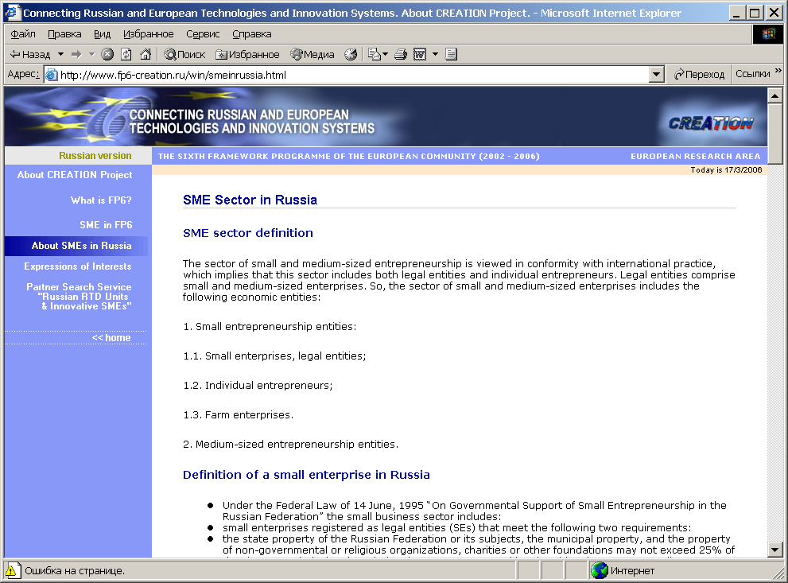

WP 5 - Consortium management activities, including dissemination of the project results
The objective of Workpackage 5 was to

- manage all stages of the project for high-quality implementation of the work and financial plans and achievement of planning results

Deliverables planned:

- High-quality and timely implementation of the project in accordance with work and financial plans
- Reports as envisaged by the Contract
- Dissemination of the project results

Deliverables achieved:

- Final activity and management reports

Milestones planned:

- Final report as envisaged by the Contract

Milestones and achieved results:

- Final reports as envisaged by the Contract
- Presentations of the project results

The consortium co-ordinator CESEP provided guidance and control of implementation of the project activities in accordance with the work and financial plans during the contract period. CESEP carried out technical management of each individual work package, linking together all the project components and maintaining communications with the Commission. The co-ordinator was responsible for the overall legal, contractual, ethical, financial and administrative management.
Each contractor disseminated the project results, promoted gender equality in the project and obtained the audit certificates.
Implementation of activities within the proposed project envisaged close collaboration of Russian and European participants from Austria, namely: Centre for Science and Education Programmes (CESEP, Russia); Centre for Science Research and Statistics (CSRS, Russia); Interdisciplinary Center for Advanced Professional Education of the St.-Petersburg State University (ICAPE, Russia); Institute for Statistical Studies and Economics of Knowledge/ State University - Higher School of Economics (ISEK/HSE, Russia); Austrian Research Promotion Agency (FFG, Austria). RTC – North (UK) and Zenit GmbH (Germany) companies were involved into the project for the purpose of establishing linkages with the CREATION website and dissemination of the project results via the companies’ websites.
The co-ordinator enabled connection between the European Commission and the project participants and supplied them with overall information on the project progress. The co-ordinator implemented the organisation of discussions and meetings of the project participants related to the project activities. The co-ordinator will receive all payments made by the Commission and administer the distribution of the Community contribution regarding its allocation between the participants and activities in accordance with the work and financial conditions fixed in the project documentation. The co-ordinator will keep accounts making it possible to determine what portion of the Community funds has been allocated to each participant.
In accordance with the project work plan, there was assigned a manager from each participanting organisation to perform particular activities under the project. The managers were responsible for the selection of proper staff and equipment for effective achievement of the project objectives and optimal use of human, material and financial resources. The managers guided and controlled implementation of the project activities in accordance with the work and financial plans. The project managers provided monitoring of timely preparation of working and financial reports by each participant.
Decision making on the particular issues was carried out by managers under joint discussion and meetings with participation of the project co-ordinator.

Table 1: Deliverables List

Del.  no. | Deliverable  name | Workpack.no. | Date due  (proj. month) | Actual  delivery date | Estimated indicative person-months *) | Used indicative person-months *) | Lead  contractor
1 | 23 CORDIS-based express-information briefs on EU RTD programmes | 4 | 1 | 1 | 7,40 | 7,40 | 5
2 | International Workshop on Russian SMEs participation in FP6 and innovation activities foreseen under FP6 thematic priorities in Moscow | 3 | 3 | 6 | 4,72 | 4,51 | 3
3 | International Workshop on Russian SMEs participation in FP6 and innovation activities foreseen under FP6 thematic priorities in St. Petersburg | 3 | - | 6 | - | 0,5 | 1
4 | Russian-English website with detailed information on FP6 thematic priorities and SME's specific programmes at the Russian part and Russian partners search services at the English part | 4 | 4 | 4 | 18,84 | 19,10 | 5
5 | Assisting and consultancy services in Moscow | 3 | 4 | 1 | 7,06 | 7,31 | 5
6 | Assisting and consultancy services in St.-Petersburg | 3 | 5 | 3 | 5,90 | 6,15 | 4
7 | Internet accessible English–language database on Russian RTD Units and Innovative SMEs | 1 | 6 | 6 | 37,20 | 37,20 | 1
8 | Russian–language digests on EU RTD results and new technologies | 2 | 6 | 6 | 12,50 | 12,50 | 5
9 | Special section on the website for presentation EU RTD programmes results and technology offers | 2 | 8 | 8 | 16,53 | 16,94 | 5
10 | Published English-language Directory "Russian RTD Units and Innovative SMEs" | 1 | 12 | 12 | 11,10 | 11,10 | 2
11 | Final activity and management reports | 5 | 12 | 12 | 1,21 | 1,21 | 1
 |  |  |  |  | 122,46 | 123,92

Table 2: Milestones List

Milestone  no. | Milestone  name | Workpackage  no. | Date due | Actual  delivery date | Lead  contractor
M1.1 | English-language database "Russian RTD Units & Innovative SMEs" | WP1 | 3 | 3 | 1
M1.2 | User-friendly Internet accessible English–language database on Russian RTD Units and Innovative SMEs with records classification by existing European S&T priorities | WP1 | 6 | 6 | 1
M1.3 | Directory "Russian RTD Units and Innovative SMEs" | WP1 | 12 | 12 | 2
M2.1 | Monthly issued the Russian–language digests on EU RTD results and new technologies | WP2 | 6 | 6 | 5
M2.2 | Special section on the website for presentation EU RTD programmes results and technology offers | WP2 | 8 | 8 | 5
M3.1 | International Workshop on Russian SMEs participation in FP6 and innovation activities foreseen under FP6 thematic priorities in Moscow | WP3 | 3 | 6 | 3
M3.2 | International Workshop on Russian SMEs participation in FP6 and innovation activities foreseen under FP6 thematic priorities in St. Petersburg | WP3 | - | 6 | 1
M3.3 | Functioning of the assisting and consultancy services on SMEs participation under FP6 at the State University - Higher School of Economics (Moscow) | WP3 | 4 | 1 | 5
M3.4 | Functioning of the assisting and consultancy services on SMEs participation under FP6 at the St.-Petersburg State University | WP3 | 5 | 3 | 4
M4.1 | 23 CORDIS-based express-information briefs on EU RTD programmes | WP4 | 1 | 1 | 5
M4.2 | Russian-English website with detailed information on FP6 thematic priorities and SME's specific programmes at the Russian part and Russian partners search services at the English part | WP4 | 4 | 4 | 5
M5.1 | Final reports as envisaged by the Contract | WP5 | 12 | 12 | 1
M5.2 | Presentations of the project results | WP5 | 12 | 12 | 5

CREATION

Project no.: 502259 (INCO)

Project acronym: CREATION

Project full name: Connecting Russian and European technologies and innovation systems

Instrument: Specific Support Action

Thematic Priority: FP6 INCO (FP6-2002-INCO-Russia+NIS/SSA-4)

D1. 23 CORDIS-based express-information briefs on EU RTD programmes

Due date of deliverable: project month 01
Actual submission date: project month 01

Start date of project: 01/01/2005 Duration: 12 months

Organisation name of lead contractor for this deliverable:
P5 Institute for Statistical Studies and Economics of Knowledge, State University – Higher School of Economics, ISEK/HSE (Russia)

Project co-funded by the European Commission within the Sixth Framework Programme (2002-2006)
Dissemination Level
PU | Public | X
PP | Restricted to other programme participants (including the Commission Services)
RE | Restricted to a group specified by the consortium (including the Commission Services)
CO | Confidential, only for members of the consortium (including the Commission Services)

CREATION

Project no.: 502259 (INCO)

Project acronym: CREATION

Project full name: Connecting Russian and European technologies and innovation systems

Instrument: Specific Support Action

Thematic Priority: FP6 INCO (FP6-2002-INCO-Russia+NIS/SSA-4)

D2. International Workshop on Russian SMEs participation in FP6 and innovation activities foreseen under FP6 thematic priorities in Moscow

Due date of deliverable: project month 03
Actual submission date: project month 06

Start date of project: 01/01/2005 Duration: 12 months

Organisation name of lead contractor for this deliverable:
P3 Asutrian Research promotion Agency, FFG (Vienna, Austria)

Project co-funded by the European Commission within the Sixth Framework Programme (2002-2006)
Dissemination Level
PU | Public | X
PP | Restricted to other programme participants (including the Commission Services)
RE | Restricted to a group specified by the consortium (including the Commission Services)
CO | Confidential, only for members of the consortium (including the Commission Services)

CREATION

Project no.: 502259 (INCO)

Project acronym: CREATION

Project full name: Connecting Russian and European technologies and innovation systems

Instrument: Specific Support Action

Thematic Priority: FP6 INCO (FP6-2002-INCO-Russia+NIS/SSA-4)

D3. International Workshop on Russian SMEs participation in FP6 and innovation activities foreseen under FP6 thematic priorities in St. Petersburg

Due date of deliverable: not planned
Actual submission date: project month 06

Start date of project: 01/01/2005 Duration: 12 months

Organisation name of lead contractor for this deliverable:
P1 Centre for Science and Education Programmes, CESEP (Russia)

Project co-funded by the European Commission within the Sixth Framework Programme (2002-2006)
Dissemination Level
PU | Public | X
PP | Restricted to other programme participants (including the Commission Services)
RE | Restricted to a group specified by the consortium (including the Commission Services)
CO | Confidential, only for members of the consortium (including the Commission Services)

CREATION

Project no.: 502259 (INCO)

Project acronym: CREATION

Project full name: Connecting Russian and European technologies and innovation systems

Instrument: Specific Support Action

Thematic Priority: FP6 INCO (FP6-2002-INCO-Russia+NIS/SSA-4)

D4. Russian-English website with detailed information on FP6 thematic priorities and SME's specific programmes at the Russian part and Russian partners search services at the English part

Due date of deliverable: project month 04
Actual submission date: project month 04

Start date of project: 01/01/2005 Duration: 12 months

Organisation name of lead contractor for this deliverable:
P5 Institute for Statistical Studies and Economics of Knowledge, State University – Higher School of Economics, ISEK/HSE (Russia)

Project co-funded by the European Commission within the Sixth Framework Programme (2002-2006)
Dissemination Level
PU | Public | X
PP | Restricted to other programme participants (including the Commission Services)
RE | Restricted to a group specified by the consortium (including the Commission Services)
CO | Confidential, only for members of the consortium (including the Commission Services)

CREATION

Project no.: 502259 (INCO)

Project acronym: CREATION

Project full name: Connecting Russian and European technologies and innovation systems

Instrument: Specific Support Action

Thematic Priority: FP6 INCO (FP6-2002-INCO-Russia+NIS/SSA-4)

D5. Assisting and consultancy services in Moscow

Due date of deliverable: project month 04
Actual submission date: project month 01

Start date of project: 01/01/2005 Duration: 12 months

Organisation name of lead contractor for this deliverable:
P5 Institute for Statistical Studies and Economics of Knowledge, State University – Higher School of Economics, ISEK/HSE (Russia)

Project co-funded by the European Commission within the Sixth Framework Programme (2002-2006)
Dissemination Level
PU | Public | X
PP | Restricted to other programme participants (including the Commission Services)
RE | Restricted to a group specified by the consortium (including the Commission Services)
CO | Confidential, only for members of the consortium (including the Commission Services)

CREATION

Project no.: 502259 (INCO)

Project acronym: CREATION

Project full name: Connecting Russian and European technologies and innovation systems

Instrument: Specific Support Action

Thematic Priority: FP6 INCO (FP6-2002-INCO-Russia+NIS/SSA-4)

D6. Assisting and consultancy services in St.-Petersburg

Due date of deliverable: project month 05
Actual submission date: project month 03

Start date of project: 01/01/2005 Duration: 12 months

Organisation name of lead contractor for this deliverable:
P4 Interdisciplinary Center for Advanced Professional Education, St-Petersburg State University, ICAPE (Russia)

Project co-funded by the European Commission within the Sixth Framework Programme (2002-2006)
Dissemination Level
PU | Public | X
PP | Restricted to other programme participants (including the Commission Services)
RE | Restricted to a group specified by the consortium (including the Commission Services)
CO | Confidential, only for members of the consortium (including the Commission Services)

CREATION

Project no.: 502259 (INCO)

Project acronym: CREATION

Project full name: Connecting Russian and European technologies and innovation systems

Instrument: Specific Support Action

Thematic Priority: FP6 INCO (FP6-2002-INCO-Russia+NIS/SSA-4)

D7. Internet accessible English–language database on Russian RTD Units and Innovative SMEs

Due date of deliverable: project month 06
Actual submission date: project month 06

Start date of project: 01/01/2005 Duration: 12 months

Organisation name of lead contractor for this deliverable:
P1 Centre for Science and Education Programmes, CESEP (Russia)

Project co-funded by the European Commission within the Sixth Framework Programme (2002-2006)
Dissemination Level
PU | Public | X
PP | Restricted to other programme participants (including the Commission Services)
RE | Restricted to a group specified by the consortium (including the Commission Services)
CO | Confidential, only for members of the consortium (including the Commission Services)

CREATION

Project no.: 502259 (INCO)

Project acronym: CREATION

Project full name: Connecting Russian and European technologies and innovation systems

Instrument: Specific Support Action

Thematic Priority: FP6 INCO (FP6-2002-INCO-Russia+NIS/SSA-4)

D8. Russian–language digests on EU RTD results and new technologies

Due date of deliverable: project month 06
Actual submission date: project month 06

Start date of project: 01/01/2005 Duration: 12 months

Organisation name of lead contractor for this deliverable:
P5 Institute for Statistical Studies and Economics of Knowledge, State University – Higher School of Economics, ISEK/HSE (Russia)

Project co-funded by the European Commission within the Sixth Framework Programme (2002-2006)
Dissemination Level
PU | Public | X
PP | Restricted to other programme participants (including the Commission Services)
RE | Restricted to a group specified by the consortium (including the Commission Services)
CO | Confidential, only for members of the consortium (including the Commission Services)

CREATION

Project no.: 502259 (INCO)

Project acronym: CREATION

Project full name: Connecting Russian and European technologies and innovation systems

Instrument: Specific Support Action

Thematic Priority: FP6 INCO (FP6-2002-INCO-Russia+NIS/SSA-4)

D9. Special section on the website for presentation EU RTD programmes results and technology offers

Due date of deliverable: project month 08
Actual submission date: project month 08

Start date of project: 01/01/2005 Duration: 12 months

Organisation name of lead contractor for this deliverable:
P5 Institute for Statistical Studies and Economics of Knowledge, State University – Higher School of Economics, ISEK/HSE (Russia)

Project co-funded by the European Commission within the Sixth Framework Programme (2002-2006)
Dissemination Level
PU | Public | X
PP | Restricted to other programme participants (including the Commission Services)
RE | Restricted to a group specified by the consortium (including the Commission Services)
CO | Confidential, only for members of the consortium (including the Commission Services)

CREATION

Project no.: 502259 (INCO)

Project acronym: CREATION

Project full name: Connecting Russian and European technologies and innovation systems

Instrument: Specific Support Action

Thematic Priority: FP6 INCO (FP6-2002-INCO-Russia+NIS/SSA-4)

D10. Published English-language Directory "Russian RTD Units and Innovative SMEs"

Due date of deliverable: project month 12
Actual submission date: project month 12

Start date of project: 01/01/2005 Duration: 12 months

Organisation name of lead contractor for this deliverable:
P2 Centre for Science Research and Statistics, CSRS (Russia)

Project co-funded by the European Commission within the Sixth Framework Programme (2002-2006)
Dissemination Level
PU | Public | X
PP | Restricted to other programme participants (including the Commission Services)
RE | Restricted to a group specified by the consortium (including the Commission Services)
CO | Confidential, only for members of the consortium (including the Commission Services)

CREATION

Project no.: 502259 (INCO)

Project acronym: CREATION

Project full name: Connecting Russian and European technologies and innovation systems

Instrument: Specific Support Action

Thematic Priority: FP6 INCO (FP6-2002-INCO-Russia+NIS/SSA-4)

D11. Final activity and management reports

Due date of deliverable: project month 12
Actual submission date: project month 12

Start date of project: 01/01/2005 Duration: 12 months

Organisation name of lead contractor for this deliverable:
P1 Centre for Science and Education Programmes, CESEP (Russia)

Project co-funded by the European Commission within the Sixth Framework Programme (2002-2006)
Dissemination Level
PU | Public
PP | Restricted to other programme participants (including the Commission Services)
RE | Restricted to a group specified by the consortium (including the Commission Services)
CO | Confidential, only for members of the consortium (including the Commission Services) | X

Section 3 – Consortium management
The consortium co-ordinator CESEP provided guidance and control of implementation of the project activities in accordance with the work and financial plans during the contract period. CESEP carried out technical management of each individual work package, linking together all the project components and maintaining communications with the Commission. The co-ordinator was responsible for the overall legal, contractual, ethical, financial and administrative management.
Each contractor disseminated the project results, promoted gender equality in the project and obtained the audit certificates.
Implementation of activities under the project envisaged close collaboration of Russian and European participants from Austria, namely: Centre for Science and Education Programmes (CESEP, Russia); Centre for Science Research and Statistics (CSRS, Russia); Interdisciplinary Center for Advanced Professional Education of the St.-Petersburg State University (ICAPE, Russia); Institute for Statistical Studies and Economics of Knowledge/ State University - Higher School of Economics (ISEK/HSE, Russia); Austrian Research Promotion Agency (FFG, Austria). RTC – North (UK) and Zenit GmbH (Germany) companies were involved into the project for the purpose of establishing linkages with the CREATION website and dissemination of the project results via the companies’ websites.
The co-ordinator enabled connection between the European Commission and the project participants and supplied them with overall information on the project progress. In accordance with the project work plan, there was assigned a manager from each participant to perform particular activities under the project. The managers were responsible for the selection of proper staff and equipment for effective achievement of the project objectives and optimal use of human, material and financial resources. The managers guided and controlled the implementation of the project activities in accordance with the work and financial plans. The project managers provided monitoring of timely preparation of working and financial reports by each participant. Decision making on particular issues was carried out by managers under joint discussion with participation of the project co-ordinator. The co-ordinator, as required, organised discussions of the actual issues during the project implementation with the consortium by e-mail, phone and at meetings of project managers. Two meetings of the project participants related to the project activities were organised in June 2005 in Moscow and St. Petersburg.
The co-ordinator will receive all payments made by the Commission and administer distribution of the Community contribution regarding its allocation between the participants and activities in accordance with the work and financial conditions fixed in the project documentation. The co-ordinator will keep accounts making it possible to determine what portion of the Community funds has been allocated to each participant.

Table 3: Workpackages – Plan and Status Barchart

Plan – 123
Fact - 123

Acronym: CREATION
Contract № 502259
Workpackages/milestones | Duration 12 months
Workpackages/milestones | 1 |  | 2 |  | 3 |  | 4 |  | 5 | 6 | 7 | 8 | 9 | 10 | 11 |  | 12
Workpackage 1
Development and maintenance of an English–language database "Russian RTD Units & Innovative SMEs"
Task 1.1 English-language database "Russian RTD Units & Innovative SMEs"
Task 1.2 User-friendly Internet accessible English–language database on Russian RTD Units and Innovative SMEs with records classification by existing European S&T priorities
Task 1.3 Directory "Russian RTD Units and Innovative SMEs"
Workpackage 2
Creation of web services and design of periodical digests for dissemination of data on research findings and technologies obtained within EU programmes to Russian high-tech SMEs
Task 2.1 Russian–language digests on EU RTD results and new technologies
Task 2.2 Special section on the website for presentation EU RTD programmes results and technology offers
Workpackage 3
Establishment of regional information, assistance and consultancy services in Russia
Task 3.1 International Workshop on Russian SMEs participation in FP6 and innovation activities foreseen under FP6 thematic priorities in Moscow
Task 3.2 International Workshop on Russian SMEs participation in FP6 and innovation activities foreseen under FP6 thematic priorities in St. Petersburg
Task 3.3 Assisting and consultancy services at the State University – Higher School of Economics, Moscow
Task 3.4 Assisting and consultancy services at the St.-Petersburg State University
Workpackage 4
Development of Russian–English FP6 web services and periodical publishing and disseminating CORDIS-based information bulletins
Task 4.1 23 CORDIS-based express-information briefs on EU RTD programmes
Task 4.2 Russian-English website with detailed information on FP6 thematic priorities and SME's specific programmes at the Russian part and Russian partners search services at the English part
Workpackage 5
Consortium management activities, including dissemination of the project results

During the project implementation the following changes occurred in comparison with the initial plan:
Milestone | Planned date | Fact date | Comments
Workpackage 3
Establishment of regional information, assistance and consultancy services in Russia
Task 3.1 International Workshop on Russian SMEs participation in FP6 and innovation activities foreseen under FP6 thematic priorities in Moscow | March 2005 | June 2005 | The workshop was postponed because of organisation and performance of two workshops in Moscow and St. Petersburg instead of the planned single workshop in Moscow.
Task 3.2 International Workshop on Russian SMEs participation in FP6 and innovation activities foreseen under FP6 thematic priorities in St. Petersburg | not planned | June 2005
Task 3.3 Assisting and consultancy services in Moscow | April 2005 – December 2005 | January 2005 – December 2005
Task 3.4 Assisting and consultancy services in St.-Petersburg | May 2005 – December 2005 | March 2005 – December 2005

All other activities envisaged under the CREATION project were performed without changes.

Section 4 – Other issues

The CREATION project was not subject to requirements and/or recommendations concerning ethical issues and it is neither an Integrated Project (IP), nor Network of Excellence Project (NoE), nor a Cooperative Research Project, nor a Collective Research Project.

Appendix 1 - Plan for using and disseminating the knowledge

Section 1 - Exploitable knowledge and its Use

Not applicable because the CREATION project has not generated exploitable results which have a potential for industrial or commercial application in research activities or for developing, creating or marketing a product or process or for creating or providing a service.

Section 2 - Dissemination of knowledge
The project participants have equal rights to use and disseminate knowledge obtained during the project implementation. The obtained knowledge includes: information, a database, publications and training programme materials. The knowledge was used and disseminated in accordance with the proposed project objectives in the framework of the envisaged activities and relevant participants’ responsibilities. The overall principles of use and dissemination of the knowledge obtained are fully in line with the objectives and regulations of the FP6 INCO programme.
The information digests and express-information briefs were regularly disseminated through a wide range of all interested parties free of charge in the electronic forms.
There were organised presentations of the project results for representatives of Russian ministries, research institutes, universities, mass media at the ISEK/HSE, CSRS (Moscow) and SPbSU (St.- Petersburg).
The website contains both cross-references and useful external links (CORDIS, European Commission, INTAS, and others). The website is registered in the most popular Russian Internet search systems and indices such as Yandex.ru, Rambler.ru, Aport.ru, Altervista.ru. For accounting of the web-site attendance and popularity, it is registered in the Internet statistical system SPYLOG. From the starting date of the website (April 2005) to the end of the project (December 2005) more than 3,000 visitors were registered.
The database is accessible for any INCO initiatives and is used by participants and targeted audience of RUSERA, TECHBRID and other INCO projects.
The Directory "Russian RTD Units & Innovative SMEs" is to be widely disseminated free of charge to all the parties concerned. It increases research co-operation between enterprises and the public science.
The project participants provided the information support, PR and publicising activities concerning FP6 and INTAS widely via the Internet and in mass media.
Newsletters about FP6, SMEs specific programme and INTAS and information letters about forthcoming international workshops were disseminated among relevant journals, newspapers and information agencies. Information was also placed on the websites of the ISEK/HSE http://www.hse.ru, CREATION http://www.fp6-creation.ru, CSRS http://fp6.csrs.ru, E-Development Partnership in the North-West of Russia (PRIOR NW) http://www.prior.nw.ru/ and other Russian science and business related websites:
http://www.businesspress.ru/newspaper/article_mId_44_aId_342946.html
http://www.rinti.ru/grants/fulldoc.dws?uid=446730442A8916AA66BA078&dui=29888
http://www.sciencerf.ru/client/events.aspx?ob_no=618
http://www.technet.ru/print.php?id=2765&type=a&url=/index.php&r=13
http://www.jyy.ru/html/nov.shtml
http://www.mbm.ru/newsitem.asp?id=28900
http://www.sme-news.ru/news.asp?SectionId=2&NewsId=17131
http://www.ubo.ru/news/public/?id=149
http://www.redtram.ru/go/7143194/
http://www.businesscom.ru/ActionShow.asp?ID=14745
http://www.icm.by/_private/News_r/co_europe_08_05.html
http://www.rbp.ru/news/?uid=819
http://www.oreanda.ru/ru/news/20050608/common/events/innovations/article95305/
http://www.tpprf.ru/ru/main/organization/ob_predpr/otdel/iof/news_current.shtml?2005/06/20050614-21708.html
http://www.nanocenter.ru/events.php?pid=frame
http://www.subcontract.ru/NewsAM/NewsAMShow.asp?ID=195754
http://www.rcsme.ru/news.asp?SectionId=1&NewsId=17131
http://www.rttn.ru/frames.php?page=news&setLang=rus
http://www.allmedia.ru/newsitem.asp?id=742655.
Examples of the relevant websites and publications are presented at Annex4.

English version of the information letter about the International Workshop

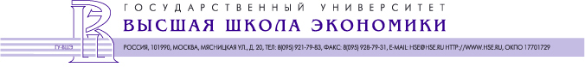

International Workshop

Participation of the Russian RTD Organisations and Small and Medium Enterprises in the Sixth Framework Programme and Innovation Activities

Dear colleagues,

The State University – Higher School of Economics is pleased to invite you to take part in a two-day International Workshop «Participation of the Russian RTD Organisations and Small and Medium Enterprises in the Sixth Framework Programme and Innovation Activities». The workshop will take place on

Wednesday, June 8 and Thursday, June 9, 2005

from 9.30 am to 7 pm

at the State University – Higher School of Economics (Room 311),

20, Myasnitskaya St., Moscow, Russia.
The workshop is organised in the framework of the ongoing projects: FP6-INCO SSA “Connecting Russian and European Technologies and Innovation Systems” (CREATION, contract No.: 502259, project co-ordinator Dr. Leonid Gokhberg) and “INTAS - FP6 NIS National Contact Point (NCP)” (FP6-SMEs NCP for Russia).
The main objectives of the workshop are the following:
- To facilitate participation of the Russian S&T community and high-tech SMEs in the Sixth Framework Programme (FP6);
- To promote the involvement of Russian RTD organisations and SMEs in EU innovation activities envisaged under FP6 thematic priorities and INTAS activities.
The first day of the workshop is devoted to the presentation of opportunities for Russian RTD organisations and SMEs within Community research programmes.
The first day of the workshop will be completed by a fourchette, which will follow the final session.
We have the honour to invite you to take part in the fourchette at the Professors’ Hall of the Higher School of Economics on the 8th of June from 7 p.m to 9 p.m.
During the second day of the workshop the Austrian Research Promotion Agency, Division for International Research and Technology Cooperation (BIT) will organise training on practical issues of participation in FP6 for Russian RTD organisations and innovative SMEs.
Looking forward to seeing at the workshop.
Yours sincerely,

Deputy Director Alexander Sokolov
Institute for Statistical Studies
and Economics of Knowledge HSE

Enclosures: Agenda
State University – Higher School of Economics, 20, Myasnitskaya St., Moscow, 101990 Russia. Telephone: +7 (095) 921-79-68
Fax: +7 (095) 925-03-67. E-mail: Sokolov@hse.ru

The CREATION partner FFG elaborated a special INCO projects information website and CREATION project information sheet, that was widely disseminated among Russian and EU participants of international events, including workshops of INTAS, RUSERA, EARMA, NCPs meetings.
FFG INCO Project Information Website
(http://www.ffg.at/index.php?cid=827)
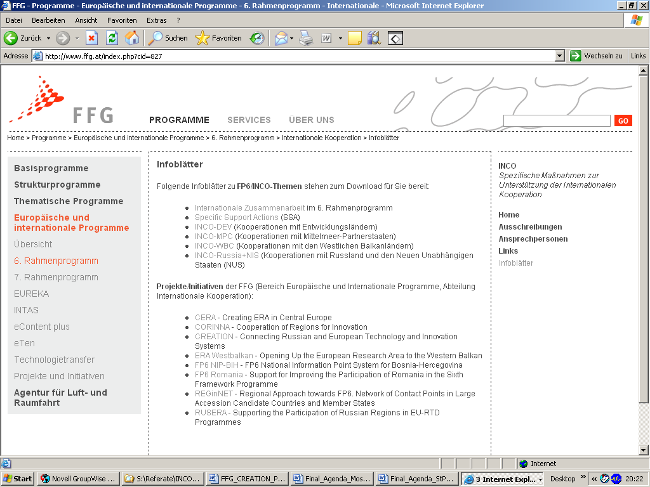

FFG CREATION Project Information Sheet – Page 1
(http://www.bit.ac.at/inco/Doks/Project_CREATION.pdf)
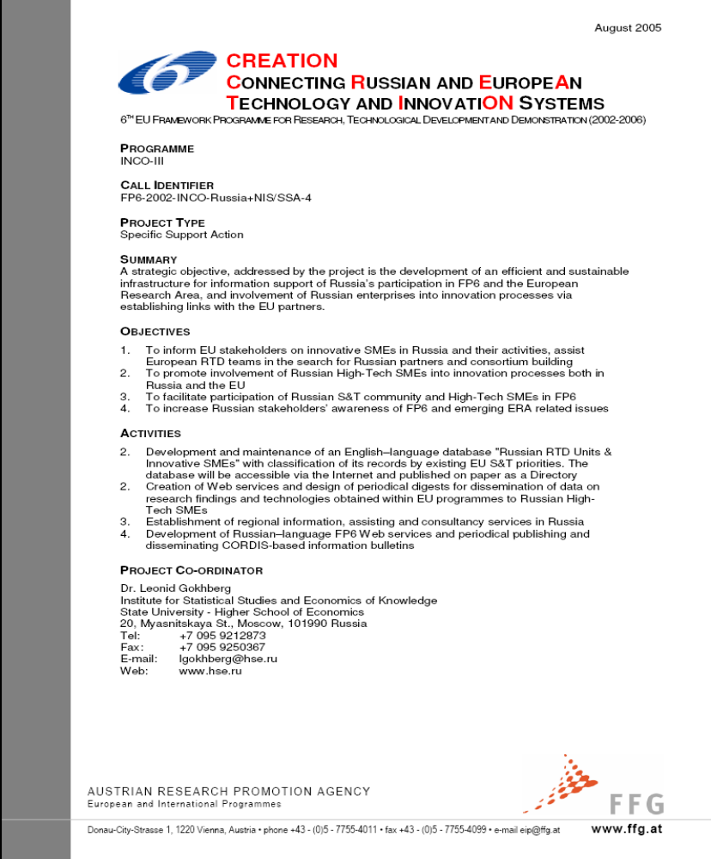
The whole project objective was to increase awareness of Russian and European research communities with respect to new opportunities to establish RTD co-operation provided by FP6, and thus facilitate broader public participation in international RTD co-operation. A number of instruments were created to bridge the gap between the EU and Russian RTD systems, including information facilities (database, publication, information briefs, etc.) and tailor-made events and activities (seminars, consultancies, etc.)

Overview table

Actual Dates | Type | Type of Audience | Countries  addressed | Size of  Audience | Partner  responsible/  involved
September 2004 | Workshop  EARMA – Association of Research Managers and Administrators across Europe  "Fundamentals of International Project Management"  27-28 September 2004, Karlsruhe, Germany | European Research Managers | EU Member States |  | P3 (FFG)
October 2004 | Workshop  “INTAS FP6 NIS Information Workshop”  25-29 October 2004, Brussels, Belgium  http://www.intas.be/index.asp?s=1_4_3&uid=  http://www.intas.be/content/INTAS&EU/inin/ININ%20workshops/Workshop%20October%202004/Final%20programme%20ININ%20Workshop%2025-29%20October%202004.pdf  http://www.intas.be/content/INTAS&EU/inin/ININ%20workshops/Workshop%20October%202004/List%20of%20speakers%20for%20web.pdf  http://www.intas.be/content/INTAS&EU/inin/ININ%20workshops/Workshop%20October%202004/CREATION%20-%20Mr%20Koenig.pdf | Russian+NIS FP6 NCP’s,  Russian+NIS INTAS NIP’s  Russian+NIS INTAS & FP6 officials | Russia+ NIS |  | P3 (FFG); P5 (ISEK/HSE)
January 2005 | Brokerage Event  FP6 SSA RUSERA Project Event  http://www.bit.ac.at/inco/rusera  Moscow, Russia | Research, Industry, Higher Education, University, Public | - Russia  - EU Member States | 110 | P3 (FFG); P5 (ISEK/HSE)
Since January 2005 | NCP activities  RTD Consultancy Services (as FP6 NCP organisation) | Research, Industry, Higher Education, University, Public | - Austria,  - EU Member  States  - Russia |  | P2 (CSRS); P3 (FFG); P4 (ICAPE); P5 (ISEK/HSE)
Since January 2005 | Publication  CORDIS-based express-information briefs on EU RTD programmes issued and disseminated throughout Russia | Research, Industry, Higher Education, University, Public | Russia |  | P1 (CESEP); P5 (ISEK/HSE)
9-10 February 2005 | Information and training seminar in Voronezh  The main scope of the Infoday and training seminar was to inform regional S&T communities on the existing opportunities for Russian scientists in FP6 and INTAS initiatives. Besides, the issues of the CREATION project were discussed. | Regional research organizations, functioning in the field of social sciences and humanities | Russia | 70 | P2 (CSRS)
Since April 2005 | Website  Russian-English website with detailed information on FP6 thematic priorities and SME's specific programmes at the Russian part and Russian partners search services at the English part | Research, Industry, Higher Education, University, Public | - EU Member  States & Assosiated Countries  - Russia |  | P4 (ICAPE); P5 (ISEK/HSE)
20 May 2005 | International Workshop “Building of the Russian National Information Network for the Development of International Mobility of Researchers” | Research, Industry, Higher Education, University, Public | - EU Member  States  - Russia |  | P5 (ISEK/HSE)
Since June 2005 | NCP activities  Dissemination (as FP6 NCP organisation) | Research, Industry, Higher Education, University, Public | - Austria,  - EU Member  States  - Russia |  | P2 (CSRS); P3 (FFG); P4 (ICAPE); P5 (ISEK/HSE)
Since June 2005 | Database  Internet accessible English–language database on Russian RTD Units and Innovative SMEs http://www.fp6-creation.ru/win/partnersearch.php | Participantrs of INCO and INTAS initiatives; targeted audience of RUSERA, TECHBRID and other INCO projects; Research, Industry, Higher Education, University, Public | - EU Member  States & Assosiated Countries  - Russia |  | P2 (CSRS); P4 (ICAPE); P5 (ISEK/HSE)
8-9 June 2005 | Workshop  FP6 SME Training Workshop, Moscow, Russia | Research, Industry, Higher Education, University, Public | Russia | 123 | P1 (CESEP); P3 (FFG); P5 (ISEK/HSE)
14 June 2005 | Workshop  FP6 SME Training Workshop, St. Petersburg, Russia | Research, Industry, Higher Education, University, Public | Russia | 39 | P1 (CESEP); P3 (FFG); P4 (ICAPE)
June 2005 | CREATION workshop websites  http://www.bit.ac.at/inco/va_moscow&stpetersburg_index.htm  http://www.hse.ru/temp/2005/06_08-09_seminar.shtml | Research, Industry, Higher Education, University, Public | - Russia,  - EU Member  States |  | P3 (FFG); P5 (ISEK/HSE)
Since June 2005 | Publication  Monthly issued Russian–language digests on EU RTD results and new technologies | Research, Industry, Higher Education, University, Public | Russia |  | P1 (CESEP); P5 (ISEK/HSE)
23-24 June 2005 | Workshop  “Opportunities for the European financing of SSH in Russia”, 23-24 June, St.-Petersburg with participation of INTAS, EC, ESF, NATO and Russian Foundation for the Humanities.  The workshop allowed to disseminate general and specific information on EU funded programmes in the field of social sciences, humanities and economics, as well as on the CREATION project among targeted S&T community and to highlight the opportunities for Russian participants. The information on the workshop was positioned on the NCP Web-site http://fp6.csrs.ru | Russian research organizations and scientists | Russia | 77 | P2 (CSRS)
June 2005 | Publication  Business Portal of Entrepreneurship Promotion in Russia  http://www.allmedia.ru/newsitem.asp?id=742655  http://www.businesspress.ru/newspaper/article.asp?aId=342946&mId=44 | Industry, Public | Russia |  | P5 (ISEK/HSE)
Since June 2005 | Websites  Information about CREATION activities:  http://www.hse.ru  http://fp6.hse.ru/mer.html  http://www.prior.nw.ru/  http://www.rinti.ru/grants/fulldoc.dws?uid=446730442A8916AA66BA078&dui=29888  http://www.sciencerf.ru/client/events.aspx?ob_no=618  http://www.technet.ru/print.php?id=2765&type=a&url=/index.php&r=13  http://www.jyy.ru/html/nov.shtml  http://www.mbm.ru/newsitem.asp?id=28900  http://www.sme-news.ru/news.asp?SectionId=2&NewsId=17131  http://www.ubo.ru/news/public/?id=149  http://www.redtram.ru/go/7143194/  http://www.businesscom.ru/ActionShow.asp?ID=14745  http://www.icm.by/_private/News_r/co_europe_08_05.html  http://www.rbp.ru/news/?uid=819  http://www.oreanda.ru/ru/news/20050608/common/events/innovations/article95305/  http://www.tpprf.ru/ru/main/organization/ob_predpr/otdel/iof/news_current.shtml?2005/06/20050614-21708.html  http://www.nanocenter.ru/events.php?pid=frame  http://www.subcontract.ru/NewsAM/NewsAMShow.asp?ID=195754  http://www.rcsme.ru/news.asp?SectionId=1&NewsId=17131  http://www.rttn.ru/frames.php?page=news&setLang=rus | Research, Industry, Higher Education, University, Public | Russia |  | P1 (CESEP); P5 (ISEK/HSE)
Since August 2005 | CREATION Website  Special section on the website for presentation of EU RTD programmes results and technology offers was launched http://www.fp6-creation.ru/win/results.html | Research, Industry, Higher Education, University, Public | Russia |  | P1 (CESEP); P4 (ICAPE); P5 (ISEK/HSE)
August 2005 | Publication  http://www.ffg.at/index.php?cid=827  http://www.bit.ac.at/inco/Doks/Project_CREATION.pdf | Public, European FP6 Multiplier System (NCP’s), Research, Higher Education, University | - Russia,  - EU Member States |  | P3 (FFG)
September 2005 | Science Day  Austria-Russia: Science and Technology Cooperation in Biotechnology, Vienna, Austria  http://www.bit.ac.at/inco/austrian-russian_scienceday.htm | Research, Industry, Higher Education, University, Public | - Austria,  - Russia | 90 | P3 (FFG)
October 2005 | Training workshop  within TACIS EuropeAid project “e-Skills for Russian SMEs” | SME, business companies |  | 40 | P4 (ICAPE)
December 2005 | Conference  “Russia as EU’s Strategic Partner?”  European Forum Alpbach, Vienna, Austria | Public authorities, Research, Industry, Higher Education, University, Public | - EU Member  States  - Russia |  | P3 (FFG)
Since January 2006 | NCP activities  Dissemination activities (as FP6 NCP organisation) | Research, Industry, Higher Education, University, Public | - Austria,  - EU Member  States  - Russia |  | P2 (CSRS); P3 (FFG); P5 (ISEK/HSE)
Since January 2006 | Publication  English-language Directory "Russian RTD Units and Innovative SMEs" | Research, Industry, Higher Education, University, Public | - EU Member  States & Assosiated Countries  - Russia |  | P1 (CESEP); P2 (CSRS); P5 (ISEK/HSE)

Section 3 - Publishable results

Not applicable because the CREATION project has not generated exploitable results for which Intellectual Property Rights (IPR) are concerned.

