Publishable final activity report
Joined European Research on Mitochondrial Medicine

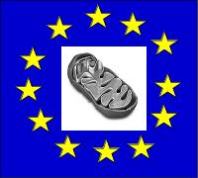EUMITOCOMBAT: Rational treatment strategies combating mitochondrial oxidative phosphorylation (OXPHOS) disorders

From 2004-2008, the European Commission financed an ambitious research programme called EUMITOCOMBAT. Twelve groups in nine different European countries joined forces in their research on diseases caused by mitochondrial dysfunction, a category of so-called rare diseases. Mitochondrial diseases are related to defects in the principal system for cellular energy production (see picture). This leads to an energy crisis in heavy energy consuming tissues, such as muscles, brain and heart, resulting in severe pathological manifestations (e.g. dementia, epilepsy, deafness, heart failure, muscle weakness). These can, moreover, develop at any age and can cause major disability and even death.

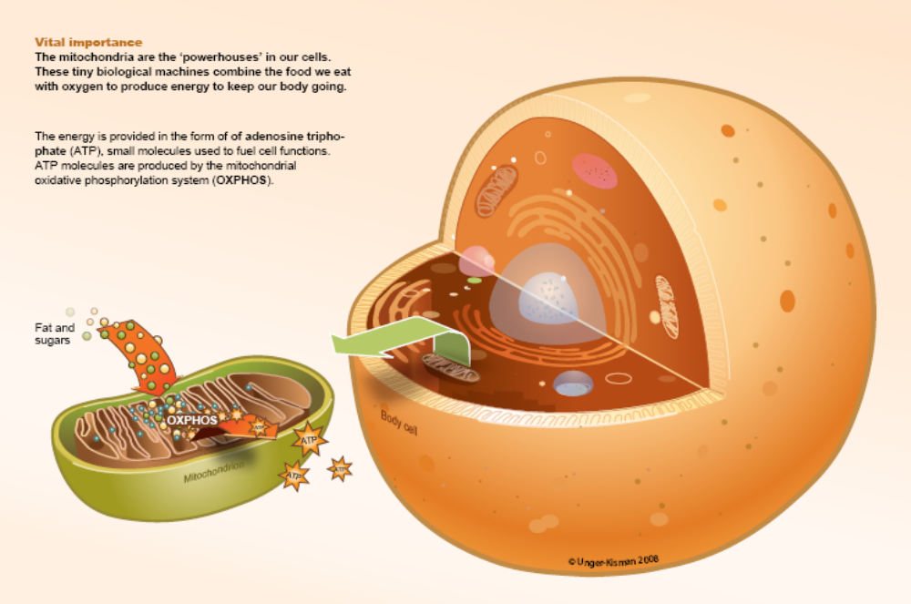

Project objectives
The project’s main goals were to obtain a detailed understanding of the clinical and pathobiological consequences of OXPHOS-disease in order to develop new treatment strategies. The efforts were focused on diseases of OXPHOS enzyme complexes I and IV, as well as on mitochondrial DNA maintenance and protein synthesis disturbances. The major objectives, around which the scientific and technological work was structured, applied to each of these disease categories:

- To understand properly the natural history of the disease, its clinical manifestations and their time-course, and the relationship between genotype and phenotype. The eventual goal was to provide routine and rapid diagnosis, which will form the rational basis for future therapy.
- To elucidate the pathophysiology of the disease by the analysis of biological models, thus revealing potential new therapeutic strategies or targets.
- To characterize in detail the cellular machinery primarily affected by the disease process (i.e. complexes I and IV, the components involved in their assembly, and the machinery of mtDNA maintenance and expression). A complete understanding of basic biological processes underlying OXPHOS will lead to the discovery of novel drug targets.
- To apply the knowledge gathered from such approaches to the rational design and testing of therapeutic agents and manipulations to ameliorate the manifestations of OXPHOS disease.

What has been achieved?
The scientific work of the consortium was structured within four Nodes. In the four years of the project (1 July 2004 to 30 June 2008) the following was achieved:

Node A: Clinical aspects of OXPHOS disease
Contractors involved: UNEW, INN, CU, UMCN, INSERM

Objectives:
- Clinical – to understand the natural history of mitochondrial disease and provide a platform for optimal management of patients
- Identification of new disease-causing genes
- Development of novel tools and technologies for diagnosis

Definition of the clinical aspects of OXPHOS disease
The first part of Node A involved the clinical aspects of mitochondrial diseases. A major aim was to obtain reliable retrospective and prospective data on patients with mitochondrial disease. Clinical assessment scales were published for both adults and children – these scales are critical for assessing the long-term prognosis and response to new therapies for patients with mitochondrial diseases. The development of these scales involved interaction between clinicians from four centres (UNEW, UMCN, INN and CU). Using validated rating scales, developed with funding from EUMITOCOMBAT, retrospective data were collected equating to 3322 patient-years. Prospective data was collected on 580 adults and 160 children. This equates to 1160 patient-years of prospective data for the adults and 224 patient-years for the children. With this data the consortium has been able to: 1) determine the prevalence of mitochondrial DNA disorders (approximately 1 in 6500 in the UK with another 1 in 3000 at risk of developing mtDNA disease); 2) compare rates of progression in adults and children; 3) show that symptoms relate to heteroplasmy levels in patients with heteroplasmic mtDNA mutations; 4) show the progression of cardiac disease is higher in patients carrying the 3243A>G mutation than in other genotypes, with the exception of patients carrying less than 30% heteroplasmy; 5) show that dysphagia and dysarthria are common symptoms which can be helped by speech and language therapists. Finally, the data collected by EUMITOCOMBAT has been crucial in the development of services for patients with mitochondrial disease in the UK. This new service National Commissioning Group Service for Rare Mitochondrial Disease Service for Adults and Children was funded from April 1st 2007 and will provide an important model for other EU countries.

Identification of new disease-causing genes
New disease-causing genes has been an area of major success. The following new genes or new mutations were identified:
- PUS1 (pseudouridylate synthase) – a novel missense mutation was found in two brothers with myopathy, lactic acidosis and sideroblastic anemia (MLASA);
- mit EFG1 and mit EFTu - novel mutations in these genes were described in two infants with severe encephalopathy;
- MPV17 - mutations were found in this novel gene in families with combined cI and cIV deficiency due to hepatic depletion of mtDNA;
- COX6B1 – mutations were found in two brothers belonging to a consanguineous family with COX deficiency;
- KIAA - a homozygous stop codon mutation in this gene was found in offspring of first-cousin parents of Arab origin, having an unusual, early-onset mitochondrial encephalomyopathy;
- GC1 – the mitochondrial glutamate transporter: mutations in this gene have been identified in families with neonatal myoclonic epilepsy;
- p53R2 (small subunit of the ribonucleotide reductase, (RNR) ) - mutations in this gene have been identified in four families with similar clinical presentation and severe muscle mtDNA depletion. mtDNA depletion was also detected in several tissues of the KO mouse model for this gene;
- COQ8 – This is a new genetic defect causing primary coenzyme Q₁₀ deficiency. We have identified CABC1 gene mutations in four ubiquinone-deficient patients in three distinct families.

Development of novel tools and technologies for diagnosis
Subunit expression-complementation of 5 different human fibroblast cell lines with Complex I mutations (NDUFV1, NDUFS2, NDUFS4, NDUFS7, NDUFS8) was accomplished with the use of the baculoviral vector system. Subunit complementation was demonstrated by native gel electrophoresis followed by Western blotting with a Complex I-specific Ab directed against the 39-kD subunit, to show the proper mobility shift of the fully assembled complex, and in situ measurement of its catalytic activity. This result shows the feasibility of complementation of Complex I mutations in human fibroblasts, and serves as proof of principle for the general use of complementation in diagnostic prescreening and Complex I mutation identification.

Node B: Pathophysiology of OXPHOS disease
Contractors involved: UMCN, INSERM, ASCR, KI, UTA, INN, UNIZAR

Objectives:
The main objective of Node B was to study the pathophysiological changes caused by mitochondrial dysfunction in living cells. The Node was divided into two workpackages: B1 and B2, dealing with different aspects of OXPHOS deficiency. In workpackage B1, the consequences of OXPHOS deficiency in the living human cell were studied in regard to three key phenomena: production of so-called reactive oxygen species (ROS), calcium homeostasis, and proteome and sub-proteome alterations. Workpackage B2 addressed the question of how OXPHOS deficiency affects the whole organism.

Pathophysiological mechanisms in cellular OXPHOS models
A database of Complex I deficient and healthy human fibroblasts was created. This is a basis for successful studies of pathology and potential treatments. In addition, a portfolio of state-of-the-art methods was established in order to measure oxidative stress, calcium levels, and levels of the energy-carrying molecule ATP in cells with a mitochondrial defect, as well as to study the proteome in cells with mitochondrial defects. One novel application was to dissect the role of mitochondrial calcium storage in cellular ATP production. It was also found that respiratory chain protein levels do not always correlate with respiratory chain function, prompting more in-depth studies to determine the regulation of mitochondrial function.

Animal models of OXPHOS disorders
The fruit fly mitochondrial disease model tko was characterized, revealing how pathological outcomes can be produced and modified by nuclear and mitochondrial genotype. Several mouse models for Leigh disease, a fatal infantile disorder, have been created and studied. A mouse model with a knockout in the Surf1 gene was studied. This exhibited a surprising prolongation of lifespan and alterations in calcium homeostasis. Several sets of so-called “transmitochondrial” mice have been created, carrying a variety of mitochondrial DNA defects analogous with those from patients with mitochondrial disease. These mice frequently suffer from muscular weakness, a common feature in patients. However, the consortium has not yet been able to attain germline transmission of these mtDNA mutations. In addition, the so-called “mtDNA mutator mouse” was used to create a large number of mouse strains carrying random mitochondrial DNA mutations, covering about 10% or the mitochondrial genome. By mating these strains the previously unrecognized phenomenon of purifying selection during oogenesis was discovered, whereby specific mutation types are counter-selected. This will have great impact when it comes to counseling to women carrying mitochondrial mutations but who plan to have children. It was also demonstrated that mtDNA sequence variability in human and mice determine differences in the performance of the OXPHOS system and the response to drugs. This observation illustrates the relevance of mtDNA sequence variability in health and disease.

Node C: OXPHOS assembly and regulation
Contractors involved: MRC, EMBL, KI, UTA, INSERM, UMCN, INN, CU, UBAR

Summary of project achievements:
- Identification and characterization of protein components of the mammalian mitochondrial nucleoid
- Enhanced collaboration between clinicians and basic scientists, enabling patients to be screened for defects linked to newly identified genes
- Characterising and substantiating the RITOLS mechanism of mtDNA replication
- Defining the biochemical roles of proteins in mtDNA maintenance thus providing novel potential therapeutic targets
- Improved understanding of the importance of mtDNA homeostasis to cellular physiology and organismal health
- Identification of the first negative regulator of mitochondrial transcription
- Advances in elucidating the molecular reaction mechanism of complex I, providing a better understanding of its role in human pathologies
- Delineation of the assembly pathway of complex I.
- The identification and characterization of new proteins involved in assembly and transport into mitochondria.

The studies of the mitochondrial nucleoid via affinity purification and mass spectrometry, led by MRC, identified many candidate proteins. Work aimed at understanding their biochemical properties and effects on mtDNA metabolism is well underway. UTA, using a cell model system, and KI, using purified recombinant proteins, have added substantial new information on Twinkle DNA helicase and DNA polymerase gamma in normal and disease states. KI have also begun to apply this knowledge in order to develop an in vitro replication system. Mouse knockout models made by KI have provided further insights into the role of the mtDNA packaging protein Tfam in mtDNA maintenance and transcription. A recent major success was the creation of a mouse lacking a gene whose protein product was inferred to function as a negative regulator of mitochondrial transcription. Refinement of EPR methods and the development of improved isolation protocols, combined with a better lipid environment, have enabled MRC’s mechanistic studies of OXPHOS complex I to advance. New factors involved in complex I assembly have been identified using bioinformatics and biochemical approaches (UMCN). The new findings define in some detail the assembly pathway for complex I. Complex IV assembly is also better understood thanks to gene-silencing studies combined with the application of native gel electrophoresis (CU and INN). A combined bioinformatic, genetic and biochemical approach to the study of mitochondrial transporters has enabled UBAR to identify new carrier family members, characterize their role in mitochondrial biogenesis and provide valuable information on defects of nucleotide metabolism that cause mtDNA depletion syndrome. New knowledge of structure-function relationships has given insight into pathological roles of members of the mitochondrial carrier family.

Node D: Developing therapies for OXPHOS disorders
Contractors involved: KI, UNEW, MRC, INSERM, INN

The main objectives of Node D were as follows:
- To design and assess methods to manipulate the levels and expression of mitochondrial DNA.
- To treat the consequences of mitochondrial disease.

Summary of project achievements
- Establishment of a high throughput method for screening small molecule libraries for modulators of mitochondrial transcription
- Identification of small molecules that inhibit mitochondrial transcription
- The biosynthesis of novel cell membrane crossing oligomers (CMCOs)
- The successful design, targeting and import of these molecules into mitochondria in culture cells;
- Demonstration of the depletion of mtDNA and mtDNA gene products following targeting of these CMCOs to mitochondria in cultured cells;
- Synthesis of novel mitochondrially targeted anti-oxidants
- Complete bioenergetic description of mitochondrially targeted antioxidants in whole cells
- Demonstration that MitoE and MitoQ are protective for cultured cells expressing a complex I defect

Towards therapies for mtDNA disease
There is currently no effective treatment for the great majority of patients with mtDNA disorders. We have tried to address this by investigating whether molecules could be designed that could access mitochondria and either a) manipulate mitochondrial gene expression, or b) scavenge reactive oxygen species, which are potentially a major cause of damage in respiratory chain disorders. We have been successful in designing and synthesising novel oligomers that can indeed affect mitochondrial gene expression. Jointly, we have established assays to determine whether these molecules directly inhibit mtDNA replication as well as causing translation inhibition due to antisense effects. Targeting small antioxidants to mitochondria is proving very successful in ameliorating ROS-mediated damage. Several derivatives are currently being assessed in UMCN and INN with the long term intention of moving into clinical trials.

Dissemination and use
The main outcomes of the EUMITOCOMBAT project have been reported through the standard, peer-reviewed scientific literature, with an emphasis on journals of high impact and good academic standing. In addition, the findings have been presented at a host of national and international colloquia, including the EUROMIT congresses of 2004 and 2008. These are the benchmark scientific meetings of the field worldwide, designed to promote interactions between clinical and basic scientists, and rapidly disseminate new knowledge for the benefit of patients. EUMITOCOMBAT members have played leading roles in organizing, chairing and presenting their findings at these meetings, in which leading North American and Asian colleagues also participate. As a consequence, the achievements of EUMITOCOMBAT in identifying new disease genes, defining fundamental cellular mechanisms, charting the natural history of disease, establishing and exploiting pathophysiological models, and progressing towards therapy, have been brought to global attention. Several new and promising avenues for therapy have emerged in the course of the work, and the collaborations established by EUMITOCOMBAT between scientists, industry and physicians will enable these to proceed to eventual clinical trials in the follow-up phase. The decision to share IPR amongst all partners, and the consequent legal and administrative complications has, conversely, acted as an impediment to the rapid exploitation of some findings, and opportunities for commercialization might have been lost. Finally, EUMITOCOMBAT scientists have taken leading roles in communicating the importance, for public health, of this previously rather neglected research area. We have greatly increased public awareness of mitochondrial disorders and their many complexities, most notably in the leading countries of the consortium (Netherlands, UK, Finland, Italy, France). We have also made policymakers, as well as the general public, much more aware of the vital role that pan-European collaboration has played in enabling pioneering research on a collection of so-called rare diseases that would otherwise be beyond the remit of any individual national research programme.

Contractors involved
The EUMITOCOMBAT Consortium consists of 12 partners, encompassing 21 scientific groups from nine different countries. The following contractors are involved:
Academy of Sciences of the Czech Republic (ASCR), Czech Republic; Charles University (CU), Czech Republic; European Molecular Biology Laboratory (EMBL), Germany; Institut National de la Santé et de la Recherche Médicale (INSERM), France; Karolinska Institute (KI), Sweden; Medical Research Centre (MRC), United Kingdom; National Institute of Neurology “C. Besta” (INN), Italy; Radboud University Nijmegen Medical Centre (UMCN), the Netherlands; University of Bari (UBAR), Italy; University of Newcastle (UNEW), United Kingdom; University of Tampere (UTA), Finland; University of Zaragoza (UNIZAR), Spain.

Contact
Coordinator details:
Coordinator Prof. dr. Jan Smeitink
Coordinator organisation Radboud University Nijmegen Medical Centre
Nijmegen Centre for Mitochondrial Disorders
Department of Paediatrics
PO Box 9101
6500 HB Nijmegen
The Netherlands
Coordinator email J.Smeitink@cukz.umcn.nl
Coordinator phone: +31-24-361 91 18
Coordinator fax: +31-24-366 85 32

Project public website www.eumitocombat.org

The EUMITOCOMBAT project is supported through Priority 1 (Life Sciences, Genomics and Biotechnology for Health) of European Union's 6th Framework Programme, contract number: LSHM-CT-2004-503116.

