
Indicators and Thresholds for Desertification,
Soil Quality, and Remediation


A specific targeted research project within the
sixth framework programme
(global change in ecosystems)
(GOCE-CT-2003-505450)

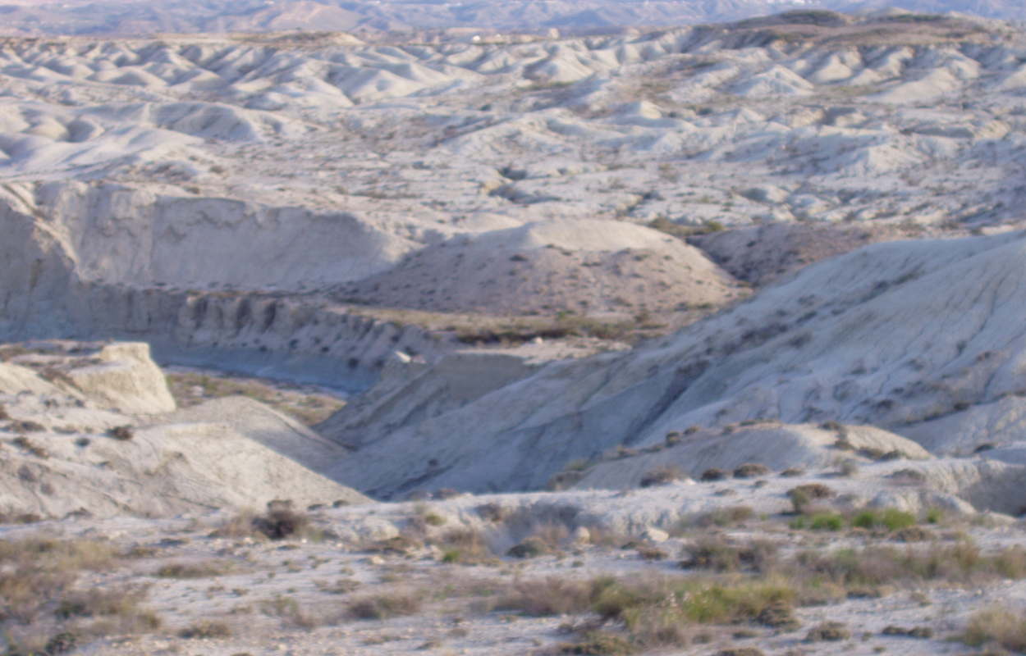

Publishable Report

Document prepared by

Ádám Zsolnay GSF - National Research Center for Environment and Health

Indicators and Thresholds for Desertification, Soil Quality, and Remediation

Ádám Zsolnay
GSF - National Research Center for Environment and Health
D – 85764 Neuherberg bei München
Germany

Abstract
The results clearly showed that universal indicators on the soil level are not possible for different pressures and states on a pan-European level. Even similar sites in the same geographical region and exposed to the same pressure will tend to have different indicator values on an absolute scale. The results do, however, show that it is possible to have such indicators for specific pressures and states with local benchmarks, since the selected indicators behaved relatively the same way for a given pressure. Potential indicators were tested for seasonal and spatial stability by testing them in different years and on verification sites for the following conditions or pressures:

- A lack of vegetation as the result of desertification processes.
- Erosion.
- Different agricultural management.

The ease with which the potential indicator could be measured was also considered in this evaluation. Finally, 7 indicators, mainly bulk microbial and enzymatic, were found to be suitable for condition I; one, based on particle size, for condition II; and 2 enzymatic ones for condition III.

In order to reduce dimensionality and to prevent intra-correlation among the predictors (indicators), factor analysis was used. For each site factor scores for the applicable indicators were calculated and with success applied. Among other results, this approached showed that:
  - Quality improvement of the soil at one site could be seen even 18 years after the application of sewage sludge and that this improvement was only prominent when at least 1.0 % sewage sludge was applied. However, the application of larger amounts did not result in major improvement.
  - In a 14 year old reforestation experiment, significant soil quality improvement was only present after the addition of organic matter. Replantation alone, with or without mycorrhiza, was not sufficient. Furthermore, it was shown that the organic matter addition was only beneficial when terracing was also undertaken.
  - In a recently initiated remediation experiment, the importance of organic matter addition as opposed to other measures was confirmed.

Studies on genetic diversity showed no statistically significant negative impacts on genetic diversity in deteriorated soils, which implies that the microbial genetic pool is robust enough to resist detrimental conditions.

1. Introduction
INDEX (acronym for Indicators and Thresholds for Desertification, Soil Quality, and Remediation) was initiated in response to the 1st call within the Global Change in EcosystemsProgram of the 6th Framework of the European Commission (EC). It was specifically designed to fulfil the EC´s request for a specific targeted research project (STREP) dealing with: “Research on mechanisms of desertification and soil quality.” Land degradation (including desertification) is a paramount international problem, and indicators have been developed to follow it. Many are based on:
  - Plant communities,
  - Soil loss, or
  - Salinity.

However, they tend to monitor the status quo over large time periods and are more suitable for crisis assessment than for risk prevention. They are also poorly suited for the sensitive monitoring of the success of remediation efforts. Therefore, the UN Convention to Combat Desertification (UNCCD) and other organisations have emphasised the continuing need for indicator development based on the mechanisms of land degradation, which are known and have been the object of many EU studies. In view of Global Change such indicators are especially needed. Changes will often be slow and subtle. An early warning system is required to indicate the need for countermeasures, while they are still economical.

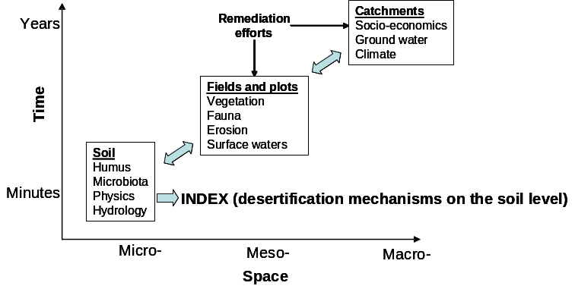
Fig. 1 The various temporal and spatial scales of possible indicators of soil quality.

The prime goal of INDEX was to apply this knowledge to develop modern, rapid, sensitive, universal, multivariate indicators with which the dynamic state of land degradation as well as its remediation can be assessed. Indicators for soil quality and desertification can be applied at different spatial and temporal scales (Fig. 1). Within this project the emphasis was to investigate the possibility of developing indicators, which reflect ecological quality at the soil level rather than at the more traditional field and catchment levels.

In order to attain this, potential indicators (parameters) were investigated within the broad categories of:
  - Microbiology including molecular biology and genetic diversity,
  - Characteristics of the dynamic humus pool and humo-enzymes, and
  - Soil physics including rheology.

The parameters were determined from samples taken during the spring, summer, and fall of 2004. If the parameters were relatively difficult to determine, they were only determined from the spring samples. A holistic approach was used and non-traditional parameters were also investigated for suitability as indicators. The temporal stability of the parameters, which showed promise as indicators, was then determined from samples obtained during the spring of 2005. The parameters, which also passed this test, were then confirmed on verification sites.

The needed activity was carried out by the consortium presented in Table 1.

Table 1. The composition of the INDEX Consortium.
Lead scientist | Organisation | Discipline
C. García  J. Cornejo | Consejo Superior de Investigaciones Cientificas  Department of Soil and Water Conservation  Murcia, Spain  Instituto de Recursos Naturales y Agrobiología de Sevilla  Sevilla, Spain | bulk microbiology  enzyme studies  mineralogy  pore space distribution
B. Cecannti | Consiglio Nazionale delle Richerche  Pisa, Italy | humus chemistry  humo-enzymes
Á. Zsolnay | GSF – Forschungszentrum für Umwelt und Gesundheit, GmbH  Institute of Soil Ecology  Munich, Germany | co-ordination  mobile humus
E. Micheli | Szent Istvan University  Gödöllö, Hungary | soil physics
E. Wellington | The University of Warwick  Coventry, United Kingdom | genetic microbiology
E. Tombácz | University of Szeged  Szeged, Hungary | rheology
M. Kuderna | wpa Beratende Ingenieure GmbH  Vienna, Austria | integration and dissemination

2. Site selection and sampling
In selecting the sites various gaols were strived for, keeping in mind that indicators as universal as possible were to be developed. At the same time the constraints of temporal and economic resources needed to be considered. In brief the sites should:
  - Cover a relatively large European area,
  - Be exposed to different ecological treatments or pressures,
  - Consist of different types (e.g. agricultural, forest).

The selected list of sites are given in Table 1 and shown in Fig. 2. In addition verification sites were also selected to confirm or reject the preliminary indicators, which were found. These sites are given in Table 3 and also shown in Fig. 2.

Samples were initially taken in spring, summer, and fall of 2004 and in spring 2005. In the agricultural fields 3 replicates of soil from 0 – 15 cm were obtained with a spade at each sampling location. The non-agricultural sites had a greater spatial variation. Therefore, each replicate was a composite of 8 sub-samples. For the determination of pF curves, it was necessary to obtain cylinders containing undisturbed soil. The verification sites were only sampled during summer 2005. Depending on the parameter investigated, samples were sent to the appropriate laboratory either air-dried or in a field fresh condition, maintained during shipment with cold battery packs.

Table 2. Sites selected and sampled during the initial phase of the project. The sites in bold were subjected to remediation efforts.
Country | Location | Variation of treatments (pressures) | Type of site
Germany | Puch | agricultural mismanagement and absence of vegetation | agricultural field
Hungary | Gödöllö | soil erosion | agricultural catena
Italy | Basilicata | different agricultural practices under arid climate | agricultural field
 | Tuscany | different agricultural practices under moderate climate | agricultural field
Spain | Abanilla | mismanagement | catena
 | Abanilla | long-term remediation as the result of sewage sludge application | plots
 | Alguilucho | remediation as the result of various reforestation strategies | field scale
 | Carcavo | revegetation of a degraded forest | degraded forest catena
 | Santomera | deforestation | forest plots
 | Santomera | mismanagement | catena
 | Tres Caminos | short-term remediation through various techniques | plots

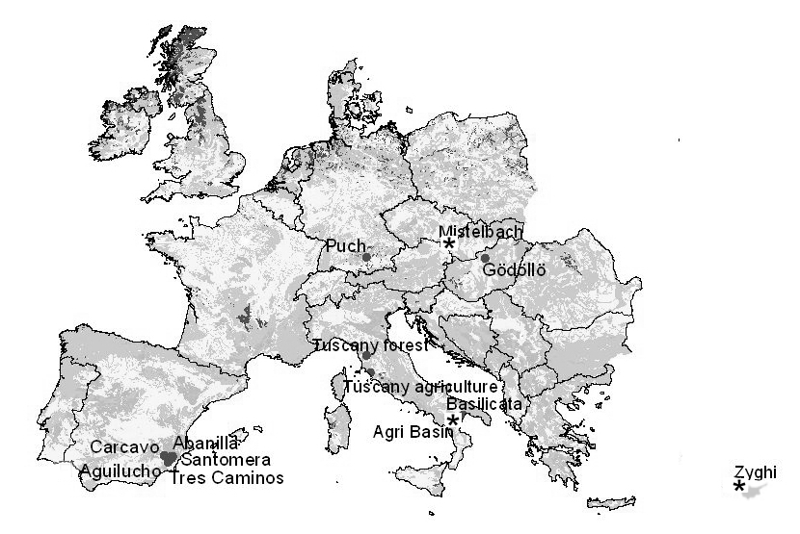
Fig. 2. Sampling sites. The ones indicated with a star were verification sites.

Table 3. The sites, which were selected to verify the results obtained from the initial sites. The verification sites were exposed to treatments or pressures similar to the initial sites.
Initial site |  | Verification site
Country | Location | Country | Location
Italy | Basilicata | Cyprus | Zyghi
Spain | various catenae | Italy | Agri Basin,
Hungary | Gödöllö | Austria | Mistelbach

3. Selected parameters (potential indicators)
Numerous ancillary parameters such as pH, pF curves, texture, mineralogy, metal content, meteorological history etc. were determined at each site but will not be presented here, since they were not directly used for the indicator development. Listed below is a brief summary of the parameters selected, including the justification for their selection

3.1 Bulk microbiological parameters
Microbial biomass carbon. Although they represent only a small fraction of the organic matter pool, microorganisms are the most active components and are normally referred to as microbial biomass. The microbial biomass carbon can be used more effectively than the total organic carbon (TOC) as an indicator of variations in soil quality, since it responds more rapidly and with a greater degree of sensitivity to such changes (degradation, contamination, misuse etc). In other words, short term measurements of biomass may reflect the long term tendency of the organic matter. It can also be used to compare natural and degraded systems (1) and to compare systems under different treatments (2). Microbial biomass carbon will be determined using a fumigation-extraction procedure, and the organic carbon in the extracts measured by oxidation with K₂Cr₂O₇ and by absorbance at 590 nm (3).

Basal respiration in soil. Respiration is a widely used parameter to estimate a soil´s microbial activity. The activity of all heterotrophic microorganisms leads to the degradation of organic matter and such decomposition has frequently been used to indicate the biological state of soils (4). CO₂ emission has been used to measure the active fraction of the microbial biomass. The measurement of a soil´s respiration in the presence of the potentially toxic products used in modern agriculture can be used to evaluate the damage caused by these products to the physicological fractions of the soil (4). The measurement of CO₂ emission is also useful for ascertaining the effect of organic matter oxidation in situ, although it can never identify which organic substrate in particular is being catabolised. The metabolic quotient (qCO2) was first described by Anderson and Domsch in 1985 and is also known as the respiratory activity. The qCO2 is related with the hypothesis of energy optimisation in developing ecosystems and is the equivalent of respiration per unit of biomass. Anderson and Domsch (5) suggested that the qCO2 should be high in young (immature) ecosystems and low in mature systems. The basal respiration will be determined for incubated samples by measuring CO₂ release with a CO₂ IR detector.

3.2 Enzymatic activities
Enzymes are the biological catalysts of innumerable reactions in soil. Similar to the effects of enzymes in others systems, the reactions which soil enzymes catalyse depend on many factors such as pH, temperature, the presence or absence of inhibitors etc. Recent years have seen a growing interest in soil enzymes. One of the first applications to which enzymatic activity measures were put was as an indicator of soil fertility, since they reflect a variety of factors, among them climate, type of amendment, crop and edaphic properties (6). Hence, the growing interest in the effect of pesticides, berbicides and municipal waste- based organic fertilisers on enzymatic activity. In the biological transformations which take place in the soil, enzymes and their activity play a very important part. Of those determined in soils, hydrolases have been the most widely studied, alongside other groups such as oxidoreductases, lyases and transferases. The enzymes found in soil originate in microorganisms, plants and animals although microorganisms are considered to be the main source. Some enzymes in soil are clearly extracellular and are released during cell metabolism and death, while others are intracellular and form part of the microbial biomass.

The soil´s enzymatic activity is responsible for the formation of stable organic molecules which contribute to the permanence of soil ecosystems and the cycles of such important elements as nitrogen (urease and protease), phosphorus (phosphatase) and carbon (b-glucosidase). Nannipieri et al. (4) showed that enzymatic activities are substrate specific and related to specific reactions. For this reason, it is difficult to use one single enzymatic activity value to ascertain the general state of nutrients in a soil or to determine its microbiological activity index. However, the simultaneous measurement of several enzymes may be useful as a marker of bioactivity and can be used as an index of a soil´s biochemical fertility (7).

Urease and Protease BAA Activity (N Cycle). Urease catalyses the hydrolysis of urea or ureic type substrates to give carbon dioxide and ammonia as reaction products. This enzyme has been studied in great depth since its synthesis can result in heavy losses of nitrogen in the form of ammonium, which may have serious economic implications. Studies, of urease, have centred on knowing its inhibition mechanisms in an attempt to lessen the above mentioned losses (8). Under the umbrella term “urease”, we include all those hydrolases capable of acting on the C-N (non-peptide) bonds of lineal amides. They are exocellular enzymes of a basically microbial origin, as has been demonstrated by several researchers (9). The protease which hydrolyses N-a-benzoil-L-argininamide (protease-BAA) is involved in the hydrolysis of proteins to ammonium. More specifically, this enzyme acts on dipeptides, which are the shortest fragments resulting from the hydrolysis of long protein chains, a process which can be catalysed by others proteins (e.g. the protease which hydrolyses casein). Protease activity is usually short-lived due to the limited life span of the substrates which induces its synthesis. Protease BAA belongs to the trypsine group, which is characterised by its ability to hydrolyse the peptide bonds with non hydrophobic chains. As in the case of urease, protease activity belongs to the nitrogen cycle and is induced by the microbial biomass.

Phosphatase activity (P Cycle). The agronomic and biotechnological importance of phosphatase is that it activates the transformation of organic into inorganic phosphorous, thus making it available to plants. Within the group of phosphatases there are numerous enzymes, each of which has its own optimum pH, which means that their field of operation is wide and varied. The phosphatase detected in acid soils are normally acidic, while in basic soils they are usually alkaline (8). Phosphatases are inhibited by inorganic phosphorus the final product of their enzymatic reaction. This is due to a feedback inhibition so that phosphatase is only synthesised if there are deficiencies in available phosphorus.

Glucosidase activity (C Cycle). Glucosidase is a hydrolase which intervenes in the carbon cycle, acting specifically in the hydrolysis of the glucosidase bonds of the long carbohydrate chains. The hydrolysis of these substrates plays an important role in the microorganisms attainment of energy from the soil.

Dehydrogenase Activity. The biological oxidation of organic compounds occurs by means of dehydrogenation processes, in which enzymes called dehydrogenases take part. The dehidrogenation activity of soils is determined by different dehydrogenase systems, which are characterised by their high substrate specificity. All these systems are an integral part of the microorganisms, and, indeed, dehydrogenase activity has been proposed as an indicator of a soils microbiological activity. Dehydrogenase activity has also been used to compare natural and cultivated soils, soils with different crops and to evaluate the effect of incorporating fresh wastes. However, despite the above, the use of this oxidoreductase as an indicator of biological activity in soils has been questioned by some authors, since it can be influenced by many factors such as pH, soil type and total organic carbon content (11) and even the redox potential, meaning that its levels may not accurately reflect the true level of a soil´s microbiological activity. Furthermore, the electron acceptors used (TTC or INT) are not as effective as oxygen so that only part of the dehydrogenase activity is determined.

3.3 Molecular microbiological parameters
The process of degradation/desertification of agricultural soils in SE Spain has been studied in detail by Garcia et al (11). They noted that a decrease in biomass carbon and basal respiration in soil was accompanied by low metabolic quotient and enzyme activity. When the soils were irrigated biological processes in the soil declined further as this treatment increased soil salinity due to the low rainfall in the region and use of underground water with high mineral content. Until now no systematic studies have been made to the changes in the actual composition of the microbial community in soils undergoing desertification. The majority of research studies conducted on the impacts of desertification concentrate on the effect of desert conditions on beneficial symbiotic microbes, mainly nitrogen fixing rhizobia and mycorrhizal fungi (12, 13), some other are dealing with cyanobacteria frequently found in the surface layer of desert soils (14). Detected decrease in microbial activities during the process of desertification could be explained in at least two ways. Firstly bacteria can be entering the so called viable but non-culturable (VBNC) or even dormant state (15) with greatly reduced metabolic activity. It is also probable that part of microbial population, less resistant to dry conditions, will be gradually dying off reducing in this way not only microbial count in soils and consequently any sign of microbial activity but also the diversity of the remaining microbial population. The latter impacts are evidenced by detection of two abundant groups of microorganisms in the Atacama Desert, where soils contain predominantly actinomycetes (spore-forming bacteria) and microaerophiles (16). In addition a study comparing survival of different microorganisms over 15 month period in the Atacama Desert showed that the most resistant microorganisms proved to be again spore-formers Bacillus subtilis and Aspergillus niger (17).

The aim of this aspect of the presented research was to compare the composition of microbial communities in soils at different stages of desertification, which would allow a study of the gradual changes in microbial populations in response to the drying out of given soils. The hypothesise is that certain desiccation resistant soil microbial groups due to their resistance to desertification could be used as indicators of impacts on soil. Traditional cultivation methods will not be capable of determining full impacts on microbial diversity as it is generally accepted that only a small part (0.1 – 1%) of soil microbial population can be cultivated (18). In addition part of the soil microbial population may be in VBNC state and will not grow on plates.

The determination of genetic diversity can be achieved directly by analysis of extracted soil microbial DNA. Most molecular studies have been based on the use of 16S rRNA as a phylogenetic marker to measure the diversity, richness and structure of microbial populations in soils (19). DNA reassociation studies provide a large-scale picture of shifts in community structure at the genomic level (18). However, PCR based fingerprinting techniques give a much higher resolution of species composition of the community and can be used to compare common species present in different samples. There are a number of fingerprinting techniques that have been used in microbial ecology. Of all these fingerprinting techniques denaturing gradient gel electrophoresis (DGGE) has been used the most extensively to study the bacterial community of soil (19). DGGE has also been used to quantify microbial communities by cluster analysis of banding patterns (20) and the Shannon-Weaver Index of diversity was used to do this. However there are still problems with efficiency of the DNA extraction and biases associated with PCR techniques.

The microbial parameters investigated are summarised in Table 3.

Table 3. Microbial parameters investigated as potential indicators
Parameter | Units | Abbreviation
Total Organic Carbon¹ | g/100g | TOC
Humic substances carbon¹ | ppm | Chum
Water Soluble Carbohydrates | ppm | WSCh
Proteins | mg albumin/g | PROT
Biomass carbon | mg C/kg soil | MBC
Acumulative respiration | mg C-CO₂ kg⁻¹ soil | ARESP
Basal respiration | mg C-CO₂ kg⁻¹ d⁻¹ | BRESP
qCO2 | mgC-CO2/g BC.h | qCO2
ATP | ng/g | ATP
Dehydrogenase activity | mg INTF/g.h | DHA
Urease activity | mmols N-NH4+ /g.h | UREASE
BAA Protease activity | mmols N-NH4+ /g.h | BAA-PROTase
b-Glucosidase activity | mmols PNF/g.h | B-GLUCOSIDASE
Basic phosphatase activity | mmols PNF/g.h | PHOSPHATASE
Shannon-Weaver Index of diversity | H=C/N*(N*logN-Σni*logni)  C=2.3  N= total intensity of all DNA bands, ni= the intensity of the ith band | Div
¹ This is not truly a microbiological unit but is treated within this WP because of its close association with microbial processes

§.4. Humus parameters
Bulk humus consisting mainly of the “stable” humic substances, which represent the “cement” of the soil mineral particles and which can also play a major role in the nutrient and water holding capacities of soils, will be characterised. The simplest parameter to do this is the total organic carbon (TOC), which can be determined with an Automatic Nitrogen and Carbon Analyser after pre-treatment with HCl to eliminate carbonates followed by combustion at 1020º C. This parameter is probably not suitable as an indicator, but it is often needed to normalise other parameters.

Humic substances consist of complex polymeric organic compounds with high molecular weight, more resistant to decomposition than the non-humic material (proteins, polyphenols, carbohydrates, etc.) (21). The low solubility and the complex chemical structure make the humic substances themselves difficult to study in situ. They will be characterised with pyrolysis-gas chromatography of the various humic substance fractions. Results from this method need to be interpreted with caution, since artefacts are possible. However, it has been shown to be suitable for fingerprinting (22), and indicators in many ways have a fingerprinting quality.

Humo-enzymes are immobilised enzymes, which can remain at a constant and stable level of activity in the soil regardless of microbial proliferation and are not influenced by the usual forms of regulation which affect enzyme synthesis and secretion. This type of immobilised enzymes may remain bonded to mineral colloids (like clay) or organic colloids (such as humic substances) and are very resistant to denaturalisation processes. Both intracellular and extracellular enzyme concentrations increase in proportion to microbial numbers, and the extracellular enzyme are able to become bound and stabilised at the many unoccupied binding sites in the soil. It is possible that an initial building of an extracellular enzyme component is vital during the early stages of microbial proliferation, because such enzymes may catalyse the commencement of degradation of the macromolecular plant substrates. Extraction and purification are essential steps to study humic carbon and active humic-enzyme compounds (23). During the biosynthesis of the stable humus pool, free enzymes are stabilised forming a humo-enzyme complex generally known as extracellular enzyme pool (24,25). Humo-enzyme complexes are universally considered of great importance in soil biological fertility and soil resilience (26). They are also a scientific interest, since they represent a “crossing-point” between mineral and organic reactions in soil, that is between chemical and microbiological soil processes. Recently, humo-enzyme complexes have been described as a type of “last barrier” against irreversible soil desertification (27). Due to these ecological properties, the humo-enzyme complexes may be extremely useful to indicate the rate of biological degradation of the entire soil ecosystem, and its resistance to adverse degradative factors, or, on the other hand, to assess the capability of a soil ecosystem to be regenerated through ecologically sound practices.

Mobile humus in the humus fraction will react more sensitively than other components such as the humic acids. It is also known as dissolved organic matter (DOM) and is a poorly defined pool of compounds, which are available for biogeochemical processes (28). These are theoretically ideal indicators both in their structure and in their function. They should be less sensitive than the microbial indicators but more sensitive than the physical ones. Unfortunately, there is no ideal or standard way to obtain this fraction (28). One simple way is by aqueous extractions. This, however, only partially reflects the in situ DOM and is more properly considered to be the water extractable organic matter (WEOM). Its organic carbon content (WEOC) can be quantified, and it can readily be qualitatively characterised with its UV absorption and fluorescence emission spectra. An interesting parameter is the fluorescence efficiency, which proportional to the quantum yield (30).

The investigated humus parameters are summarised in Table 4.

Table 4. Humus parameters selected as potential indicators
Parameter | Units | Abbreviation
Total organic carbon | % | I-TOC
Total inorganic carbon | % | TIC
Total pyrophosphate extractable carbon | mg/g | TEC
Total pyrophosphate extractable carbon>10000 Da | mg/g | TEC>10⁴
Total nitrogen | % | TN
Enzyme activities in pyrophosphate soil extracts
B-Glucosidase | mgPNF/g*h | Gluc
Phosphatase | mgPNF/g*h | Phos
Urease | mgNH₃/g*h | Urea
Protease BAA | mgNH₃/g*h | Prot
Pyrolitic Indices of soil
Mineralization index: Furfural/Pyrrole | - | N/Os
Humification index: Benzene/Toluene | - | B/E3s
Mineralization index: Pyrrole/Phenol | - | O/Ys
Energetic index: Aliphatic/Aromatic | - | AL/ARs
Pyrolitic Indices of pyrophosphate extracts
Mineralization index: Furfural/Pyrrole | - | N/Oex
Humification index: Benzene/Toluene | - | B/E3ex
Mineralization index: Pyrrole/Phenol | - | O/Yex
Energetic index: Aliphatic/Aromatic | - | AL/ARex
b-glucosidase activity in the stable humic complex (bands 3 and 4) after IEF | mgPNF/gss*h | ACTIVE HUMUS
Carbon % of the stable humic complex (bands 3 and 4) after IEF, with respect to the total IEF located carbon | % | % ACTIVE CARBON
Relative content of B-glucosidase activity of the stable humic complex (bands 3 and 4) with respect to the total carbon content in the soil extract (fraction>10⁴ Dalton)*1000 | mgPNF*h | RELATIVE ACTIVITY
b-glucosidase: specific enzyme activity in dialysed soil extracts (fraction>10⁴ Dalton) *1000 | mgPNF*h | SPECIFIC ACTIVITY
Aqueous (0.1 N CaCl₂) extracts (WEOM)
WEOC in extraction solution | mg C dm-3 | DOC
WEOC per g dry soil | µg g-1 | DOC1
UV absorption of solution ( = 254 nm) | cm-1 | UV
Summed emission fluorescence (_{ex} = 254 nm; (_{em} = 300-480 nm) | a.u. (arbitrary unit) | SF
Lower emission fluorescence ((_{ex} = 254 nm; (_{em} = 300-345 nm) | a.u. (arbitrary unit) | L
Higher emission fluorescence ((_{ex} = 254 nm; (_{em} = 435-480 nm) | a.u. (arbitrary unit) | H
Absorptivity (UV / DOC) | m-1 mg C-1 dm3 | Abs
Relative summed emission fluorescence (SF / DOC) | a.u. mg C-1 dm3 | rFsum
Relative lower emission fluorescence (L / DOC) | a.u. mg C-1 dm3 | rlq
Relative higher emission fluorescence (H / DOC) | a.u. mg C-1 dm3 | rhq
Humification Index (H / L) | dimensionless | HIX
Fluorescence Efficiency (SF / UV) | a.u. cm | FE

3.5. Physical paramers
Particle size stability analysis gives information on cementing agents and strength of bounding. The soil samples were dispersed with different chemicals (water, acid, oxidising agents) and different mechanical methods. The single treatments and combination of the treatments provided specific information on the particle cementation. (SIU)

Rheology is a new tool in physical testing of particle-particle network and strength in soils. The rheological measurements provide advanced quantitative parameters in addition to the shear strength, which is measured by a simple technique in soil mechanics (31). Rheological measurements of concentrated suspensions can provide information on particle-particle interaction of microaggregates. In the rheological methods the soil particles are experiencing either increasing shear rate and than decreasing shear rates (controlled rate, CR, ramp) or different shear stresses (constant or increasing stress in the stress controlled, CS, measurements) produced by a Rheometer. The CR ramp results in flow curves and yield values for plastic systems. The continuous increase of the applied stress with time (stress ramp) results in the yield point, above which the particle network collapses. The stretching and breaking of the particle network bonds (at the true yield stress) under virtually static conditions can be measured by vane method. These rheological parameters are related to the strength of the physical network built up from particles. The shape and the reversibility of flow curves, the presence and size of thixotropic hysteresis loops reveal the fine structural details related to particle adhesion, sensitivity to mechanical effects, breakdown and recovery of particle network structure. An example is given in Fig. 3.

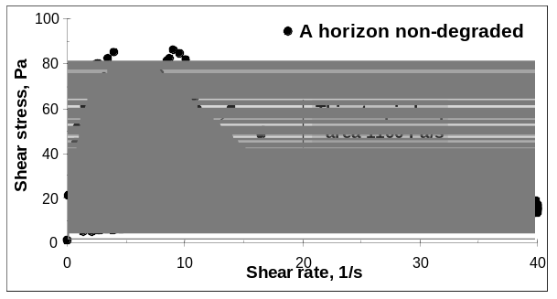 | 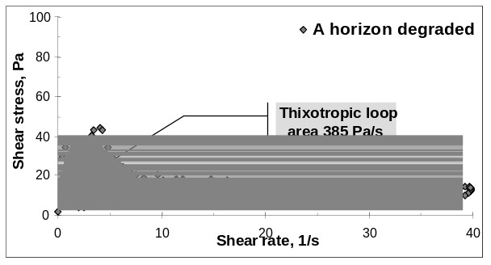

Fig. 3. Example for the flow curves of non-degraded and degraded soil samples.

Total pore space and pore size distribution are important parameter that give information on the functions of pores. Large pores (generally large than 30 micrometers in diameter) are important in aeration but cannot hold water. Middle size pores important in the soil water holding capacity, while small pores (smaller than 3 micrometers in diameter) are very important living medium for microbes. A lack of any group of pores can decrease soil function and initiate degradation processes. Pore size distribution and specific surface area of the samples were characterised by measurement of mercury intrusion curves, gas adsorption (N₂ ,CO₂), and retention of polar liquid ethylene-glycol.dimethyl-ether.

Water retention is critical in the support of vegetation and other ecological processes and was determined. Table 5 lists the physical soil parameters, which were considered.

Table 5. Physical soil parameters investigated as potential indicators
Parameter | Units | Abbreviation
Pore volume | mm3/g | 100-10 Å
Pore volume | mm3/g | 0.1-10 Å
Pore volume | mm3/g | 0.001-0.1 Å
Total cumulative volume | mm3/g | T.C.V
Specific surface area | m2/g | S.S.A.
Pore radius average | µm | P.R.A.
Moisture retained by disturbed samples | % | Wks
Particle size (0,01mm) in water (A) | % | FPdv
Particle size (0,01mm) in pyrophosphate (B) | % | FPnp
Dispersion factor short = A/B | - | Qdf
Aggregate stability (Sekera optical method) | % | AS
Rheological parameters
Water content of soil suspension | g/100 g | H2Og/100g
Maximum of shear stress vs time function | Pa | t0, Pa
Initial shear stress | Pa | tinimax, Pa
Area of thixotropic loop in low shear region from 0.1 to 10 1/s | Pa/s | Athixo, Pa/s
Extrapolated yield value from shear stress vs. shear rate function | Pa | tB, Pa
Slope of the linear part of down flow curve (shear stress vs. shear rate function) | Pa s | hpl, Pas

4. Preliminary indicator selection
As the data became available, it became apparent that a universal indicator approach was not tenable. Fig. 6 shows the enormous spread of values for one of the parameters over the entire suite of the initial samples. Unfortunately, the results from stressed and from non-stressed locations could not be differentiated in the results. This can be seen in more detail in Fig. 7. The respiration from the bare location in Santomera had higher respiration values than the high vegetation coverage location at the Abanilla site, even though Abanilla and Santomera are in the same Spanish province, Murcia, and were exposed to similar pressures.

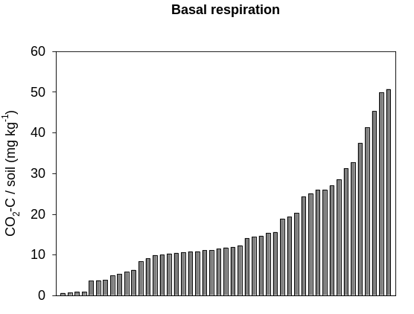 |  | 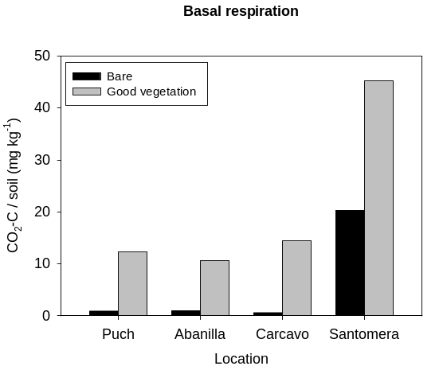
Fig. 6. Basal respiration values averaged over time at each site in 2004. |  | Fig. 7. Average basal respiration values from the Spring 2004 samples.

It was also found that parameters, which served as good indicators for one type of state or pressure, were not necessarily suitable for another type of state or pressure. Fig. 8. gives an example of this. Basal respiration readily differentiated the bare location from that with good vegetation at Abanilla but could not differentiate at all between the eroded and non-eroded locations in Gödöllö.

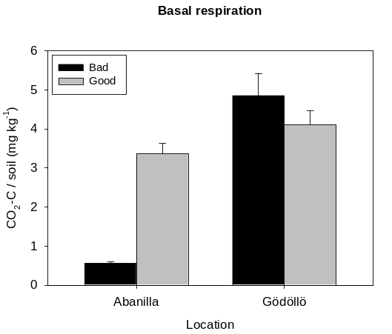
Fig. 8. Basal respiration measured in Spring 2004 at 2 different sites under 2 different states (Spring 2004).

Therefore a 2 tiered approach for indicator selection was adopted. Firstly, the sites were differentiated according to similarities in states and/or pressures as shown in Table 6.

Table 6. The investigated sites grouped according to the nature of the causes of their potential degradation.
Group | Main cause of potential soil degradation (“pressure”) | Sites
I | A lack of vegetation as the result of desertification processes | Catanae in Spain; Puch, even though the devegetation was anthropogenic. Verification: Agri Basin
II | Erosion (with no major variation of vegetation) | Gödöllö. Verification: Mistelbach
III | Different agricultural management | Sites in Italy. Verification Zyghi

Each of the individual potential indicator parameters were then evaluated at each site independently. This was done with an analysis of variance (ANOVAR) and a grade was given based on the results (Table 7).

Table 7. Grading system for analysis of variance (ANOVAR) results at each site.
Result of ANOVAR | Grade
Perfect significant differentiation (p < 0.05) between the different locations at each site in a logical sequence (ex. forest > shrub > bare) | 2
Significant but not complete differentiation (ex. forest = shrub > bare) | 1
No significant differentiation | 0
Significant differentiation in a faulty sequence (ex. shrub > bare = forest) | -1

This was done for samples from spring, summer, and fall of 2004, whenever possible, since some parameters were only measured once in 2004. A score was then calculated by dividing the total grade by the highest grade possible. Parameters with a score > 0.49 were then exposed to the subsequent temporal verification. All others were discarded.

4.1. Temporal verification
Parameters, which had a score > 0.49 for 2004 were then temporally verified by giving them a grade for the sample obtained in 2005. The grading was done the same way as described for 2004. All parameters, which had a final score > 0.5, were considered to be potential indicators for a given pressure/state and were verified spatially with the verification site samples.

4.2. Spatial verification
The indicators selected above were applied to the verification site for their specific pressure or state (Tables 3 and 6) and also tested with an ANOVAR. If they did not significantly differentiate or differentiated in an illogical manner at the verification site for their pressure or state, they were rejected. In conclusion, the indicators in Table 8 were retained after temporal and spatial verification.

5. Final indicator selection
The indicators in italics in Table 8 were, however, subsequently removed for different reasons. In the case of Group I, it was felt that total and humic substances carbon were good indicators for the state of the soil but are not sensitive enough to monitor changes. "BAA-protease activity" was removed, because it caused too many experimental difficulties in practice to warrant its retention. Furthermore from Group II the "furfural/pyrolle mineralization parameter" was removed, because it is relatively cumbersome to determine. By the same token "b-glucosidase activity in the stable humic complex after IEF" was removed from Group III, even though it had a perfect score.

All in all it can be seen that indicators are most readily available to monitor sites where vegetation has been diminished (Group I). For example, few indicators are available to monitor the impact of erosion or agricultural practise, because all of the sites studied in this regard had abundant vegetation, despite erosion or different agricultural practices.

Table 8. Parameters, which passed all the required thresholds in their evaluation as indicators for a specific Group. The ones in italics were rejected, mainly for practical reasons (cf. text).
I: A lack of vegetation as the result of desertification processes |  | II: erosion |  | III: agricultural practice
score | indicator | score | indicator | score | indicator
0.81  0.75  0.72  0.69  0.69  0.64  0.64  0.61  0.58  0.58 | Basal Respiration  Microbial Biomass  Carbon  Humic Substances  Carbon  ATP  Basic phosphatase  activity  Proteins  b-Glucosidase activity  Total Organic Carbon  BAA Protease activity  Fluorescence Efficiency | 0.75  0.75  0.50 | Humic substances  carbon  % Particles <0.01mm  in pyrophosphate  Mineralization index:  Furfural/Pyrrole | 1.00  0.88  0.88 | b-glucosidase activity in the stable humic complex after IEF  b-Glucosidase activity  Urease activity

6. Selected indicator application
In the case of Group I (lack of vegetation) the selected indicators would have resulted in an indicator space with 7 dimensions. This dimensionality was reduced with factor analysis, which also had the advantage of removing the intra-correlation of the predictors. The factor analysis was done for each sampling site and sampling date separately. No rotation was performed to maximise the loadings on the 1st factor. Factor scores were calculated by the regression method. At sites of Group I the first factor accounted for 65% to 92% of the variation according to the sampling site and date.

Although the results for Group II (different agricultural practices) could be shown in 2 dimensions, a similar factor analysis was made to make the illustration of the results more similar and to prevent the possible effects of intra-correlation. The 1st factor explained 57% to 99% of the variation. Only one indicator was retained for Group II (erosion). Therefore, no additional data manipulation was needed. All the results presented here are from the samples of spring 2004. The results from the other sampling dates were essentially the same, showing that the indicators were temporally stable.

Clear differentiation in regards to the Santomera cantena was attained (Fig. 9). The results from the Carcavo site are especially of interest (Fig. 10). For example the soil at the abandoned location (ABS) is still in relatively good condition based on the indicators applied here. Any significant change in its state can readily be monitored. Furthermore, the figure also shows the importance of slope direction at this site. The soil on the slope facing towards the south is considerably more degraded than its counterpart on a north facing slope.

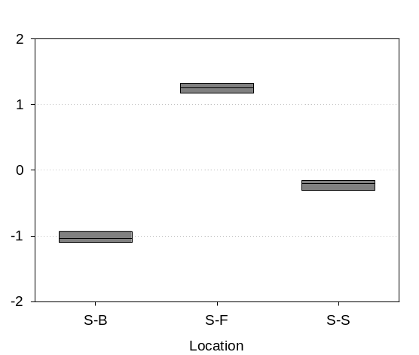 |  | 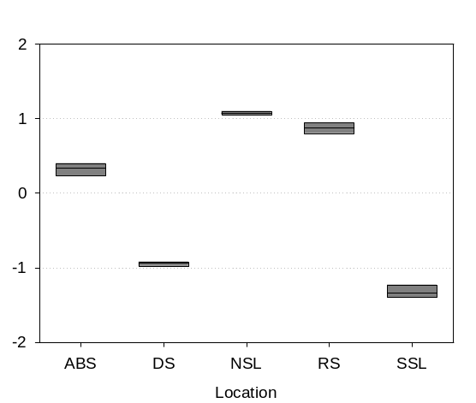
Fig. 9. 1st factor of Group I indicators applied to the Santomera cantena. S-B is the bare location, S-F the forest and S-S the shrub area. |  | Fig. 10. 1st factor of Group I indicators applied to the Carcavo site. ABS is abandoned soil, DS degraded soil, NSL north slope location, RS reforested, and SSL south slope location.

Fig. 11. illustrates the application of the appropriate indicator to the eroded site near Gödöllö. A clear pattern is present and any changes in the low erosion location can be readily monitored. The results obtained at Mistelbach were similar.

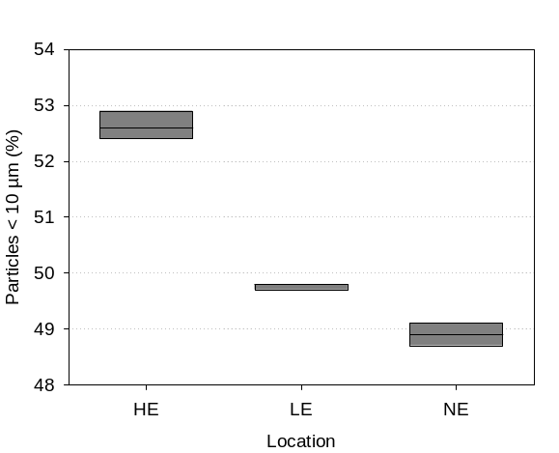 |  | 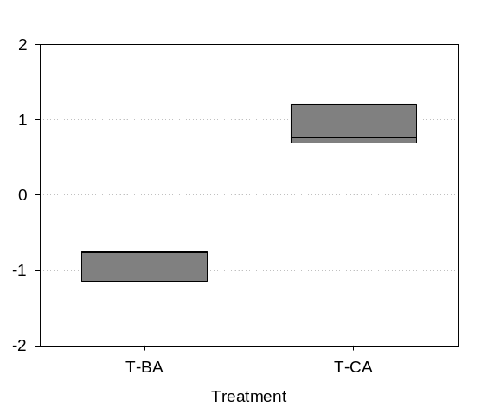
Fig. 11. The particle size indicator applied to the site near Gödöllö. HE is the high, LE the low, and NE the no erosion location. |  | Fig. 12. 1st factor of Group III indicators at the Tuscany agricultural site. BA is biological and CA is conventional agriculture.

The indicators for agricultural management show differentiation at the soil level (Fig. 12) The results for the Basilicata and Zygi sites are similar.

6. Application to remediation sites
A successful application of the indicators can be seen with the samples from the Abanilla remediation site, where different amounts of sewage sludge were applied 18 years ago. In Fig. 13 can be seen that the sludge application can continue to have a beneficial effect on the soil even after this long period of time. An application of less than 1.0% however only has a limited long term effect, but amounts greater than 1.0 % do not result in major improvement and are probably not necessary to remediate this soil and can be avoided for economic reasons. The same results were obtained for all the sampling dates in 2004 and 2005.

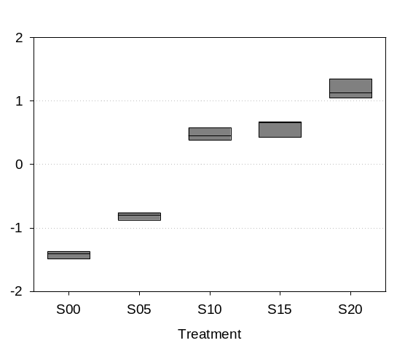 |  | 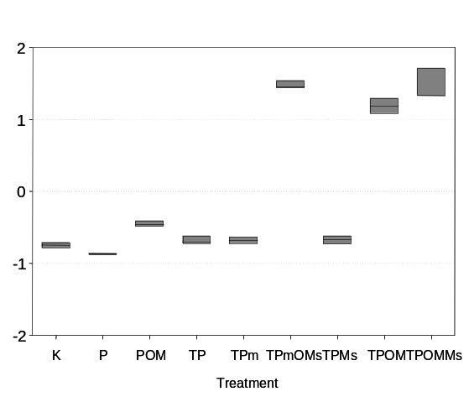
Fig. 13. 1st factor of pressure I indicators applied to the remediation site in Abanilla. The numbers in the X-axis divided by ten indicate the amount of carbon added as sewage sludge in %. |  | Fig. 14. 1st factor of pressure I indicators at the Alguilucho reforestation site. Cf. text for details.

At Alguilucho reforestation was initiated 14 years ago with pines (P) in some cases with terracing (T) and with mycorrhiza inoculation (m). Furthermore in some cases organic matter was added (OM) sometimes with mycorrhiza addition to the soil (Ms). The results in Fig. 14. clearly show the beneficial effects of adding organic matter but only when the experimental location is terraced. On the other hand the reforestation alone with or without mycorrhiza resulted in no major improvement. The same results were obtained for all the sampling dates.

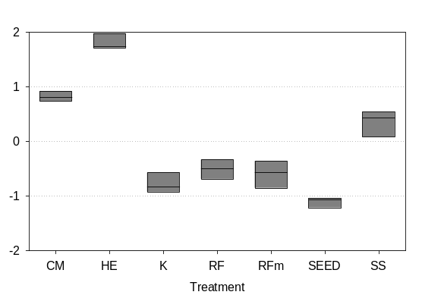 |  | 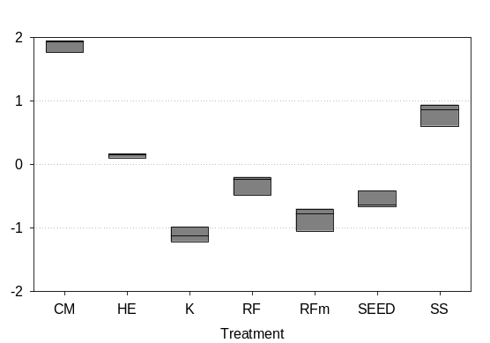
Fig. 15. 1st factor of Group I indicators applied the remediation site at Tres Caminos several d after remediation had been initiated. Details are in the text. |  | Fig. 16. 1st factor of Group I indicators applied the remediation site at Tres Caminos ca. 27 months after remediation had been initiated. Details are in the text.

A more recent remediation effort was started at Tres Caminos during the spring of 2004. The following treatments were applied:

- SS, Organic matter (fresh organic waste, sewage sludge),
- CM, Mature organic matter (composted sewage sludge),
- HE, Addition of the humus-enzyme complex obtained from organic wastes,
- RF, Authoctonous vegetation (lentiscus),
- RFm, Authoctonous vegetation but submitted to mycorrizhation processes,
- SEED, Seeding mixture with a seed selection for semiarid climate, and
- K, Control

The 3 remediation measures in which organic matter was added (composted sewage sludge (CM), humus-enzymes (HE), and fresh sewage sludge (SS)) resulted in an immediate improvement (Fig. 15). That of HE addition was especially significant, perhaps because it was added in liquid form. However Fig. 16 shows that after ca. 27 months the beneficial effects of HE had decreased markedly, leaving CM as the remediation method of choice. The temporal course of the efficacy of the remediation efforts can be seen in Fig. 16.

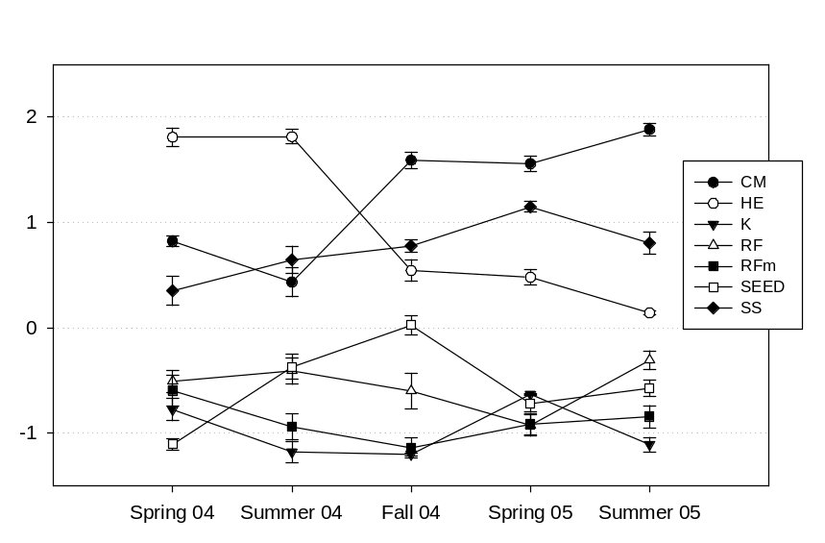

Fig. 17. 1st factor of Group I indicators (means with standard errors) applied the remediation site at Tres Caminos following their course for 5 seasons from 2004 to 2005. Details are in the text.

Acknowledgement
This research was supported by a specific targeted research project (STREP) within the Sixth Framework Programme (Global Change in Ecosystems, GOCE-CT-2003-505450)

References
(01) Ross, D. J. K., R. Tate, A. Cairns, K.F. Meyrick, and E.A. Parsic. (1982). Soil Biology and Biochemistry 14: 575-581.
(02) Smith , J. L., R.I. Papendick, D.F. Bezdicek, and J.M. Lynch (1993). Soil organic matter dynamics and crop residue management. In: Blaine Meeting, (Ed.) Soil microbial ecology. Marcel Dekker. New York.
(03) Sims, J. R. And V.A. Haby, (1971). Soil Science 112: 137-141.
(04) Nannipieri, P., S. Grego and B. Ceccanti (1990). Ecological significance of the biological activity in soils. In: Bollag, J. M., Stotzky, G. (Eds.) Soil Biochemistry, Vol 6. Marcel Dekker, New York., pp 203-355.
(05) Anderson, J. P. E. (1982). In: Methods of soil analysis, chemical and microbiological properties, Part 2, 2nd ed. (Eds A.L.Page et al.,) pp 539-579. Agronomy vol 9, American Society of Agronomy, Madison, Wisconcin, USA.
(06) Skujins, J. (1976). Critical Review of Microbiology 4: 383-421.
(07) Gil-Sotres, F., M.C. Trasar Cepeda, C. Ciardi and B. Ceccanti, (1992). Biology and Fertility of Soils 13: 25-30.
(08) Dick, W.A., and M.A. Tabatabai (1993). Significance and potential uses of soil enzymes. In: Blaine, F. (Ed.) Soil microbial ecology. Marcel Dekker, New York, pp 95-127.
(09) Ceccanti B., Garcia C. (1994). Coupled chemical and biochemical methodologies to characterize a composting process and the humic substances. In: N. Senesi and T.M. Miano (Eds.) Humic substances in the global environment and implications on human health, pp. 1279-1284 Elsevier
(10) Nannipieri, P. (1994). The potential use of soil enzymes as indicators of productivity, sustainability and pollution. In: Pankhurst, C. E., B. Doube, V.V.S.R., Gupta, P.R. Grace (Eds.) Soil Biota. Management in Sustainable Farming Systems, CSIRO, Victoria, Australia.
(11) Garcia, C., T., Hernandez, and F. Costa (1997). Communication in. Soil Science and Plant Analalysis. 1-2: 123-134.
(12) Requena, N., Perez-Solis, E., Azcon-Aguilar, C., Jeffries, P., and Barea, J-M. (2001). Appl. Environ. Microbiol. 67:495-498.
(13) Maatallah, J., Berraho, E.B., Munoz, S., Csanjuan, J., and Lluch, C. (2002). J. Appl. Microbiol. 93:531-540.
(14) Garcia-Pichel, F., and Pringault, O. (2001). Nature 413: 380-1.
(15) Ghezzi, J.I., and Steck, T.R. (1999). FEMS Microbiol Ecol. 30(3):203-208.
(16) Opfell, J.B., and Zebal, G.P. (1967). Life Sci. Space Res. 5:187-203.
(17) Dose, K., Bieger-Dose, A., Ernst, B., Feister, U., Gomes-Silva, B., Klein, A., Risi, S., and Stridde, C. (2001). Orig. Life Evol. Biosph. 31:287-303.
(18) Torsvik, V. Salte, K., Sorheim, R., Goksoyr, J. (1990). Appl. Environ. Microbiol. 56:776-81.
(19) Heuer, H., Krsek, M., Baker, P., Smalla, K., and Wellington, E.M.H. (1997). Appl. Environ. Microbiol. 63: 3233-3241.
(20) Ampe, F., and Miambi,E. (2000). Int J Food Microbiol. 60(1):91-7.
(21) Ceccanti B., Alcaniz J.M., Gispert M., Gassiot M. (1986). Soil Sci., 142: 83-90.
(22) Zsolnay, A. (1991). Chem. Geol. 92: 355-362.
(23) Ceccanti B., Nannipieri P., Cervelli S., Sequi P. (1978). Soil Biol. Biochem., 10, 39-45.
(24) Masciandaro G., Ceccanti B., Gallardo-Lancho F.J. (1998). Agric. Ecosys. Environ., 67: 267-274.
(25) Ceccanti, B., amd C. García (1994). Coupled chemical and biochemical methodologies to characterize a composting process and the humic substances. In: N. Senesi, N and Miano, T. (Eds.) Humic substances in the global environment and its implication on human health. Elsevier, New York.
(26) Lal R. (1994). Sustainable land use systems and soil resilience. In: D.J Greenland and I. Szabolcs (Eds.), Soil resilience and sustainable land use. CAB International Wallingford, Oxon OX10 8DE, UK.
(27) Ceccanti B. and Masciandaro G. (2001). Stable humus-enzyme nucleus: the last barrier against soil desertification. International Workshop on Soil Enzimology. Alcalà de Henares, Spain May 24th-25th, 2001.
(28) Zsolnay, Á. (2003). Geoderma 113: 187-209.
(29) Zsolnay, A., E. Baigar, M. Jimenez, B. Steinweg, and F. Saccomandi (1999). Chemosphere 38: 45-50.
(30) Ewald, M., P. Berger, and S. A. Visser (1988). Geoderma 43: 11-20.
(31) ASTM Standard Test Method for Field Vane Shear Test in Cohesive Soil, D 2573-94

