Project no.: 510457

Project acronym: Hungary for FP6

Project title:
Reinforce and develop the network of Hungarian organisations disseminating FP6 information and providing advisory services with the aim of assisting the successful Hungarian participation in the 6th Framework Programme

Instrument: Specific Support Action
Thematic priority: Specific Support Action for Associated Candidate Countries (all thematic priority areas)

Final Reports

Period covered: Date of preparation:
from 01 June 2007 to 31 December 2007 February 2008

Start date of project: Duration:
01 June 2004 43 months

Project coordinator name:
Ms. Marianna Vári/Dr. Dóra Groó

Project coordinator organisation name:
Hungarian Science and Technology Foundation

Contents:

Publishable final activity report 3

Final plan for using and disseminating the knowledge 7

Final management report 10

Project no.: 510457

Project acronym: Hungary for FP6

Project title:
Reinforce and develop the network of Hungarian organisations disseminating FP6 information and providing advisory services with the aim of assisting the successful Hungarian participation in the 6th Framework Programme

Instrument: Specific Support Action
Thematic priority: Specific Support Action for Associated Candidate Countries (all thematic priority areas)

Publishable Final Activity Report

Period covered: Date of preparation:
from 01 June 2007 to 31 December 2007 February 2008

Start date of project: Duration:
01 June 2004 43 months

Project coordinator name:
Ms. Marianna Vári/Dr. Dóra Groó

Project coordinator organisation name:
Hungarian Science and Technology Foundation

Hungary for FP6

Reinforce and develop the network of Hungarian organisations disseminating FP6 information and providing advisory services with the aim of assisting the successful Hungarian participation in the 6th Framework Programme

http://hufp6.tetalap.hu

Summary description of the project
The overall objective of the Hungary for FP6 project was to raise the quantity and quality of research projects with Hungarian participation as partners or coordinators in all types of instruments of the 6th and 7th EU Framework Programme (FP6/FP7). This overall objective is planned to be achieved by three major lines of activities:
- by networking and training the major Hungarian organisations taking significant role in the dissemination of FP6/FP7 related information and fostering their relations with European partner organisations,
- by providing information to potential European partners on Hungarian R&D, and
- by supporting the research community in Hungary with tailor-made information, assistance and services.

Further specific objectives of the project are:
- to enhance the building-up of know-how related to FP6/FP7 information dissemination in Hungary,
- to guarantee and improve the exchange of experience and expertise within the national and trans-national network of well-experienced and “new-coming” FP6/FP7 information multiplicators,
- to improve the service for Hungarian researchers by training the staff of FP6/FP7 support organisations,
- to increase visibility of researchers and R&D institutions from Hungary, promote them as partners in FP6/FP7 and assist their match-making with researchers all over Europe,
- to increase the access of possible Hungarian applicants to the FP by providing tailor-made information, assistance and coaching, following their specific needs.

In order to fulfil these objectives, a project consortium consisting of 9 partners has been set up. They are representing the seven regions of Hungary, as well as the country’s major R&D institutions and R&D oriented industrial players. The consortium includes the Hungarian Academy of Sciences, 4 universities, 2 chambers of industry, an applied research organisation, the home institution of IRC Hungary and the Hungarian Science and Technology Foundation as coordinator. Important stakeholders, like industrial associations and groupings, scientific societies, regional development agencies, etc. have also joined the project as additional non-contracted partners.

Partic. No. | Participant name | Participant short name | Country
1 | Hungarian Science and Technology Foundation | HSTF | Hungary
2 | Secretariat of the Hungarian Academy of Sciences | SHAS | Hungary
3 | Budapest University of Technology and Economics | BUTE | Hungary
4 | University of Debrecen | UNIDEB | Hungary
5 | University of Szeged | USZ | Hungary
6 | University of Pannonia | PE | Hungary
7 | Bay Zoltan Foundation for Applied Research | BZF | Hungary
8 | Chamber of Commerce and Industry of Pecs-Baranya | CCIPB | Hungary
9 | Chamber of Commerce and Industry for Györ-Moson-Sopron County | GYMSKIK | Hungary

Coordinator contact details:
Dr. Dóra Groó
Hungarian Science and Technology Foundation
1027 Budapest, Bem József u. 2.
Phone: +36-1-214-7714, Fax: +36-1-214-7712
E-mail: hufp6@tetalap.hu

Work performed and results achieved during the project
In measurable and verifiable terms, the following overall achievements were reached by the Hungary for FP6 consortium during the project:
Activities supporting FP6 information multiplicator organisations:
- 4 two-day and 2 one-day training sessions with 174 participants
- 4 orientation meetings with 189 participants for the network of Hungarian FP6 multiplicators to provide up-to-date information to the network members
- exchange of experience between partners of the Hungary for FP6 project and well-experienced foreign partners by inviting 25 representatives of foreign partner organisations, as well as 11 representatives of the EC Research DG to Hungary.
Activities supporting research centres, SMEs and individual researchers:
- 4 national information days on FP6/FP7 with about 1000 participants
- 4 national training sessions for SMEs on FP6/FP7 with 315 participants
- 6 sectoral information days for SMEs and industrial associations/groupings in the following areas: material sciences, IST, renewable energy, life sciences, food technology, telecommunication&electronics
- 3 brokerage events facilitating proactive match-making in the topics of life sciences and information technology
- 21 electronic FP6/FP7 newsletters in Hungarian
- 4 publications in Hungarian (European Research Area, 7th Framework Programme, FP7 Model Grant Agreement, FP7 Negotiation Guide)
- a handbook for SMEs on FP6 participation possibilities in Hungarian
- a handbook for SMEs on FP7 participation possibilities in Hungarian
- presentations on the expertise offered by Hungarian researchers and institutions at 5 international conferences (Communicating European Research, Brussels 2005; World Science Forum, Budapest 2005; European researchers of Tomorrow, Stuttgart 2007; Mobile and Wireless Communication Summit, Budapest 2007; e-Challenges, the Hague, 2007)
- a booklet and CD entitled “Research Teams in Hungary” listing Hungarian R&D teams with outstanding research results providing their organisational details, contacts, activities, and research potential
- a booklet and CD of Hungarian industrial associations and groupings
- a booklet and CD of Hungarian Marie Curie host organisations
- a booklet of FP6 contact points in Hungary
- project website (http://hufp6.tetalap.hu), providing also the research landscape of Hungary

The effect of these measures is well-trained multiplicators for FP6/FP7. They have the expertise and skills to provide tailored services and assistance to the local researchers and SMEs. This will lead to an increased number of successful FP participants from Hungary and foster the co-operation between research communities from Member States, Associated and Candidate Countries, thus contributing to the creation of a real European Research Area.

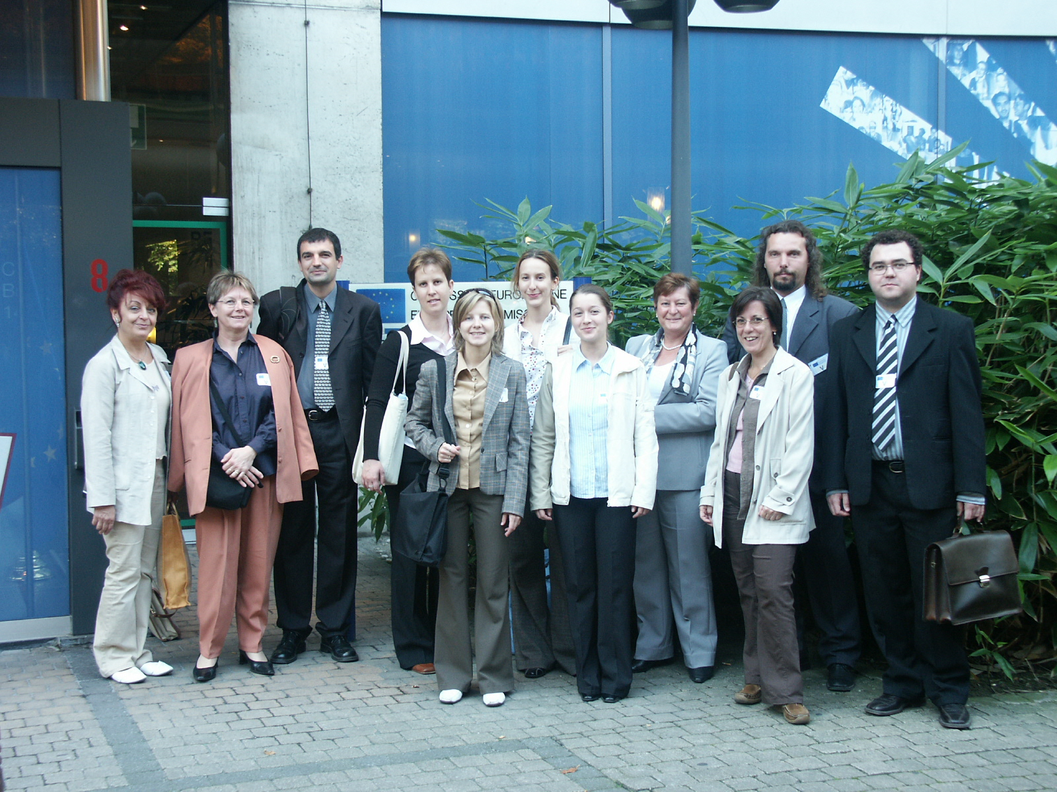

Project no.: 510457

Project acronym: Hungary for FP6

Project title:
Reinforce and develop the network of Hungarian organisations disseminating FP6 information and providing advisory services with the aim of assisting the successful Hungarian participation in the 6th Framework Programme

Instrument: Specific Support Action
Thematic priority: Specific Support Action for Associated Candidate Countries (all thematic priority areas)

Final Plan for Using and Disseminating the Knowledge

Period covered: Date of preparation:
from 01 June 2007 to 31 December 2007 February 2008

Start date of project: Duration:
01 June 2004 43 months

Project coordinator name:
Ms. Marianna Vári/Dr. Dóra Groó

Project coordinator organisation name:
Hungarian Science and Technology Foundation

Section 1 - Exploitable knowledge and its Use – n.a.

Section 2 – Dissemination of knowledge

 | Dates | Type | Type of audience | Countries addressed | Size of audi-ence | Partner respon-sible /involved
Press release (press/ radio/  TV) | 2004-2007 | 45 press releases were issued during the project’s lifetime; among them 5 news on CORDIS, 4 TV interviews and 7 radio interviews | All | EU/  Hungary |  | All
Confe-rence | 2004-2007 | The project partners participated at 8 conferences during the project to advertise Hungarian research excellence. The two most notable ones were: | All | EU |  | All
Confe-rence | November 2005 | “Communicating European Research” event, Brussels | Researchers, general public, industry | EU | 2000 | HSTF, BUTE, GYSMKIK
Confe-rence | November 2005 | World Science Forum, Budapest | Researchers, policy makers | EU | 800 | HAS, HSTF
Confe-rence | February 2007 | Hungarian FP7 Launch Conference, Budapest | Researchers, SMEs, industry | Hungary | 700 | HAS
Confe-rence | July 2007 | 13th Annual Conference of EARMA, Warsaw | Researchers, SMEs, industry | EU | 180 | BUTE
Confe-rence | July 2007 | 16th Mobile and Wireless Communication Summit, Budapest | Researchers, SMEs, industry | EU | 600 | BUTE
Confe-rence | October 2007 | eChallanges 2007 Conference and Exhibition, the Hague | Researchers, SMEs, industry | EU | 400 | BUTE
Publi-cations | 2004-2007 | Publications in English:  Research Teams in Hungary,  Industrial Associations and Groupings in Hungary,  Host Institutions in Hungary,  FP6 Contact Points in Hungary | Researchers, SMEs, industry | EU | 4000 | HSTF, BUTE, HAS
Publi-cations | 2004-2007 | Publications in Hungarian:  Az Európai Kutatási Térség,  Az EU 7. Kutatási Keretprogramja,  A 7. Kutatási Keretprogram általános modell szerződése,  FP7 Szerződéskötési útmutató,  Vesenyképesség és innováció FP6 kézikönyv KKV-k számára,  Kutatás-fejlesztés-innováció FP7 kézikönyv KKV-k számára  A siker útja | Researchers, SMEs, industry | Hungary | 5000 | HSTF, BUTE, UNIDEB, CCIPB
Project website | 2004-2007 | http://hufp6/tetalap.hu | All | EU/  Hungary | 10600 | HSTF
Posters | November  2005 | Hungary for FP6 poster at the CER conference, Brussels | Researchers, SMEs, industry | EU |  | HSTF
Posters | May 2007 | Hungary for FP6 poster at the “European Researchers of Tomorrow” conference, Stuttgart | Researchers | EU |  | BUTE
Posters | July 2007 | Hungary for FP6 poster at the 16th Mobile and Wireless Communication Summit, Budapest | Researchers, SMEs, industry | EU |  | BUTE
Flyers | 2004-2007 | 4000 flyers were distributed dzring the lifetime of the project | Researchers, SMEs, industry | EU/  Hungary | 12000 | All
Direct  e-mailing | 2004-2007 | 67200 direct e-mailing were reported by the partners | All | Hungary | 120000 | All
Film/  video | November 2005 | A short video was presented at the CER conference | Researchers, general public, industry | EU | 2000 | HSTF

Section 3 - Publishable results – n.a.

Project no.: 510457

Project acronym: Hungary for FP6

Project title:
Reinforce and develop the network of Hungarian organisations disseminating FP6 information and providing advisory services with the aim of assisting the successful Hungarian participation in the 6th Framework Programme

Instrument: Specific Support Action
Thematic priority: Specific Support Action for Associated Candidate Countries (all thematic priority areas)

Final Management Report

Period covered: Date of preparation:
from 01 June 2007 to 31 December 2007 February 2008

Start date of project: Duration:
01 June 2004 43 months

Project coordinator name:
Ms. Marianna Vári/Dr. Dóra Groó

Project coordinator organisation name:
Hungarian Science and Technology Foundation

SUMMARY FINANCIAL REPORT

For the period June 1, 2004 – December 31, 2007

Part-ner nr.PartnerCost modelManage-ment direct costManagement indirect costManage-ment totalOther Specific Activities direct costOther Specific Activities indirect costOther Specific Activities totalAdjust-ments to previuos periodsTotalRequested EC contribution1HTSFFCF26 289,974 978,0031 267,97201 405,3236 143,03237 548,35407,02269 223,34266 895,342SHASFCF1015,89203,181 219,0724 897,654 979,5329 877,186047,2637 143,5133 968,073BUTEAC94,39094,3960 098,3511 435,0271 533,37-8605,4663 022,3063 022,304UNIDEBAC4500450,0030 735,526 147,0936 882,61 37 332,6137 332,615USZAC120001 200,0015 933,783186,7619 120,54 20 320,5420 320,546PEAC236,950236,9517295,393459,0720 754,46-1100,8619 890,5519 890,557BZFFC238,050238,0520 105,034 020,9324 125,96-471,7423 892,2722 642,278CCIPBFCF987,280987,2841 879,758 375,5450 255,29-512,2150 730,3649 372,059GYMSKIKFCF789,820789,8217 930,083585,6221 515,70-593,74821 711,7720 586,77Total 31 302,355 181,1836 483,53430 280,8781 332,59511 613,46-4 829,74543 267,25534 030,50

