

Project no. 510470
Project acronym: MINAEAST-NET
Project title: MIcro and NAnotechnologies going to EASTern Europe through NETworking

Instrument: SSA
Thematic Priority: General

PUBLISHABLE FINAL ACTIVITY REPORT

Period covered: from 01.05.2004 to 30.10.2006 Date of preparation: 14.11.2006
Duration: 30 months

Project coordinator name: Dan DASCALU
Project coordinator organisation name: National Institute for Research and Development in Microtechnologies (IMT-Bucharest)

Dissemination Level: Public

Authors: Project coordinator - IMT (P1-CO)

Address: National Institute for Research and Development in Micro technologies (IMT)
126 A (32B) Erou Iancu Nicolae Street, 077190 Bucharest, Romania
Phone: +4021-490.84.12/+4021-490.85.84
Fax: +4021-490.82.38
Email: net@imt.ro

- Project execution

1.1 Project overview
MINAEAST-NET project’s aim was to support the participation of organizations from Acceding and Candidate Countries (ACC) in FP6 projects on micro- and nanotechnologies domain (MNT), according FP 6 priority 2 - IST (related to micro and nanosystems) and FP 6 priority 3 - NMP (nanotechnologies).
The partners involved in the project were research institutes and universities active in MNT field, from eight ACCs (Romania, Hungary, Poland, Slovenia, Slovakia, Lithuania, Bulgaria and Turkey), France, Germany and Greece.
MINAEAST-NET significantly helped in improving the visibility of ACCs in member states (MS) and facilitated the joining of research groups from ACC on MNT in consortia for FP6 together with MS partners. The project was mainly focused on networking and dissemination activities. Various workshops, info-days and scientific events, meetings, exhibitions were organized/co-organized by the project. The events brought together participants from NCP’s, EU officials, foreign researchers and representatives of industry as invited speakers, for a better information and understanding of EU programmes, exchanging of information and future cooperation in FP6/7 between ACC and MS scientific community and for establishing a better interaction between research, education and industry.
Dissemination activities included also articles for information and partners search published in international publications and announcements through web pages and e-newsletters, allowing the exchange of information about research performed by organizations in Eastern Europe.
During the project, an inventory of researchers and research organizations from ACCs and NMS was performed with the aid of databases for collecting data about specialists and research centres in MNT domain. For the calls launched during the project lifetime, databases for partners matching were implemented. The registered entities provided information about their expertise and interest in accordance with topics from each call, in order to find suitable partners for new projects financed by FP6. The information from the databases hosted on the MINAEAST-NET project website was published in various formats in order to reach interested organizations from MS, therefore increasing the chances for researchers to participate in European projects.
At local level of ACCs, MINAEAST-NET attracted industrial partners, by disseminating the scientific results of the research centres. The Eastern project partners set-up and coordinated local networks, each being connected with national “high quality centres of research” interacting between them. At European scale, the project cooperated and exchanged information with other international networks, projects in the MNT field.

1.2 Project Consortium:
- National Institute for Research and Development in Microtechnologies, IMT, Romania (CO)
- Budapest University of Technology & Economics, Dept. of Electron Devices, BUTE, Hungary
- Faculty of Electrical Engineering, University of Ljubljana, Laboratory of Microsensor Structures, UL-FE, Slovenia
- Institute of Control and System Research of the Bulgarian Academy of Sciences, ICSR, Bulgaria
- Institute of Solid State Physics of the Bulgarian Academy of Sciences, ISSP, Bulgaria
- Kaunas University of Technology, Institute of Physical Electronics, IPE, Lithuania
- Kaunas University of Technology, Ultrasound Institute, KTU, Lithuania
- Technical University of Kosice, TUK, Slovakia
- Sabanci University, Faculty of Engineering & Natural Sciences, Istanbul, SU, Turkey
- National Centre of Scientific Research “Demokritos”, Institute for Microelectronics, Athens, IMEL, Greece
- Techniques of Informatics and Microelectronics for computer Architecture, TIMA, France
- Technical University of Berlin, Research Centre of Microperipherics Technology, TUB, Germany
- Institute of Electron Technology, Department of Silicon Microsystem and Nanostructure Technology, IET, Poland

1.3 General project objectives
The project addressed to following objectives:
  - MINAEAST-NET acted as a key source of information about resources and results in MNT from ACCs and about the strong points of the ACC organizations, in order to increase the visibility and better cooperate with MS institutes and companies
  - For all MNT interested organizations from ACC, MINAEAST-NET represented an important source of MNT specific project and partnership information: MNT related information about EC calls, international networking activities, partnership search from abroad.
  - MINAEAST-NET supported the interaction between ACC and MS organizations to initiate FP6 proposals through organizing meetings, workshops and support travel cost for ACC researchers to attend proposal preparation meetings/events in MS.
The objectives of the project MINAEAST-NET were focused on the objectives of the call, targeting the following actions:
- Activities intended “to mobilise the human and material resources existing in a given field in associated candidate countries”: Knowledge collection and processing: information about high quality research centres from ACCs participants in MINAEAST-NET, active in the field, is collected, processed and stored in databases with institutions & specialists (resources and results). These databases are linked with the webpage of MINAEAST-NET and may be accessed by research centres from MS in order to search partners for proposal in FP6; Networking: a webpage, with links to all participants of MINAEAST-NET “greatly facilitated communication between the centres having similar scientific interest”.
- Dissemination of “scientific information as well as the results of research”, by delivering to the researchers from ACCs and NMS the information about FP6, but also offering to the researchers from MS the information about resources and results from ACCs and NMS. Electronic media (Webpage, e-mail, CD-ROMs), publications (Annual Reports, quarterly Information Bulletin) and events (Workshops with invited scientists from EU countries covering certain thematic priority areas for the FP6, seminars, meetings).

  - Work performed and achievements; Results

All the MINAEAST-NET partners were actively involved in networking activities during all the project duration.
Each partner has collected and updated information about human and material resources for the ACCs and NMS participants, about national policies, national plans, strategies, scientific parks, technological transfer, national contact points, events in the MNT field.
The partners identified the national networks in the MNT domain and contribute to attract new partners in order to enlarge the existing networks or set-up new networks formed by national high quality centres of research active in MNT. If networks in MNT already existed in a respective country, the project partner facilitated the communication and co-operation between MINAEAST-NET consortium and the existing network, by information exchange through electronic media (web pages, e-room platform, e-mail communication, electronic newsletter, e-Flash News), dissemination materials (flyers, posters) and participation to events.
IMT-Bucharest, Romania exchanged information and established connections with other networks for attracting them to cooperate with Eastern research institutions, like MINOS-EURONET (“MIcro-NanOSystems EURopean NETwork pursuing the integration of NMS and ACC in ERA”, SSA), NEXUSplus, NANOFUN-POLY (NANOFUN-POLY network (“NoE on Nanostructured and Functional Polymer-Based Materials and Nanocomposites”).
BUTE, Hungary performed a survey on existing nano-related networks in Hungary, like HUNN, BUTE NANO Office, NENAMAT, NanoClub of HAS and connected these network with MINAEAST-NET by participating to their meetings, delivering presentations about MINAEAST network and its offers, announcements of events, travel grants.
ICSR and ISSP, Bulgaria collected information at national level, collaborated with the Bulgarian National Centre on Nanotechnology which provides expert support at micro- and nanotechnology area, established successful contacts with Technical University of Sofia, Gabrovo, Plovdiv and Varna, assisted research organizations for cooperation in research projects.
IPE and KTU, Lithuania identified the existing Lithuanian local MNT network, collected information about the status of MNT field in Lithuania by preparing an inventory of national MNT projects and providing lists of projects involving the participation of research institutions from Lithuania to the international programmes in the MNT field.
TUK, Slovakia collected information on MNT actors and activities in Slovakia and disseminated them. TUK established cooperation with EU network NENAMAT coordinated from Slovakia.
SU, Turkey collected and updated information at national level about the status of the MNT field. Gathering information about MNT in Turkey, SU have combined the information gathered during the earlier reporting period of the project and prepared a website to demonstrate/present/share them. This website was primarily addressed the professionals/researchers working in the area of Micro/Nanotechnologies and systems in Turkey.
IET, Poland: Establishment of the national Scientific Network MINAS “MIcro-and NAno- Structures for interdisciplinary applications” under MINAEAST initiative www.ite.waw.pl/minas. This network is cooperating with the MINAEAST project in dissemination of MINAEAST information through its mailing list.
Information exchange with Western networks (both sides) was performed by dissemination of MNT information through the e-newsletter, e-flashnews, MNT Bulletin, MST News, leaflets, posters.
MINAEAST-NET established good connections and information exchange with several NoE’s and IP’s coordinated by Western Europe institutions: PATENT-DfMM “Packaging, Test and Reliability Engineering in Micro & Nanosystem Technologies”, FP6 NoE, priority 2, IST; 4M “Multi-Material Micro Manufacture: Technologies and Applications”, FP6 NoE Priority 3 – NMP; NANO2LIFE “A network for bringing NANOtechnologies TO LIFE”, FP6 NoE priority 3, NMP; AMICOM: Advanced MEMS for RF and Millimeter Wave Communications, NoE FP 6 - priority 2, IST.

One key element for networking is represented by structuring the information into electronic databases, in order to be easily accessed by people looking for partners, interested in establishing connections for future projects proposals.
A database for networks was created and implemented (http://www.minaeast.net/databases.htm).
The inventory of research centres and specialists in the MNT field was performed with the aid of databases for registering of research centres, specialists and international projects, created and implemented (http://www.minaeast.net/databases.htm) since the first months of the project.
The database for registering research organizations allows the inventory of the inventory of scientific research centres (either independent or autonomous from the scientific point of view, i.e. labs from universities and even institutes) interested in the participation to FP6 and FP7 is performed. The database questionnaire has various possibilities of data selection, assuring an efficient search. The information can be periodically updated. The users have to introduce information regarding the organization profile, interest in FP6 and FP7, competence and resources relevant to FP6 and FP7. A free search could be performed for research centers, related to the interest in thematic research fields (as defined by priorities of FP 6), by Country, keywords, domains and priority.
The database for registering specialists includes information related to the specialist profile, affiliation, competence domains, participation in the most relevant international R&D projects, interest in collaboration.
The advantages of databases are the following: people registering into the databases have to complete a minimum of data in order to get password controlled access, but free of charge, since the databases are public (access means registration of data, updating of these data, as well as search into the whole content); the information from certain databases is publicized through other means (e.g.: volumes edited with the data extracted from the database on certain topics of interest and distributed to participants at various events); names of persons, projects, organizations are available for web search engines.
Along the project lifetime, the databases were improved with new features and functionalities in order to facilitate the access to the information and the management of profiles for the registered users.
There were a total of 378 research centers registered in the database after the first two years (compared to 284 centres registered during the first year) and 327 specialists (compared to 115 registered during the first year), among which 118 specialists were active in micro-nano domain.
Restricting the area and performing a search by research centers and specialistas active in micro-nano-bio domain, at the end of the project, in October 2006, the database for research centres included 162 centres and the database for specialists included 222 specialists. The distribution per countries is presented in the charts below. The data for Romania have been introduced mainly with support from another SSA project devoted to Romania (“ROMNET-ERA”).
These electronic databases represent a key point for facilitating networking, a way for rapidly establishing new contacts, in order to select the best partners when preparing a new project proposal. The database has various possibilities of data selection, assuring an efficient search and the information introduced by the users can be periodically updated.
The databases from MINAEAST-NET project were further developed, improved and maintained in the SSA project MINOS-EURONET “MIcro-NanOSystems EURopean NETwork pursuing the integration of NMS and ACC in ERA” (www.minos-euro.net) and will be maintained available with information a number of years after the project end.

For the calls launched during the project lifetime, databases for partners matching and expressions of interest dedicated to FP6 calls were designed and implemented, for collecting data where the registered entities provided information about their expertise and interest in concordance with topics from each call: for Second Joint Call between thematic priorities 2 and 3; Call IST-4 in FP6; NMP call in FP 6 FP6-2004-NMP-NI4; NMP call in FP 6 FP6-2004-NMP-TI4 (http://www.minaeast.net/databases.htm; http://www.nano-link.net/db/infodb.htm).
These databases were designed in order to help research groups and researchers to promote their competencies and initiate cooperation with other organisations in field of micro-nano-biotechnologies and identify research groups with specific competencies according to topics from calls published in IST and NMP for 2006
These electronic databases open the way for rapidly establishing new contacts, in order to select the best partners when preparing a new project proposal.
All the databases are interactive and accessible free of charge to qualified individuals after registration (they are in the public domain).

A series of events, like meetings for preparation for partnerships on FP6 proposals and proposal preparation, training visits to MS partners, project preparation workshops in ACC and meetings with invited speakers from European Commission and MS were organized by MINAEAST-NET project.
The project offered facilities for NMS/ACC researchers and academic or industrial organizations in the form of individual grants for training visits or participation to training events in MS (Western Europe) and for participation to meetings (brokerage, proposal preparations).

The First MINAEAST-NET Workshop “East/West Partnering Workshop within the MINAEAST-NET Initiative” was organized in Berlin, Germany, by the partners TU Berlin and 4M2C on April 22, 2005.
24 participants from Germany, Romania, Poland, Turkey, Lithuania, Bulgaria, Hungary and Slovakia attended the event. The aim of the workshop was to help organizations from East European countries in participating to EC FP6 projects. During the workshop, Eastern organizations presented their expertise for FP6/FP7 projects. Existing projects looking for further partners and special actions to support cooperation with Eastern partners were also put forward. At the end of the workshop, a Lab tour through TUB/IZM facilities was provided. In the view of the participants the event had been very effective and the format will be used for future MINAEAST-NET events.
For the “East/West Partnering Workshop within the MINAEAST-NET Initiative” in Berlin, 11 travel grants were offered to Eastern Europe participants from Turkey, Romania, Lithuania and Bulgaria.
As a result of participating to the workshop, TUK, Slovakia started to prepare a project proposal in collaboration with Wroclaw University and other partners, based on first contacts on MINAEAST-NET Workshop in Berlin.

“The Second MINAEAST-NET Workshop within the MINAEAST-NET EU project” was organized in Athens, Greece, by the Institute for Microelectronics (IMEL), National Centre of Scientific Research “Demokritos”, on 15th July 2005. The workshop was intended to intensify the collaboration with Eastern Europe in the micro-nanotechnologies domain. During the first part of the workshop, the hosts from IMEL/ NCSR “Demokritos” presented their research activities and experience in international projects and networks. Dr. Androula Nassiopoulou, the director of IMEL, presented the research activities at IMEL, envisaging the main research domains and results, research projects, collaboration with industry and institute infrastructure and also the EU NoE “SINANO: A Network of Excellence for Silicon Nanoelectronics” within IST priority. Other presentations from IMEL were related to other international succesfull projects like “TASNANO - ΕU STREP on “Tools and Technologies for the analysis and synthesis of nanostructures”), “BIOMIC – An EU project on Monolithic Silicon Optical Biosensors”), “EU Nano2life NoE”, More-Moore, NanoPlasma.
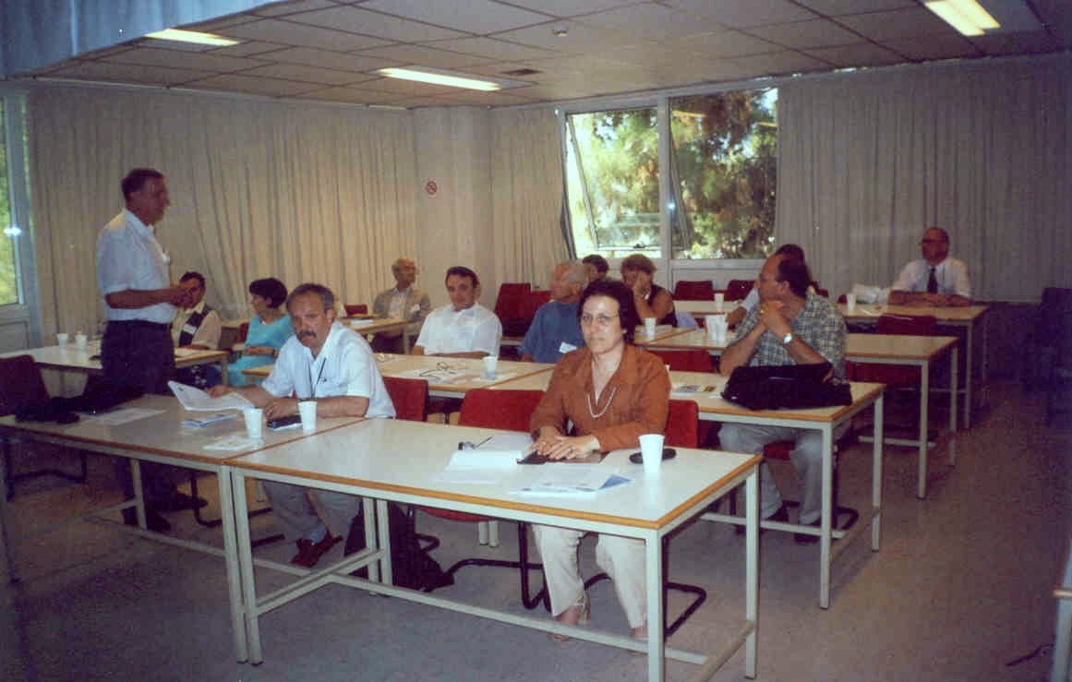
A tour of the IMEL laboratories was provided by Dr. Nassiopoulou between the two parts, showing the main institute facilities. During the second part, the Eastern participants presented recent research results obtained in the MNT domain, current projects and also the human and material potential, together with possibilities for cooperation.
20 participants from different countries, including the MINAEAST-NET project partners, attended the event. 2 participants from Bulgaria and Hungary benefited from travel grants for attending the workshop, offered by the MINAEAST-NET project.
The presentations given at the workshop can be accessed on the project website, at the address http://www.minaeast.net/15July_workshop.htm. The event offered the participants the chance to identify better the scientific and technological capabilities of Eastern and Western organisations and opportunities for cooperation. New contacts were established between the participants and new project ideas put forward.

“The Third MINAEAST-NET Workshop” was organized by TIMA, France (Techniques of Informatics and Microelectronics for computer Architecture) in Villard-de-Lans, France, in the period 26-27 January 2006. (http://www.minaeast.net/past_events.htm)
The workshop gave the possibility to strengthen the relationships between Western and European organisations that are active in MNT, including the dissemination of information about various projects, networks, local events in each organization / country participating in the MINAEAST-NET project.
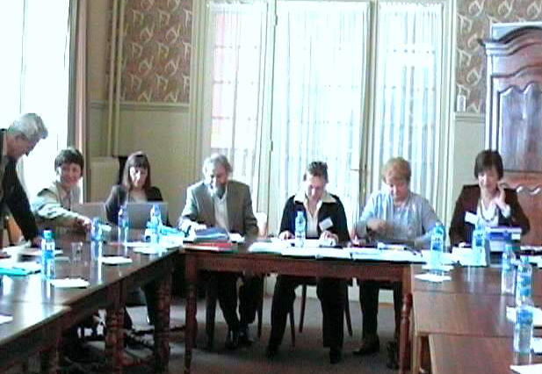
Participants from 9 different countries, including the MINAEAST-NET project partners, attended the workshop and several grants for Eastern participants were offered by MINAEAST-NET for participating in the event.
Presentations of Western networks were delivered during the first part: the Nano2Life NoE (FP6 priority 3) - presented by Dr. Patrick Boisseau from CEA, France; the NEXUS - the European Microsystems Association and its offer to ACC/NMS organisations, including results from the latest NEXUS Market Analysis - presented by Mr. Patric Salomon, from 4M2C Patric Salomon GmbH, Berlin, Germany (subcontractor in MINAEAST-NET); the PATENT NoE (FP6 priority 2), coordinated by Dr. Andrew Richardson, University of Lancaster, UK. During the second part, presentations of TIMA and Eastern partners were given. An overview of research groups and laboratories including current research topics, technologies, applications and projects was given and issues related to technology transfer and dissemination/education offer were presented as well.
The Eastern partners presented the activity of represented organizations, national networks or projects in the MNT field, as well as offers for collaboration.

The Fourth MINAEAST-NET Workshop “Preparing the European cooperation in FP7” was organized at IMT-Bucharest, Romania, on 16-17 October 2006.
The workshop was focused mainly on opportunities of cooperation in FP7 or other programs and addressed the following topics, provided by Romanian organizations, together with representatives of European organizations: preliminary info about topics in FP7; perspectives to participation to MNT activities through European organizations such as NEXUS and EUROPRACTICE (the actual status); “good practice” of new member states in developing local/national initiatives fostering European cooperation (networks, programmes, structural funding etc.).
Prior to the workshop, the participants visited research laboratories and the technological area, including the clean room and demonstration of remote use of e-beam lithography (EBL) in IMT.
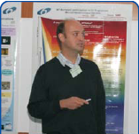
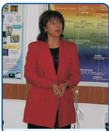
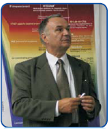
The workshop was opened by the MINAEAST-NET project coordinator, Prof. Dan Dascalu. Presentations were delivered by all MINAEAST-NET project partners who attended the Workshop, but also representatives from other institutions delivered presentations of interest: Ministry of Education and Research, NMP National Contact Point for NMP, Romania; University “Politehnica” of Bucharest, Romania; iMediaSoft IMS Romania Technical University of Sofia, Bulgaria. The partners presented recent research activities in their organizations or countries, involvement in technology platforms, offers for collaboration in FP7. 49 participants from different countries, including the MINAEAST-NET project partners, attended the event.
Prof. Karl-Friedrich Becker, TU Berlin
Prof. Anna Andonova,
Technical Univ.
of Sofia

Prof. Dan Dascalu, IMT, Romania
The event offered the chance to strengthen the links between Eastern and Western organisations and to identify the scientific and technological capabilities of the participants, in order to start future cooperation projects in FP7.
The workshop agenda and presentations can be accessed on the project website, at the address http://www.minaeast.net/2006.10.16/. The event is presented in detail in MNT Bulletin Vol.7/No.3 – 2006.

The project partners participated to meetings for project proposals preparation, organized by the project partners or by organizations outside the consortium and to brokerage meetings in NMS/ACC for preparation of proposals.
During the first year of the project, representatives from IMT participated in preparing the project proposal “Enabling Technologies for Next Generation Intelligent Microsystems Based on Wide Band Gap Materials”, submitted for IST Call 4. During the second year, IMT participated to the 4th workshop of the NOSE II network and proposals preparation meeting, Istanbul, Turkey, 07-08.11.2005. The workshop offered an opportunity to discuss the upcoming FP7 programme and how the fields in technology and applications, in which NOSE members are active, fit in the proposed themes of FP7. The MINAEAST network was presented during the oral presentations by one representative from IMT-Bucharest. Other meetings where IMT participated were meeting for preparing the proposal “Enabling Technologies for Next Generation Intelligent Microsystems Based on Wide Band Gap Materials”, STREP proposal, 4 days, Rome, IT.
One representative from the National Institute for Non-ferrous and Rare Metals, Romania participated in Norway to a meeting for project preparation (“Hybrid Nanostructured Materials for Biosensors and Biobanks”) on April 28, 2005.
Representatives from Romania and Bulgaria attended the forth NEXUS IP and NoE meeting, in Paris, France on 05-06.12.2005. The meeting gave the opportunity to establish contacts for future proposal preparations and received information about FP7 - meeting for proposals preparation.
IET, Poland participated to the “e-Cubes” FP6 IP proposal preparation in Munich, Germany on 20 Dec. 2004, to the “CHARACTER” FET proposal preparation in Warsaw on April 10-11, 2005, to “PREMISS” Project preparation meeting in Caen, France. IET representatives also attended a meeting organized by IRC Hungary concerning marketable research opportunities in renewable energy systems, in particular photovoltaic systems, with the aim of the meeting was to determine opportunities for participation in FP6-2005-TREN-4 call. As a result, the WEBMOSS proposal with IET participation was submitted.
A meeting for preparation the participation to European programmes was the visit of Sonion Company to IET, Poland in October 2006. The intention of the visit was to find out the possibilities for R&D cooperation in EU projects or direct collaboration. During the visit, the potential of the IET was presented and the experiences in collaboration within FP5 and FP7 Programs were discussed. IET presented the production program and outlined the R&D interests. In conclusion of the meeting it has been agreed that SONION will study information provided by IET and will consider undertaking research collaboration with IET within coming FP7 Program.

As results of the meetings for proposal preparation, several MINAEAST-NET partners have submitted project proposals for calls corresponding to the priority thematic areas 2.IST and 3.NMP.
The “MINOS-EURONET” project (“Micro-Nanosystems European Network pursuing the integration of NMS and ACC in ERA”), submitted to the IST call 3 in FP6 was successful. The project coordinator is IMT, Romania and partners from MINAEAST-NET are: BUTE, UL-FE, KTU, IET.
“INTEGRAMplus” (IP for Call 4, IST) was another project financed, where IMT, Romania, is partner.
“IMT-POLE” was a FP6 project proposal coordinated by IMT, Romania, submitted to the call FP6-2004-ACC-SSA-2, but was not approved for financing. Eastern partners from Bulgaria and Turkey were integrated into the project proposal.
Partners from BUTE, Hungary and TIMA, France participated to the preparation of the EUROSOC project proposal in Budapest, delivered in March 2005.
TUK, Slovakia submitted the project proposal “Nano-modified smart materials for multifunctional paints, coatings, and cooling agents”, coordinated by Wroclaw University of Technology, call title: FP6-2004-NMP-TI-4, No of project in EPSS: 033206.
IET Poland submitted 21 project proposals to different FP6 calls in the period 2004-2006 to IST and NMP priorities.

The MINAEAST-NET project partners participated to meetings with invited speakers from European Commission and MS, where last calls in FP6 and the future FP7 were presented.
Representatives from IMT, Romania participated to the NEXUS meeting, June 2005, Budapest, Hungary. The event took place with participation of representatives from the EC. One representative from IMT delivered an oral presentation about MINAEAST-NET. During the event, the last calls for IST and the results from the last competition were presented.
MINAEAST-NET partners attended to the 1st MINOS-EURONET Forum “High technologies, innovation policy and regional development”, organized in Bucharest, Romania, at Chamber of Commerce of Romania, on 18-19 May, 2006. The workshop was organized by the MINOS-EURONET project, coordinated by IMT-Bucharest, with EC support. The Forum included a brokerage section during the first day, when a poster exhibition was available. Two participants from Institute of Solid State Physics, Bulgaria and one from Institute of Electron Technology, Poland, attended the Forum. They actively participated at the poster exhibition providing info about participation to EU programmes, national and regional infrastructures for research and innovation. They established contacts and attended the discussions for future collaborations in joint projects in FP7 with Romanian institutions and organizations from abroad. 27 foreign participants (including 3 representatives of the European Commission and 12 participants from MS) attended the event. During the information part, the representatives of the European Commission delivered presentations related to “Preparing for FP7: EU policy”, followed by a panel discussion: Dr. Stephan Pascall, Advisor, Information Society and Media Directorate-General, European Commission: “The development of the knowledge society in the new member states of the EU, Romania and Bulgaria”; Gisele Roesems, Unit of nanoelectronics, Directorate Components and Systems, INFSO/DG, European Commission: “Eco-zones and European Technology Platforms in Nanoelectronics (ENIAC) and Photonics (Photonics 21)”; Griet Van Caenghem, Unit Micro- and Nanosystems, Directorate Components and Systems, INFSO/G, European Commission: “Micro-nano technology and microsystems: A decade of European progress and outlook for the future.”
Another event where EC representatives delivered presentations about the Community framework programs was the workshop “Nanotechnology in FP7”, organized in Brno, on 20-21st September 2006, where representatives from TUK, Slovakia presented the activities and intentions for participation in FP7.
Representatives from IPE, Lithuania attended the Information day “FP6. Nanotechnologies and NEST - oportunities in the 2005 year” in Kaunas, Lithuania. Evaluation aspects of FP6 projects were discussed with emphasis on the projects in the field of nanotechnologies.

- Dissemination

The MINAEAST-NET project web page (http://www.minaeast.net) was active from the first month and then continuously enlarged functionally. The web site was constantly updated with new information about important events in micro-nano-biotechnologies area, databases, main publications of the project, links to the FP6 and FP7 calls and thematics and various announcements.
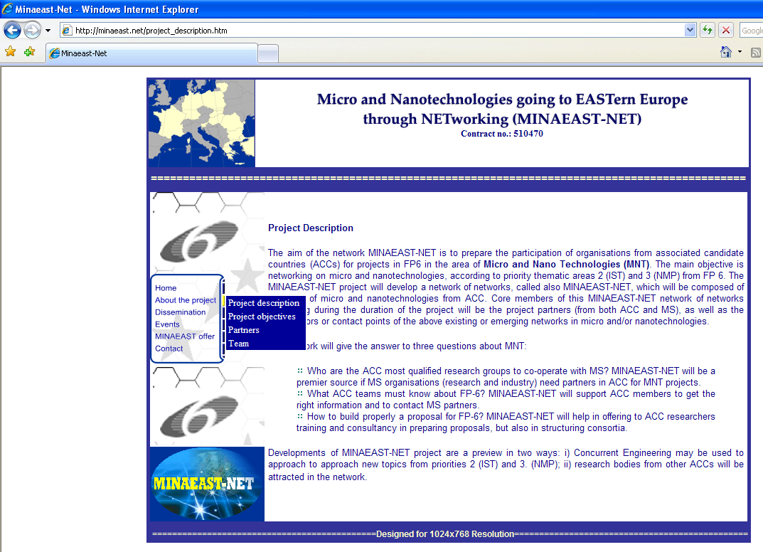

The users registered in the MINAEAST-NET databases receive the MINAEAST-NET e-newsletter (http://www.minaeast.net/e-newsletter/arhiva.htm), and the MINAEAST-NET Flash News (http://www.minaeast.net/Flash%20News/arhiva.htm), which disseminate information about the most relevant past and future events in the MNT field, calls for proposals, training courses and various announcements. Starting September 2005, these two electronic publications were issued in common with the SSA project MINOS-EURONET. The common MINAEAST/MINOS e-newsletter is promoting both national networking in MNT in Eastern Europe (MINAEST) and pan-European networking (MINOS). Information from the e-newsletter was further distributed by the project partners to their local and regional contacts. 25 editions of e-newsletter and 13 editions of e-flash-news were distributed during the project duration.
These electronic publications represent an important tool for dissemination, being distributed to approximately 1600 addresses, compared to 1350 addresses at the end of the second year and 400 addresses for the first year.
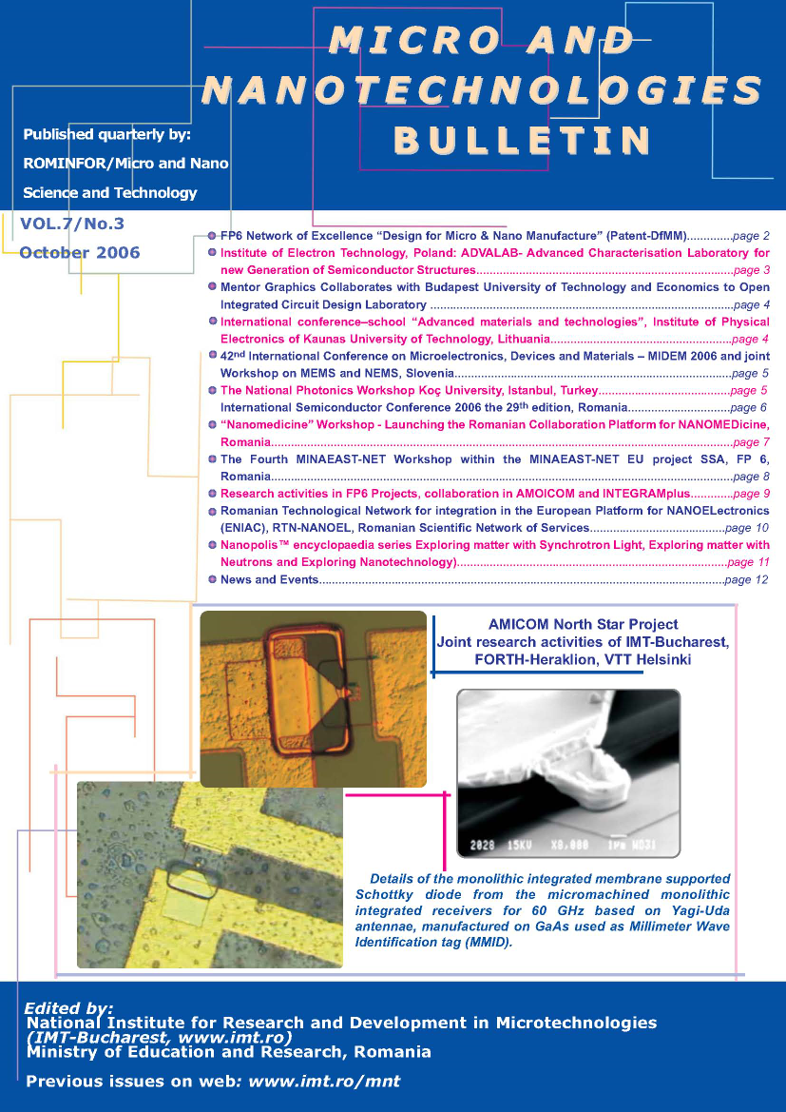
The “Micro and Nanotechnologies Bulletin” (“MNT Bulletin”), edited and published by IMT-Bucharest every three months also represents a powerful tool for disseminating information about MNT activities all over Europe. The MNT Bulletin offers space for dissemination of news from Eastern Europe and is distributed (free of charge) all over Europe to qualified individuals and institutions working in the MNT field (with the occasion of various events). This printed publication is also available on web at the address http://www.imt.ro/mnt. The materials presented into the Bulletin are not scientific papers, but other types of contributions such information about new centres of research, networks, successful cooperation, events with special focus in MNT.
The articles published in MNT Bulletin (www.imt.ro/mnt) are searched by the “Google” searching engine on the web, displaying the articles where the searched entity appears.
9 numbers of MNT Bulletin supported by MINAEAST-NET were published during the project lifetime.

News pages about the MINAEAST-NET project and its partners were disseminated in the European MNT journal “MST News”, edited by VDI/VDE, Germany, as a way to reach about 11.000 MNT interested researchers and industry people in Europe. Information from MINAEAST-NET was disseminated outside the network and especially in MS countries in 12 editions of MST news.
The Almanac “Inventions, Technologies and Innovations meet National Business” under auspices of MINAEAST-NET Project is created in order to respond to the European and Bulgarian needs for cooperation in the MNT domain.

The project partners attended scientific events, working groups meetings on scientific subjects related to MNT, especially in new, multidisciplinary areas, where they disseminated information about the project by leaflets, posters and oral presentations.
Examples:
ISSP, Bulgaria, attended the conference “New trends in development of nanostructured thin films, hard and superhard coatings” (NANOHARD’2006), at the Central Laboratory of Applied Physics, BAS, Sozopol, Bulgaria. With this occasion, a presentation about the aims and opportunities of MINAEAST-NET project for strengthening of MNT activities in Bulgaria was delivered, links were established between Bulgarian researchers working in the filed of MNT and new collaborators were emerged for development of future joint projects of FP7.
A delegate from partner ICSR, Bulgaria attended the “Science Days in BAS” (Bulgarian Academy of Sciences) in 2006 and presented a lecture concerning the Nanotechnologies’ future in sensors, with European guests and also supervised the related discussions. Young scientists, PhD students and Post docs were attracted in order to discuss issues about their research working in the field of micro- and nano-science and technologies. MINAEAST-NET leaflets were distributed with this occasion.
IPE, Lithuania organized the 8-th International Conference – School “Advanced Materials and Technologies”, on June 19-30, 2006 and August 27-31, 2006. Latest developments in the field of micro and nano-technologies for the material synthesis and processing were presented for the young researchers and PhD students by the speakers from word leading research institutions. During the conference, talks on the development of MNT network in Lithuania took place. MINAEAST-NET leaflets were distributed with this occasion.
TUK, Slovakia attended the International Conference NANOVED 06-NENAMAT, in Stará Lesná, Slovakia, where the participants were informed by poster and abstracts in proceedings about MINAEAST –NET project and the using of project databases.
IET, Poland organized the Workshop “Interdisciplinary Applications of Microsystems: Microsystem Technology for Medical Implants in 6th FP”, Warsaw, Poland.

The partners participated at booths at exhibitions / conferences on MNT in NMS and MS in order to disseminate information and actively participate to discussions.
Examples:
Minaeast-Net had a dedicated booth for the whole duration of the Conference “Design, Test, Integration and Packaging of MEMS/MOEMS”, Montreaux, Switzerland, 1-5.06.2005.
IMT, Romania participated to “ARIES Brokerage Event for FP6-IST”, Sinaia, Romania, 20-21.05.2005: the event gave the opportunity to establish new international consortia for applying to research programmes funded by the EU; to the 4M Workshop “Micro/nano Engineering: Technology & Applications”, Sofia, Bulgaria; Seminar “A new CEEX competition: preamble to Romanian participation in FP7”, Bucharest, Romania. To all these events, Minaeast-Net leaflets and/or posters were distributed.
Participants from Institute of Control and Systems Research ICSR, Bulgaria attended the following events: International Technical Fair Plovdiv - BAS exhibition - Development and perspectives of Nanotechnology sensors and systems, three editions, in 2004, 2005 and 2006, Bulgaria, participation with posters; International Technical Fair Plovdiv 2006, BAS exhibition, for 1 week, September 2006, where information about MINAEAST-NET was disseminated.
BUTE representatives participated in NANO-MAT-PROD workshop, a brokerage event in Budapest, Hungary, where promotion materials on MINAEAST-NET were disseminated. They also attended a brokerage event connected to SEMINANO workshop, in Budapest, Hungary, September 2005 and a brokerage event connected to the Carbon Materials International Symposium in Hungary, October 2005, where the project offers were promoted.
Representatives from IPE, Lithuania delivered an oral presentation “Evaluation aspects of FP6 projects” at the Information day “FP6. Nanotechnologies and NEST – oportunities in the 2005 year”, Kaunas, Lithuania.
MINAEAST-NET was presented in the poster session at Nanoved 06, 14-17th May 2006, Slovakia, by TUK representatives.
IET, Poland participated to “Nanotechnology in Northern Europe Congress”, Helsinki 26-28 April 2005, www.nano.fi, to “Nanotechnology Networks workshop” www.nano.fi/nano_networks.htm, to "Micro et Nanotechnologies en Europe et Midi-Pyrenees”, Tolouse, France, 5 December 2005, where they delivered the presentation "Micro- and Nano Technology in Poland Competence trough cooperation”. The aim of the presentation was to establish contacts with MNT related research groups in Midi-Pyrenees region and to check possible fields of cooperation for MINAS scientific network established under MINAEAST initiative as well as to disseminate information about MINEAST.NET network activities.

Methodology and approaches

The information about high quality research centres from ACCs participants in MINAEAST-NET were compiled from various sources and used to pursue these organizations to complete the project databases. The communication platform was implemented from the first year of the project, consisting in the project web page, databases, e-newsletter, flash-news and MNT Bulletin.
The information coming in (databases for registration) and information going out (distribution list, e-newsletter, and web pages) was continuously monitored in order to create a dynamic, self-generating structure.
Networking was realized mainly by using the dedicated databases and participation to the events organized by the project. The participants interacted between them and with networks from other NMS or MS, as well as with pan-European networks with the occasion of various events organized or co organized by the project. The events brought together researchers with similar or complementary interest, including scientists, experts in writing proposals and specialists available for scientific/technical consulting.
MINAEAST-NET offered a strong specific support for NMS and ACC researchers. The Eastern participants were supported to participate to meetings for project proposals preparation in the IST and NMP priorities from FP6.
Dissemination of the project offers and the activities developed within MINAEAST, success stories, partnership opportunities was performed by participating to events and delivering oral presentations, leaflets and posters, and also by distributing the e-newsletters, articles in publications like MNT Bulletin and MST news.
The information from MINAEAST-NET databases about European research resources, centres of research, specialists, international projects and networks were disseminated with the occasion of various events organized by the project.
One characteristic of this methodology intended to be the central role of communication and self-organisation. The conventional means were complemented by new an innovative means of electronic communication, characteristic to the knowledge – based society.
All the activities developed in the MINAEAST-NET project increased the visibility and the chances of NMS organizations for a better participation to FP 6 project proposals. The project helped in revealing and promoting the research potential, the competences and offers of Eastern Europe organizations in order to enhance the collaboration with Western partners.

