

Contract no: COOP-CT-2004-512864

Project acronym: Chimeric Vaccines

Project title: Development of influenza delNS1 virus as a vector for foreign antigens

Instrument: Co-operative Research Project

Thematic Priority: Integrating and strengthening the ERA

Final Activity Report
Month 1-30

Period covered: from 01/11/2004 to 30/04/2007
Date of preparation: June 19 2007

Start date of project: 01/11/2004
Duration: 30 months

Project coordinator name: Dr. Joachim Seipelt
Project manager name: Dr. Karla Valdés Rodríguez
Project coordinator organisation name: Avir Green Hills Biotechnology Research Development Trade AG
Table of contents

Public executive summary 4
Overview on the development of the project 6
Benefits for SME partners 8
Statements of SMEs involved in the project 8
Scientific WP-progress of month 1-30 11
WP1 – Definition of target antigens 11
1. Objectives and starting point at the beginning of the project 11
2. Results 11
3. Deviations 12
4. Output beyond the project 12
5. Deliverables and Milestones 13
WP2 – Vector development 14
1. Objectives and starting point at the beginning of the project 14
2. Results 14
3. Deviations 19
4. Output beyond the project 20
5. Deliverables and Milestones 20
WP3 – Virus engineering of chimeric vaccine viruses 21
1. Objectives and starting point at the beginning of the project 21
2. Results 21
3. Deviations 21
4. Output beyond the project 22
5. Deliverables and Milestones 22
WP4 – Evaluation of chimeric vaccine viruses in animals 23
Introduction 23
WP 4.1 Vaccine candidates in animal trials 24
1. Objectives and starting point at the beginning of the project 24
2. Results 24
3. Deviations 32
4. Output beyond the project 33
5. Deliverables and Milestones 33
WP4.2 Selection of immunogenic H5-derived peptides 34
1. Objectives and starting point at the beginning of the project 34
2. Results 34
3. Deviations 41
4. Output beyond the project 41
5. Deliverables and Milestones 41
WP5 – Vaccine production process development 42
1. Objectives and starting point at the beginning of the project 42
2. Results 42
3. Deviations 46
4. Output beyond the project 46
5. Deliverables and Milestones 46
WP6 – Chimeric vaccine virus production 47
1. Objectives and starting point at the beginning of the project 47
2. Results 47
3. Deviations 47
4. Output beyond the project 47
5. Deliverables and Milestones 48
WP7 – Chimeric vaccine toxicological evaluation 49
1. Objectives and starting point at the beginning of the project 49
2. Results 49
Deviations 52
3. Output beyond the project 52
4. Deliverables and Milestones 52
WP8 –delNS1 virus as adjuvant and preparations to Phase I/II trial 53
1. Objectives and starting point at the beginning of the project 53
2. Results 53
3. Deviations 55
4. Output beyond the project 55
5. Deliverables and Milestones 55
Consortium management 56
WP 9 – Project management and dissemination 56
1. Objectives and starting point at the beginning of the report period 56
2. Results 56
3. Deviations 58
4. Output beyond the project 58
5. Deliverables and Milestones 58
Project timetable: bar chart m1-30 62
List of Work packages (month 13-30) 63
List of deliverables 64
List of Milestones 69

Public executive summary

In collaboration with partners in five European countries, Avir Green Hills Biotechnology AG is developing a novel chimeric vaccine against avian influenza, within the framework of a research project subsidized by the European Union. The project budget totals two million Euro.

The general objective of this project is to use influenza virus as a vector for antigens of foreign pathogens, such as human and avian influenza virus, that is safe and immunogenic in humans. The project is using an engineered influenza virus as its starting point. This modified virus is unable to replicate based on a gene deletion, but still expresses immunogenic influenza proteins on its surface. To make the vaccination provide immunity against influenza and bird flu, additional avian influenza antigens can be built into the vaccine virus ore used in an adjuvant strategy. To identify optimal antigens for expression by the vaccine vector, sophisticated bioinformatic methods were used that were further supported by experimental verification in newly established and validated assays. Immunogenic antigens were defined and novel results concerning the reactivity of these antigens were obtained. Several vaccine constructs were tested as a proof of principle of the chimeric vaccine concept. In addition, data about immunogenicity and efficiency of the delNS1 influenza vector system in animals has been generated.
To be able to produce the resulting vaccine in an efficient manner and according to standards required for subsequent use in clinical trials, a cell-based production process was established by Avir Green Hills Biotechnology involving contract manufacturers. The purification of the vaccine virus was significantly improved by use of proprietary purification technologies and resulted in a full protocol for GMP based manufacture of vaccines.

This project was carried out by an international consortium over a 30 months period. Besides Avir Green Hills Biotechnology, a total of three other companies and two universities are participating in the development of the vaccine. Bioinformatic expertise was brought in by Emergentec Business Analytics, Vienna. Experimental validation of predicted epitopes demonstrated clearly that the bioinformatic methods developed by Emergentec are highly useful and predictive. The vaccine was tested in preclinical experiments at BioTest s.r.o., Czech Republic, and a wealth of information is now available demonstrating the biological properties and usefulness of these types of vaccines. An innovative production process that is based on cell culture and a new purification method was developed by Avir Green Hills Biotechnology and BIA Separations d.o.o, Slovenia.

To support the SME driven research activities, additional preclinical research in the field of vector technology, influenza reverse genetics and immunological testing was performed at the Medical University Vienna, Austria and at the Goethe University Frankfurt, Germany. Significant results have been obtained that further support the initial concept established by the involved SMEs. In order to put these vaccines to clinical use as quickly as possible, one of the partners is the Russian WHO Reference Institute for Influenza in St. Petersburg, which has abundant experience in testing new vaccines. During this project, laboratory facilities were expanded and further modernized.

The technological basis and coordination of this ambitious project rests with the Viennese biotechnological company Avir Green Hills Biotechnology AG. Based on contacts established in this project a long lasting and sustainable partnership between the project participants was developed that led to joint patents, bilateral agreements and several follow-up projects.

Avir Green Hills Biotechnology AG
Gersthofer Strasse 29-31
1180 Vienna, Austria

Tel: +43 1 31 99 670
Fax: +43 1 31 96 099
E-mail: j.seipelt@greenhillsbiotech.com

Overview on the development of the project
Project aims
This project is aimed at generating a novel vaccine based on an attenuated, replication deficient influenza virus. This virus harbours a deletion of the pathogenicity factor NS1. Therefore, the resulting virus is replication deficient and thus attenuated. As the NS1 protein is an immunosuppressant, the delNS1 virus is an immunostimulatory virus that can be used as a vaccine, to express foreign epitopes or as an adjuvant.

Project Proceeding
To reach the goal to provide a vaccine against avian and human influenza, several objectives have to be fulfilled and were addressed in research and development in this project.

One objective was to identify immunogenic human and avian influenza virus antigens. This was achieved by analyzing the sequences of the respective influenza viruses employing state-of the art bioinformatic methods. Promising predicted epitopes were experimentally verified in biological assays. Most immunogenic epitopes were identified and can now be inserted into a novel generation of delNS1 virus vectors.

Another objective is to define an optimal vector. Specifically, an influenza delNS1 virus that is capable of effectively expressing antigens of foreign pathogens was developed. As an important supportive tool, a method to generate viruses using reverse genetics was established allowing generating new constructs fast and in a highly efficient manner. A model antigen was inserted in different positions of the delNS1 virus. Several constructs were tested for the successful expression of foreign antigen and for vector stability. As several influenza delNS1 constructs failed to induce sufficient expression or were found to be genetically unstable, the project has been extended by 6 months to allow more time for optimization of the vector. As a contingency strategy, in addition the potential of the delNS1 vector as an adjuvant was analyzed in animals.

Another objective is to analyze the potential of delNS1 vectors in suitable animal models. Ferret experiments have been carried out that clearly show that the delNS1 vector system can be used for the desired vaccination purposes both in terms of immunogenicity and safety.
In addition to animal experiments, a number of immunological and virological tests (e.g., TCID₅₀, neutralization assay, Elisa, microneutralisation) were set up and standardized. These tests were used to assess the immunological potential of predicted epitopes and to analyze samples from animal experiments. A close collaboration between the bioinformatics groups, the animal facility and immunological and virological labs evolved and efficient logistics to handle biological samples was established.

A prerequisite for use of delNS1 vaccines in clinical trials is to establish a process for efficient production and purification of the vaccines. A robust production process based on Vero cells was established at the labs of GHB. This process has been developed and optimized by GHB and was successfully transferred to the contract manufacturer Henogen in Belgium. Subsequently, a master virus stock of a vaccine virus was made. It is a NS1 deletion virus composed of internal genes of influenza A/PR8/34 virus and the HA and NA from influenza A/New Caledonia/20/99. This virus was used as a proof of principle, to establish methods for more efficient purification and to develop an optimized production process under cGMP. To increase the yield in the purification process, a novel purification technique using monolithic columns was used and optimized.

Summary and Outlook
Within the project most aims were fulfilled. Based on proof of principle experiments and a series of optimizations, finally a suitable stable expression vector was found and a corresponding joint patent is currently being filed. The consortium plans to further develop this vector into a flexible chimeric vaccine that is useful for a variety of diseases. Importantly, methods for reverse genetics have been established and optimized in the project. Therefore, it is now easy to insert different and optimized epitopes either from influenza of from other targets of interest. It is noteworthy that influenza epitopes not only were predicted by bioinformatics but were already validated in experimental systems. From the production side the production process development is a clear success. We successfully produced GMP material of a delNS1 virus vector grown on certified Vero cells that can be used in clinical trials and in proof of principle experiments. It is highly likely that also future chimeric vaccines will follow this production process.
Based on the over-ambitious timescale of the original project proposal and difficulties in obtaining a stable chimeric virus, the clinical trial initially planned could not be done. As a contingency, additional experimental data regarding the adjuvans effect of delNS1 vaccines were successfully performed in Russia. However, from the clinical side this project served in many ways to pave the way for clinical investigation of delNS1 vaccines: the facility in St. Petersburg was constantly upgraded, and validated assays have been developed for the monitoring of toxicological and clinical trials. Therefore, optimal conditions for follow up projects were created.

The project founded a sustainable partnership between academic institutions and SMEs that serves as a basis for long-term cooperation. Most of the partners continue to cooperate in follow-up projects within FP6 and FP7. In addition, bilateral collaborations between partners outside of EC-funded research projects were concluded.

Benefits for SME partners
The statements below show that SMEs took important benefits from the project for the increase of know-how and competitiveness. The participation brought also valuable results to our academic partners, leading to publications and to joint patent applications. Additionally, during the course of the project, GUF validated immunoassays for toxicological and patient analysis and is currently in the process of extending the ISO 2007 diagnostics facilities of the institute in order to offer these immunoassays on a commercial basis.

Statements of SMEs involved in the project

Emergentec
“In the course of the project Emergentec had the opportunity to apply its technology platform in the specific area of influenza vaccine development. This led to a very valuable and dramatic increase of a close contact network with other companies active in the field. It was possible to successfully deliver the proposed results for the project and refine the technology framework towards antiviral vaccine development. This might lead to significant exploitation opportunities for Emergentec in the future and strengthened our position on the market. Two new scientific co-workers could receive a special training on Emergentec´s analysis workflows. Finally the CRAFT Project Chimeric Vaccines had a very positive impact to Emergentec in respect of opening new perspectives in product development and exploitation.”

BioTest
“During the participation at the project CHIMERIC VACCINES BioTest experienced improvement in growth of the enterprise, enhancement of quality and extension of the cooperation network.
BioTest had 51 employees in 2004 and the staff increased to 60 employees in 4/2007. This increase is due partly to stabilization of this type of long-term cooperation. Direct grant amount is estimated for an increase of 2 employees. The chimeric vaccine project was Bio Test’s first partnership in Framework Program FP6. The extent of know-how or experience resulting from this step has been enormous. During two following years, five additional contracts of cooperation in FP6 were made.
Improvements in Quality
Final experimental work had to be done in accordance with OECD Principles of Good Laboratory Practice (GLP) C (97)186/Final, Directive 2004/9/EC and Directive 2004/10/EC, and U.S. Food and Drug Administration’s Regulations - 21 CFR Part 58. The Quality Assurance program of BioTest was improved. The GHB QA and one FDA consultant (QC2) contributed to considerable improvement of GLP compliance.
Further projects/contracts
The project will foster the competitiveness of BioTest and contribute to integration in European research networks. The project permits to apply respective technologies to new targets in next projects and other activities. A long-term cooperation in research and development of new drug candidate with GHB was contracted.
Identification of technologies/knowledge
The aim of the project was to evaluate safety, immunogenicity and protection efficacy of the vaccine strain GHB01L1. BioTest has taken part in these steps, each involving an improvement of the technique used. The product was derived by reverse genetics and belongs among “genetically modified organisms” (GMO). BioTest had to obtain for the first time national authorization for using GMO (level II.) Conventional experimental unit for laboratory animals and procedures had to be organized to conform to the rules of Biosafety Level II.
BioTest possesses expertise in studies to analyze the effect of immunization in several animal models. An important prerequisite was basic experience with an untypical laboratory animal – ferrets. Ferrets are considered the best model in analyzing influenza virus. A main benefit is the expansion of know-how of ferret experimental technology starting from collecting historical data (haematology, biochemistry, pathology). Finally, BioTest can perform long-term toxicological studies of the vaccines in ferrets under GLP conditions.
BioTest can apply the respective technologies to new targets in an attractive project in the biotechnology sector. This project will also strengthen the facility basis for negotiation with investors and increase the value of the company”.

BiaSeparations
“Before the start of the Chimeric Vaccine Project, BIA Separations had achieved several important milestones:

- ISO 9001:2000 Certification (Q-579)
- The receipt of our first Drug Master file and a portion of our company successfully passing an FDA audit
- The first implementation of our material in an industrial process.

During the Chimeric Vaccine project we were able to develop new applications (some of which were prepared with partners from the chimeric vaccine project using our CIM® monolithic column platform technology. Due to the project requirements, a level 2 bio-safety laboratory was established enabling the establishment of animal cell culture cultivation and virus quantification methods.
BIA Separations also gained additional experience with virus purification and gained insight into customer requirements. This knowledge will enable our company to develop products that precisely match the customer’s virus purification requirements.
The most important result of BIA Separations cooperation in the Chimeric Vaccine project has been the validation of CIM® monolithic columns for virus purification which makes us more competitive in the bio-chromatography market and establishes us as a reliable partner and supplier.
Not only has our knowledge grown, but our company has grown to 36 very talented people that are working on a wide variety of bio-chromatographic applications and who are also applying their expertise in chromatography to solving non-biotech related purification challenges.
To date, this project has been successful for us and our partners because we have built up on the knowledge of the past and we have continued to learn, grow, and improve our approach to the purification of a promising candidate vaccine.”

Avir Green Hills Biotechnology AG
“The participation of GHB at the project was a challenging experience, being Chimeric Vaccines the first EU-project in which the company was involved as a lead contractor. We coped with the responsibility to coordinate the project and gained experience in the solving of unexpected problems.

Coordination of multi-disciplined and multi-centre activities
From the perspective of coordination of the project, we built up our competence in the supervision and guidance of interdisciplinary activities such as animal models, immunoassays, vector development, virus generation, upstream and downstream process development and GMP manufacturing.
The gain of knowledge within these topics has been substantial for our company. GHB is a R&D company that aims to bring health products to the market. As a SME, several technologies have to be delegated to cooperation partners. We experience now in parallel projects that the competences expanded in the Chimeric Vaccine project helps in interactions with other enterprises responsible for manufacturing, analytics, clinical research, preclinic and clinical development.

Extension of the cooperation network
The participation at this project motivated us to further apply to grants of the FP6 and FP7. Currently we are coordinating four projects in FP6. On the other side, we have been approached by several research centres and industry organizations that are interested in cooperation with us. From these contacts, new projects emerged, both within European projects and in other frameworks.

Quality Assurance
Within the project duration our company increased personnel from 13 in 2004 to 44 employees. Research groups were extended and new were formed, supported by a Quality Management team. The QA team contributed to improve standards for animal experiments at BioTest, and for process development of purification at Biasep. GHB built up knowledge on influenza virus production. After first success of the downstream process at Biasep, GHB supervised and supported the technical transfer at the contract manufacturer, which was trained in the manufacturing of vaccine candidate batches.

New knowledge
During the project we submitted patent applications in cooperation with consortium members (MUW, Biasep, and Emtec). Knowledge resulting from the project form the basis of further European Union funded projects and led to novel strategies for product development. These findings will definitely bring exploitable results for GHB and the co-inventors.

Reputation
The involvement of GHB in this project motivated us to apply as coordinator for further European projects. Our successful proposals and quick progress on objectives has provided a good reputation within the Austrian scientific community. Importantly, our engagement in European projects as coordinators has been an indicator of the quality of our work and vaccine development concepts for investors and potential investors.
In conclusion, GHB had a notable benefit from the project Chimeric Vaccines in means of increase in competitiveness, knowledge, scientific and industry network and expert capacities.”

Scientific WP-progress of month 1-30

WP1 – Definition of target antigens

work package number | 1 |  | start month: 1 |  |  |  |  | end month: 4
definition of target antigens
participant id |  | EMTEC
total planned pms |  | 10,5

Lead contractor: EMTEC
Contributors: GUF, BIOTEST
- Objectives and starting point at the beginning of the project
The objective of this work package was the identification of immunogenic human and avian influenza virus antigens.
- Results
According to plan, the hemagglutinin sequences for avian influenza virus, for human A and for the B influenza virus was used for bioinformatic analysis using proprietary software.
Sequences used were:
A/New Caledonia/20/99(H1N1)-like virus (accession ISDNAU0001)
A/California/7/2004 (H3N2)-like virus (Cell-passaged accession ISDN110647)
B/Shanghai/361/2002-like virus (accession ISDN80784)
Avian influenza hemagglutinin sequence:
A/VietNam/2004/1203 (H5N1)
Sequences were processed in the proprietary fluBASE analysis environment at Emergentec.

Selection of B-cell epitopes
In this work step the hemagglutinin of different influenza strains was scored applying a set of different antigenicity classification functions. The proteins were then screened to locate areas with high scores, and these areas were furthermore analyzed for their local 3D structure (threading to known crystal structures) as well as local solvent accessibility.
The following bioinformatics and external data sources were used for epitope selection:
E-Score
Alternative profiles
Glycosylation sites
Site variability and homology to human sequences
Analysis of accessible sites

Selection of T-cell epitopes
For Selection of T cell epitopes Allele frequencies for MHC classes were determined from the web database. The selection of T-cell epitopes focused on the most frequent alleles A1, A2 and B7 (MHC class I) and DRB1 (MHC class II). For the prediction of T-cell epitopes a method based on coefficient tables in the following referred to as ebd-tcct (and ebd-tcct-I for DRB1 alleles), as well as a method based on a neural network in the following referred to as ebd-tcnn was used for HLA peptide binding prediction. A method based on a neural network was used to predict potential cleavage sites. T-cell epitopes were mapped to cleavage sites (cleavage site score). Subsequently, T-cell epitopes were ranked using the sum of the normalized scores and T-cell epitopes reported in the literature were compared to the reference sequence.
A ranked list of antigenic polypeptides for circulating human influenza virus and avian influenza virus was delivered. The homology of hemagglutinin of the influenza strains under investigation was analyzed and respective polypeptides can be selected for maximum difference and homology.
The analysis of H5N1 hemagglutinin of the A/Viet Nam/1203/2004 strain was further refined by comparison to other H5N1 strains (human and avian hosts) regarding changes of amino acids and by characterization and selection of antigenic polypeptides for rabbit immunization (incl. 3D structure)
These results were documented in a report.
Work package 1 and corresponding deliverables were finalized in the reporting period 1. Activities in reporting period 2 cover updates and refinements of results generated in reporting period 1.

- Deviations
As an extension to the initial project plan, the reactivity of candidate epitopes was tested experimentally. Reactivity of candidate epitopes was analyzed by GUF (see WP4). This fits in an experimental round of validation of predicted sequence data and thus allows optimizing the results of purely bioinformatic prediction. This decision was based on a series of meetings between the project lead, partners involved in experimental verification, and Emergentec. The modification of corresponding experimental plan was done in an update of the Technical Annex at the end of RP1.

- Output beyond the project
The sera generated based on the bioinformatic prediction are currently being tested at GUF for reactivity. Results will be further analyzed by EMTEC by use of the proprietary MultiMize program suit, a force field-based Monte Carlo simulated annealing conformational search routine. Based on these results, a more refined selection of multimeric polypeptides will be performed. Results of these combined efforts will be published in an adequate scientific journal.

- Deliverables and Milestones

D1 | Three antigenic polypeptides derived from circulating human influenza viruses
Bioinformatics selection of B- and T-cell epitopes was finished in RP 1. An updated Report CRAFT-GUF-V1.0_20060912.pdf covers comparison of polypeptides showing activities in the ELISA experiments with reference sera. This document combines and summarizes bioinformatics and experimental results (see WP 4).

D2 | Three antigenic polypeptides derived from avian influenza viruses

Bioinformatics selection of B- and T-cell epitopes was finished in RP 1. Report CRAFT-avian-V4.1_20051129.pdf and CRAFT-avian-V4.2_20051212.pdf cover analysis and suggestion of polypeptides to derive anti-sera specific to an avian influenza reference strain via immunization of rabbits. The report was delivered in RP1 and selected peptides were used for immunisation experiments (WP 4).

D3 | Three antigenic polypeptides derived from consensus sequences

The report EMTEC-CRAFT-2006-01-18 covers comparison of polypeptides showing activities in the ELISA experiments with reference sera. This document combines and summarizes bioinformatics and experimental results (see WP 4).

M1 | Definition of antigenic multimers

Milestone fulfilled. In silico predicted multimers were defined and reported. Regarding the multimers, no further activities were performed in reporting period 2.

WP2 – Vector development

Work package number | 2 |  | Start month: 0 |  |  |  | End month: 24
Vector development
Participant id |  | GHB | MUW
Person-months per participant |  | 9,6 | 82

Lead contractor: MUW
Contributors: GHB

Objectives and starting point at the beginning of the project
This work package is based on the concept that a modified influenza virus can be generated that is safely attenuated. Moreover, this attenuated influenza virus should be able to express foreign epitopes to elicit an immune response towards foreign proteins.
So far, GHB and MUW were able to develop so-called delNS1 viruses – influenza viruses that can be used as vectors and vaccines. The step to modify these viruses to allow expression of foreign epitopes is highly demanding and based on specific know-how of GHB and MUW. A main problem is that during genetic manipulation, influenza viruses tend to lose their infectivity. For the proposed vaccine, a high level of gene expression of foreign epitopes and stability in virological terms is desired. A main part of work in this work package is devoted to find an optimal vector construction.

Results
GHB in collaboration with MUW established a plasmid based, reverse genetics method adapted for rescuing of influenza delNS1 mutant viruses in certified Vero cells. This allows generating vaccine virus candidates in a fast and efficient way. These vaccine strains were used as vectors for delivery of desired antigens. Several model antigens were inserted in different positions of the truncated NS gene. Expression levels and stability of the vectors was compared. Stable vectors that show the best growth and immunogenicity parameters were selected and can now be used for the expression of avian influenza antigens or other foreign epitopes. The goal in this work package was to obtain a construct which does not over-attenuate the delNS1 virus that would lead to reduced viral replication while at the same time efficiently expresses the inserted foreign antigens. In addition, the selected virus must exhibit sufficient genomic stability for further use.

Main results in this WP were the development of a reverse genetics system for delNS1 influenza viruses and the generation of a genetically stable delNS1 virus that expresses a foreign protein. This viral construct is now the basis for further chimeric vaccine candidates. The prototype virus was characterized in detail and was subjected to patenting.

Construction of transfectant influenza viruses
The aim of this part was to define a bicistronic delNS1 influenza virus construct which permits the most efficient expression of a foreign epitope cluster (EPIclust). It was planned to fuse them a truncated neuraminidase comprising the leader peptide, the transmembrane region as well as the stalk region.
EPIclust-Flag plasmid constructions
In order to monitor EPIclust expression levels, the model epitope FLAG was fused to the truncated neuraminidase. This epitope was chosen based in availability of antibodies. The following bicistronic constructs were cloned and verified by sequencing:

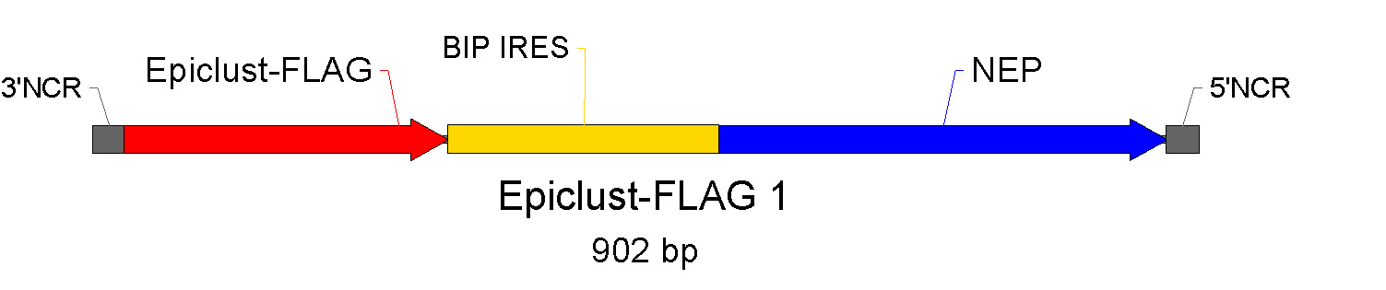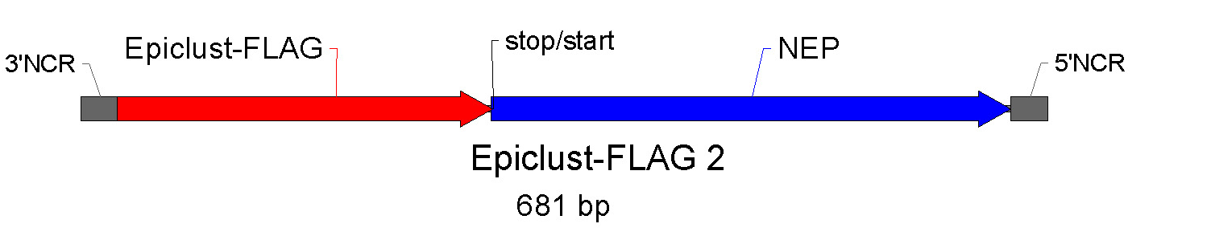

Fig.1: Epitope cluster strategy 1

In the original proposal it was planned to include another construct in which EPIclust is fused directly to the C-terminus of the whole NS2 via a protease (e.g. caspase) cleavage site. This was omitted based on literature evidence of stability problems (Kittel, Ferko et al. 2005). As an alternative, EPIclust-FLAG 4 was constructed. Since the group of Kawaoka showed that the NS1 and NS2 coding regions contain signals needed for vRNA packaging, with each about 30 nucleotides of the NS1 5’ end and the NS2 3’ end being sufficient for packaging of a model vRNA (Fujii, Fujii et al. 2005), EPIclust-FLAG 1 and 2 were redesigned to yield the constructs EPIclust-FLAG 6 and 5, respectively.

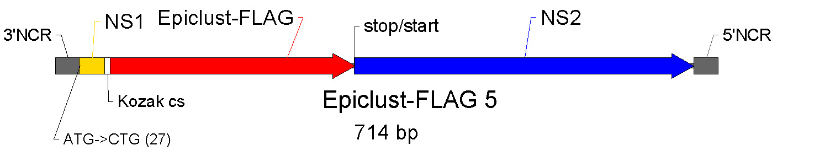

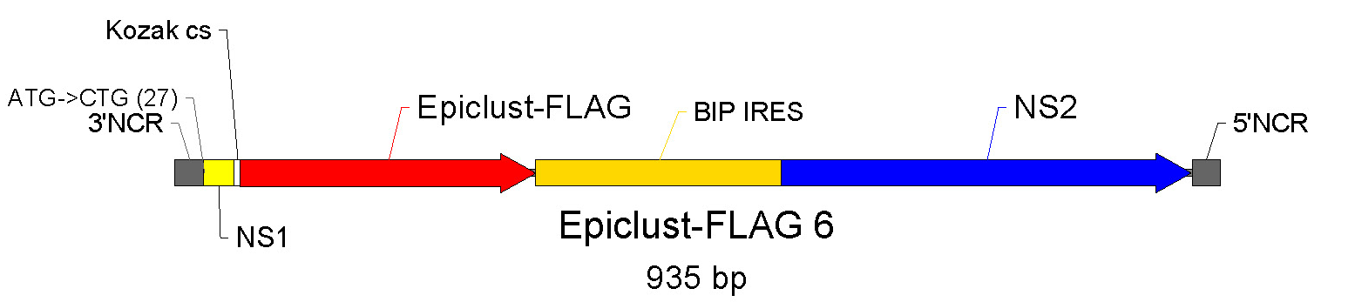

Fig.2: Epitope cluster strategy 2

In addition, a derivative of EPIclust-FLAG 4 was constructed in which the Stop/Start pentamer (TAATG) was replaced by the Bip IRES sequence (EPIclust-FLAG 7).

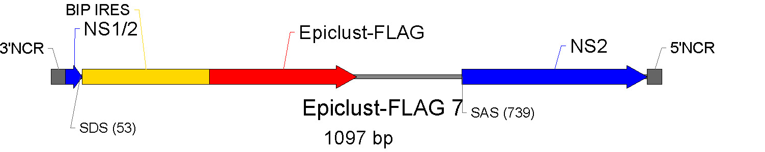

Fig. 3: Epitope cluster strategy 3

PR8 EPIclust-FLAG virus rescue and evaluation of NS2 and FLAG expression
PR8 plasmids along with the respective EPIclust-FLAG plasmid were transfected into Vero cells. Although several experiments were performed we were only able to rescue the EPIclust-FLAG 4 virus.
In parallel, Vero cells were transfected solely with the respective EPIclust-FLAG plasmid, and subsequently expression was analysed by immunoblot for NS2 as well as EPIclust-FLAG. FLAG expression levels were found to be significantly lower in cells transfected with construct 4 compared to the other constructs. This observation is in accordance with a paper published by Egorov and colleagues (Kittel, Ferko et al. 2005), and is due to the relatively low translation initiation efficacy of the stop/start pentamer.

Cloning and rescue of the Vero-adapted delNS1 virus GHB1056N
Since we were not successful in rescuing EPIclust virus 5, 6 and 7, we opted to further improve virus rescue. Therefore, all eight segments of a Vero-adapted delNS1 strain were cloned. As a source for the Vero-adapted segments we chose a PR8 delNS1 reassortant strain available in our lab that grows to titres of at least 10E7 pfu/ml (GHB1056N). This virus carries the HA and NA segments of the New Caledonia/20/99 strain which is currently recommended for H1N1 vaccine production by the WHO.
All cloned segments were sequenced and verified to be 100% identical to the virus they were derived from. Transfection of the eight GHB1056N plasmids into Vero cells clearly demonstrated a significant improvement in virus rescue. Already three days after transfection a strong cytopathic effect (CPE) was observed that was 100% on day four. The virus generated by this procedure grew to the same titres as its classically reassorted parent strain. These results strongly suggest that the cloned Vero-adapted segments should also be of advantage for rescuing the planned chimeric viruses.

Plasmid constructions with EGFP-Flag
Another cause for the failure to rescue EPIclust-FLAG 6 and 7 viruses might be the significantly higher EPIclust-FLAG expression levels found with the constructs 6 and 7 as compared to construct 4. Higher expression levels of the truncated neuraminidase in EPIclust might interfere with viral neuraminidase tetramer formation und thus virus release. To address this issue we replaced EPIclust-FLAG in constructs 4, 6 and 7 with EGFP which is assumed to be a neutral reporter protein. Construct 5 was omitted since NS2 expression from the stop/start pentamer is expected to be too low to allow virus rescue.
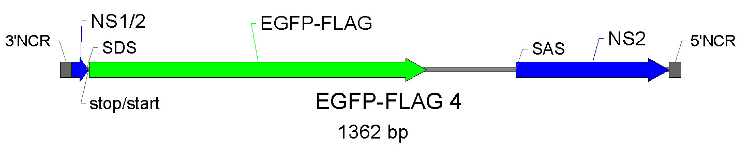

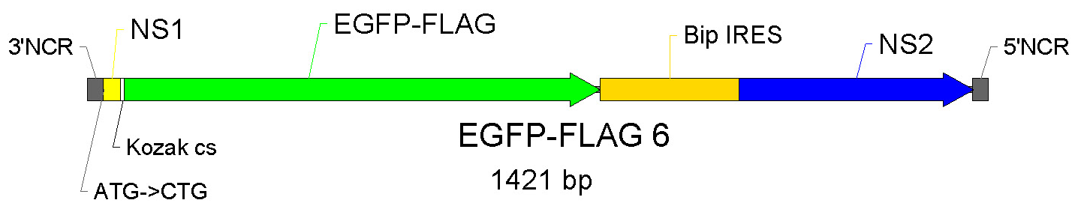

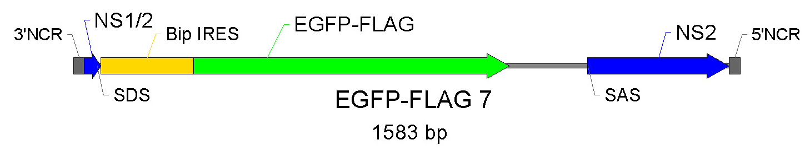

Fig.4: Epitope cluster strategy 4

Vero cells were transfected with seven GHB1056N or PR8 plasmids plus the respective EGPF plasmid. Fluorescence microscopy clearly demonstrated EGFP expression from all three constructs 24h after transfection (Fig.5). However, the corresponding EGFP viruses were not rescued.

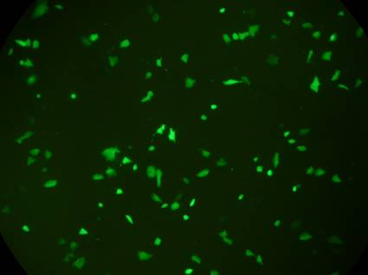
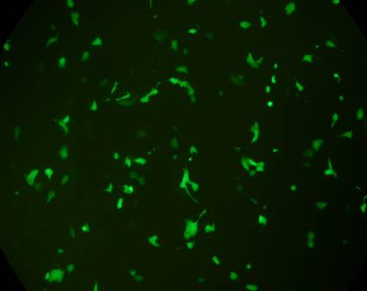
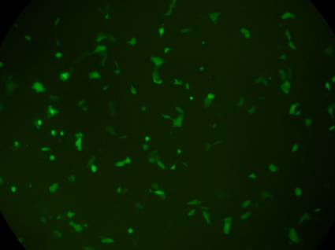

EGFP6
GHB1056N
EGFP7
EGFP4

Fig.5: EGFP expression after transfection

Optimization of the splice region of NEP mRNA for enhancement of virus rescue
One further obstacle in creation of influenza delNS1 vectors could be that suboptimal splicing of the NEP mRNA (coding for the second protein encoded by the NS genomic fragment) is affected by insertion of foreign sequences. In order to modulate the expression level of the NEP protein from the bicistronic NS segments we successively optimised the splice donor and acceptor sites. We were able to rescue a GHB1056N delNS1 virus that expresses EGFP at relatively high levels. The respective bicistronic delNS1 construct carries a strong synthetic splice acceptor site instead of the weak natural one. Upon serial virus passaging however EGFP expression was lost due to instability of the bicistronic segment. Deletions were found to occur in the EGFP open reading frame. Since stable EGFP expression from a bicistronic NS1-125 construct in the PR8 background was described in the literature, we evaluated this construct in the GHB1056N background. However, this bicistronic NS1-125 construct was found to be highly unstable. Therefore, we evaluated the influence of the genetic background on the bicistronic segment stability.

Further vector optimisation of vector
Since there are concerns that EGFP might be toxic for at least some host cells that might cause instability we decided to proceed with human interleukin-2 (IL-2) as a reporter gene. Besides being smaller than the EGFP (450 bp versus 750 bp), IL-2 is very unlikely to be toxic for Vero cells.
Careful optimisation of the 5’- and 3’-splicing sites in the chimeric delNS1-IL-2 segments allowed us to generate a novel delNS1 viruses in the GHB01 background that express high levels of IL-2 of >10ng/ml compared to 500 pg as reported in the literature. Our data indicate that IL-2 expression from these viruses is stable even upon serial passaging. Further optimisation might yield even higher expression levels of up to 100ng/ml. Therefore, the main aim of the WP has been met. Indeed, the resulting construct shows great potential and is currently in the process of being patented. Considering the results we obtained so far with IL-2-expressing delNS1 viruses it is now very likely that expression of other heterologous sequences (up to 450 bp) including the initially proposed epitope clusters can be reached.

Optimization of Vero transfection
Among the cell lines generally used for influenza virus production only Vero cells are recommended by the WHO. Furthermore, Vero cells are known to provide a good growth environment for the delNS1 mutant virus. Ideally, besides virus production also virus rescue has to be performed on Vero cells. In order to optimize this step, several methods were evaluated for their efficacy to transfect Vero cells. Liposomal reagents (Lipofectamine-2000, Fugene-6), a polycation (Exgen-500) as well as electroporation were used to transfect a beta-galactosidase-encoding reporter plasmid. Following in situ beta-galactosidase staining, the percentage of transfected cells was estimated. Electroporation, followed by Fugene-6 were by far the most efficient yielding up to 90% transfected cells.

Initially, it was planned to perform chimeric influenza virus rescue by means of a temperature sensitive helper virus (25A-1). Since the passage history of this virus strain is unknown, regulatory complications may preclude a later clinical use of the reassortant viruses. Therefore, we decided to generate the chimeric viruses entirely from plasmids. Basically, two systems have been described so far ,) the bidirectional plasmid system developed by Dr. Hoffmann in Prof. Webster’s lab being the more efficient.

Generation of PR 8delNS1 entirely from plasmids
The bidirectional PR8 wild-type virus plasmids (pHW2000 derivatives) were kindly provided by Dr. Erich Hoffmann. In order to evaluate delNS1 virus rescue entirely from plasmids, the delNS1 segment was cloned into the parental bidirectional plasmid pHW2000. Following cotransfection of all eight plasmids into Vero cells, a clear cytopathic effect (CPE) was observed after one passage of the initial cell supernatant on Vero cells (i.e. 5-6 days after transfection). The rescued virus grew to a titre of approximately 10⁶ pfu/ml. Thus we established the proof of principle that influenza A delNS1 virus generation entirely from cloned cDNA is possible. After further optimisation of this method, a standard operating procedure for fast generation of delNS1 viruses was established and delivered as D5 in reporting period (SOP: fast vector generation).

Deviations
The project plan aimed to develop an optimal vector which is capable of expressing foreign epitopes within six months of the project. This ambitious aim could not be achieved based on technical difficulties in vector development and instability of the obtained viruses.
Since the generation of such a chimeric vector is one important aim of the project and is important for both commercial and scientific reasons, the project partners agreed to extend the respective work package 2 within the predefined budget limits. As one consequence, this led to significant delays in several deliverables based on D4. However, at the end of the project not only the reverse genetics method was firmly established but also a stable expression vector based on delNS1 technology was obtained. This is a significant advancement in the field.

Output beyond the project
The delNS1 vector that was obtained in this project serves as a prototype expression vector for foreign antigens. From a scientific side, the optimisations that were done during the project were successful and led to an optimized and stable product. From a commercial standpoint, this virus is highly interesting as different antigens can now be inserted easily. In addition, based on advances in reverse genetics that were obtained in this project, novel viruses can now be generated by a standardized, fast and efficient method entirely from plasmids
To exploit these results further, a patent protecting the vector construct was prepared. Other target antigens of interest will be inserted and the resulting chimeric vaccines will be tested in suitable experimental systems.

Deliverables and Milestones

D4 | Optimised vector construct

A genetically stable vector was generated that expresses a foreign epitope.

D5 | Standard operating procedure for fast vector generation

A standard operations procedure for fast vector generation entirely from plasmids was developed and reported.

M2 | Optimised vector

Milestone fulfilled. As a main result, a stable delNS1 vector expressing IL-2 as a foreign antigen was developed that will be further used to express foreign antigens.

WP3 – Virus engineering of chimeric vaccine viruses

Work package number | 3 |  | Start month: 5 |  |  |  |  | End month: 30
Virus engineering of chimeric vaccine viruses
Participant id |  | GHB |  | MUW
Person-months per participant |  | 0,1 |  | 0

Lead contractor: GHB
Contributors: MUW

Objectives and starting point at the beginning of the project
Aim of this WP was to use reverse-genetics technology established in WP2 to obtain chimeric influenza vaccine virus candidates. In particular, avian influenza derived polypeptides, or human influenza derived polypeptides fused to the N-terminal part of the influenza neuraminidase were planned to be introduced into the genome of the influenza virus delNS1 virus vector.

Results
Expression of a model T-cell antigen into the NS1 open reading frame of the delNS1 construct
To characterize the immunogenicity of the delNS1 vaccines we pursued expression of a chimeric epitope in the NS1 open reading frame. Since the NS1 gene is a highly expressed cytoplasmic protein it might be specifically suitable for the expression of T-cell epitopes. A model T-cell antigen has been inserted in the NS1 open reading frame. NS1 was truncated to amino acids position 10, 80 and 124. The cytokine response induced by three different viruses in dendritic cells was tested and found to be comparable. All viruses induced significant higher levels of TNF and type I IFN as compared to wild type virus. We tested whether the chimeric viruses containing a NS1 truncation to 80 induced a cytotoxic T-cell response using HLA matched human monocyte derived dendritic cells as antigen presenting cells and HLA matched peripheral human T-cell for stimulation. A CTL response could be demonstrated using blood from three different subjects. The CTL response was approximately half as strong as the response to the viral M1-T-cell epitope. These experiments provide further data about the feasibility of expression of immunogenic epitopes in the delNS1 vector system in immunological terms.

Deviations
Based on the instability of early vector candidates generated in WP 2 and the need for further optimisation this WP was delayed. Therefore, it was essential to further optimize vector design as described in WP2. According to the original plan, an epitope cluster that was predicted purely by bioinformatics was supposed to be inserted in the vector backbone. We decided to substantiate results of bioinformatics by experimental evidence by GUF as described in WP1 and WP4. Essentially, a stable and efficient proof of concept virus expressing foreign epitopes was generated in WP2 (delNS1 IL-2) that is now the basis for insertion of experimentally validated epitopes.

Output beyond the project
Based on the vector generated in WP2 and the epitope selection in WP1 and WP4 now validated epitope clusters can be inserted into the model vector. This can be done only after the end of the project and will rely on strategic commitment of the consortium members.

Deliverables and Milestones

D6 | Three chimeric influenza vaccines containing antigenic polypeptides derived from circulating human influenza viruses
Will be finalized after the project end.

D7 | Three chimeric influenza vaccines containing antigenic polypeptides derived from consensus sequences of subtypes H1 and H3 and of type B
Will be finalized after the project end.

D8 | Three chimeric influenza vaccines containing antigenic polypeptides derived from avian influenza
Will be finalized after the project end.

M3 | Chimeric vaccine candidate viruses ready for tests in animal trials
Will be finalized after the project end.

WP4 – Evaluation of chimeric vaccine viruses in animals

Work package number | 4 |  | Start month: 7 |  |  |  |  | End month: after end of project
Evaluation of chimeric vaccine viruses in animals
Participant id |  | GHB |  | GUF | MUW | BioTest
Person-months per participant |  | 6 |  | 42 | 1 | 37,9

Lead contractor: GHB
Contributors: MUW, EMTEC, GUF, BioTest

Introduction
The aim of this work package is to use relevant animal models to assess the properties of novel modified influenza viruses such as delNS1 viruses and chimeric viruses. Animal trials should evaluate safety, tolerability, immunogenicity and protection efficacy of chimeric influenza vaccine viruses that are based on delNS1 technology. These trials in mice and ferrets should in also provide biological material for the assessment of immunological parameters by project partners GUF.

To better separate the tasks in this package, two sub-work packages to WP4 were introduced in RP1:

WP4.1 Vaccine candidates in animal trials.

WP4.2 Selection of immunogenic H5-derived peptides.

WP 4.1 Vaccine candidates in animal trials
Lead contractor: GHB
Contributors: BioTest, GUF

Objectives and starting point at the beginning of the project
At the beginning of this project, no experience using delNS1 vector systems in ferrets was available. Therefore, this package was aimed at to characterise the safety, tolerability, immunogenicity and protection efficacy profile of the delNS1 vectors in ferrets, to improve ferret facilities at BioTest and to gain experience to handle sensitive biological material such as vaccine viruses.

Results
Study plans were designed in a collaboration of GHB and BioTest. In life data were summarized by BioTest whereas the analytical part of these studies such as immunogenicity and TCID50 assays were conducted at GHB. Study reports were elaborated in a close cooperation of both partners and the summaries are presented below. For all studies, full reports are available.

Titration of Challenge virus
All ferrets were i.n. infected with Influenza A/New Caledonia/20/99. Application volume was 100µl/ferret, the dose for group 1 (low) was 1x10⁴ pfu/ml, for group 2 (intermediate) 1x10⁵,5 pfu/ml and for group 3 (high) 1x10⁷ pfu/ml. There were observed flu symptoms in all animals on day 2 and 3. Nasal washings were made, body weight and temperature was registered and symptoms were monitored. Between days 2-4 following infection the mean body temperature reached a maximum and influenza symptoms were seen in all animals. On day 10 health status of all animals was normal again.

Influenza virus challenge study
The animals of groups 2-5 were primed intranasally in light anaesthesia with priming virus GHB-479 (200 µl/ ferret) at three different dose levels: group 2 (low) 1 x 10⁴pfu/ ml, group 3 (intermediate) 1 x 10⁶ pfu/ ml, groups 4 and 5 (high) 1 x 10⁸ pfu/ ml. Application was performed with a sprayer. Animals of group 1 received PBS (200 µl/ ferret) intranasally as vehicle control. All animals were without pathological findings after priming. The day of priming is designated day 0 of the study.
All animals (group 1-5) were challenged intranasally on day 41 in light anaesthesia with influenza virus A/New Caledonia/20/99. Groups 1-4 received 1 x 10⁶ pfu/ ml and group 5 received 1 x 10⁴ pfu/ ml. Application volume was 100 µl/ ferret. Nasal washings were collected, serum samples withdrawn, body weight and temperature was registered and symptoms were monitored.
After the challenge, flu symptoms were observed from day 43 to 47 in group 1, on days 43 – 49 in group 2 and group 3, on days 43 – 46 in group 4 and on days 43 – 45 in group 5. On day 50 (the 9th day after infection) all animals were without pathological findings.

Influenza virus GHB – 1056N study in ferrets
The animals of groups 1-3 were infected intranasally in light anaesthesia with virus GHB-1056N (500 µl/ ferret) at three different dose levels: group 1 (high) 7.5 x 10⁷ pfu/ ferret, group 2 (intermediate) 7.5 x 10⁶ pfu/ ferret, group 3 (low) 7.5 x 10⁵ pfu/ ferret. Animals of group 4 (control) received influenza virus A/New Caledonia/20/99 (500 µl/ ferret i.n.) at 1.5 x 10⁵ pfu/ ferret. The day of infection is designated day 0 of the study.
Blood samples were taken and a protocol for nasal washings and total cell count were performed in accordance with a separate protocol (Preparation of nasal washings). Body weight and temperature was registered and symptoms were monitored. Only slight influenza symptoms were monitored after infection. The body temperature was without major deviations from the baseline temperature. The most considerable decrease of activity level of all animals was registered on day 1 and day 2, an obvious weigh decrease of a few animals was monitored on day 2, sneezing only in 2 animals in days 1-2 and one female (20F/1) in days 1-6, and nasal discharge in 4 animals in days 2-3. From day 7 all animals were without pathological findings. Histopathological analysis was performed.

Influenza virus challenge study of plasmid derived virus
This deliverable was introduced during the RP2.
The aim of this study was to evaluate the immunogenicity, protection efficacy and safety of the vaccine strain GHB01NC (a H1N1 influenza virus whose genome composition consist of genes encoding HA and NA derived from the epidemic A/New Caledonia/20/99 –H1N1 and remaining genes are from the standard IVR-116 “master” vaccine virus) which was derived entirely by reverse genetics. The virus preparation used was bulk harvest in OptiPro medium.
Three groups of seronegative (HAI <10) ferrets (N=4) received intranasal applications of 0.5ml of either 1.0 x 10E⁷, 1.0 x 10E⁶ or 1.0 x 10E⁵ pfu/ferret of GHB01NC(H1N1). Three additional groups of animals (N=4) received IVR-116 wild-type virus at the same dose levels and via the same route of application for comparison. Ferrets were challenged intranasally with 1.0 x 10E⁶ pfu/ferret of wild-type IVR-116 virus 28 days following immunisation.
Throughout the course of the study ferrets were monitored daily for body weight, body temperature and clinical symptoms of influenza infection (sneezing, nasal discharge, decreased activity). Blood samples were collected 21 days following immunisation and the virus-specific immune response was evaluated by HAI and microneutralization assays (MNA). Nasal washings were performed at days 1 and 2 following challenge. Virus titres in nasal wash samples were determined by the TCID₅₀ assay. Histopathology was performed on all animals at the end of the study.

Clinical symptoms
No fever reactions (>39°C of daily means) were recorded in animals immunised i.n. with different doses of GHB01NC(H1N1) (Fig. 6, days 0-5).
Ferrets receiving GHB01NC(H1N1) showed only mild symptoms e.g. traces of serous nasal discharge. Sneezing was observed in one ferret of the highest dose group. In contrast, in animals treated with the wild-type virus at the higher dose levels (10E⁷, 10E⁶) moderate to severe clinical symptoms e.g. the presence of mucopurulent nasal discharge, accompanied with decreased activity and sneezing following immunisation were observed.
These finding emphasize the safety of delNS1 vaccine viruses in doses as high as 1x10E⁷ pfu/ferret.

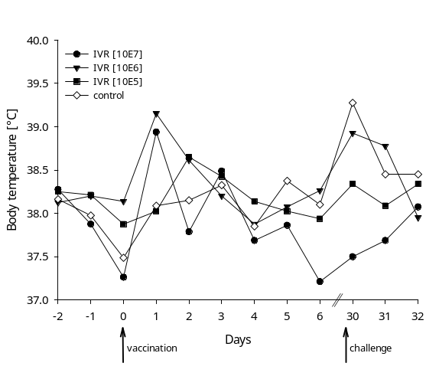

Fig. 6. Mean body temperatures of ferrets treated with wt virus
Mean body temperatures of ferrets immunised i.n. with either 1.0 x 10E⁷, 1.0 x 10E⁶ or 1.0 x 10E⁵ pfu/ferret of IVR-116 or PBS. At day 28 after immunisation the ferrets were challenged by intranasal application of 1 x 10E⁶ pfu/ferret of IVR-116 wild-type virus.

Virus re-isolations
In order to investigate the load of challenge virus in nasal wash samples of ferrets 1 and 2 days post challenge, virus re-isolation was evaluated by TCID₅₀ assay on MDCK cells. 24 hrs post challenge TCID50 titres ranged between 10E³ and 10E⁵/ml in all dose groups of the GHB01NC(H1N1) virus and PBS, and no titres were found in the group treated with IVR-116 (data not shown). 48 hrs post challenge the TCID₅₀ titres isolated from ferrets treated with PBS were in the range of 10E⁴/ml.

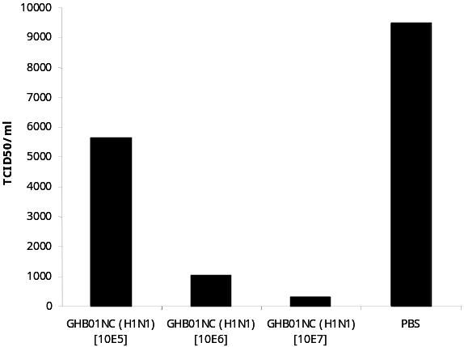

Fig. 7: Geometric mean TCID50 titres in nasal wash samples
GM TCID₅₀ titres of the viral load determined in nasal wash samples two days after the ferrets immunised with either 1.0 x 10E⁷, 1.0 x 10E⁶ or 1.0 x 10E⁵ TCID₅₀/ferret of the GHB01NC(H1N1) virus or PBS were challenged with IVR-116

Protection
In the intermediate (10E⁶) and low doses (10E⁵) of vaccine virus a temperature increase above 39°C could be noted after challenge with wild-type. In contrast, the mean body temperature in ferrets immunised with the highest GHB01NC(H1N1) vaccine dose (10E⁷) was not elevated, thus demonstrating a protective effect in the highest treatment group. Reduction in viral load in nasal washings after wild-type challenge correlated with absence/reduction of severe symptoms such as mucopurulent discharge and fever.

Immune response
HAI titres of serum samples collected 21 days following immunisation were <10 for all ferrets receiving GHB01NC(H1N1) while the titres of ferrets receiving IVR-116 ranged between 40 and 640 (GMT 226.7). In addition, all sera tested in the HAI assay were also evaluated for neutralizing antibodies by MNA. In this assay titres of neutralizing antibodies were detected in serum samples of ferrets receiving the highest dose level of GHB01NC(H1N1) (MNA titres ranged from 10 to 80, GMT 28.3).

Histopathology
No pathological findings connected to the virus administration were detected in ferrets immunized with the GHB01NC(H1N1) virus.

Conclusion
Results demonstrate the protective efficacy of the GHB01NC(H1N1) virus against wild-type virus challenge with best protection in animals vaccinated with 1 x 10E⁷ pfu/ferret. The results further confirm that the virus is well tolerated and safe since no gross-pathological findings, fever and only occasional short lived mild clinical symptoms (sneezing and traces of serous nasal discharge) could be observed following the primary immunization. These experiments strongly support the further development of the proposed chimeric vaccine.

Evaluation of immunogenicity, protection and shedding in ferrets immunized with the GHB01L1 vaccine virus candidate (Study No 411/06)
This deliverable was introduced during the RP2.
Seronegative (HAI <10) ferrets received i.n. 0.52 ml of 1.0 x 10E⁸ or 1.0 x 10E⁷ TCID₅₀/ ferret of GHB01L1 (N=12 for day 1-5, first viral load testing was performed at day 5, N=6 for sacrifice at the end of the study). As a control ferrets received 1.0 x 10E⁵ TCID₅₀/ferret of IVR-116 (N=6) in the absence of anaesthesia. The control group of animals (N=8) consisted of animals immunized i.n. with the vehicle (SPG). Blood samples were collected before and than 3 days as well as 21 days following immunization to perform standard serological evaluations. Nasal washes were collected 5 days before and then 2, 4, 6 and 21 days post priming to evaluate virus load and mucosal immune response in respiratory secretions. Four and 8 days following priming a selected proportion of immunized animals has been sacrificed and gross pathological examined (evaluation ongoing). Tissue samples were collected from brain, lung and, nasal mucosa to identify virus load in the sensitive tissues.
21 days p.i. all ferrets were challenged intranasally under slight sedation with the replicating 1.0 x 10E⁵ pfu/ferret of IVR-116 virus. Nasal washings were performed at days 1, 3, 5 and 7 following challenge and virus titres in nasal wash samples were determined by the TCID₅₀ assay. Throughout the course of the study ferrets were monitored daily for body weight, body temperature and clinical symptoms of influenza infection (sneezing, nasal discharge, activity level).

Clinical symptoms
No sneezing, decreased level of activity or rise in body temperature could be determined in ferrets primed i.n. with either of the dose of GHB01L1 virus at any time point monitored p.i. (Fig. 8). The only clinical finding observed was the presence of weak serous discharge traces on the nose restricted to days 2 and 3 p.i. in the group of ferrets receiving 1x10E⁸ TCID₅₀/ferret of GHB01L1 vaccine virus and at day 2 p.i. only in ferrets receiving the lower dose (1x10⁷ TCID₅₀/ferret). Moreover, no virus could be re-isolated from the nasal wash samples collected at days 2, 4, 6 and 8 p.i. or tissue extracts derived from nasal turbinate, lungs or brain collected at days 4 and 8 p.i. (data not shown).

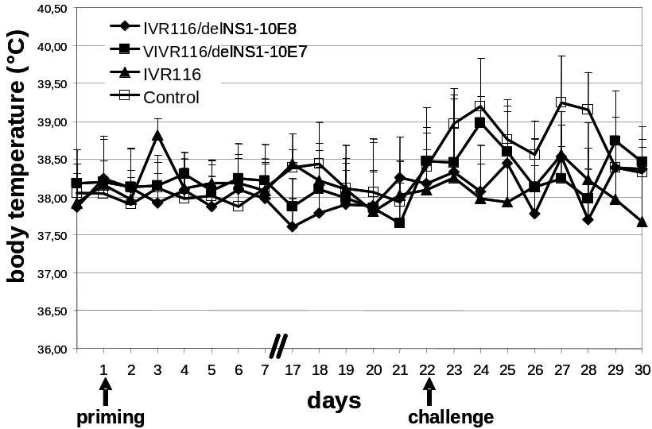

Fig. 8: Mean body temperatures of ferrets immunised i.n. with either 1.0x10E⁸, 1.0x10E⁷ TCID₅₀/ferret of GHB01L1, 1.0x10E⁵ TCID₅₀/ferret of IVR-116 and SPG (control). At day 21 after immunization ferrets were challenged by intranasal application of 1x10E⁵ TCID₅₀/ferret of IVR-116 wild-type virus. Shown are daily means (two temperature measurements per day) plus standard deviations.

In contrast, animals immunized i.n. with the replicating IVR-116 virus revealed an mean increase of body temperature of almost 1°C (Fig. 8) at day 2 p.i.; an increased level of activity (max. mean level of activity observed at days 3-5). Sneezing and the presence of mucopurulent nasal discharge starting at day 2 p.i. were observed in all immunized animals of this group.

Immunogenicity
The dose-dependent effect of the GHB01L1 virus vaccine in inducing an immune response in ferrets was shown in the HAI assay, MNA and ELISA. Increasing antibody titres could be observed in all three assays performed (HAI: GMT 34.82; MNA: GMT 95.14; ELISA: GMT 158.74):
HAI titres of serum samples collected 21 days following immunisation ranged between <10 and 40 (GMT 34.82) for ferrets receiving the high dose of GHB01L1 while the titres of ferrets receiving IVR-116 ranged between 640 and 1280 (GMT 718.38). No serum antibody titres could be detected in ferrets immunised with the low dose of GHB01L1 virus or SPG.
In addition, all sera tested in the HAI assay were also evaluated for neutralizing antibodies by MNA. In this assay titres of neutralizing antibodies were detected in serum samples of ferrets receiving the high dose level of GHB01L1 (MNA titres ranged from <10 to 160, GMT 95.14) but no serum antibody titres could be detected in ferrets receiving 1 x 10E⁷ TCID50/ml of GHB01L1. All ferrets primed with the IVR-116 wild-type virus developed MNA titres of 1280.
Furthermore, IgG and IgA antibody levels were determined: Antibodies contained in ferret serum and nasal washing were obtained prior to immunization with the GHB01L1 virus antigen and then at study day 21. Reactivity of antibodies was evaluated by ELISA. Specific binding was determined in ferret serum samples of the high dose group 1 (range < 100 – 800) and group 3 immunized with the replicating IVR-116 wild-type virus (range 200-12800). Due to high unspecific background reaction no virus specific IgA could be determined in the nasal washings of any of the immunization groups of ferrets.
Although a dose of 1 x 10E⁸ TCID₅₀/ferret of GHB01L1 did not reach the serum antibody titres induced by immunization with the replicating IVR-116 wild-type virus (HAI GMT 718.38; MNA GMT 1280; ELISA GMT 4525.5), this observation is consistent with previous findings (study no. 428/05 and 001/06/L).

Protection
To compare the efficacy of the GHB01L1 virus and the IVR-116 wild-type virus in inhibiting virus replication in the upper respiratory tract, nasal washings were collected on day 1, 3, 5 and 7 after challenge with 1 x 10E⁵ TCID₅₀/ferret of IVR-116. Unvaccinated control animals shed challenge virus from day 1 to 7, whereas immunization with the IVR-116 wild-type virus completely inhibited virus replication after 3 days. A high dose of GHB01L1 reduced the number of ferrets with detectable challenge virus on day 3 to 1 of 6 and no challenge virus could be detected after that time point. Ferrets that received the lower dose of GHB01L1 shed challenge virus until day 5.

Following challenge, body temperature was elevated at day 2 p.i. (>+1°C) in ferrets primed with the low dose (10E⁷ TCID₅₀/ferret) and in control animals at days 2, 5 and 6 following the IVR-116 virus challenge. Despite of the short fever peak animals immunized with the low dose of the GHB01L1 virus were protected against typical disease symptoms e.g. the occurrence of mucopurulent nasal discharge and decreased level of animal activity. Mucopurulent nasal discharge and decreased level of activity was detected only in unprotected control animals, whereas ferrets primed with both dose levels of GHB01L1 or the replicating IVR-116 exhibited only traces of serous nasal discharge. Occasional sneezing was observed in individual animals in all immunization groups. However the highest frequency and duration of sneezing was noted in control animals (data not shown).
The challenge virus could be recovered from nasal wash samples collected one day post challenge in each group of immunized animals. But in contrast to unprotected control ferrets still shedding high amounts of virus 7 days post challenge, challenge virus was cleared from the respiratory secretion at day 3 in IVR-116 primed animals and day 5 in ferrets immunized with the high dose (10E⁸ TCID₅₀/ferret) and day 7 in ferrets immunized with the low dose of GHB01L1 virus.

Shedding
To determine whether replication of the GHB01L1 virus occurs in the ferret, tissue samples were taken on day 5 and 9 after immunization and analysed in the TCID₅₀ assay. No virus could be detected in tissue homogenates from lung, brain and nasal mucosa. In addition, nasal washings collected at day 2, 4, 6 and 8 from ferrets immunized with the GHB01L1 virus were analysed for virus replication in the upper respiratory tract and again no virus could be rescued.

Conclusion
In conclusion, this trial showed that the GHB01L1 vaccine virus does not induce fever, nor any severe clinical symptoms, behavioural changes or vaccine virus shedding. Animals immunized with the high dose (10E⁸/ferret) of the GHB01L1 are protected from body temperature elevations, decreased level of activity and induction of mucopurulent nasal discharges in a comparable manner as animals primed with the replicating IVR-116 virus following the challenge infection (10E⁵ TCID₅₀/ferret of the replicating IVR-116 virus). Challenge virus infection in these animals could be significantly reduced at day 3 and completely cleared from respiratory secretions at day 5 post challenge. Interestingly, ferrets primed i.n. with the lower dose (10E⁷ TCID₅₀/ferret) of GHB01L1 were not protected from a short-lived rise in mean body temperature but were protected from disease symptom manifestation and could efficiently clear the challenge virus from respiratory secretions seven days after the challenge infection. These data indicate that despite a suboptimal systemic antibody response ferrets immunized with the GHB01L1 vaccine are protected from influenza disease symptoms following the challenge infection, thus further supporting the concept of the chimeric vaccine approach.

Generation of selected H5 short polypeptide-specific polyclonal sera in rabbits
The immunizations of rabbits with KLH-coupled peptides were performed by BioTest (Study Nr. 410/ 06 “Generation of selected H5 short polypeptide-specific polyclonal sera in rabbits”)
In brief, peptide-KLH complexes were mixed with incomplete Freund’s adjuvant and the suspensions were administered by i.m. and s.c. route to rabbits. Four immunizations with intervals of about three weeks between immunizations were performed (2 rabbits/peptide). Serum samples were collected after the 2nd immunization and the final bleed was performed 11 days after the fourth immunization. Serum samples (baseline samples and samples after 2nd and 4th immunization) were immediately frozen and transmitted via a courier service to GHB for further assaying. GHB performed a microneutralization assay adapted to Vero cells (WHO) to determine the neutralizing properties of rabbit antisera. Genetically modified influenza H5N1 reassortant viruses of different antigenic clades or subclades were included into the assay as viral antigens. These delNS1 viruses are reassortants (6/2 variants available) where the surface glycoproteins (HA and NA) originate from following human H5N1 virus isolates:
The remaining six internal genes are derived from the IVR-116 influenza virus strain (PR8-like genome. Thus, the HA sequence of those reassortant viruses corresponds to those of the w.t. parent virus except the targeted genetic modification performed in the cleavage site (no peptide for immunization spanned this area) in order to attenuate the virus.
For simplicity, the H5N1 reassortant viruses are referred as A/VN-IVR (6/2); A/HK-IVR (6/2) and A/Ind-IVR (6/2). Neutralizing titres determined by the MNA assay on Vero cells are summarized in table 1.

Peptide ID | Animal No. | Reciprocal endpoint titre* |  |  | Peptide ID | Animal No. | Reciprocal endpoint titre
Peptide ID | Animal No. | A/HK-IVR (6/2)) | A/VN-IVR (6/2) | A/Ind-IVR (6/2) | Peptide ID | Animal No. | A/HK-IVR (6/2)) | A/VN-IVR (6/2) | A/Ind-IVR (6/2)
Avian1 | 1 | 10 | 10 | 20 | Avian7 | 1 | 10 | 10 | 20
 | 2 | 10 | <10 | 10 |  | 2 | 10 | <10 | 10
Avian2 | 1 | 20 | <10 | 10 | Avian8 | 1 | 20 | 10 | 20
 | 2 | 10 | <10 | 10 |  | 2 | <10 | 10 | <10
Avian3 | 1 | <10 | <10 | <10 | Avian9 | 1 | <10 | <10 | 10
 | 2 | 20 | <10 | 10 |  | 2 | <10 | <10 | 10
Avian4 | 1 | 10 | <10 | 10 | Avian10 | 1 | 10 | 10 | 10
 | 2 | 20 | <10 | 10 |  | 2 | <10 | <10 | <10
Avian5 | 1 | <10 | 10 | <10 | Avian11 | 1 | 20 | 10 | 20
 | 2 | 20 | <10 | 10 |  | 2 | 40 | 10 | 10
Avian6 | 1 | <10 | <10 | 20
 | 2 | 10 | 10 | 20
*The cut-off for the determination of neutralizing endpoint titres was calculated following the equation
(average of OD480nm value of virus infected wells - average of OD490 values of empty cell control wells/2) - average of OD490 values of empty cell control wells.
The neutralizing endpoint titres are expressed as reciprocal of highest serum dilution with OD < cut off.

Table 1. The neutralizing endpoint titres of H5-peptide -specific rabbit antisera

As shown in Table 1 we were able to determine neutralizing activity in sera of rabbit immunized with the selected H5 peptides. The baseline serum samples were always l<10. Neutralizing titres of 20 and 40 are therefore considered as promising values to be confirmed in MNA using w.t. H5N1 viruses.

Peptides with the best neutralizing activity (e.g. avian11, avian 6) were selected for further approaches to develop a potent peptide based vaccine or may serve as candidates for the inclusion in the delNS1 expression system of the influenza virus vector.

Deviations
A main deviation was that instead of the final vector containing epitopes the prototype vector was used for evaluation in animal experiments. However, the output of this WP is clearly highly valuable as in several studies the safety and immunogenicity of delNS1 vaccines was demonstrated for the first time. This is a strong support to the concept of the whole project.

Output beyond the project
The results obtained in this WP are used to demonstrate the feasibility of delNS1 vaccines. Clearly, the early animal experiments in this project were instrumental to enhance the knowledge both in handling ferrets and viruses, to develop sample handling and sample analysis in standardized assays and finally, to demonstrate safety and to clearly show a protective efficacy of delNS1 vaccines.
Based on the experimental work carried out in this work package, several follow-up projects were started, both within the framework of the EC and outside. GHB brought a similar delNS1 vaccine into a clinical trial that started in Spring 2007.

Deliverables and Milestones

D11.2 | Challenge Study in Ferrets
This deliverable was introduced during the RP2. Completed.

D11.3 | Evaluation of immunogenicity, protection and shedding in ferrets immunized with the GHB01L1 vaccine virus candidate (Study No 411/06)
This deliverable was introduced during the RP2. Completed.

M4 | Characterized chimeric vaccine candidates: definition of the immunogenic properties of tested chimeric vaccine virus variants

Proof of concept in animals has been provided regarding the immunogenic and protective properties of delNS1 viruses. The antigenic potential of epitopes was assessed separately.
WP4.2 Selection of immunogenic H5-derived peptides.

Objectives and starting point at the beginning of the project
At the beginning of the project, only limited literature evidence covering the antigenicity of certain influenza strains was available. A main task was to define broadly cross-protective epitopes.

Results

Immunogenicity:
In order to select broadly-cross-protective, conserved, frequent and antigenic peptide sequences derived from the hemagglutinin sequences of human H5N1 virus bioinformatic methods were used (Emtech, WP1). To verify the antigenicity of predicted B-cell epitopes a set of peptides was subjected to analysis with reference sera.
Following epitopes from the prediction of Emtech (WP1) were sent to GUF in form of biotinylated peptides (CMO Mimotopes, Australia):
27 H1N1 peptides (A/New Caledonia/20/99)
25 H3N2 peptides (A/New York/55/2004)
21 Influenza B peptides (B/Jiangsu/10/2003)
23 H5N1 peptides (A/VietNam/1203/2004)

These peptides were tested on their immunogenicity in ELISA and neutralisation blocking assays.
Specifically, the ELISA, the neutralization assay and neutralization blocking assay, and a cytotoxic assay for the identification of immunodominant epitopes was established. Work procedures of all assays were validated according to GLP-recommendations to ensure proper quality and documentation standards for downstream clinical trials.
To identify the immunogenicity of the different epitopes we performed ELISA assays with sheep reference sera from NIBSC, United Kingdom, against A/New Caledonia/20/99 (H1N1), A/New York/55/2004 (H3N2) and B/Jiangsu/10/2003 (Fig. 9-11). The reference sera reacted very specific to the epitopes of the respective virus but they also showed cross reactivity to peptides from the other viruses

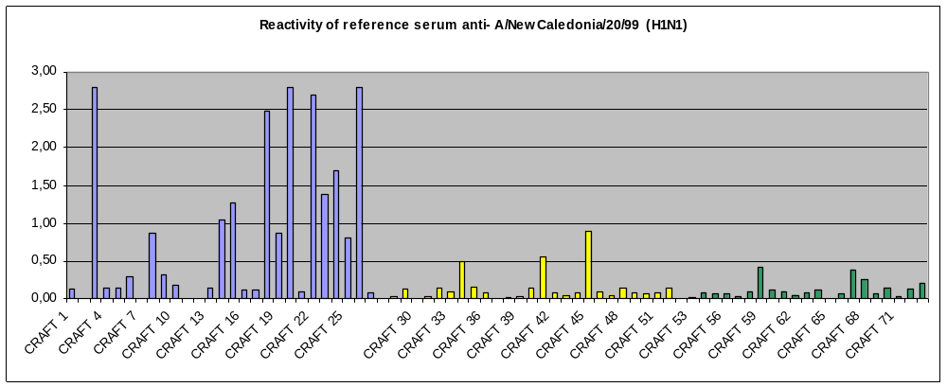Fig. 9: Results of peptide screening with reference serum anti-A/New Caledonia/20/99 (H1N1). OD450 values against the H1N1 peptides are indicated in blue, against the H3N2 peptides in yellow and against the B peptides are indicated in green.
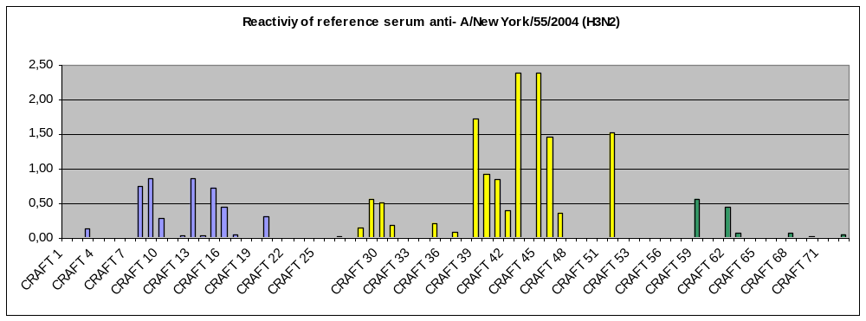
Fig. 10: Results of peptide screening with reference serum anti- A/New York/55/2004 (H3N2).
OD450 values against the H1N1 peptides are indicated in blue, against the H3N2 peptides in yellow and against the B peptides are indicated in green.

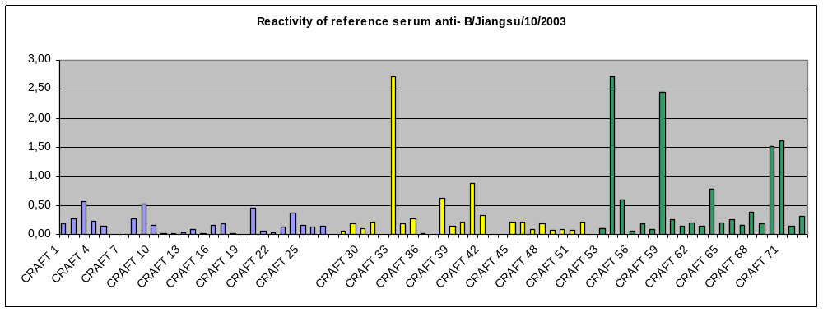
Fig. 11: Results of peptide screening with reference serum anti- B/Jiangsu/10/2003.
OD450 values against the H1N1 peptides are indicated in blue, against the H3N2 peptides in yellow and against the B peptides are indicated in green.

To identify the immunogenicity of the avian influenza epitopes from A/Vietnam/1203/ 2004 we performed ELISA assays with sheep reference sera from NIBSC, UK, against:
-A/New Caledonia/20/99 (H1N1)
-A/New York/55/2004 (H3N2) and
-B/Jiangsu/10/2003.
Results are presented in Fig. 12 below.
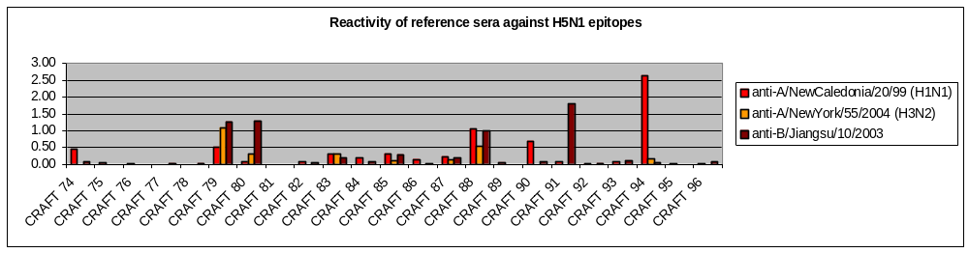

Fig 12: Results of peptide screening with reference serum anti- B/Jiangsu/10/2003.
The OD450 values of anti-A/New Caledonia/20/99 (H1N1) are indicated in red, of anti- A/New York/55/2004 (H3N2) are indicated in orange and of anti-B/Jiangsu/10/2003 are indicated in brown.

All peptides were also screened in ELISA with antiserum against NIBRG-14. This is a reassortant virus composed from Hemagglutinin of A/Vietnam/1194/2004 (H5N1) in which the polybasic HA cleavage site has been excised and inserted into an A/PR/8/34 (H1N1) virus backbone. These results are presented in Fig. 12A.

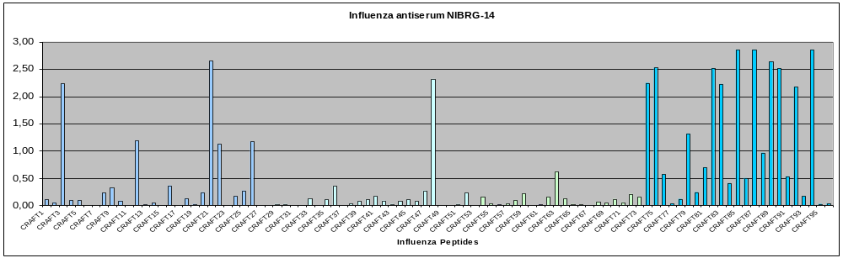

A/New Caledonia/20/99 (H1N1) peptides
A/New York/55/2004
(H3N2) peptides
B/Jiangsu/10/2003
peptides
A/VietNam/1203/2004
(H5N1) peptides

Fig. 12A: Results of peptide screening with reference serum anti- NIBRG-14.
The reference serum reacted very specific to many identified epitopes of the A/VietNam/1203/2004 but it also showed cross reactivity to peptides from H1N1, H3N2 and B influenza viruses.
Responses >0,5 OD450 value were measured against following peptides:
CRAFT 3, 12, 21, 22 and 26 of A/New Caledonia/20/99
CRAFT 48 of A/New York/55/2004 and
CRAFT 63 of B/Jiangsu/10/2003.

The reference serum anti-NIBRG-14 was tested against A/Thailand/1(KAN-1)/H5N1, Influenza A/VietNam/1203/2004 (H5N1), the respective reassortant virus NIBRG-14, Influenza A/HongKong/213/2003 (H5N1), the respective reassortant NIBRG-12 and Influenza A/VietNam/1194/2004 (H5N1). The neutralisation titres against all these viruses were ≥ 1:1280.
We also tested sera of human patients with and without antibodies against H1N1 against H5N1. We could not observe any neutralisation capacity of human patients’ sera (8 sera with and 5 sera without antibodies against Influenza A H1N1) against Influenza A/Thailand/1(KAN-1)/H5N1.

Selected peptides were then synthesized, coupled to KLH (GHB) and rabbit immunogenicity studies were performed at BioTest. Subsequently, GHB evaluated the rabbit sera for neutralizing activity directed against H5N1 viruses of different classes. Promising peptide sequences were re-tested and selected for vector inclusion and/or considered as candidates of peptide based cross-protective influenza vaccine candidates. Sera from animals immunized with selected H5 peptides (sera are described under D11.4) were tested on their specific binding capacity on the respective peptide in ELISA assay. The results are shown in Fig. 13.

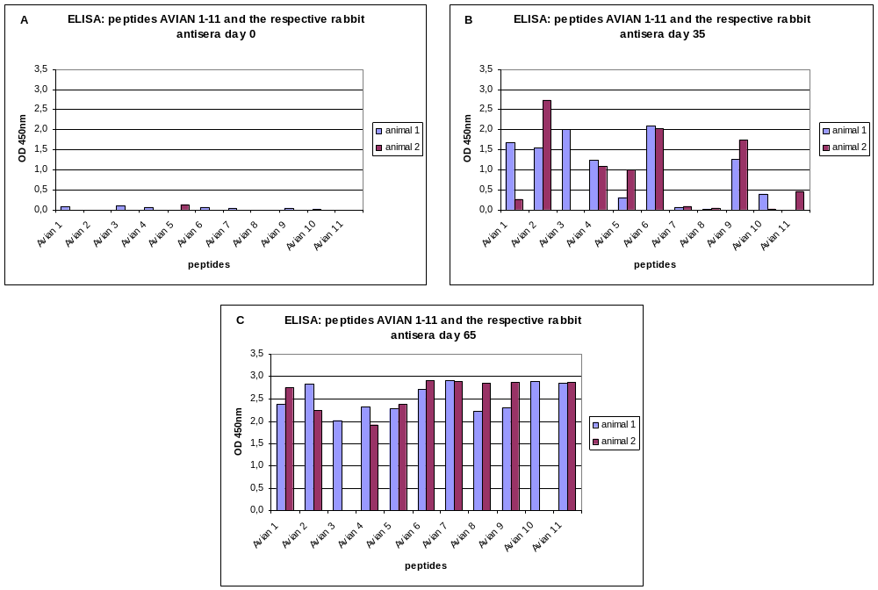

Fig. 13: Each serum from H5 peptide immunized rabbits was tested against all peptides in ELISA assay. Only the results of sera against their immunization peptides are shown (only one rabbit sera was tested against peptide Avian 3 of d0, d35, d65 and peptide Avian10 of d65).
A: pre-immunization sera - no response against any peptide; B: 35 days post-immunization – specific responses of some immunization sera; C: 65 days post-immunization – specific responses of all immunization sera.
The rabbit sera showed no cross reactivity against any peptide before immunization. The response increased from day 35 to day 65 after immunization. Also after immunization the sera showed no cross reactivity against all other peptides (data not shown).

To determine neutralizing properties of the rabbit antisera GUF performed a microneutralization assay on Vero cells. H5N1 wild type viruses (A/Thailand/(Kan-1)/H5N1 and A/VietNam1203/04) were used as viral antigens. The results of microneutralization assay are shown in Table 2.

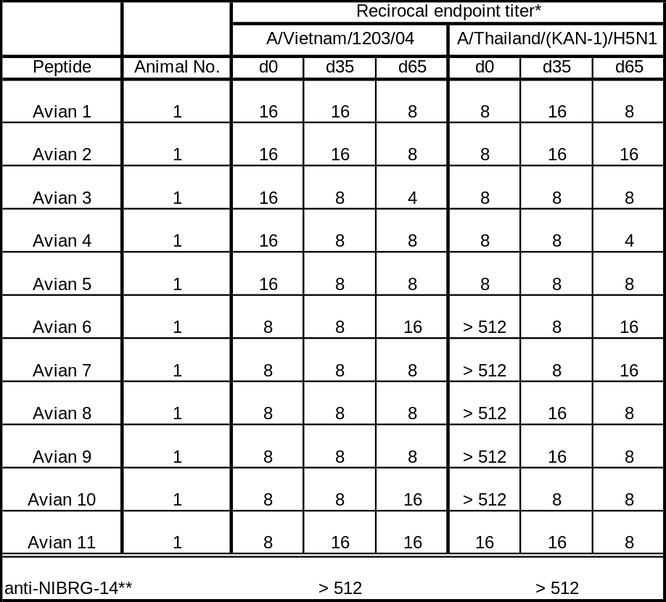

Table 2. The neutralizing endpoint titres of H5-peptide -specific rabbit antisera against wild type viruses Influenza A/VietNam/1203/04 and Influenza A/Thailand/(Kan-1)/H5N1

*The cut off for the determination of neutralizing endpoint titres was calculated following the equation:
(average of OD450nm value of virus infected wells - average of OD450 values of empty cell control wells/2) - average of OD450 values of empty cell control wells. The neutralizing endpoint titres are expressed as reciprocal of highest serum dilution with OD < cut off.
**Anti-NIBRG-14: Influenza anti A/VietNam/1194/04 (NIBRG-14) HA Serum (sheep SH440&SH442).

We were not able to determine any detectable specific neutralizing activity by sera of rabbits immunized with the selected H5 peptides (table 2) against wild type viruses Influenza A/VietNam/1203/04 and Influenza A/Thailand/(Kan-1)/H5N1. This is in contrast to results from neutralizing experiments performed with reassortant viruses from A/Vietnam/1204/04 clade 1 (represents the prototype sequence), A/HongKong/156/97 clade 2 (subclade3) and A/Indonesia/5/05 clade 2 (subclade 1).

Deviations
Slight deviations were based on technical problems (e.g., a defective peptide delivery with wrong labels leading to resynthesis and time delay) and reagents such as highly pathogenic virus strains that were unavailable at that time. However, all issues could be solved within the project.

Output beyond the project
Results of the epitope selection procedure were published on scientific meetings and will be published in adequate scientific journals after IP issues have been clarified.

Deliverables and Milestones

D9 | Immunogenicity and efficacy data of chimeric influenza vaccine (human influenza)
Test methods were set up and evaluated.

D10 | Immunogenicity and efficacy data of Del NS1 influenza vaccine (consensus sequences)
D10 was reported in RP1.

D10.1 | Immunogenicity and efficacy data of chimeric influenza vaccine (consensus sequences)
Test methods were set up and evaluated.

D11 | Immunogenicity and efficacy data of chimeric influenza vaccine (avian influenza)
Test methods were set up and evaluated.

D11.1 | Immunogenicity and efficacy data of selected epitopes (avian influenza)
The most promising peptides were used for immunisation of rabbits. Sera from these rabbits were used in microneutralisation tests.

WP5 – Vaccine production process development

Work package number | 5 |  | Start month: 13 |  |  |  |  | End month: after end of project
Vaccine production process development
Participant id |  | GHB |  | Biasep
Person-months per participant |  | 6,2 |  | 38,9

Lead contractor: Biasep
Contributors: GHB, Biasep, Subcontractor

Objectives and starting point at the beginning of the project
The objective of WP5 “Vaccine production process development” was to establish a cGMP production and purification process for influenza vaccines.

Results
Specifically, in this project following steps were carried out under the current project:
- A GMP master cell bank was generated at the subcontractor Bioreliance.
- Subsequently, it was decided to continue a Tech Transfer from GHB to subcontractor Henogen, (preparations to enter GMP facility, SOPs, QC of Vero cell bank, optimisation and approval).
- In addition, a GMP master virus seed stock was prepared.
- Other steps in establishing the production under GMP conditions were financed by GHB and other projects.

Production
In this work package GHB has developed a cGMP production process for production and purification of chimeric influenza vaccines. This is achieved by combining the expertise in influenza virus fermentation of GHB with cGMP production knowledge of contract manufacturers Bioreliance and Henogen, and the know-how in virus purification of Biasep.
For the fulfilment of this work package, two subcontractors were assigned. Bioreliance was used for the generation of the master cell bank. The master virus stock was done at Henogen. Henogen additionally contributed on the establishment of the virus production process.

Master cell bank, master virus stock (Contract manufacturer)
Establishing a Master Cell Bank (MCB) and a Working Cell Bank (WCB) are the first steps in the manufacturing process for biopharmaceuticals. This was performed in collaboration of GHB with a contract manufacturer, Bioreliance. Production of the cell bank was carried out under current Good Manufacturing Practices (cGMP) in a validated facility. The whole process was fully documented. The cell banks assure that an adequate supply of equivalent cells exist for production of a vaccine.
In parallel, a master virus seed stock was made according to cGMP procedures at Henogen. This vaccine serves the purpose to establish and optimize both the production and the purification process. All methods will be used for further vaccines based on delNS1 technology as these vaccines should behave similarly in tissue culture and in purification.

Production Method development
GHB developed and delivered a production method for influenza virus. Briefly, cells are thawn from the master cell bank and expanded in a batch size of 15 CF10 tissue culture flasks. Subsequently, cells are infected with a multiplicity of infection 0.002 and incubation for 2 d. Virus is harvested, pooled and subjected to clearance filtration. Removal of DNA is accomplished by Mustang Q - reverse membrane anion exchange chromatography. A concentration step using tangential flow filtration (TFF) and re-concentration by TFF trough hollow fibres yields ~1,5L per harvest. Ultracentrifugation in a 60% / 30% sucrose gradient, removal of virus band and pooling of band is followed by a second ultracentrifugation (30% sucrose cushion). Last steps in this protocol are final formulation in SPG buffer, sterilizing filtration through a 0.22mm filter, vialing in siliconed glass vials, 1.1 ml/tube, and final storage at -80°C
For all steps SOPs were developed. The process is robust at GHB and was transferred to the contract manufacturer, where four preGMP runs were performed.

Purification
Biasep has developed a purification method for the vaccine based on CIM monolithic chromatographic supports. This was achieved by using influenza viruses delivered by GHB. CIM is developed and produced by Biasep. CIM are a single block of porous material with highly interconnected channels that enable very fast transfer of the sample molecule between the mobile and stationary phase. The separation properties of this chromatographic supports make it an ideal choice for the efficient purification of viruses. Critical points in the purification of influenza virus are: speed, retained infectivity, product purity in regard to host cell protein, DNA content and the use of buffers which are accepted by authorities.

Purification Methods
Different types of viruses were used for purification. Main parameters optimized were loading conditions, gradient, buffers and pH.
Resvir-17 (H3N2) was supplied by GHB (100 ml of 10 x concentrated virus, 6x10E⁸ pfu/ml). Purification of the virus was performed under conditions used for GHB1056N (HEPES buffer, pH 7.5). Additional test were done on CIM DEAE and CIM EDA columns by using Resvir 17 (H3N2). Results on CIM EDA show that majority of the virus eluted at 1.5 M NaCl. At lower conductivities (0.3 M and 0.5 M NaCl) only traces of virus eluted. GHB1056N was supplied by GHB. Experiments done on CIM EDA by Resvir were repeated with GHB1056N. Since results are different additional tests on CIM EDA were performed.

GHB-1056N was loaded on CIM disks under different conditions and eluted in different gradients of NaCl. Only partial separation of virus from contaminating proteins was achieved.
Two different stationary phases for size exclusion chromatography, Fractogel and Toyopearl, were tested. Both results were satisfactory, but Toyopearl resin especially gave probably very pure virus. Main problem is how to show this purity, since proteins content was under silver stain detection limit.

Different amounts of GHB-1056N were loaded on CIM QA and CIM DEAE disks and even when binding capacity was reached yield remain at more than 50%. Collected samples were tested for total protein content, host cells DNA content and SDS PAGE was also done for all samples.

The hemagglutinin assay was established to analyze the progress of virus purification. According to hemagglutination recovery rate is in the range of GHB1056N, showing that existing purification method is probably robust enough. Samples intended for plaque assay are stored at -80ºC.

CIM Optimisation for influenza A
CIM “mini” units were tested with by standard methods to verify applicability. CIM mini QA and DEAE disks with volumes 3,4 and 34 µl were prepared. Problems with 3,4 µl CIM QA disk preparation persisted. CIM DEAE disks with the volume of 3.4 and 34 µl were used for dynamic binding capacity determination. Dynamic binding capacity (DBC) of CIM DEAE and CIM QA for GHB-1056N was tested several times. All results are in the range of 10E¹⁰ GHB-1056N viral particles per 1 ml of CIM DEAE support.

Purification method developed in first reporting period was based on tangential flow filtration (TFF), anion exchange chromatography (AIEX) and size exclusion chromatography (SEC). It was tested on two different influenza A viruses, H1N1-like GHB1056N and H3N2-like Resvir-17. TFF was optimized by GHB and continuously prepared concentrates were used in further purification steps.

During first reporting period we selected strong anion exchange monolithic support on the basis of separation and dynamic binding capacity (DBC). AIEX step was optimized on CIM QA monolithic columns. Robustness of the method was tested with two different influenza viruses and small variation was observed in recovery and purity. In second reporting period recovery and robustness were increased by fine tuning of buffer system, NaCl gradient and loading conditions. Existing method on CIM QA monolithic column enables host cell DNA, endotoxins and partially host cell proteins removal.

On CIM QA column host cell DNA is separated from the virus to acceptable level, but some host cell proteins were eluted together with the virus. To remove remaining host cell proteins and to exchange buffer to final formulation buffer virus need to be further purified by SEC. In first reporting period two different SEC supports were tested. Both Fractogel BioSEC and Toyopearl HW-75F performed satisfactory regarding purity of the virus but reproducibility was worse than required and expected. Therefore additional screening test were done. The best results were achieved on Sepharose 6 FF. When loaded on Sepharose 6 FF column virus eluted in single peak separated from other impurities and virus recovery was higher than on previously tested SEC supports. Lower dilution factor was achieved and main contaminants, host cell DNA and host cell proteins, were under the limit defined for human use.

Main concern of developed purification process is its robustness and suitability for different chimeric vaccine viruses. Additional test were done to ensure process robustness. Dynamic binding capacity (DBC) of CIM QA support was tested with different viruses and no significant difference was found. Experiment for DBC determination require large amount of virus and to lower amount we prepared CIM monolithic column with bed volume 34μl, which is 10 fold less than standard CIM disks. Dynamic binding capacity for tested influenza virus types was in the range of 1E¹⁰ influenza virus particles/ml, which means DBC is not significantly influenced by virus type. The same was found for elution conditions where 0,5M NaCl ensure high recovery for all tested influenza virus types. All tested influenza viruses are stable in buffer used for elution from CIM QA columns.

Robustness of the second chromatography step, size exclusion chromatography on Sepharose 6 FF, was also challenged. In spite of relatively high recoveries achieved (70%), there were indications that influenza viruses interacts with Sepharose 6 FF and partially elutes together with host cell proteins. To prevent non-specific interactions and even increase the recovery we performed a series of experiments with buffers with different NaCl concentration. As expected low NaCl concentration in running buffer diminish interaction between influenza virus and Sepharose 6FF and as a consequence virus is eluted in smaller volume. We also showed that some influenza viruses probably interact strongly with Sepharose 6 FF than others but these interactions can be prevented by increased NaCl concentration in running buffer which is acceptable form physiological and regulatory point of view.

We demonstrated that existing influenza virus purification process is robust. However, it is possible that minor changes in the process will be needed for chimeric vaccine virus. Since we determined critical points in the process such possible obstacles can be easily overcome by minor changes in mobile phases and buffers.

Purity Determination Methods
Samples collected during GHB1056N and Resvir-17 purification were also tested for total DNA content with Picogreen assay. Results for GHB1056N purification were good showing that concentration of DNA in fractions containing majority of the virus is around 13 ng/ml. Results for Resvir-17 purification was less favourable (80ng/ml).
SDS PAGE was further optimized by testing different ready to use gels. Best results were achieved on PAGE Gold (Cambrex) gels, which are used for further experiments. Samples from different purification experiments were analysed on SDS PAGE.
The Picogreen assay for determining DNA content was established. It can detect a very low concentration of DNA but it is also influenced by many substances. Fractions containing majority of the virus contained app. 10 ng of total DNA/ml.
Alternatively, real time PCR was tested for the host DNA quantification. TaqMan® Universal PCR Master Mix and system for eukaryotic rRNA detection (Eukaryotic 18S rRNA Endogenous Control) (Applied Biosystems) were used. Host DNA was not detected in fractions containing majority of the virus. Requirements for the threshold assay (another DNA quantification method) were studied.
Total protein content of samples resembling different purification steps was tested by BCA method.
A method for detecting influenza virus at low titres is needed and ELISA was already tested using commercially available antibodies for Influenza A.

Agglutination Analysis
Possibility exist that virus particles will agglutinate during production and purification process. Since electron microscopy can be used to test agglutination and we have an access to EM we decided to adopt the method. At the beginning, samples containing GHB1056N were prepared by different contrasting methods. Samples prepared were tested for aggregation on transmission electron microscope. No aggregation was observed under any conditions.

Deviations
Apart from a change in the contract manufacturer company no significant deviations occurred.

Output beyond the project
This project part was fully successful and represents a major achievement in the overall project. Both the prerequisites for a production process and an innovative purification process were developed and are currently being transferred to industrial scale in further projects.

Deliverables and Milestones
D13 | Standard operating procedure for cGMP chimeric vaccine virus production
On the basis of described experiments a SOP for cGMP purification of influenza viruses was prepared by and delivered in RP2. If relevant, adaptation of SOP for purification of chimeric vaccine viruses will be implemented.

M5 | Production and purification method for chimeric vaccine
Milestone fulfilled.

WP6 – Chimeric vaccine virus production

Work package number | 6 |  | Start month: 13 |  |  |  |  | End month: after project end
Chimeric vaccine virus production
Participant id |  | GHB |  | Biasep | GUF
Person-months per participant |  | 7,6 |  | 0 | 0

Lead contractor: GHB
Contributors: Biasep, GUF, Subcontractor

Objectives and starting point at the beginning of the project
It was planned in the proposal, that GHB, the contract manufacturer and Biasep should perform a cGMP-production of two chimeric influenza vaccines based on the SOP delivered in WP5.

Results
A delNS1 vaccine was produced under GMP conditions and was used for preclinical experiments and toxicity studies. Full documentation is available.

Deviations
Since the generation of candidate chimeric vaccine virus was delayed, the consortium decided to establish a proof of principle cGMP production method and produce a delNS1 virus without foreign epitopes for preclinical and clinical use.

Output beyond the project
This project part was fully successful and represents another major achievement in the overall project. The cGMP material is essential for further development of delNS1 based vaccines.

Deliverables and Milestones

D14 | cGMP grade purified vaccine containing avian influenza epitopes
As stability issues in the vector delayed the insertion of foreign epitopes, this deliverable will be obtained after the reporting period.

D15 | cGMP grade purified vaccine containing human influenza virus epitopes

Fulfilled. Clinical grade material produced under cGMP conditions.

M6 | cGMP grade purified vaccines manufactured for use in toxicological evaluation and animal trials

Milestone fulfilled. A GMP batch of delNS1 vaccine was produced including full documentation.

WP7 – Chimeric vaccine toxicological evaluation

Work package number | 7 |  | Start month: 16 |  |  |  |  | End month: 30
Chimeric vaccine toxicological evaluation
Participant id |  | BioTest |  | GUF | GHB
Person-months per participant |  | 25 |  | 13 | 1,3

* Participant was introduced to this WP during RP2.

Lead contractor: BioTest
Contributors: GHB, GUF

Objectives and starting point at the beginning of the project
Acute toxicity trials in adequate animals such as mice and ferrets were planned and initiated.

Results
Based on animal experiments reported in other work packages, in this WP toxicity trials are performed in ferrets. As a vaccine virus, the human H5N1 vaccine candidate A/Vietnam/1203-IVR (6/2 reassortant) was selected instead of a chimeric influenza vaccine to reach the goal of providing a vaccine against human and avian influenza. Importantly, assay development focussed on supportive immunological assays such as the TCID₅₀ assay. These assays were established and validated in a set of experiments to fulfil regulatory requests as additional assays in toxicology.
The plan for a toxicity study with the selected human H5N1 vaccine candidate A/Vietnam,/1203-IVR (6/2 reassortant) was initiated with BioTest as a key partner.
The study plan outline is given in Table 3. The full study plan is available upon request. As of now, the in-life part of the study is already completed.

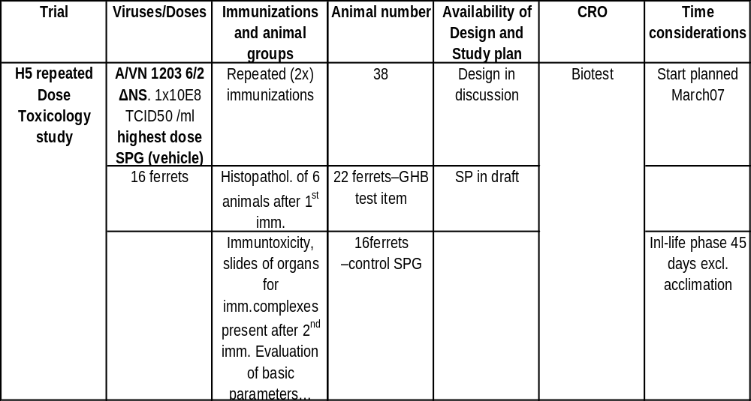

Table 3: Outline for a repeat-dose toxicology trial in ferrets.

Qualification of TCID₅₀ assay
Supportive experiments for the toxicological evaluation were initiated for the qualification of the TCID₅₀ assay. This assay is needed for samples evaluation during the toxicology trial.
Precision and accuracy was measured by spiking negative tissue extracts and nasal washes with three virus concentrations (5.5 x 10¹, 5.5 x 10³, 5.5 x 10⁵ TCID₅₀) and triple analysis via TCID₅₀ assay. Specificity of the assay was tested with 6 tissue extracts and 6 nasal washes, spiked with 5.5 x 10¹ TCID₅₀/ml and 5.5 x 10⁵ TCID₅₀/ml virus concentration, as well as testing of 10 negative tissue extracts and 20 negative nasal washes.
For the TCID₅₀ assay samples were diluted and pipetted onto 96-well plates with cell monolayer. Cells were examined microscopically after approximately 72 hours and visible CPE in individual wells was noted. The plate arrangement for these experiments is shown in Fig 14.

5,5x10¹ 5,5x10¹
 | 1 | 2 | 3 | 4 | 5 | 6 | 7 | 8 | 9 | 10 | 11 | 12
A | 1:10 |  |  |  |  |  | 1:10
B | 1:100 |  |  |  |  |  | 1:100
C | 1:1000 |  |  |  |  |  | 1:1000
D | CC |  |  |  |  |  | CC
E | 1:10 |  |  |  |  |  | 1:10
F | 1:100 |  |  |  |  |  | 1:100
G | 1:1000 |  |  |  |  |  | 1:1000
H | CC |  |  |  |  |  | CC
5,5x10³ 5,5x10³

Fig.14: Plate arrangement for TCID₅₀ assay for precision and accuracy and specificity experiments.

Many tissue extracts and nasal washes showed a strong toxic effect on the cells. For this reason and for means of reaching a higher sensitivity of the test we changed the protocol. Samples were used in a lower dilution and incubated for one hour on the cells. The new plate arrangement is shown in Fig. 15.

sample 1 sample 2 sample 3 sample 4
 | 1 | 2 | 3 | 4 | 5 | 6 | 7 | 8 | 9 | 10 | 11 | 12
A | 1:2 |  |  | 1:2 |  |  | 1:2 |  |  | 1:2
B | 1:20 |  |  | 1:20 |  |  | 1:20 |  |  | 1:20
C | 1:200 |  |  | 1:200 |  |  | 1:200 |  |  | 1:200
D | CC |  |  | CC |  |  | CC |  |  | CC
E | 1:2 |  |  | 1:2 |  |  | 1:2 |  |  | 1:2
F | 1:20 |  |  | 1:20 |  |  | 1:20 |  |  | 1:20
G | 1:200 |  |  | 1:200 |  |  | 1:200 |  |  | 1:200
H | CC |  |  | CC |  |  | CC |  |  | CC
sample 5 sample 6 sample 7 sample 8

Fig. 15: Plate arrangement for 8 samples on one plate. Samples were removed after one hour incubation on the cells.

After this qualification experiments we tested samples from immunised animals provided by BioTest.
We tested tissue extracts from nasal mucosa, brain and lung from day 4 as well as nasal washes from day 2, 3 and 4. None of these samples showed development of CPE indicating no infectious virus is contained in the nasal washes and tissue extracts.

Deviations
No deviations

Output beyond the project
The data of the GLP toxicology are important prerequisites for further development of the vaccine.

Deliverables and Milestones

D16 | Toxicology programme for chimeric influenza vaccines containing human influenza antigens
Will be started when the final chimeric vaccine virus is available but will be analogous to the experiments performed in this WP.

D16.1 | Toxicology programme for the human H5N1-delNS1 vaccine candidate in experimental animals
Completed.

D17 | Test plan toxicology chimeric avian influenza vaccine

Completed.

M7 | Toxicological test report, EMEA/FDA standard

In life phase of study completed, report is in preparation

WP8 –delNS1 virus as adjuvant and preparations to Phase I/II trial

Work package number | 8 |  | Start month: 21 |  |  |  |  | End month: 30
Determine the potential of influenza delNS1 virus as adjuvant for inactivated influenza vaccines and preparations to Phase I/II safety and immunogenicity trial
Participant id |  | IF |  | GHB
Person-months per participant |  | 12,5 |  | 0,2

Lead contractor: IF
Contributors: GHB

Objectives and starting point at the beginning of the project
According to the technical plan at the beginning, in this work package a Phase I/II safety and immunogenicity trial using delNS1 virus was planned. However it became very clear early that the projected timescale of 18 months to a clinical trial is highly unrealistic. However, in this project significant progress towards a clinical trial was made. The consortium decided in addition to analyze the properties of influenza delNS1 virus as adjuvant for inactivated influenza vaccines

Results

Clinical facility:
The influenza vaccine trials need the special laboratory control inside the volunteers’ clinic, including facilities for re-isolation of vaccine viruses. For these purposes a special virology laboratory was created inside the clinics. In addition, general facilities for volunteers were improved. Now the laboratory is completely equipped as necessary for viral isolation, identification, growth etc. and thus is ready for the planned clinical trials. The set of necessary equipment was approved by the working team. The plan for clinical trials of the designed vaccine was prepared, taking into account new requirement to replication deficient vaccines.

DelNS1 as an adjuvans:
As planned in the updated technical annex, immunogenicity studies were performed using delNS1 H1 virus as adjuvant to trivalent inactivated influenza vaccines by either intranasal or intraperitoneal application.

The delNS1 virus was tested in mice as immune adjuvant by admixing with trivalent inactivated influenza vaccine. The effect of a deletion of NS1 gene on virus adjuvant potency was tested by comparison of delNS1 or PR8 wild type virus in parallel experiment. Mice received different doses of inactivated vaccine coupled with live virus components. Mixed vaccines were delivered by intranasal or intraperitoneal routes. Three weeks after immunization, serum samples from mice were tested for antibody response to each component of trivalent vaccine and to live vaccine component. Antibodies were tested in hemagglutination inhibition test (HI) and by ELISA, specifying the isotype of immunoglobulin.

Conclusions:
- Influenza viruses A/PR/8/34 wild type and delNS1 mutant virus, when used as adjuvant, stimulate immune response at approximately the same extent, and only after parenteral inoculation. The maximal stimulation effect was observed at the highest doses of inactivated vaccine when about 2,5-fold increase in the titre of antibodies was detected in comparison to the group receiving only vaccine.
- After intranasal inoculation of mice, the level of antibodies to the viruses H1N1, H3N2 and B did not significantly exceed the background values. The titres of antibodies to influenza virus A/PR/8/34 was highest among those for four studied antigens and depended on the dose of infecting virus.
- Subtyping of antigen- specific antibodies in ELISA test have shown that both delNS and wtPR8 influenza viruses could stimulate the humoral immune response to all components of trivalent vaccine. In general, the extent of this stimulation is almost equal between two viruses, although at low doses of the antigen the stimulation by delNS virus was slightly stronger than that of wtPR8.
- Both tested viruses after i.p. inoculation stimulated predominantly induction of Th1 immune response reflected in higher titres of IgG2A antibodies. However, delNS1 mutant virus showed better stimulation effect comparing to wild type PR8 virus. Thus, delNS1 influenza virus is more active in polarization of immune response towards Th1.

In summary, upon intranasal co-administration the delNS1 virus did not enhance the antibody response to inactivated vaccine. In contrast, by intraperitoneal co-injection it was possible to detect increased response with polarization towards Th1 response.

We have shown that intranasal administration of live delNS1 virus in combination with inactivated trivalent vaccine could induce enhancement of immune response in mice towards inactivated antigen components. However, this effect was only achievable when vaccine mix was delivered by subcutaneous or intraperitoneal routes, but not when administration happened intranasally. This could be explained by competition of viral components for cellular receptors. Therefore, it has been decided to test a combination of delNS1 virus coupled with the HA that is disabled in its binding to specific receptors. For this purpose the H5 haemagglutinin of avian origin was cloned into a baculoviral vector for production in insect cells (Spodoptera frugiperda). As a source of HA the A/Chicken/Kurgan/5/05 virus was taken.
A plasmid for recombinant baculovirus construction was obtained and verified by sequencing. A baculoviral vector was designed for expression of fusion protein where the N-terminal part comprises the first 125 amino acids of NS1 protein, elongated by the full size HA ectodomain. The transmembrane and cytoplasmic domains were removed. The gene was placed under control of the polyhedrin promoter; the gp64 leader sequence was added to the construct at the N-terminus to allow secretion of recombinant protein into the culture medium. The construct was additionally supplemented with a hexahistidine sequence in its C-terminus for purification via metal-agarose columns. Recombinant baculovirus was rescued.

Deviations
According to the technical plan at the beginning, in this work package a Phase I/II safety and immunogenicity trial using delNS1 virus was planned. However it became very clear early that the projected timescale of 18 months to a clinical trial is highly unrealistic. Nevertheless, in this project significant progress towards a clinical trial was made. The consortium decided -instead of performing a clinical trial - to establish influenza delNS1 virus as adjuvant for inactivated influenza vaccines.

Previous experiments have shown that subcutaneous or intraperitoneal routes of application, but not intranasal administration of delNS1 vaccine in combination to a trivalent inactivated influenza vaccine can induce enhancement of immune response. This could be explained by competition of viral components for cellular receptors. Therefore it has been decided to test a combination of delNS1 virus coupled with the HA disabled in its binding to specific receptors.
Since intranasal co-administration of delNS1virus with trivalent inactivated vaccine did not immunogenicity of inactivated component, the experiments with avian influenza virus derived antigens were omitted.

Output beyond the project
The upgrade of the clinical facility and establishment of a special virology laboratory inside the clinics will help to perform clinical trials with influenza vaccines faster and more efficient. Supporting laboratory methods were established. Data generated using delNS1 as an adjuvant led to a patent application. These results are exciting as the principle of using delNS1 as an immunostimulans can easily be extended to other antigens and might represent a novel mechanism for enhancing different kinds of vaccines.

Deliverables and Milestones
D18. | Immunogenicity of delNS1 in combination with trivalent vaccine
Completed

D19 | Immunogenicity of delNS1 in combination with avian vaccine

Since intranasal co-administration of delNS1virus with trivalent inactivated vaccine did not immunogenicity of inactivated component, the experiments with avian influenza virus derived antigens were omitted.

M8 | Draft report for preIND Submission from collected data

The draft report was prepared.

Consortium management

WP 9 – Project management and dissemination

Work package number | 9 |  | Start month: 0 |  |  |  |  | End month: 30
Project management and dissemination
Participant id |  | GHB
Total planned pms |  | 5,2

Objectives and starting point at the beginning of the report period
Main objective was to administer and manage this project according to EC guidelines, finding a balance between management, controlling and reporting duties and to provide assistance to partners whenever necessary.

Results
- Successful organisation and operation of the project
- Effective management of knowledge and exploitation
- Compliance with provisions of EU-funded projects

General status of the project
The consortium has been able to join expertise and develop a contingency plan upon problems encountered in the generation of a stable vector. We proposed in RP1 and the modified technical annex that the project priority would include safety and efficacy testing of the delNS1 vaccine candidates (BioTest) in its applicability as an adjuvant to passive immunization agents.
Importantly, recently a stable vector suitable for the final cloning of the chimeric vaccines has been generated in the project (MUV, GHB).
In a parallel approach, peptides selected through bioinformatics suitable for B and T-cell immunization have been designed (Emtech) and tested (GUF, GHB, MUV). Based on bioinformatics and immunogenicity results, we now have the opportunity to include best epitopes from wp1 and wp4 to produce chimeric vaccines against influenza.
Production and purification methods have been established for the delNS1 vaccine strain and it is very probable that these will be suitable for the production and purification of the chimeric vaccine strains, given some fine tuning.
Besides the strong effort to the production of a stable vector (MUV, GHB), all partners kept on performing their tasks according to the original plan. In case of tasks that were on queue due to the absence of the vector, alternative strategies were conducted.
We have confirmed safety and efficacy of the delNS1 influenza vaccine and assessed its potential as an adjuvant. As described in the RP1 period, we have also improved the infrastructure of the facilities at our clinical partner (IF). The group is now ready to begin with clinical trials in premises that have been optimized for hospitalization of subjects.
All these activities could only happen based on efficient communication, coordination, reallocation of tasks and necessary change of strategy. The overall project could get well on track on time. All partners are fully engaged into the project and are still continuing to finish remaining work in this project, as results are promising.

Communication
As in many aspects of the project tight interaction was needed, many meetings between participants took place. Depending on need, MUW and GHB had regular meetings in weekly to monthly intervals. Also, the production process involved regular meetings between GHB, Biasep and the contract manufacturer. In addition, frequently teleconferences were done. At least monthly meetings were performed between GHB and Biotest. Meetings with other partners (GUF, IF, Emtec) were carried out at monthly to three-monthly intervals. Immediate items were resolved by phone. Routine communication within the project was done mainly via email. In addition, a kick-off meeting, mid term meeting and a final meeting with all participants was organized.

Changes in responsibilities and changes to the consortium
- BioTest: Due to an internal change at BioTest, Prof. Jebavy was replaced by Martin Slais as the team leader in 2006. The new head of BioTest is Dr. Jan Zabsky.
- GHB: The team leader of the purification work package Andreas Grassauer left GHB in autumn 2005 and was replaced by Elisabeth Maurer.
- The overall project manager Franz Kalthuber left GHB in January 2006 and has been replaced by Dr. Joachim Seipelt. He is supported by Dr. Karla M. Valdés Rodríguez. Dr. Thomas Muster and Michael Tscheppe have kept their responsibilities as scientific coordinator and financial coordinator, respectively.

Administrative activities
-Organization of general assembly meetings
-Presentation of project management status at the general assembly meeting
-Provide support to partners concerning the local administration of the project in means of research documentation, financial documentation, financial controlling, and access to guidelines of the EC.
-Provide up- to-date information on current contractual and administrative issues to all partners
-Overall central communication within the project.
-Major contribution to the production of the joint reports to the EC which are based on the collected reports from all contractors.

Documentation
-Production of draft documentation formularies for interim reporting and the yearly reports to the EC. These will include drafts for scientific, dissemination, financial and training reporting.
-Collection of network interaction activities in means of exchange of scientific stuff for research, training or dissemination activities.
-Collection of interim reports and yearly reports for the EC.
-Financial controlling of incurred costs in a half year basis, based on the half year interim financial reports requested from all contractors.
-Scientific controlling of timelines, based on the quarterly interim scientific reports requested from all contractors.
-Controlling on dissemination and exploitation activities based on the half year dissemination reports requested from all contractors.
Project website
-Implementation of the public website.

Dissemination
-Central organization of major dissemination and training activities
-Dissemination in form of presentation of the project at research funding organizations.

Changes in the decision making structure
No changes have been made in the decision making structure.

Support Actions
A main task of the coordinator was also to ensure that sufficient support was available for technical help, accounting, filling of forms, legal help and performing of audit certificates.

Further Activities
Partnerships established in this project were successful in means of scientific cooperation and interaction. Therefore, partners contributed to a joint application for another EU-funded project termed “H5 vaccines” that was granted and started in 2007..

Deviations
The initial project manager was replaced by Joachim Seipelt. Several unforeseen obstacles had to be resolved as described in the project management plan.

Output beyond the project
The management structure that was generated in this project will be used for further projects in FP6 and FP7. The partners have already successfully extended their cooperation based on bilateral agreements and by EC funded projects. Knowledge in EC regulations, procedures and problem solving represent a unique added value for the coordinator’s company. Importantly, based on that knowledge management of further projects can be made more efficient based on the experiences generated in this project.

Deliverables and Milestones
Wp.  No. | Del.  No. | WP/Deliverable name | Timeline³ | corrective  timeline ³
9 |  | Management and dissemination | 0 | 24
 | 20 | Consortium agreement | 1 | 1
 | 21 | Minutes of the steering committee meetings | 12 | 12
 | 22 | PM handbook | 12 | 12
 | 23 | Controlling | Monthly basis | Half year basis
 | 24 | Progress report | 12; 24; 30 | 12;24;30
 | 25 | Audit certificates | 30 | 30
 | 26 | Statement of accounts | 12 | Continuously if relevant
 | 27 | Press release |  | Continuously if relevant
 | 28 | Filling of patents |  | Continuously if relevant
 | 29 | Exploitation and dissemination plan | 6 | Continuously if relevant
 | 30 | Exploitation and dissemination plan term version | 24; 30 | 24;30
 | 31 | Web platform public side | 6 | 14
 | 32 | Public progress report 1 | 12 | 12
 | 32 | Public progress report 2 m13-24 | 24 | 24
 | 33 | Public progress report 3 m13-30 | 30 | 30
 | 34 | Final report | 30 | 31

D20 | Consortium Agreement
D20 was delivered in RP1

D21 | Minutes of the steering committee meeting
The second general assembly meeting took place in July 2006.
D22 | Project Handbook
D22 was delivered in RP1

D23 | Controlling

In RP1 a monthly reporting system was set up. However, it turned out that in a monthly timeframe only intermediate results were obtained that could not be reported properly as the experiments usually took more time. The monthly report therefore was insufficient to draw conclusions and to set corrective actions. Regular meetings (either phone conferences or physical meetings) between involved partners allowed a better discussion about project aims and contingency plans.
Also monthly financial reports were very time consuming, as some of the partners did not have sufficient administrative staff to ensure reporting on a monthly basis. So we decided to perform scientific and finance controlling in a half year basis.
All financial reports delivered to the coordinator were of good quality. The university institutions all use accounting systems such as SAP which gives a clear overview about the financial status whenever requested. Accounting systems between small SME companies differ but also produced satisfactory results.

D24 | Progress report

RP2 progress report was produced by the close cooperation and effective information exchange between partners. The project manager produced all drafts for reporting and distributed them to all participants. The project manager provided assistance to all partners for the filling of drafts and documents for the reporting. Team leaders reported to the project manager.
The project manager, together with the project coordinator and scientific coordinator produced the joint period activity reports and management reports (m1-12; m13-24; m13-30, final report) as required by the Commission.

D25 | Progress report
Partners were informed on the guidelines for preparation of audit certificates according to the rules of the European Commission. Enclosed to the RP2 m13-30 report, we submit the audit certificates for m1-30 of the project from all project participant groups.

D26 | Statement of accounts
D26 was delivered in RP1

D27 | Press release
Press releases are displayed in the plan of dissemination.

D28 | Filling of patents
The RP2 has led to two patent applications:
- Application of delNS1 Vector as Adjuvant.
- Expression of immunomodulatory proteins/peptides. This patent is in filing process.

D29 | Exploitation and dissemination plan
The plan has been delivered with this periodic activity report.

D30 | Exploitation and Dissemination plan and report
The dissemination plan was submitted in RP1.The report for activities for RP2 m13-30 was submitted.

D31 | Web platform public side

The announcement of the project to the open public through a website has been implemented by the integration of publishable summary to the pages exclusively devoted to EU –projects at GHB at the company’s website www.greenhillsbiotech.com . In the course of the project, the website was actualized several times.

The EU-Project part of the website has been designed to summarize the current projects of FP6 within the field of influenza research in which GHB and partners are involved. Contrary to the approach to reach the open public through an exclusive website for each individual project, we have decided to take advantage of the network around GHB and our partners. Our website incorporates current EC projects of the FP6 programme that bridge the gap between academic scientists and industry for a novel vaccine development technology. Instruments of the EC for which the projects apply are explained, the expertise of partners is described, and contact data to the respective deputies is provided as well as links to their websites.

The website has been created for scientists, physicians, students and open public interested primary in the specific projects, but linking that information to other related projects, to the participants involved, to the EC instruments applied as well as to interested public in state to the art influenza research. We believe that a joint site increases the impact of publicity in a chain-like manner. Moreover, the site shows the strengthening support of the EC on a network between academic research groups and companies, and most importantly, the stimulation of the small and medium enterprises in the R&D field of the European Area.

D32 | Public progress report RP1 m1-12

The public progress report was delivered
D33 | Public progress report RP2 m13-30

The public progress report was delivered.

D34 | Final report m1-30

Final reports are being prepared and will be submitted within the term fixed (30.07.2007).
After review of reports and receipt of final payment, the final report on distribution of the Commission’s contribution will be submitted, according to EC rules.

Project timetable: bar chart m1-30

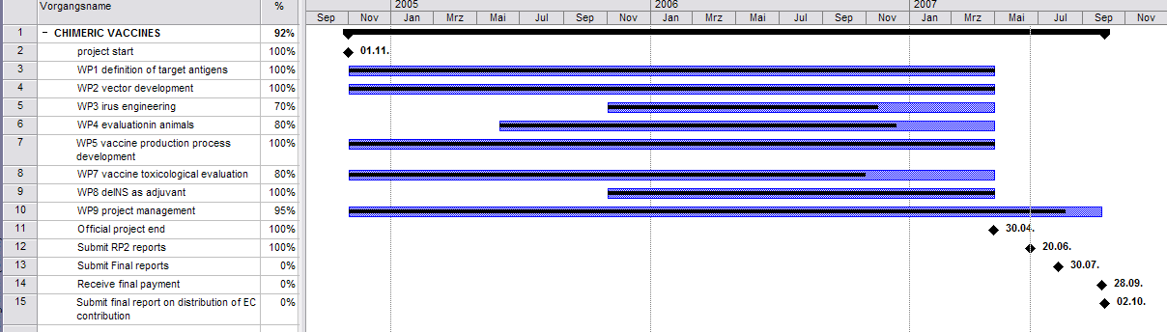

Project timetable as reported in RP 12-30. In the meantime, additional activities have been carried out that led to the completion of almost all open tasks.

List of Work packages (month 13-30)

Wp No. | work package name | lead  participant | all participants | Indicative  person  months | start  month | end  month | Corrective end-month
1 | Definition of target antigens | EMTEC | - | 16 | 0 | 4 | 16
2 | Vector development | MUW | GHB | 18 | 0 | 6 | 30
3 | Virus engineering of chimeric vaccine viruses | GHB | MUW | 18 | 5 | 9 | after end of the project
4 | Evaluation of chimeric vaccine viruses in animals | BioTest | GHB, GUF, MUW | 35 | 7 | 12 | after end of the project
5 | Vaccine production process development | Biasep | GHB | 30 | 0 | 12 | 30
6 | Chimeric vaccine virus production | GHB | Biasep, GUF | 36 | 13 | 18 | after project end
7 | Chimeric vaccine toxicological evaluation | BioTest | GUF | 24 | 16 | 21 | after end of the project
8 | Determine the potential of influenza delNS1 virus as adjuvant for inactivated influenza vaccines and preparations to Phase I/II safety and immunogenicity trial | IF | - | 18 | 21 | 24 | 30
9 | Management and dissemination | GHB | - | 18 | 0 | 24 | 30
 | TOTAL |  |  | 771

1. Indicative person months mean planed work effort for the full duration of the project.

List of deliverables
Wp.  No. | Del.  No. | WP/Deliverable name | wp leader | Other participants | used indicative person months | Nature ¹ | dissemination  Level ² | Timeline ³ | corrective  timeline ³
1 |  | Definition of target antigens | EMTEC |  | 0,5 | R | CO | start m0 – end m4
 | 1 | Three antigenic polypeptides derived from circulating human influenza viruses |  |  |  | R | CO | 4 | 16 - achieved
 | 2 | Three antigenic polypeptides derived from avian influenza viruses |  |  |  | R | CO | 4 | 16 - achieved
 | 3 | Three antigenic polypeptides derived from consensus sequences |  |  |  | R | CO | 4 | 16 - achieved
2 |  | Vector development | MUW | GHB | 43,6 | R | CO | start m0 – end m6
 | 4 | Optimised vector construct |  |  |  | R | CO | 6 | achieved
 | 5 | Standard operating procedure for fast vector generation |  |  |  | R | CO | 6 | 12 - achieved
3 |  | Virus engineering of chimeric vaccine viruses | GHB | MUW | 0,1 | R | CO | start m5 – end m9
 | 6 | Three chimeric influenza vaccines containing antigenic polypeptides derived from circulating human influenza viruses |  |  |  | R | CO | 9 | after end of the project
 | 7 | Three chimeric influenza vaccines containing antigenic polypeptides derived from consensus sequences of subtypes H1 and H3 and of type B |  |  |  | R | CO | 9 | after end of the project
 | 8 | Three chimeric influenza vaccines containing antigenic polypeptides derived from avian influenza viruses |  |  |  | R | CO | 9 | after end of the project

Wp.  No. | Del.  No. | WP/Deliverable name | wp leader | Other participants | used indicative person months | Nature ¹ | dissemination  Level ² | Timeline ³ | corrective  timeline ³
4 |  | Evaluation of chimeric vaccine viruses in animals | BioTest | GHB, GUF, MUW | 2,2 | R | CO | start m7– end m12
 | 9.1 | Immunogenicity and efficacy data of selected epitopes for chimeric influenza vaccine (human influenza) |  |  |  | R | CO | 13 | 25 achived
 | 9 | Immunogenicity and efficacy data of chimeric influenza vaccine (human influenza) |  |  |  | R | CO | 12 | 30
 | 10 | Immunogenicity and efficacy data of Del NS1 influenza vaccine |  |  |  | R | CO | 1 | achived RP1
 | 10.1 | Immunogenicity and efficacy data of chimeric influenza vaccine (consensus sequences) |  |  |  | R | CO | 12 | after project end
 | 11 | Immunogenicity and efficacy data of chimeric influenza vaccine (avian) |  |  |  | R | CO | 25 | after project end
 | 11.1 | Immunogenicity and efficacy data of selected epitopes (avian influenza) |  |  |  | R | CO | 14 | 20 achived
 | 11.2 | Challenge study in ferrets |  |  |  | R | CO | 14 | 18 achived
 | 11.3 | Evaluation of immunogenicity, protection and shedding in ferrets immunized with the GHB01L1 vaccine virus candidate |  |  |  | R | CO | 17 | 22 achived
 | 11.4 | Selection of immunogenic H5-derived peptides |  |  |  | R | CO | 19 | 23 achived
5 |  | Vaccine production process development | Biasep | GHB | 11,2 | R | CO | start m0 – end m12
 | 12 | Production and purification method for chimeric vaccine viruses |  |  |  | R | CO | 12 | RP1 achived
 | 12.1 | Further optimization of purification method |  |  |  | R | CO | 26 | 28
 | 13 | Standard operating procedure for cGMP chimeric vaccine virus production |  |  |  | R | CO | 12 | RP1 achived
 | 13.1 | Further optimization of SOP for cGMP chimeric vaccine production |  |  |  | R | CO | 26 | 28
6 |  | Chimeric vaccine virus production | GHB | Biasep, GUF | 2,6 | R | CO | start m13 – end m18
 | 14 | Pre cGMP grade purified vaccine containing avian influenza epitopes |  |  |  | R | CO | 18 | 30
 | 15 | Pre cGMP grade purified vaccine containing human influenza virus epitopes |  |  |  | R | CO | 18 | 30
7 |  | Chimeric vaccine toxicological evaluation | BioTest | GUF | 24,1 | R | CO | start m16 – end m21
 | 16 | Toxicology programme for chimeric influenza vaccines containing human influenza antigens |  |  |  | R | CO | 21 | after end of the project
 | 16.1 | Toxicology program for the human H5N1-delNS1 vaccine candidate in experimental animals |  |  |  | R | CO | 23 | 30 achived
 | 17 | Test plan Toxicology chimeric avian influenza vaccine |  |  |  | R | CO | 22 | 26 achived
8 |  | Determine the potential of influenza delNS1 virus as adjuvant for inactivated influenza vaccines and preparations to Phase I/II safety and immunogenicity trial | IF | - | 2,5 | R | CO | start m21 – end m24
 | 18.1 | Draft report immunogenicity of delNS1 in combination with trivalent vaccines |  |  |  | R | CO | 14 | 20 achived
 | 18 | Immunogenicity of delNS1 in combination with trivalent vaccine |  |  |  | R | CO | 24 | 28 achived
 | 19 | Immunogenicity of delNS1 in combination with avian vaccine |  |  |  | R | CO | 24 | cancelled

Wp.  No. | Del.  No. | WP/Deliverable name | wp leader | Other participants | used indicative person months | Nature¹ | dissemination  Level² | Timeline³ | corrective  timeline ³
9 |  | Management and dissemination | GHB | - | 0,9 | R | CO | 0 | 24
 | 20 | Consortium agreement |  |  |  | R | CO | 1 | 1 achived
 | 21 | Minutes of the steering committee meetings |  |  |  | R | CO | 12 | 12 achived
 | 22 | PM handbook |  |  |  | R | CO | 12 | 12 achived
 | 23 | Controlling |  |  |  | R | CO | Monthly basis | Half year basis
 | 24 | Progress report |  |  |  | R | CO | 12; 24; 30 | 12;24;30 achived
 | 25 | Audit certificates |  |  |  | R | CO | 30 | 30 achived
 | 26 | Statement of accounts |  |  |  | R | CO | 12 | Continuously if relevant
 | 27 | Press release |  |  |  | R | CO |  | Continuously if relevant
 | 28 | Filling of patents |  |  |  | R | CO |  | Continuously if relevant
 | 29 | Exploitation and dissemination plan |  |  |  | R | CO | 6 | Continuously if relevant
 | 30 | Exploitation and dissemination plan term version |  |  |  | R | CO | 24; 30 | 24;30 achived
 | 31 | Web platform public side |  |  |  | R | CO | 6 | 14 achived
 | 32 | Public progress report 1 |  |  |  | R | CO | 12 | 12 achived
 | 32 | Public progress report 2 m13-24 |  |  |  | R | CO | 24 | 24 achived
 | 33 | Public progress report 2 m13-30 |  |  |  | R | CO | 30 | 30 achived
 | 34 | Final report m1-30 |  |  |  | R | CO | 30 | 31 achived

List of Milestones
Wp.  No. | M.  No. | milestone name | wp leader | Nature ¹ | dissemination  Level ² | Timeline ³ | corrective  timeline ³
1 | 1 | Definition of antigenic multimers | EMTEC | R | CO | - | fulfilled
2 | 2 | Optimized vector | MUW | R | CO | - | 30 fulfilled
3 | 3 | Chimeric vaccine candidate viruses | GHB | R | CO | - | after end of project
4 | 4 | Characterized chimeric vaccine candidates | BioTest | R | CO | - | Partly achived, will be completed after end of project
5 | 5 | Production and purification method for chimeric vaccine | Biasep | R | CO | - | 28 fulfilled
6 | 6 | cGMP grade purified vaccines | GHB | R | CO | - | 30 fulfilled
7 | 7 | Toxicological test report, EMEA/FDA standard | BioTest | R | CO | - | Ongoing, after end of project
8 | 8 | Draft report for preIND submission from collected data | IF | R | CO | - | 30 draft generatedt
9 | 9 | Successful completion of the project | GHB | R | CO | - | 36

Kittel, C., B. Ferko, M. Kurz, R. Voglauer, S. Sereinig, J. Romanova, G. Stiegler, H. Katinger and A. Egorov (2005). "Generation of an influenza A virus vector expressing biologically active human interleukin-2 from the NS gene segment." J Virol 79(16): 10672-7.
Fodor, E., L. Devenish, O. G. Engelhardt, P. Palese, G. G. Brownlee and A. Garcia-Sastre (1999). "Rescue of influenza A virus from recombinant DNA." J Virol 73(11): 9679-82.
Hoffmann, E., G. Neumann, Y. Kawaoka, G. Hobom and R. G. Webster (2000). "A DNA transfection system for generation of influenza A virus from eight plasmids." Proc Natl Acad Sci U S A 97(11): 6108-13.

