

Project no. TST4-2005-516205

Project acronym: INTERGAUGE

Project title:

INTEROPERABILITY, SECURITY AND SAFETY OF GOODS MOVEMENT WITH 1435 AND 1520 (1524) mm TRACK GAUGE RAILWAYS: NEW TECHNOLOGY IN FREIGHT TRANSPORT INCLUDING HAZARDOUS PRODUCTS

Instrument: STREP

Thematic Priority: SUSTAINABLE DEVELOPMENT, GLOBAL CHANGE AND ECOSYSTEMS

PUBLISHABLE
FINAL ACTIVITY REPORT

Period covered: from 01.01.2006 to 30.06.2008

Date of preparation: July/August 2008

Start date of project: 01.01.2006

Duration: 30 months

Project coordinator name: Andrzej Chudzikiewicz

Project coordinator organisation name: Politechnika Warszawska
(Warsaw University of Technology)

1. Project execution

The main objective of the project is to develop new freight movement technologies INTERGAUGE enabling the interoperability of transport between railways with different gauge widths, using tank bogie car with gauge adjustable wheel set SUW-200 II working at higher capacity and higher speed, as well as automatic new generation track gauge changing station. The new transport technology allows to limit time required for the trains or groups of cars to move through a border crossing with gauge changing station as well to minimize environmental hazards, especially with regard to dangerous products.
The project was carried out by following participants:
Warsaw University of Technology, Poland (PW);
Kiev University of Transport Economy and Technologies, Ukraine (KUTET);
Railway Scientific and Technical Centre, Poland (CNTK);
State Research Centre of Railway Transport of Ukraine (SRCUZ);
University of Żlina, Slovakia (UŻ);
Rolling Stock Repair Works, Poland (ZNTK);
Azovmash, Ukraine;
JP-Transplan, Finland (POYRY);
Koltram, Poland (KOLTRAM),
Tens, Poland (TENS),
Polish State Railways, Poland (PKP PLK)

INTERGAUGE is a system consisting of three subsections:
1) switching station operation technology and theoretical track layouts for gauge switching
stations
2) rail vehicle with a bogie equipped with automatic gauge adjustable wheel sets
for 1435/1520 mm railways with increased axle load to 225 kN and adopted to
speed 120 km/h;
3) track gauge switching station (TSP) with automation appliances to automate operation and
monitor the switching process
The INTERGAUGE technology enables reduction of the total time of the transfer of hazardous
cargoes through border stations with track gauge change for entire trains at about 70%,
and for groups of cars at about 40%.
Following components of the new technology were developed and verified:
- A tank-car documentation with prototype of bogies equipped with wheel sets having gauge-change wheels of the SUW 2000 II system,
- A new generation track gauge-change facility prototype equipped with electronic diagnostic system,
- Scope of adjustments of the existing border station infrastructure where railways with different track gauges meet each other (track gauge-change facility that makes application of the new technology possible),
- Organisation and technology of work of the border crossing station on which track gauge-change facility is located.

The tank-car with prototype of new bogies type 7RS/N fulfills parameters accepted to the project (axle load 225 kN, speed of run 120 km/h, tare weight coefficient 0.28 and technical availability factor 0.92-0.95). One can consider design of a new generation bogie equipped with wheel sets having gauge-change wheels can be claimed as outstanding achievement to be applied under various types of freight car bodies. The bogie passed a set of strength tests on test stands and trial runs. The Railway Rolling Stock Repairing Works in Poznań – a member of the INTERGAUGE consortium – is owner of design and technological documentation and manufacturer of the new bogie.
Design documentation of the tank-car body was worked out by the Ukrainian AZOVMASH Wagon Construction Factory – a member of INTERGAUGE consortium – while its verification in terms of conformity with the standards being in force on railways with track gauges 1520 and 1435 mm was carried out by specialists working for the University of Zilina (Slovakia). AZOVMASH is owner of body documentation, but it did not, however, construct body prototype – so, this way it did not utilized means allocated by the EC within the INTERGAUGE project. Operational verification of project results was executed using a substitute car body.
The new generation track gauge-change facility prototype (TSP-4) meets parameters assumed in the project (axle load of cars passing through the facility – 225 kN and increased durability by 35%) as well as it was equipped with the electronic diagnostic system ASDEK/ESD2. The system is stationary tool, unattended, making measurements of wheel sets of variable wheel shift, using point sensors of surface and force. Identification and measurement procedures start with the moment of shunt on the measurement basis of the station. State of the measurement process is displayed au courant on the display of the computer of the registering-measuring set and the terminal in the signal box. The possibilities of the set are in the following terms: wheel gauge and blocking mechanism disks assessment, wheel blocking correctness, axle load of running car measurement, possible work of the system with station traffic control equipment and recording of the parameters assessed. KOLTRAM – a member of the project consortium is owner of TSP-4 design and technological documentation, while ASDEK/ESD2 is owned by TENS – another member of the INTERGAUGE project consortium.
Based on the existing station systems on the Ukrainian-Polish border, the following possible locations of track gauge-change facility on stations were determined where railways with different track gauges have their interfaces:
- two TSP on each side of the border on tracks where trains (groups of cars) are taken over from the partner railway,
- single TSP on one side of the border depending on agreement between railways involved concerning trains (groups of cars) taking over from partner railway and trains dispatching to another partner railway.
Track system in close vicinity of TSP-4 can be solved as:
- one-way system enabling rolling stock runs in order to change track gauge along TSP;
- two-way system enabling rolling stock runs in order to change track gauge with use of pull-out track.
Capacity of track systems in close vicinity of TSP-4 amounts to 14-16 trains (groups of cars) daily in both directions that represents 17 per cent of total capacity of railway lines going to the state border. It means a single track gauge-change facility can provide service of three passenger trains, three freight trains (32 cars each) and 10 freight car groups (5 car each) assuming two-way traffic operation. This ensures transport of freights suitable for the technology amounting to 4 million to yearly in both directions (at present freight traffic by railway mode passing through all rail border crossings accounts for abort 11.5 million ton yearly).
Technological process of pass a train (32 cars) through border station using the SUW 2000 II system (32 cars) through border station developed within the framework of the INTERGAUGE project through track gauge-change facility requires 240 min. in comparison to 1320 min. according to technological systems operated nowadays.
The Dorohusk station track system was adapted to requirements of the INTERGAUGE project in accordance with the above-mentioned principles. All components of the new technology developed in the INTERFGAUGE project were examined and verified during tests carried out on Dorohusk station. On 6 June 2008 final demonstration and seminar on which contractors of the project presented results its execution was held at the Dorohusk station with participation of representatives of Polish and Ukrainian ministries, railway administrations, transport companies, scientific institutions and the press.
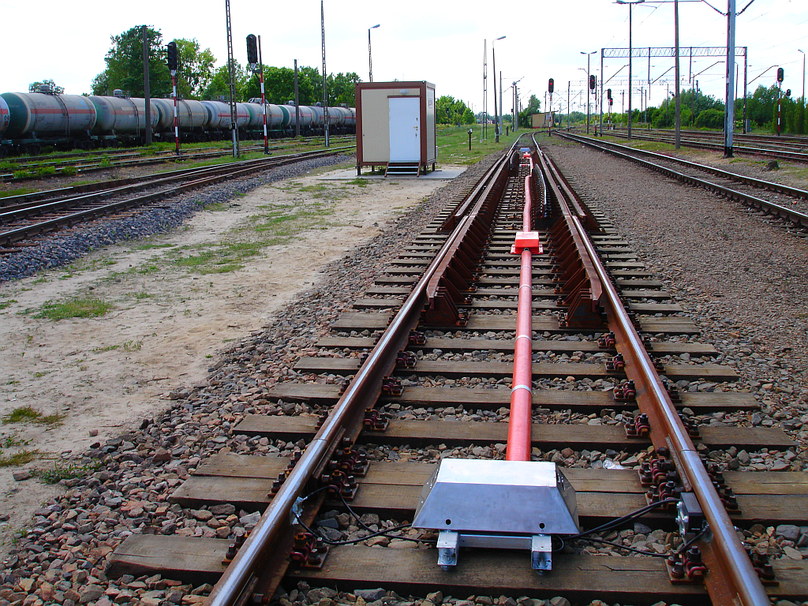
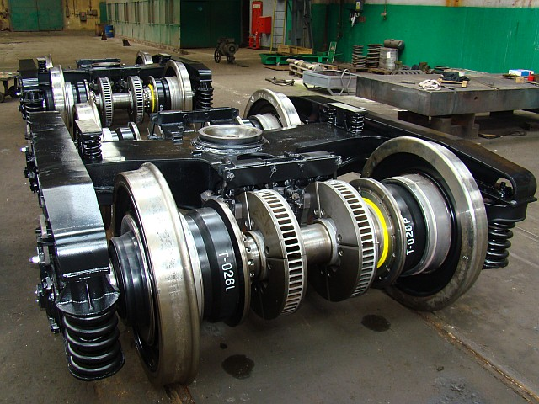
Complete 7RS/N bogies. View of TSP station with integrated
sensors and controllers

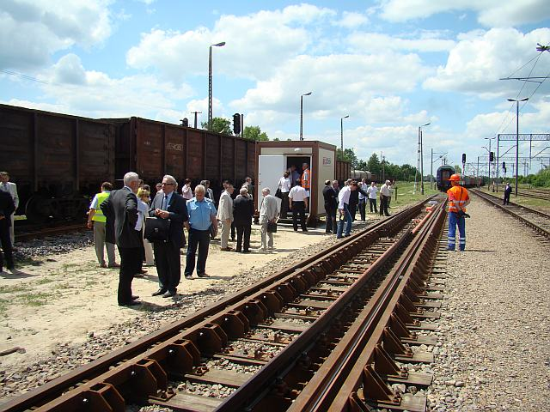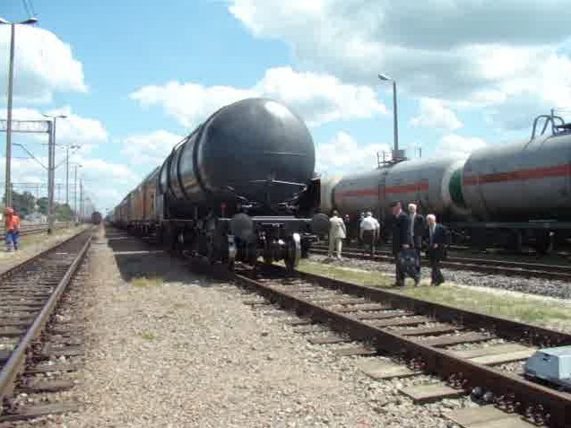

Gauge change facility – Dorohusk, June, 6th 2008 – passing through TSP (2)

2. Dissemination and use
The results obtained due to realization of the INTERGAUGE project were disseminated by means of their presentation on such international conferences as : International Scientific-Technical Conference “Science in transport dimensions” - Kiev (2006), International Conference and Fair – Moscow (2006), ‘Rail Vehicle’ - Kazimierz nad Wisłą (2006), Transport of 21th Century – Stare Jabłonki (2007), International Scientific Symposium „Cooperation of Transport Scientific Faculties in Scheme of FP7 European Projects - Warsaw (2007), 7th International Conference on Railway Bogiem and Running Gears, Budapeszt – (2007) and by publishing them in professional journals: The Parliament-European Politics and Policy Magazine (Issue 247, 2007), ‘Railway Issues’ - “Problemy Kolejnictwa” and ‘Transport Review’ - “Przegląd Komunikacyjny” (2007).
Railway administrations of Poland and Ukraine intend use adjustments of the Dorohusk station infrastructure allowing them to apply the new technology of transport between both countries. Common work is continued on preparation of scheduled train services through Dorohusk station in passenger and freight traffic as well as work on simplification of border control procedures.
Obtained results of the project that had been verified on example of the Dorohusk station were of general guidelines and recommendations nature to be applied widely on other 16 border crossings situated in the region of Europe where railways with different track gauges could be met (Finland-Russia, Lithuania-Poland, Poland-Ukraine, Ukraine-Slovakia, Hungary-Ukraine, Ukraine-Moldova-Rumania, Azerbaijan-Iran inland connections as well as Ukraine-Bulgaria and Georgia-Rumania ferry links).

