


NMP3-CT-2005-517045

SMART

Specific Support Action

Thematic Priority: 3

Publishable final activity report

Period covered: from April 2005 to March 2007
Date of preparation: 08.06.2007

Start date of project: 1. April 2005 Duration: 2 Years

Project coordinator name: Gerd Schumacher
Project coordinator organisation name: Research Centre Juelich, Project Management Juelich

Future Perspectives of European Materials Research

Gerd Schumacher, Stuart Preston, Alan Smith, Pavol Sajgalik

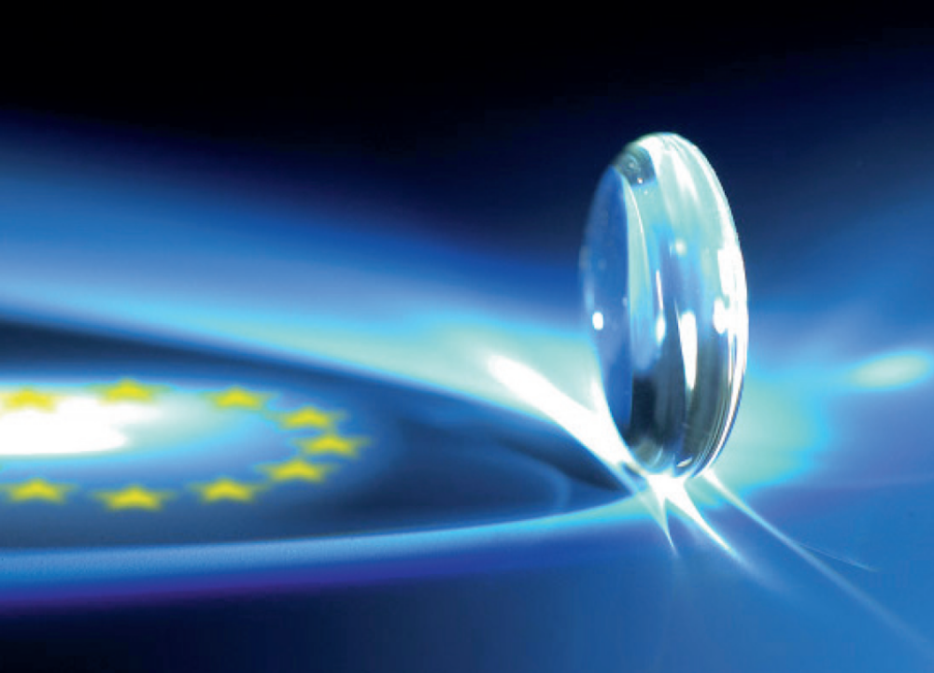

Proposal/Contract no.: SSA 517045 SMART
Contents

Foreword 5
Introduction 6
Methodology of roadmapping 8
Today’s Materials Technology from a global perspective 11
Basics about mapping and Bibliometrics 11
Development of materials research 11
Relevance of materials technology for different industrial sectors 12
Global mapping of materials research activities 15
European Materials Research Regions 18
Tomorrows Materials innovations - Looking ahead 20
Foresight: materials innovation demands by society 20
Screening for materials hot spot areas 25
Roadmaps: Materials powering Europe 28
Fission and fusion technologies 30
Materials for Energy Efficiency and CO₂-Capture 32
Increasing Energy Efficiency 39
Increasing efficiency of power generation 39
Energy Efficiency in Construction 40
Energy Efficiency in the Steel Sector 41
Efficiency in Electrical Energy Storage 42
Hydrogen Economy 43
Materials for sustainable energy technologies 48
Wind energy 49
Hydropower, tidal and wave power 51
Biomass and waste to energy 52
Solar 55
Roadmaps: Materials for a safe Europe 61
Sensors 61
Protection 65
Roadmaps: Materials improving our life 73
Biomaterials and Materials for Medical Applications 75
Improvement of existing implants and medical materials 76
Artificial solutions by smart materials 77
Materials research for regenerative medicine 82
Roadmaps: Materials for Packaging 87
Greening in convenient and priceless packaging materials 87
Materials for intelligent and safe packaging 92
Roadmaps: Materials for high tech textiles 95
Smart textiles 96
Technical Textiles 100
Strategies to keep Europe´s strong position in materials technology 107
Summary 110
Index of figures & tables 113
References 115

Foreword

Dear Reader

This report summarises the results of the SMART project. Smart is a Specific Support Action within the 6th European Framework Programme which aimed at a mapping of future materials research topics and excellent research groups throughout Europe. Members of the SMART consortium are the British Institute of Materials, Minerals and Mining (IOM3), the Liten Laboratory of the French CEA, the UACH Institute of the Slovakian Academy of Science, the German Fraunhofer INT-Institute and the German Agency Project Management Juelich at the Research Centre Juelich. It is important to notice that besides the four authors mentioned on the front cover of this report, many more experts enabled this work: Dr. Pierre Juliet (CEA), Dr. Etienne Bouyer (CEA), Brian Knott (IOM3), Dr. Birgit Weimert (FhG-INT), Stefan Reschke (FhG-INT), Dr. Show-Ling Lee-Müller (PtJ), Dr. Bernd Steingrobe (Research Centre Juelich), Dirk Tunger (Bibliometrics, Research Centre Juelich), Silvia Bach (Financial Administration, PTJ) and many more.
Due to the SMART concept a forecast and a foresight process were carried out in parallel. While the analyses of foresight studies led to the three focus areas of the roadmapping workshops, in the forecast process an initial literature screening was carried out, which was followed by expert interviews and the workshops. Therefore the information presented in this report is based on expert opinions and not necessarily those of SMART members or EC views. As much as possible we tried to cite relevant papers and to give references of our sources. On behalf of all SMART partners I would like to thank all the experts, of which over 300 were involved in the interviewing and almost 100 in the workshops, for their strong support for this project. Of course we would also like to thank the European Commission for funding this action.

Gerd Schumacher, Project Management Juelich, Germany
Coordinator of the SMART Project

Introduction

The objective of modern materials sciences is to develop and tailor materials in order to obtain a desired set of properties suitable for a given application. In addition to the conventional experimental approach of trial and error, an increasing number of essential data on materials collected by the conventional approach allows for analytical as well as predictive modelling and simulation. Thus, the knowledge base is continuously expanded, enhanced and refined, allowing for more precise experimental set-ups, more precise simulations and tailoring of goal-oriented materials, resulting in higher all-over success and increased opportunities for applications. The SMART project aims at providing support for establishing a sound knowledge base for future strategic decisions concerning the strengthening of the European Research Area.

SMART is a Specific Support Action funded by the European Commission within the 6th Framework Programme in Priority 3 “Nanotechnology and Nanosciences, knowledge based multifunctional materials, new production processes and devices”. The objective of the SMART project is to give the scientific community and the European Commission important information about specific strengths and weaknesses in European materials technology as well as to draw a picture of materials research in the future. The aim of SMART is to create European maps of excellence in materials science and to identify most relevant materials research topics for the next two decades by data screening, interviewing and roadmapping. At the core of the SMART-strategy is a two-fold concept in which both a traditional forecast and an innovative foresight approach are followed (see Figure 1). The SMART process can be divided into several different stages. The first stage involved data screening on the forecast side and identification of relevant studies on the foresight side. In the second stage expert interviews and analysis of studies led to further progress. In the third and final stage the roadmapping exercises combined both the forecast and foresight results by three thematic workshops.
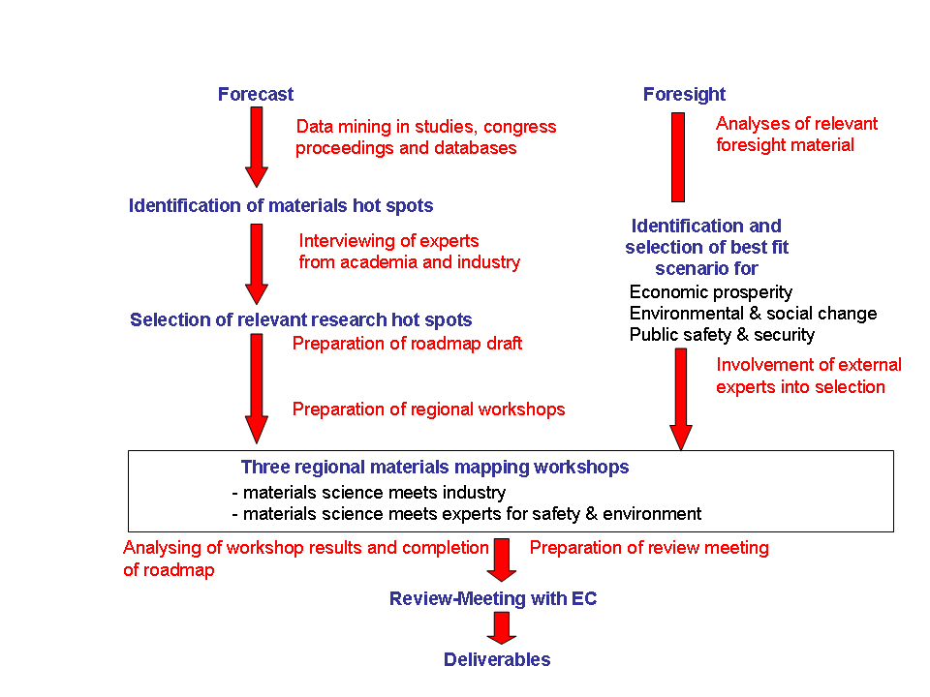
Figure 1: SMART process

The project started in April of 2005 with a total budget of approximately 480t€ and a duration of two years. The consortium consisted of five partners from four different countries. Project Management Juelich (Germany), a project agency mainly managing activities for the German Federal Ministry of Education and Research, was the coordinator of SMART and contributes its 20 years of materials research experience into the project. The data screening and Foresight work was done by the German Fraunhofer Institute INT in Euskirchen, which has been mainly active for the German Ministry of Defence but also for other public sector clients and industry for more than 20 years. The French CEA research organization was responsible for expert interviewing. CEA has a wide variety of materials research activities and is one of the leading research institutions in materials technology in Europe. IOM3 from the United Kingdom is one of the largest European materials societies. IOM3 is involved in national Foresight activities for the UK Department of Trade and Industry. Their main task in SMART was the development of roadmaps. The fifth partner was the UACH Institute (Institute of Inorganic Chemistry) of the Slovak Academy of Sciences. The institute has an excellent overview of materials activities in Europe and especially in the new member states. UACH was responsible for the Foresight analysis.

Methodology of roadmapping

There are a number of different methods that can be used to predict up-and-coming developments. Different methods aim at different time horizons. Before any method can be applied the target area has to be specified in detail. Therefore literature screening was used to characterize the area of materials research and to define certain subgroups (see Figure 2).

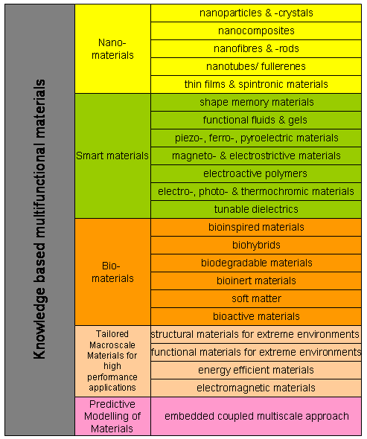
Figure 2: Structure of modern materials research area as used to define SMART search term for bibliometrics and literature screening. The field of biomaterials was later changed to bioconceptual materials, which has a broader focus.

For short term forecasts (up to 5 years), patent analyses, literature screening, portfolio analyses, quality function deployment, benchmarking and lead user analyses can be applied. For this roadmapping activity literature screening and benchmarking have been used. Also patent analyses could have been used, but were not applied since such analyses are extremely complex and would have used up almost all capacity of the SMART consortium.
In the mid-term forecast range (up to 15 years) tools that can be used are expert interviewing and expert panels, roadmapping, simulations and “Publikationsvernetzung” (also using bibliometric tools). In this roadmapping activity both expert interviewing and roadmapping were used. The expert interviewing was supported by a questionnaire so that statistical analyses of the results was possible. The expert interviewing led to initial roadmapping drafts. The drafts were extended and verified at the three SMART roadmapping workshops. These workshops were carried out by setting up SWOT analyses. The different steps in SWOT analyses are shown in Figure 3. The results of the SWOT analyses were clustered into different research areas and later converted into roadmaps.
Predictions for the long-term time horizon are extremely difficult and many experts doubt the reasonability of such predictions. Methods are Delphi-studies and scenario methods. Many European activities in long-term predictions are summarized in Europe under the term foresight. Foresight activities can be divided into studies (thinking the future), forums (debating the future) and innovation processes (shaping the future). The Delphi method is a very complex process and therefore not useful for small projects. In SMART scenario methods were used by analysing existing recent foresight studies. Foresight studies from all relevant areas like economic studies, security studies and environmental studies were analysed. Out of the many described scenarios those that would cause a demand for materials innovations were identified. An overview about recent foresight studies was recently published by VDI

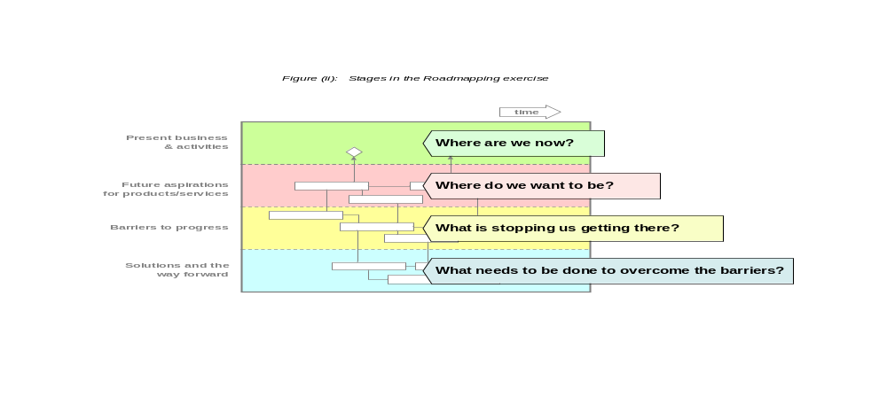
Figure 3: Stages in the roadmapping process

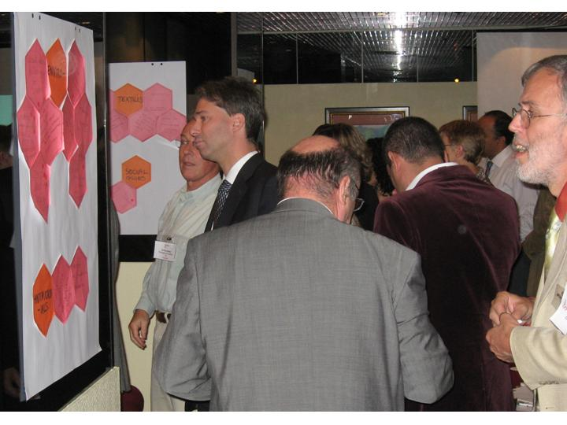
Figure 4: Participants clustering topics for SWOT anaylsis at SMART workshop

Today’s Materials Technology from a global perspective

Basics about mapping and Bibliometrics

A goal of trend analysis is to decrease uncertainties and to increase factual security concerning knowledge of possible changes and effects on foreseeable future developments. At the same time trend analysis must reach goal times efficiently and reliably. Being aware of the changes and possible timelines is a good basis for taking the right decisions.

Bibliometrics describes the application of statistical methods for the investigation of science publications. An example is the creation of timelines and hot-spot areas for different topics. Bibliometric analyses focus more on statistics than on real content. These analyses are generated from literature databases that do not just comprise of bibliographic data but also information on the citation and response of articles. The Science Citation Index from Thomson Scientific has proved its suitability for the natural sciences. It supplies good coverage, high precision and rapid provision of data.

Development of materials research

The number of scientific and technical publications has risen continuously throughout the last decades. This is also true for materials technology.

Looking a little closer at the statistics shows that while all types of materials research produced an increase in published output, different research fields had very different growth rates. While the number of nanomaterials publications tripled between 2000 and 2005, there was only a moderate increase in the number of publications in the field of classical macroscale materials. The percentage of macroscale publications has declined in relative terms since the beginning of the 90ties.

It should be noted here, that some authors also started using nano-buzz-words in this time period for classical topics, so that there has been some relabeling of classical macroscale topics.

There are two strong increases in the number of nanomaterials publications after 1994 and 2000. The effect in 2000 took place because of the National Nano Initiative started by President Clinton.

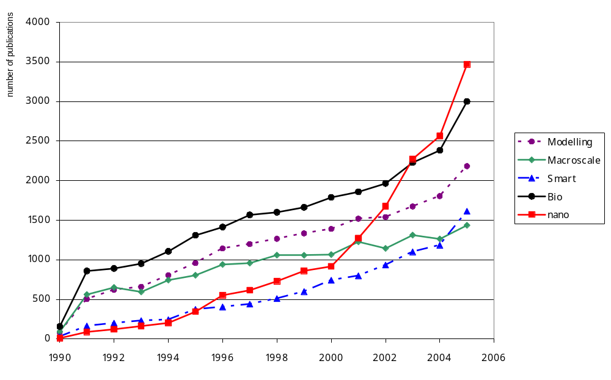
Figure 5: Development of all SMART Topics. number of publications

Relevance of materials technology for different industrial sectors
Materials innovations are an important part of the European cultural heritage which can best be seen at the typical European Design. Current industrial sectors with a high dependence on competitiveness on materials innovations are:

- Automotive industry
- Aerospace industry
- Chemical industry
- Electronics
- Textile industry
- Energy technology
- Medical technologies
- Construction
- Defence & security

The European automotive industry is responsible for 3% of the GDP and for 2 million direct jobs and 10 million indirect jobs. With annual R&D investments of 20 billion € the automotive industry is the largest R&D investor in Europe. Road safety, environmental issues and comfort are the main innovation drivers in this sector, which all rely on materials innovations.

In the European aerospace industry more than 7000 companies are active, which have a workforce of 433,000 direct workers and 1.5 million indirect jobs. This industry invests 9 billion € into R&D. Milestones like satellite systems (Galileo and GMES) and aircraft development are pushing innovation in this sector, in which materials for extreme environment, light weight structures and electronic materials play an especially essential role.

The Chemical and Pharmaceutical sector has 31,000 companies in Europe and employs a total staff of 1.9 million people. The chemical sector (excluding the pharmaceutical sector) spends 98 billion € per year for R&D.. Sustainability (energy, environment, resources) and flexibility in the production process as well as regulations (i.e. REACH) are the main innovation drivers in this sector. Nanotechnology and industrial biotechnology provides the means and innovations to meet these challenges. Biomaterials are the backbone of a thriving medical products industry that currently exceeds $50 billion in annual revenues in the United States.

The Electronics industry in Europe consists of more than 10,000 companies and 2 million employees. Drivers of innovation are post silicon chip technology, energy efficiency and regulation on electronic waste and emissions

More than 2 million jobs in over 150.000 companies (mainly SME) are still operating in the textile industry. This industry is in a process of deep transformation. Innovation is a key factor in developing high value added products which are seen as a solution to the current crisis. Today, technical textiles are already responsible for 50% of the turnover in the textile industry in some European countries. The technical textile industry sector is a growing very strongly in Europe.

Annual growth in medical plastics is 8% in Europe and the US, but is 15% in China.
Over recent years, a growing trend to transfer textile production from EU firms to developing countries, especially in Asia, has been noted. EU industry has played a leading role in the development of new products in the manufacture of textile fibres and technical textiles. The relevance of the global textile and clothing industry can be seen from the fact that textiles have a 5.7% share of the production value of the world's production, 8.3% of the value of producer goods, and more than 14% of world employment. The global market for textiles is worth more than 1 trillion Euros. In the European Union 120,000 textile and clothing companies employ more than 2 million workers. The European Union is the largest world market of textile and clothing products. However, because of the trend to transfer production to developing countries special emphasis should be placed on the development of high added value textile products (textronics), which are of special significance to the development and application of intelligent systems, intelligent clothing, textiles and footwear, as well as online systems for automatically monitoring the sewing processes of high-quality garments.

Global mapping of materials research activities
Bibliometric tools were used to obtain a benchmarking of Europe´s international position in materials research. Therefore the publication activity and the impact (CPP) of publications were considered. Table 1 to Table 5 give an overview about the relative European position regarding the publication activity. Europe’s position is competitive in all subgroups of materials science. Only in the area of smart materials is Europe’s position weak. Such mappings were also carried out on a city level taking the impact of papers into additional consideration. The following regions are some examples of very high ranked regions in these mappings: Abingdon (Great Britain), Albuquerque (USA), Ann Arbor (USA), Argonne (USA), Auckland (New Zealand), Baltimore (USA), Bangalore (India), Berkley (USA), Berlin (Germany), Cambridge (USA), Chicago (USA), Clayton (Australia), Eindhoven (The Netherlands), Evanston (USA), Halifax (Canada), Houston (USA), Jülich (Germany), Karlsruhe (Germany), La Jolla (USA), Lausanne (Switzerland), Liverpool (Great Britain), Los Alamos (USA), Louvain (Belgium), Mainz (Germany), Medford (USA), Minneapolis (USA), Murray Hill (USA), Paris (France), Pasadena (USA), Pittsburgh (USA), Potsdam (Germany), Richland (USA), Santa Barbara (USA), Seattle (USA), Sendai (Japan), Singapore (Singapore), St. Paul (USA), Troy (USA), Ufa (Russia) Washington (USA). These results are in good comparison to the mapping of Thomson.

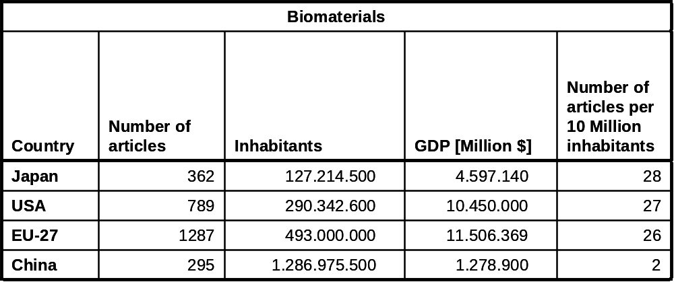
Table 1: Comparison of global publication activity in the area of biomaterials.

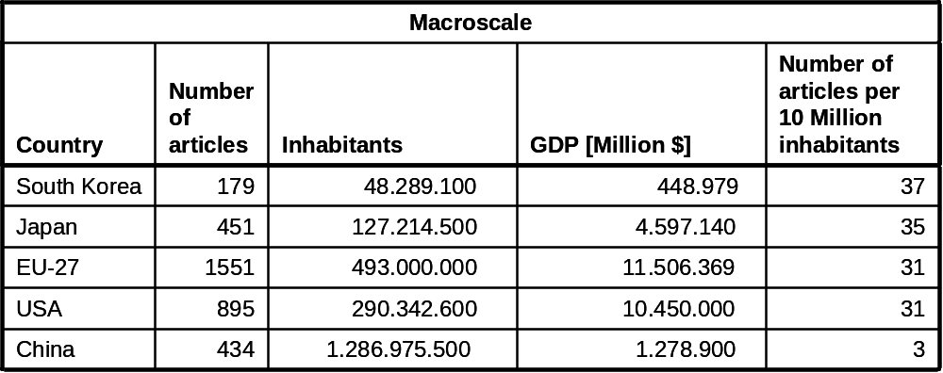
Table 2: Comparison of global publication activity in the area of macroscale materials.

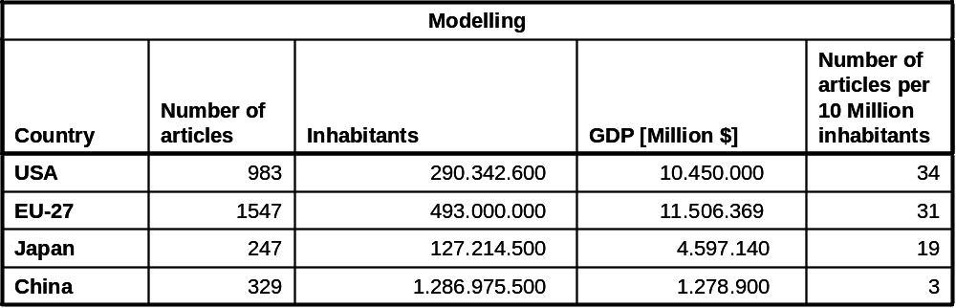
Table 3: Comparison of global publication activity in the area of modelling.

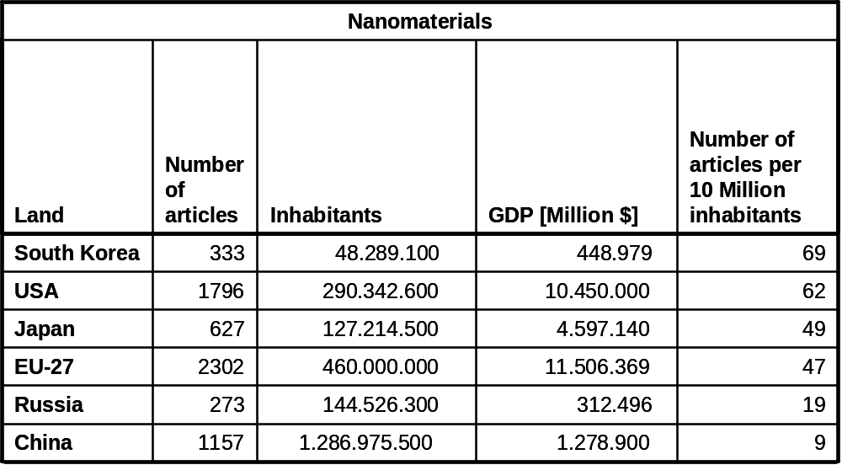
Table 4: Comparison of global publication activity in the area of nanomaterials.

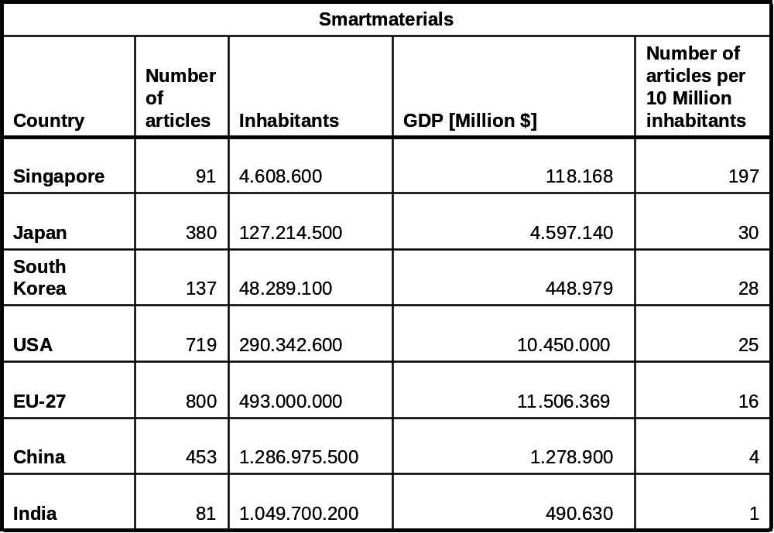
Table 5: Comparison of global publication activity in the area of smart materials

European Materials Research Regions

The most comprehensive compendium of materials activities was published by the so called white book. While the white book followed an approach to map activities and potentials by requesting overview articles from excellent researchers, in SMART activities and excellence of materials research was identified statistical by bibliometrics and qualitatively by interviewing (reputation).

By analysing the number of publications in different materials research areas per year it was found that Germany, Italy, France and United Kingdom have a high output of scientific materials science publications in all research areas. Poland and Spain have a significant publication number per year in the field of Macroscale Materials. Spain has also a high output in bio-, smart- and nanomaterials publications. Sweden has a significant activity in modelling. It has to be noted that this mapping does not contain any information about the excellence of the research in these regions. These results are in good comparison with the results of the global mapping in the area of biomaterials carried out by University of Leiden and Fraunhofer in 2001.

Additionally to the European regions mentioned in the listing of on page 15 (by bibliometrics) the following cities have been mentioned as being excellent in materials research in the interviewing of experts:
Bordeaux (France), Cambridge (UK), Darmstadt (Germany), Delft (The Netherlands), Dresden (Germany), Grenoble (France), Saarbrücken (Germany), Sheffield (UK), Stuttgart (Germany), Torino (Italy), Würzburg (Germany), Zürich (Switzerland).

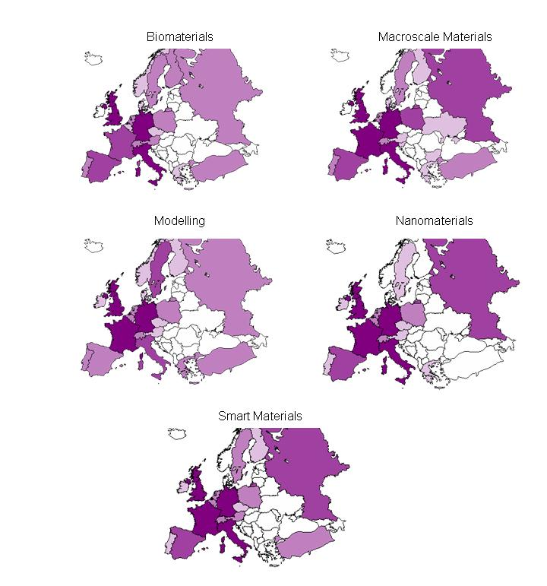
Figure 6: Mapping of materials activities in Europe

Tomorrows Materials innovations - Looking ahead

Foresight: materials innovation demands by society

Looking into the future is a very complex matter. It is impossible to give a precise prediction of the future, but different possible scenarios for the future can be drawn up. Globalization is not limited to trade today, but also affects all areas of economy and society including research and development and the competition for excellent workers. Therefore most countries worldwide began in the late 90ties to develop strategies for growth and wealth fare. These strategies have elements of innovation, resources, education and international marketing in common. In United States, a national strategy was set up to meet the challenges in the globalization of materials R&D. For Europe the European Council reacted to these demands in March of 2000 by setting up the Lisbon strategy which aims to make Europe the most competitive and dynamic economy by factors of innovation, a “learning economy” and social and environmental renewal. All actions in these mentioned fields rely on predicted scenarios. An important tool for predictions in the EU is the foresight method. Foresight that emerged in recent years is a method that aims to identify innovation priorities on the bases of scenarios of future developments in science, economy and society. Since such predictions are essential for implementing the Lisbon strategy, the Commission runs the Institute for Prospective Technological Studies - one of seven Joint Research Centres of the EU, which mainly undertakes strategic support of the development of EU research policies by foresight studies. As mentioned in the chapter about methodology on page 8, scenario-methods in the SMART project are used to identify long-term developments that might cause materials research demands.

Therefore in the SMART study about 40 recent foresight studies have been evaluated to extract materials of interest for the next 10 to 20 years. Unfortunately, nearly 1/3 of foresight studies could not been used because either no potential impact of the topic towards materials innovations was identifiable or they were too general. The remaining studies, both national and industrial, were investigated in detail. For this purpose a special questionnaire was developed and used by all investigators.
By analysing these studies, general priorities the studies are dealing with and the materials research hot spot fields which can be concluded from the scenarios can be distinguished.
The field of Priorities can be roughly divided into three groups of interest: Energy often connected to environmental issues, Better Life often connected to medicine and Security.
The analyses of foresight studies showed that the scenarios would have impact on all five subgroups used in the SMART terminology: Nano-, Smart-, Bio-, and Tailored-materials supported by Simulation.

The results of statistical evaluation of both general priorities and materials hot spots are shown in Figure 7. Column “Total” represents the number of all evaluated studies, while the other columns show in how many foresights the subgroup have been mentioned. Because more than one priority could be mentioned in the foresight studies, the sum of subgroups is not equal to column “Total”.

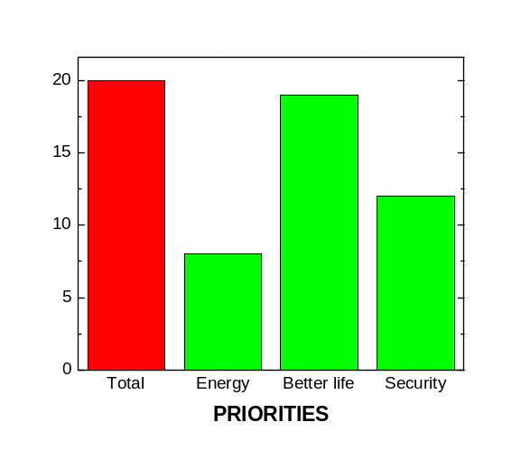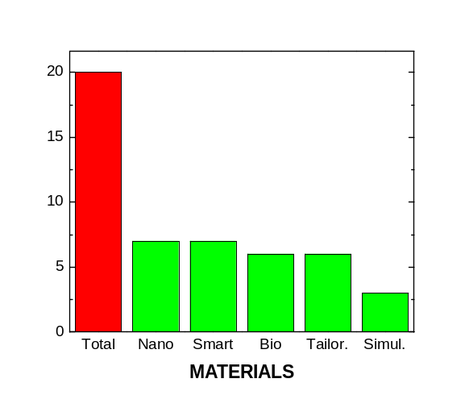
Figure 7: Distribution of foresight studies regarding to a) political priorities and b) materials subgroups

It is evident that in the field of Priorities the interest in subgroups increases in the order: Energy, Security, Better life, (Figure 7 a). According to these results higher interest can be anticipated in technologies that could positively modify the human life (Better life). Surprisingly the subgroup Energy had the lowest frequency of appearance in the studied foresights, even though the problems in the Middle-East, where the largest resources of oil are, are well known. The Security subgroup has been mentioned more often than Energy, most probably due to the terrorist attacks in the USA and Europe. These results could lead to the impression, that intensive foresight activities are started in those areas that are currently of interest, so that there is a response-delay. This shows a weakness of the foresight studies which focus on future fields from today’s perspective and which rely on financial funding, which is given to actual political topics rather than for anti-cyclical investigations.
As has been mentioned, in the foresight, several materials priorities were discussed. It means the combination of these priorities will be the focus of interest of European countries in the future. An example is the search for alternative energy sources with low impact on environment, which can contribute to both Energy and Better Life subgroups.

A detailed view on the field of materials in Figure 7 shows relatively random reference to the subgroups of materials in the foresight studies. The materials subgroups (except Simulation) have been mentioned at nearly the same level in the foresight studies. On the basis of these results it is impossible to select the best materials subgroup which would play a significant role in the future compared to other materials. The Simulation subgroup has been less frequently discussed in the foresight studies. Simulation is a highly interdisciplinary and integrative research and development tool for all subgroups and therefore will also be part of each material subgroup (i.e. second level sub-group). Its importance should not be underestimated as it has been mentioned in all more detailed foresight studies.

The priorities have also been evaluated from the point of view of how relevant materials innovations are for the scenarios drawn in these priority fields. It was estimated to which extent materials innovations would be needed for certain foresight scenarios. For example, in one foresight nano-materials and smart-materials have been mentioned for application in the field of Security, while in the other foresight nano-, smart- and bio-materials for category Better Life. It means from this two foresights two entries were added to priority Security and three entries to subgroup Better Life. The numbers of all materials, relevant to the given Priority subgroup have been calculated in this way, and the results are shown in Figure 8.
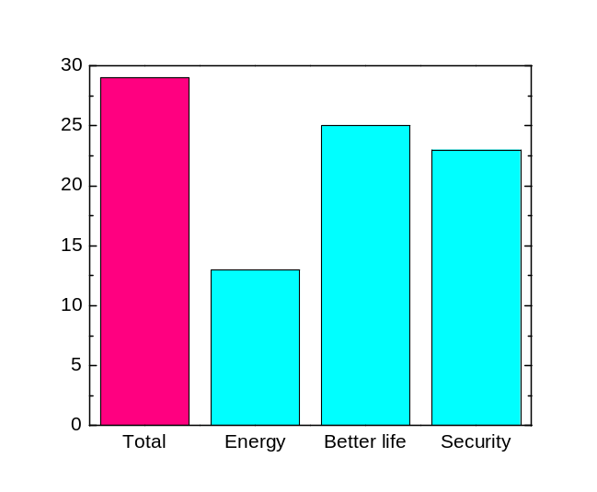
Figure 8: Relevance of materials innovations for selected foresight scenarios.

The detailed distribution of materials subgroups in Priorities subgroups is shown in Figure 9.

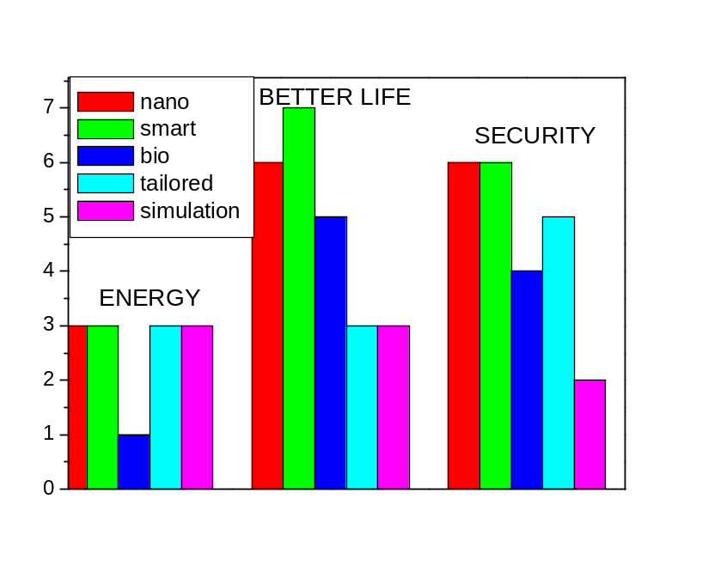
Figure 9: Comparison of foresight priorities and materials relevance, i.e. distribution of the specified materials in the Priorities subgroups (Energy, Better life and Security).

The results show that priority “Energy” would be enhanced with substantial progress in nano-, smart- and tailored-materials development together with simulation. This progress can be partially enhanced by bio-materials.

Priority “Better life” will depend on all studied subgroups. The main attention in future materials development for “better life” is expected in the field of smart-, nano-, and bio-materials. Additionally, the tailored materials and simulations should stimulate this progress.

The priority “Security” shows similar distribution of the materials subgroups, however the tailored materials gained higher importance in this field. The leading position of nano-, and smart-materials remained. The development of new bio-materials and application of simulations will also contribute the higher security in Europe.

The results of the foresight analyses regarding materials innovations are that energy, better life and security are relevant areas for shaping tomorrow’s world. In all three areas materials play an important role. All subgroups of materials research should be considered.

Screening for materials hot spot areas

The forecast work covered the left branch in the SMART project (Figure 1). This is the traditional approach to find future outcome using methods like trend extrapolation, expert interviewing and roadmapping. Therefore the forecast process started with the data screening and was followed by expert interviewing.

In the data screening more than 300 papers have been fully analysed. The analyses of these papers also led to the identification of keywords. The keywords were used to identify thematic hot spots and groups of excellence. Figure 10 shows the countries from where the corresponding authors originate and Table 6 gives an overview of their research fields.
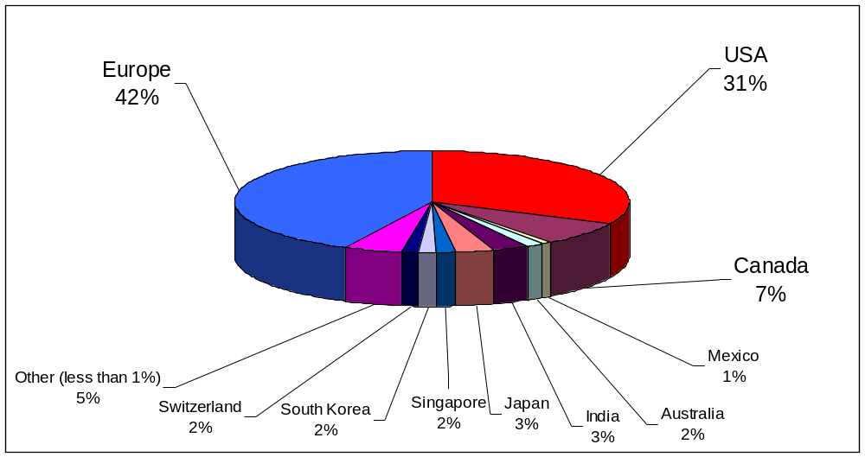
Figure 10. Data screening: Distribution of the review papers by affiliated country of the institute of the corresponding author.

Review-Paper-Analysis Corresponding Authors Research Field
Bioinspired Materials | 15%
Nanomaterials | 24%
Tailored Macroscale Materials | 25%
Smart Materials | 23%
Simulation | 13%
Table 6. Review paper analysis, statistics on corresponding author's research field

Analysis of the review papers lead to a list of 260 materials research topics with the potential for significant future impact on society and technology. These 260 topics were condensed by clustering to 36 different materials research fields. The analysis showed that most authors of materials science review papers expect soft matter, nanomaterials and tailored macroscale materials to be the important research topics in the near future (Figure 11). Even when the difference in the percentage of papers in the five Level-1 topics is taken into consideration, soft matter and nanomaterials still lead the statistics. In addition the analysis showed that 50% of the 36 materials research fields belong to more than one discipline, indicating that multidisciplinary approaches will play a much more important role in the future.

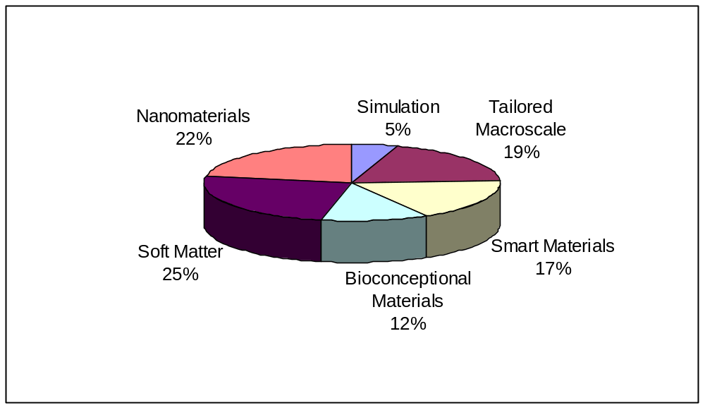
Figure 11. Relevance of materials research fields identified by review analysis. Allocation of hot spot topics, mentioned in review papers as highly relevant for the future, to Level-1 topics (multiple allocation was allowed).

Roadmaps: Materials powering Europe

Materials powering Europe was one of the three focus areas in the SMART forecast process to identify future materials research needs. All focus areas were identified through the foresight process by analysing recent foresight studies connected to social, economic and safety issues (see foresight chapter on page 20). The three roadmapping chapters are a synthesis of the three stages of the SMART forecast work combining the results of the literature screening, expert interviewing and expert workshops. The focus of the workshop “Materials powering Europe” was on energy, climate and natural resource issues. Within this category the SMART process was open and no topics were excluded, but emphasis was mainly on materials for energy efficiency and CO₂ capture and materials for renewable energy systems. However before examining these two fields some general aspects of worldwide energy trends and nuclear technology will be briefly considered.

According to the International Energy Agency (IEA) energy production and consumption will increase by 65 % in the next three decades of this century compared to the last three decades of the last century (Figure 12). The growth in energy production and consumption will mainly happen in today’s developing countries (non-OECD countries). Asia is seen as the strongest growing energy market. IEA predicts that without policy changes fossil fuels will remain the primary source of energy, while natural gas will grow fastest and nuclear power will drop in comparison to renewable energies (Figure 13). Since CO₂-emissions are very likely a major cause of recent climate changes, there is a growing interest in CO₂-free technologies like some renewables, energy saving strategies and nuclear technologies.

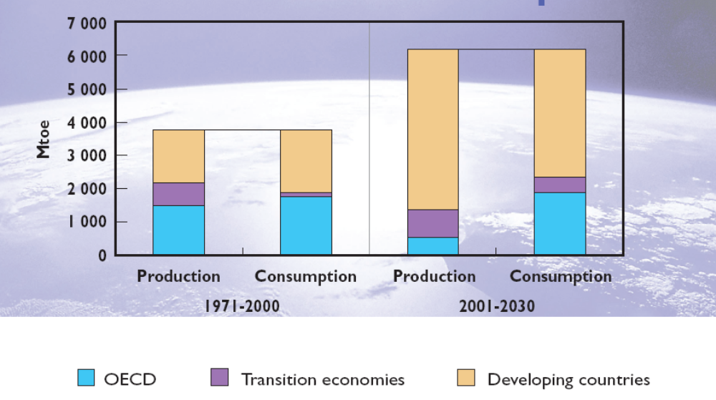
Figure 12: World Energy Outlook, Energy Trends 2005 www.worldenergyoutlook.org)

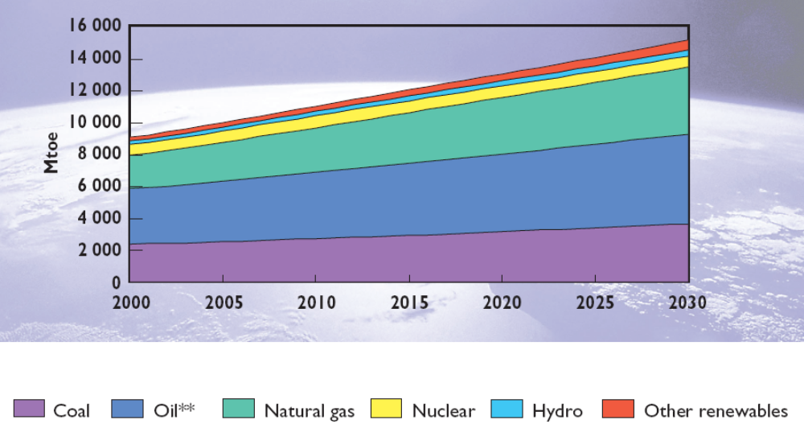
Figure 13: World Energy Outlook, Energy Trends 2005 , www.worldenergyoutlook.org)

Fission and fusion technologies

Today there are more than 440 nuclear power plants in operation in 31 countries worldwide. Currently (2007) there are 23 new nuclear power plants under construction and further 39 nuclear power plants are in an advanced planning stage. Even though this is a CO₂-free form of energy generation there is a lack of social acceptance in some countries and uranium supply is a bottleneck, since exploration has to be widened. Nuclear Fission is a process in which a heavy atomic nucleus absorbs a neutron and splits into two lighter fragments. Most relevant isotopes for fission are Uranium-235, Plutonium-239 and Uranium-233. This fission process is accompanied by an enormous energy release that is 10 million times greater than the energy released when one atom of carbon from a fossil fuel is burned. The released heat is converted into electricity via conventional steam and gas turbines. Today 66000 tons of Uranium is used per year but only less than 1% of the Uranium consists of U-235. The high market demand has caused the uranium price to rise twelve times in value since 2001. A Massachusetts Institute of Technology study in 2003 “The future of nuclear power” states that worldwide evaluation of uranium resources is needed. Furthermore this study states that R&D of the fuel cycle, a reduction in cost of the light water reactor and to enable the HTGR for power generation is required. The MIT researchers favour the once through cycle because of cost efficiency and safety. According to the study cost and waste criteria are likely to be the most crucial for determining nuclear power’s future. From the technical point of view the plants being in operation today are generation II and III plants. An international group of countries founded the “Generation IV International Forum”. This consortium (Euratom is one of the members) aims to develop a new generation of nuclear power plant that will produce less waste, address non-proliferation, lower costs of operation and have an improved safety standard. The Generation IV Roadmap also describes the materials R&D that has to be carried out within the next years. A challenge of materials in Gen IV plants will be the increased radiation damage - materials also have to have long service lifetimes. Since there is a lack of available data on candidate materials a broad testing program has to be undertaken to set up a basis for materials selection. A bottleneck is the limited number of test facilities for irradiation testing of materials, which later on will be used for in-core components. Also materials modelling is seen as a keyfactor in understanding the response of various alloy systems to higher temperature and radiation doses.

Besides fission nuclear technology, researchers are developing fusion technology but this will not be ready for use for quite some time. The principle fusion process of energy production is very similar to processes that take place in our sun. There are two approaches to realize fusion on earth. Inertial fusion consists of microexplosions of small fuel pellets by means of powerful lasers or particle beams. The second approach uses magnetic fields to confine the fuel. A fusion reaction that can be realized probably best on earth is the fusion between the nucleuses of deuterium and tritium. Both are isotopes of hydrogen. The fusion reaction leads to the formation of a helium atom and a high energetic neutron. In fusion first the electrons are stripped from the atom, so that plasma is created. The plasma is electrically conducting and therefore can be confined by strong magnetic fields. When heated to temperatures around 100 million degrees, energetic collisions between the plasma ions produce fusion reactions. High amounts of energy are then set free. In developing environmental friendly and cost efficient fusion technology structural materials for fusion reactors are a technological barrier. The challenge in the development of structural materials for the fusion technology are the high thermal stresses that are caused by the extreme heat flux through the fusion vessel and the degradation of thermo-mechanical properties of the surrounding material by activation through high energy neutrons. Currently an international consortium is constructing the first 500 MW fusion power plant, called ITER. Construction of ITER will last at least 8 years and then a service time of 15 years of the plant is expected, which will have demonstrative and prototype characteristics. On the basis of ITER the next step towards a cost competitive fusion plant would be the construction of a 2000 MW fusion reactor. While ITER can be constructed with existing materials, for the advanced plant advanced materials have to be developed,Error: Reference source not found. There are a number of different materials such as ferritic martensic steels, vanadium-based alloys and fibre reinforced composite materials under consideration.

According to fission technology the SMART workshop “Materials powering Europe” experts suggested that the hydrogen economy might depend on energy provided by nuclear power plants and therefore the necessary R&D in this materials field has to be undertakenError: Reference source not found. Experts also suggested a better communication between materials R&D engineers working in the nuclear field and those working in the area of fossil power plants. According to fusion technology the experts noticed the limited number of new materials that might fulfil the requirements for advanced fusion technology. The defined goal at the SMART workshop of developing materials that will withstand 2000°C could bring up some new candidate materials for an advanced cost and waste efficient fusion technology.

Present and Future Developments in Materials for Energy will be affected by the demand to reduce energy by being more efficient, and to produce less CO₂. Although in the long-term CO₂-capture, nuclear power plants, solar technology and in the very far future fusion might enable CO₂-free energy generation, the vanishing resources, the growing world population and evidence of significant climate changes force us to act very promptly, since projections based on today’s energy consumption and growth rates predict a steep increase in CO2 generation (see Figure 14).

Materials for Energy Efficiency and CO₂-Capture

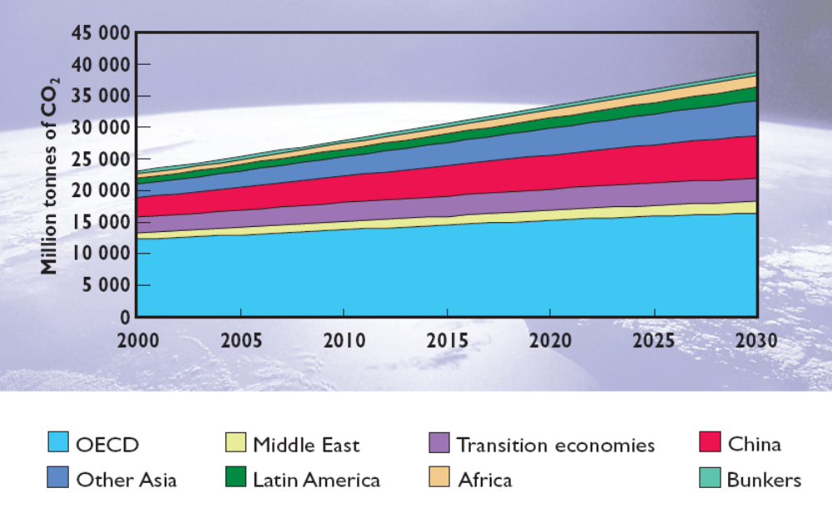
Figure 14: World Energy Outlook, Energy Trends 2005 , www.worldenergyoutlook.org)

Today fossil sources (oil, gas, coal) account for 80% of the world energy demand. Only 6.5% of the world’s energy is produced from nuclear and just 0.4% from wind and by solar technology. 25% of energy is produced from coal and 34% from petroleum. Therefore even if innovations and progress towards renewable and sustainable energy technology is on the way, the extreme long planning period for conventional power plants fired with coal and their long time in-service are reasons to also focus on drastic advances in conventional energy technology. Also alternative energy technologies have to be further developed and efficiencies have to be increased. On the other hand CO₂ emissions are increasing exponentially - there was a total coal-fired power plant capacity more than 330 GW in the USA in the year 2000 and in Europe new power plants with a total capacity of 800GW will be installed up to 2030. Also the enormous challenges can be seen from the fact that every week China is constructing the equivalent of two 500 MW power plants.

The CO₂ concentration in our atmosphere reached a value of 380 ppm. This is the highest value in the last 600.000 years. It is likely that CO₂ is one factor that triggers climate change. Since it is today unpredictable how this change will affect our environment, the European Union along with many governments and the United Nations started to take action to reduce CO₂. According to the Kyoto protocol the CO₂ content in the atmosphere should be stabilized and in the long-term lowered towards 280 ppm. One way to reduce CO₂ is to switch to energies that do not release CO₂. These are technologies like wind energy, solar cells, geothermal and tidal energy, fission and fusion technology. An overview about potentials and bottlenecks of these technologies will be given in the chapter Materials for sustainable energy technologies on page 48.
While a hydrogen-based economy would have many advantages, the distribution, transport and storage is a critical problem. For the Hydrogen Economy, a recent workshop was held, at Oak Ridge National Laboratory to develop an international strategic plan entitled Transforming Our Energy Future: Advancing the Role of Science and the Critical Connections with Applied Energy Programs.

Another technology, that might be ready sooner and hopefully could be realized fairly soon at a very larger scale, is CO₂ capture and storage technology. This technology has been identified as a key-technology for that advances in materials research are needed. This research area is enlabeled membranes for gas separation in SMART Roadmap “Materials for Energy” on page 61.

There are plenty of CO₂ sources. Besides power generation with fossil fuels also cement industry, iron and steel production and converting natural gas to fuel are CO₂ sources. Depending on the fuel and the different types of combustion processes, there are different possible strategies for CO₂-capture. In most cases CO₂ first has to be separated from other substances of the so called flue gas. This separation is needed since most power plants carry out the combustion of fossil fuels with air. Therefore the flue gas of coal combustion only contains 10 to 15% CO₂ and combustion product of natural gas just 5% CO₂. Storing the entire combustion product would mean storing mainly unproblematic nitrogen and therefore inefficient usage of storage capacities. Therefore the CO₂ should be separated from the flue gas after combustion or combustion has to be carried out in a way that the product contains almost no CO₂. For the first option chemical technology can be used by letting CO₂ reacted with a solution of amines or physical adsorption or even liquefying CO₂ are options. The second strategy would be combustion in pure oxygen. In this so called oxyfuel process the combustion product contains up to 80% CO₂. A challenge of the oxyfuel process is to separate oxygen from the rest of the air. The oxygen could be liquefied or membranes could be used for selective extraction of oxygen or materials could be used that adsorb nitrogen. These materials research challenges have been identified as a key issue for future materials research in the Roadmap on page 61. ExpertsError: Reference source not found, also state that oxyfuel processes change the entire combustion process and call for research on corrosion of advanced materials in such power plants. A third strategy could in some cases be to remove the carbon from the fuel and for example just burn up hydrogen.

Finally the CO₂ has to be stored. There are different options to store CO₂. The German Physical Society analysed the different options. In principle storage is possible in oil and gas reservoirs, mine cavities and in saline aquifers or in the Ocean/ Deep Sea. The storage in geological formation of porous and permeable sandstone like empty oil and gas reservoirs would be an opportunity for long-term CO₂ sequestration. The storage capacity in such formations is relatively low, as with mine cavities. There is an almost unlimited storage capacity in the oceans and the Deep Sea. However experts warn that environmental effects of dissolving CO₂ into seawater cannot be predicted. This technology is therefore too unsafe. Deep Sea storage would be from the safety point of view an option, but this technology would be extremely expensive. Saline aquifers have significant storage capacity (several 1000 Gtons capacities worldwide). Storage in saline aquifers would only increase the price of 1 kWh by 5 ct. Even if CO₂ production would increase exponentionally this storage would probably last for several decades. A risk of this technology would be an undiscovered leakage or a sudden release.

The energy working group of the Asia Pacific Economic Cooperation (APEC) carried out a huge three-phased project to explore CO₂-storage capacities in the APEC region (region includes USA, Canada, Australia, Russia, China, Mexico, Peru etc.) and to evaluate technological requirements for CO₂ sequestration. Two case studies are taking place at the moment. The Saline Aquifer CO₂ Storage project is carried out by Statoil in the Norwegian North Sea. A second project takes place in Weyburn, Saskatchewan –Canada. In Germany the first CO₂-free 30 MW coal fired power plant is under construction by Vattenfall at Schwarze Pumpe in Brandenburg, Germany. BP oil company built the first large scale plant for production of CO₂-free electricity in Scotland. The BP plant will transform natural gas into hydrogen and CO₂. The hydrogen will be used to operate a 350 MW power generator. Latest developments in CO₂ capture technology can be found at the website of the FP6-project ENCAP (www.encapco2.org).

Even though many experts expect that CO₂ capture and storage has the greatest potential to avoid a further increase of CO₂ emissions, it is still unclear if up scaling of this technology towards a global scale will be possible from the political, technical and economic point of view. At the same time it is for sure that the fossil energy resources are limited so that attempts to use energy more efficiently are highly important for future energy supply. A significant reduction in CO₂ production could be realized by savings in energy consumption. Some of these savings are also connected to materials research demands, like to switch to energy saving LED lighting (organic electronic materials). The world market of LED is currently at 6 billion € with an annual production of 50 billion units. Already half of the production are high-brightness LED for lighting applications like automotive tail lights, stop lights and large displays.

Construction of light weight structures is another application area for energy savings. Energy savings are very important in the mobility sector. Already today there are more than 600 million cars and trucks worldwide. For air and land transport light weight concepts are already being applied by using light weight materials like foams, Al or Mg-based alloys, composites (bio-composites) and by setting up smart structures of conventional materials (like steels) that contain less materials with the same or even a better performance. Nanomaterials like nanocomposites have widened the opportunities for engineering of light weight structures. Also Nanomaterials enable to lower friction in moving parts and therefore to increase the energy efficiency in engines. Further approaches for energy saving could be through smart materials concepts. Phase change materials could be used for climate control in housing.

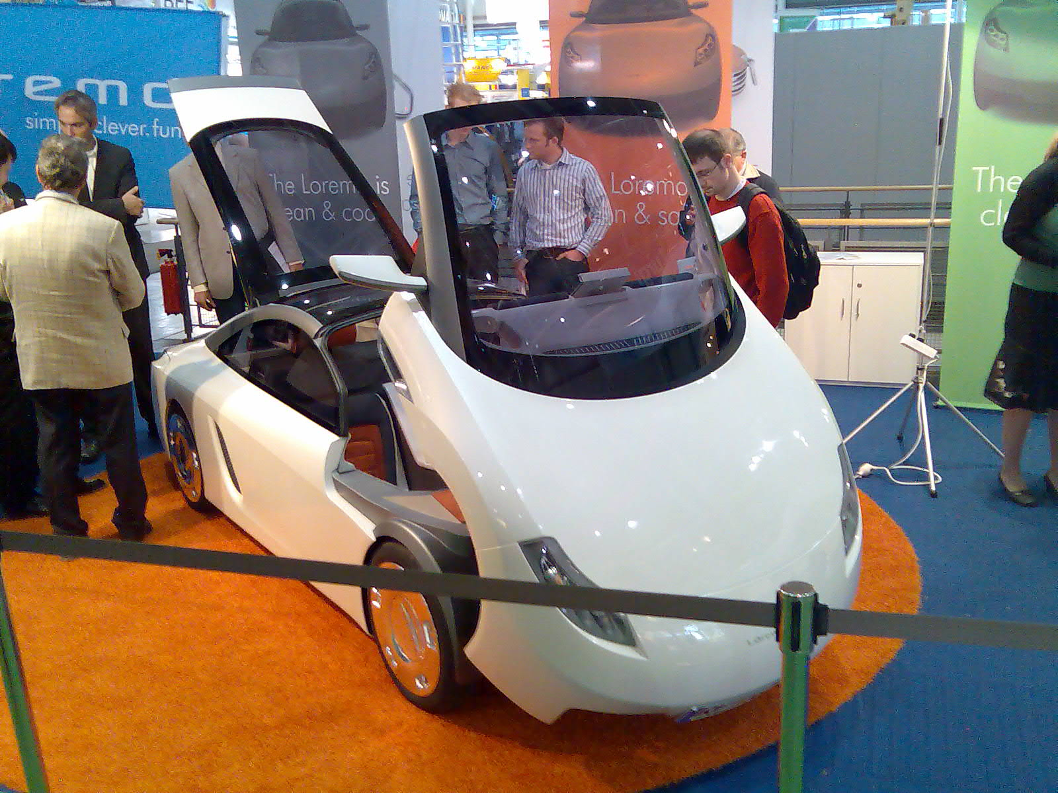
Figure 15: Just simple engineering with today`s available innovations allowed Loremo to construct a car with 1,5 litres of fuel consumption per 100 kilometers. This car is powered by a 2 cylinder turbodiesel.

Energy Transmission

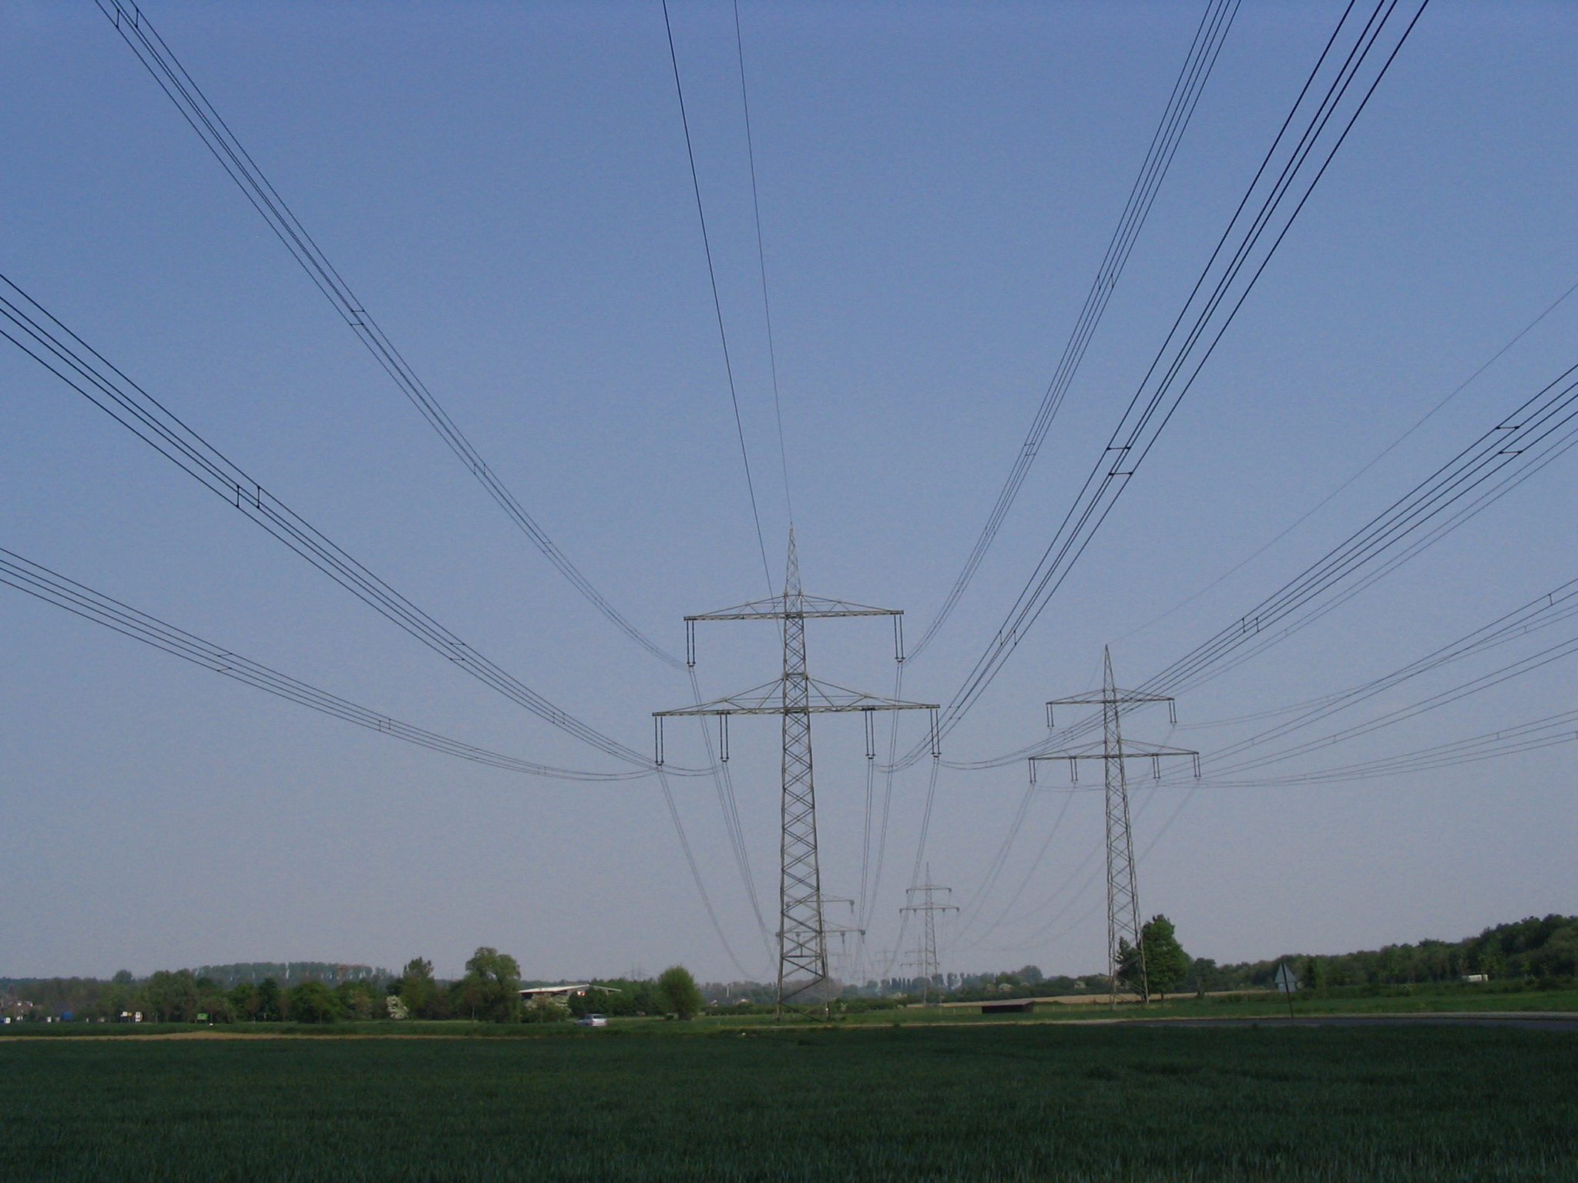
Figure 16: Energy losses in power transmission are about 8 to 10%.

The European vision of the future electricity transmission network can be found in the Strategic Research Agenda of the European Technology Platform SmartGrids. The future networks should be highly flexible fulfilling customer needs, with high efficient power generation and low or zero CO₂ emissions, reliable and economic. Materials play a great role in the development of the future power cable. There are a number of developments going on including the development of fluid- and gas-filled cables. Another keyfactor is the intrinsic conductivity of some polymers, which could lead to the development of polymer dc-power cables that are produced through a simple triple extrusion process. In the future many experts expect enhanced transmission will be carried out by superconducting cables. In the search for practical use of the superconducting effect (discovered in 1911) it seemed in 1986 that a breakthrough was very close when Bednorz and Müller found superconducting high-temperature copper oxide in a research lab in Switzerland. In the late 80ies and early 90ies there was a research hype going on in finding even better materials. Finally it was not the materials but their processing that was making applications expensive. Important progress in superconductor research was made in 2001 by two Japanese researchers who found superconducting intermetallic magnesium diboride (transition temperature: -234°C). At the same time progress was made in finding highly efficient cooling systems that do not use helium anymore. Superconductors have already a variety of applications today and by reducing their costs more promising applications might be seen in the future. Today the biggest market for superconductors is in the high performance sensors of Magentic Resonance Imaging (MRI). Potential upcoming applications cover HTS and LTS power cables with ultra low ac losses, transformers (oil-free and more efficient), motors, current limiters, SQUIDs for measuring brain waves and for enhanced devices in radio communication. Recently Nexans and RWE reported that they successfully tested a current limiter in 10 kV grid. Superconductors could reduce the weight of generators in wind turbines by 30% (up to 150 tons).

Power lines on the countryside consisting of nanotubes that have been announced by US-National Nanotechnology Initiative seem to be unreachable from today’s point of scientific knowledge. There might be contactless energy transmission in the future through microwave transport via satellites in the orbit, but it is very likely that most energy will be transported as energy along the earth’s surface trough wires. The most significant changes in the future might be seen through changes in the energy grid itself. It can be expected that most consumers will also be energy producers in the future and have their own local energy storage. A transition to smart, resilient, distributed energy system coupled with pollution-free energy carriers, e.g. hydrogen and electricity can be expected.

Increasing Energy Efficiency

There are several sectors where increasing energy efficiency is of strategic importance. These are dominated by power generation but energy efficiency is equally important in the construction sector (especially the built environment), steel production and electrical energy storage.

Increasing efficiency of power generation

The highest effects in energy savings could be realized at the source itself by increasing the efficiency in power generation and combustion processes. The best current efficiency of coal-fired energy generators is 55%. Further improvements in efficiency developments in gas turbines and boilers are needed. In the sections “High Temperature Advantages of Conventional Power Plant Generation” and “materials efficiency” of the roadmap on page 61 needed materials developments to make energy generation more efficient have been identified.

Modern gas turbines require a significant increase in gas inlet temperatures in order to obtain maximum efficiency. Europe is probably some 50 degrees C behind the USA in this respect. Therefore enhancements in the service temperature and the corrosion resistance of the blade material are needed. In general, corrosion and environmental degradation are thermally activated processes with an expected increase in severity as the temperature increases. In power generation, an industry currently dominated by the use of fossil fuels, fuel flexibility is now a coveted goal. Use of coal and synthetic gas can potentially lead to hot corrosion issues.

The blades in modern aero, marine and industrial gas turbines are manufactured exclusively from nickel-based super alloys. Gas turbine blades materials developments are going towards ceramics, reinforced aluminides and silicide based components although completely new materials systems, not materials, will be required by 2020. As the nickel based super alloys are actually operating above their melting points in many cases, improvements in thermal barrier coatings (TBC) are essential. The nickel-based super alloys are coated with a hot corrosion resistant MCrAlY-bond coating. This coating also provides the needed rough surface for the thermal barrier coatings (TBC) that go on top of the MCrAlYs. TBC are ceramic coatings that protect the metallic blades from the high temperature and hot corrosion attack. For the development of these materials new measurement techniques for mechanical properties of coatings are needed. Higher temperature ceramic systems (> 1400ºC) especially for industrial gas turbines have to be developed as well as better bond coatings. Current technologies used to deposit the coatings are electron beam physical vapour deposition (EBPVD) on aircraft engines and Plasma Spray on power generation turbines. Both techniques are line of sight so complex geometry parts cannot readily, if at all, be coated all over. The usual material for TBC is Yttria Stabilised Zirconia,YSZ. Their failure mechanisms, non-destructive evaluation, life prediction and life remaining assessment will continue to be active research topics. Technologies will need to be developed that improve coverage and reduce thermal conductivity. All TBC sinter in service which progressively reduces the porosity and increases the thermal conductivity (the porosity provides the insulation).

Since gas turbine technology is a very safe sensitive field in aircraft applications and because of long lifetime requirements very critical in energy plant applications materials modelling for improved coatings and life prediction is a key factor for gas turbine developments.

For the future combustion energy plant advanced boiler and steam turbine materials have to be developed. These materials will have to face conditions of temperatures above 700ºC and pressures at 350bar. These materials will be required by 2015. Austenitic steels for high temperatures are needed, with Cr steels decreasing. Today there are solutions for up to 600ºC. Predictions are based on trial and error. In general a better understanding of microstructures in such materials is needed.

Energy Efficiency in Construction

Huge amounts of energy are produced for heating and lighting buildings, often in an unsustainable manner from fossil fuels. Such uses account for around 42% of all energy consumed in Europe, whereas construction activities account for about 5% of energy used.

For this reason, energy consumption of urban areas and of buildings, in particular, must be dramatically reduced. In 2002, the domestic and service sectors accounted for 41% of all final energy consumption in the EU-15.

The first requirement is to develop a new generation of “highly efficient buildings”, with reduced energy demand. But the existing stock has a long life-time and solutions to retrofit existing buildings are lacking. In today’s context, 80% of energy consumed during the whole life-cycle of a building is consumed during its service life (only 20% for materials, construction and demolition).

Reduced energy consumption must therefore be done for both new and existing buildings. The two areas need different R&D programmes. Energy efficient buildings require new concepts and technologies to retrofit existing buildings and for affordable new buildings with very low energy consumption. Medium term this will require embedded renewable energy sources, cladding and ventilation technologies, sensors and pervasive computing systems to develop the concept of the “Intelligent Building”. In the longer term buildings will need to be developed as an active part of the entire energy system.

Similarly there is a requirement for efficient and environmentally friendly construction materials. For example, innovative materials and technologies for the recycling/reuse of construction waste, reduced raw material demand and integrated life-cycle processes for flexible buildings and infrastructures.

Energy Efficiency in the Steel Sector

Almost all European manufacturing sectors are largely based on the utilisation of steel in various forms. These are dominated by the construction and automotive sectors. The construction sector has been discussed above. The automotive sector has to address environmental sustainability owing to energy consumption, CO₂ emissions, resource efficiency, dismantling and recycling behaviour such as the UK “End of Life Vehicle” directive.

Electricity and natural gas supplies make up a significant part of steel production costs although energy consumption and CO₂ generation in the European steel industry have decreased by 50% and 60%, respectively over the past 40 years.

Since the beginning of the 1990s, blast furnace processes have approached their physical upper limits with respect to energy efficiency.

A sustainable approach towards by-products and residues is a must. Three major themes have been identified: the greenhouse gas challenge, energy effectiveness and resources savings and the social impact of materials.

Certain research areas have been identified that will be required to produce safe, clean, cost effective and energy efficient steel production. These include development of sensors, robotics and process modelling.

Efficiency in Electrical Energy Storage

Fuel cells and hydrogen storage have already been identified on the roadmap as medium term requirements for energy storage. (see following section on hydrogen economy). Another important area will be the development of materials for batteries often integrated with fuel cells for medium-power applications.

An important criterion for the choice of battery material is the relationship between specific energy and energy density. The old lead-acid battery is at the bottom of the scale (and is large in size) with Zn-air batteries at the top of the scale (small in size).

Future considerations will look at multifunctional materials and systems. Where weight is an important factor, as in electric-propelled unmanned air vehicles (UAVs) polymer lithium-ion cells are being developed and refined to form part of the overall storage system. These light weight batteries may also be considered for automotive applications and would be particularly attractive when combined with renewable energy, such as wind turbines, for re-charging.

Hydrogen Economy

Fuel Cells could be used in mobile applications, in stationary applications and to power portable devices like notebooks. The fuel cell is an electrochemical power generator. The fuel cell principle has been known for over 150 years.

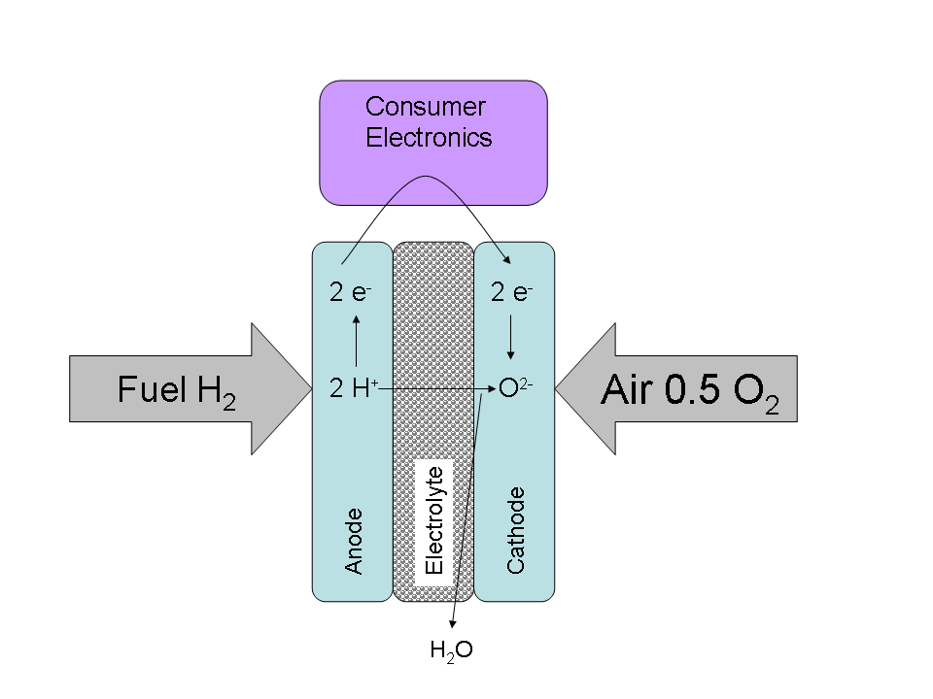
Figure 17: fuel cell principle

There are a variety of fuel cells which differ in working pressure, working temperature, employed fuels and electrolytes. A common principle of all fuel cells is that two electrodes are separated by an electrolyte (principle shown in Figure 17). One of the electrodes, called anode is supplied with hydrogen or a hydrogen-rich gas, and forms positively charged hydrogen ions. The other electrode, the cathode, produces negative oxygen ions through oxygen or an oxygen-rich gas. The result is electric voltage between the electrodes. This voltage can be used in practice by linking the electrodes over a circuit. Electrons flow through an external circuit and work there, whilst the movement of ions in the electrolyte produces the charge transport in the cell. The theoretical cell voltage under standard conditions is calculated as 1.23 V (in practice technical cells will get cell voltages oscillating between 0.6 and 0.9). To achieve higher voltages serial or parallel connections of various cells have to be made.
Five fuel cell types have been developed commercially. These are the alkaline fuel cell (AFC), the polymer electrolyte membrane fuel cell (PEMFC), phosphoric acid fuel cell (PAFC), molten carbonate fuel cell (MCFC) and solid oxide fuel cell (SOFC). These fuel cells can be categorized due to their working temperature into low, medium and high temperature fuel cells.

Alkaline fuel cells, polymer electrolyte membrane fuel cells and direct methanol fuel cells belong to the low temperature fuel cells, which means that they are operating at about 80°C. AFC is operated with potassium hydroxide solution as electrolyte. All materials problems in AFC are seen as been solved, but due to the incompatibility with CO₂ and CO most companies and institutes stopped the development of this fuel cell type.

PEMFC analogous to the AFC even small amounts of CO can damage the catalysts. Therefore carbon monoxide produced together with hydrogen during reforming has to be reduced to a content of about 10 ppm. The electrolyte used for the polymer electrolyte membrane fuel cell is a thin, gas tight, proton conducting plastic membrane. The water content, necessary for ion conducting in the currently available perfluorinated polymer membrane limits the possible working temperature. The strong acid character of the membrane makes it necessary to use precious metal catalysts. PEMFC has reached a high technical maturity. The DMFC is an improved version of the PEMFC. The electrolyte is again plastic. The great advantage of the DMFC is that the anode can be supplied with methanol while the cathode can be supplied with air. So methanol does not first have to be converted in a reformer into hydrogen. Further research is needed on the precious metal catalysts and on the reliability of the membranes. DMFC is still in the development stage and some research bottlenecks like diffusion, intermediate products blocking the catalysts surface have to be solved.

The PAFC is an intermediate temperature fuel cell that is operated at 200°C and supplied with hydrogen fuel usually reformed from natural gas and air. The PAFC works with an electrolyte of nearly water free phosphoric acid gel. The advantage of the PAFC is it’s high tolerance towards CO₂. Even though this fuel cell type has a low efficiency, it is a cell type that is commercially available. Installations from 200 kW to 11 MW have been already made. However the profitability of this fuel cell type still needs improvement.

The Molten Carbonate Fuel Cell (MCFC) working at about 650°C and the Solid Oxide Fuel Cell (SOFC) operating at 1000°C are high temperature fuel cells. MCFC have an electrolyte of the carbonates Li2CO3 and K2CO3 which is fixed in an porous ceramic matrix. Carbonate ions play a key role in the MCFC concept. Since CO₂ is part of the carbonate cycle in MCFC this fuel cell type is very advantageous in converting carbon fuels into electricity by using the so called internal reforming process which is driven by waste heat of the stack and converts the fuel to hydrogen and CO₂. Therefore MCFC is able to process directly natural gas, biogas and coal gas. This fuel cell type is constructed by very affordable materials like steel, ceramics (carries electrolyte) and nickel/ nickel oxide (electrodes). However there are strong materials research demands since the molten carbonates create a highly corrosive surrounding. This is a key issue since the low life time of this cell type and cost consuming maintenance work are bottlenecks for a broader use of MCFC. Today first MCFC pilot power plants are operating in the range of 2 MW.

The high operating temperature of SOFC is causing a variety of problems. SOFC have a gastight ceramic electrolyte (yttrium stabilized zirconium dioxide). The high temperature is needed, so that the conductivity of the electrolyte is high enough. Because of the high temperature again internal reforming of the fuel gas (same as by MCFC) is possible. Cost reductions in materials processing is highly needed, so that researchers try to lower the operating temperature of SOFC below 800°C. Materials problems are high corrosion rates and stress through different thermal expansion coefficients. SOFC is the least developed of all fuel cell types.

Therefore it can be summarized that materials innovations could be a technology enabler for especially PEM/ DMFC, MCFC and SOFC. Problems in today’s fuel cell technology are high cost of materials and their processing, availability of costless specific catalysts, sealing, thermal cycling, corrosion and reliability problems (see also field fuel cells in the roadmap on page 61).

Recently a lot of effort is put into fuel cell development for mobile applications. The vision is the zero emission vehicle. But not every fuel cell system and infrastructure would be more beneficial than today´s conventional drives. Fuel cells would only be part of a future sustainable economy, if the produced hydrogen fuel would be produced by non- CO₂-emitting energy technologies. The fuel cell vehicle is basically an electric vehicle were the battery is replaced by a power generating fuel cell. The best developed fuel cell system for vehicles is the Polymer Electrolyte Membrane Fuel Cell (PEMFC). This fuel cell type has to be powered with almost CO-free hydrogen and air. Hydrogen storage in vehicles and its distribution to service stations is still an unsolved problem. Therefore novel materials for hydrogen storage, direct methanol fuel cell and the development of energy efficient reformers are other important topics. In the 5th Framework Programme the EU tried to overcome the technological barriers of fuel cells with projects like HYTRAN, ZeroRegion and CUTE. Within the 6th Framework Programme more than 40 projects are aiming at the improvement of fuel cell technology and to enable the application of this technology. The European Hydrogen and Fuel Cell Technology Platform published a roadmap “European Roadmap for the development and deployment of H₂ and fuel cell technologies” (timeframe 2007 to 2015) in which materials innovations play a key role to develop MCFC and SOFC for combined heat and power applications as well as power generation.

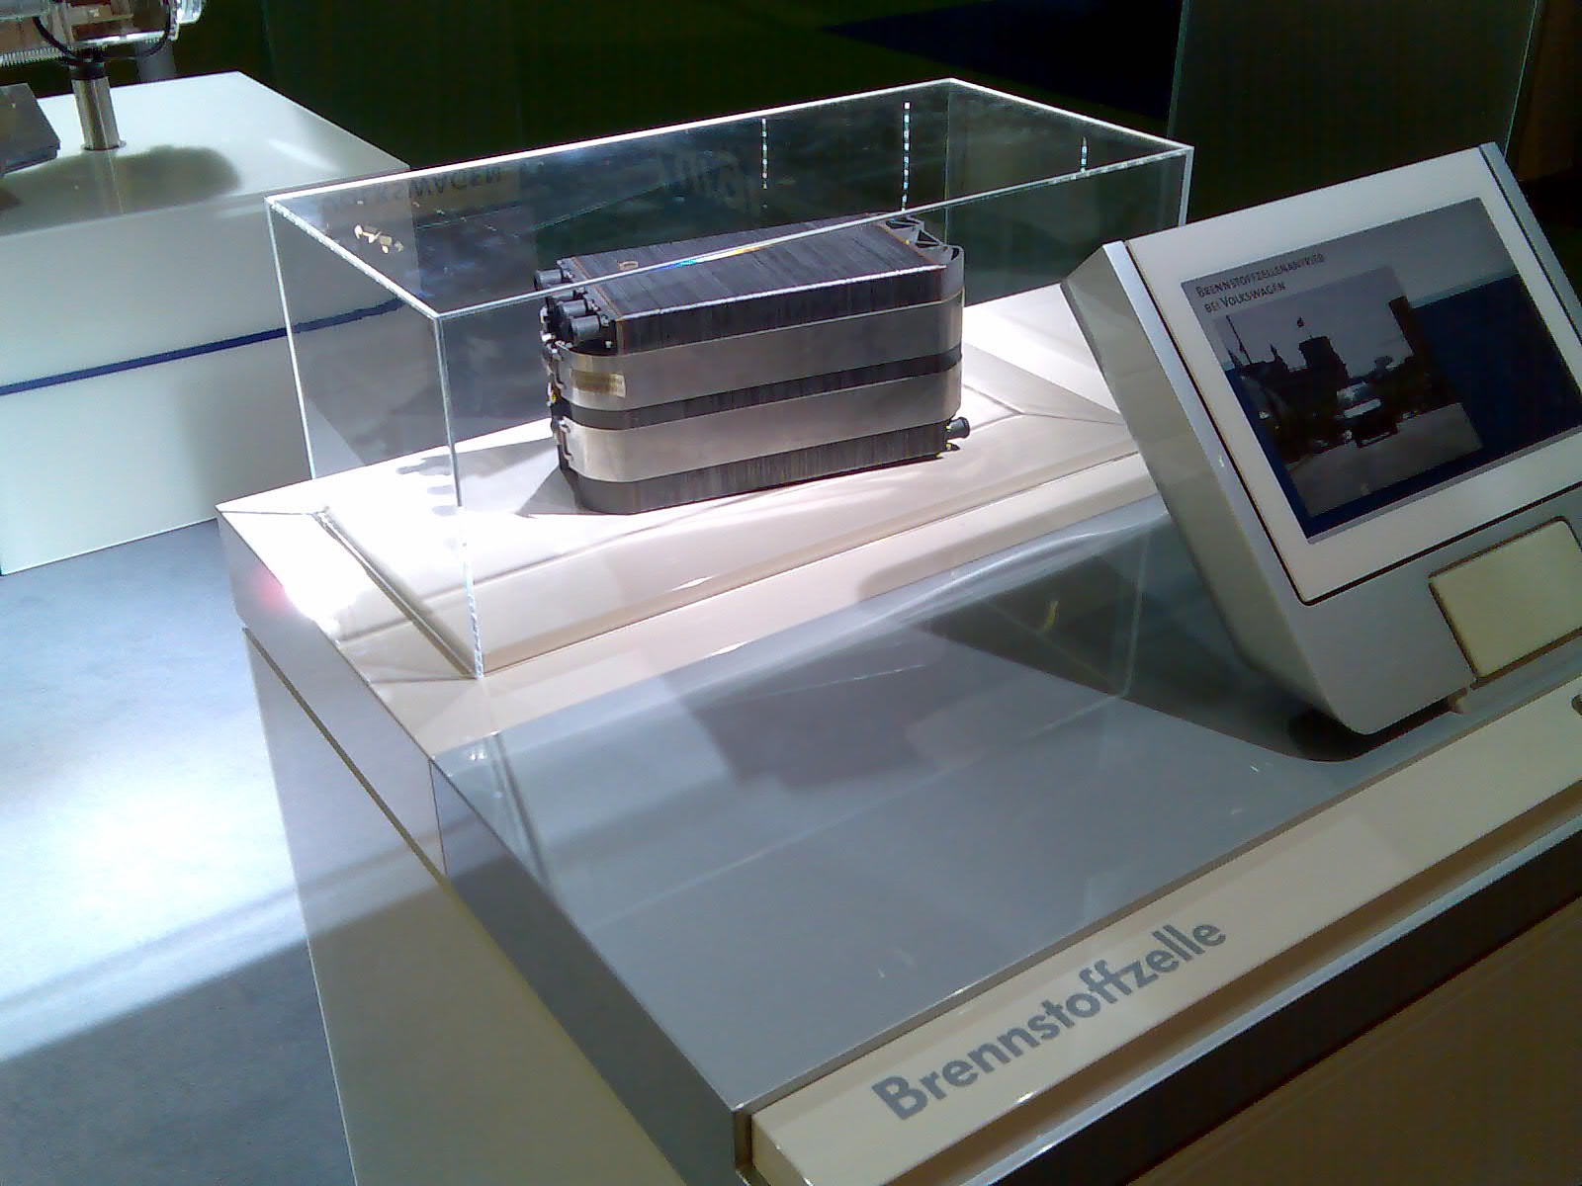
Figure 18: Volkswagen high temperature fuel cell (photo taken at Hannover Fair 2007).

While a hydrogen-based economy would have many advantages, the distribution, transport and storage is a critical problem. Pressurized hydrogen takes a great deal of volume compared to today’s gasoline - about 30 times more volume at 100 bar. Condensed hydrogen is 10 times denser, but too expensive and there are safety concerns. Therefore research is going on to find materials for hydrogen storage like carbon structures (fullerenes, nanotubes), metals and metal alloys. A promising way for hydrogen storage is seen in the formation of hydrides by reaction of the hydrogen with the atoms of the energy storage material. To realize high energy efficiency the hydrogen has to be realized from the storage medium with minimal energy consumption. Binding energies make it very difficult to find a medium with a high hydrogen storage density and easy hydrogen release. Recently, researchers are focussing investigations on metal-organic framework (MOF) compounds. MOFs consist of metal-oxide clusters connected by organic linkers. MOFs are a relatively new class of nano-porous material that shows promise for hydrogen storage applications because of their tunable pore size and functionality. MOFs might even be used for CO₂-storage, since so called MOF-177 that has the highest carbon dioxide capacity of any porous material. Lately covalent organic frameworks (COFs) have been found, which have similar properties to MOF but do not contain metals.

Materials for sustainable energy technologies

While for the short to medium time range energy efficiency is an important strategy in the long run it is important to find non- CO₂-emitting renewabels energies that can serve the exponential growing world energy demand. Figure 19 gives an overview of renewable energy sources.

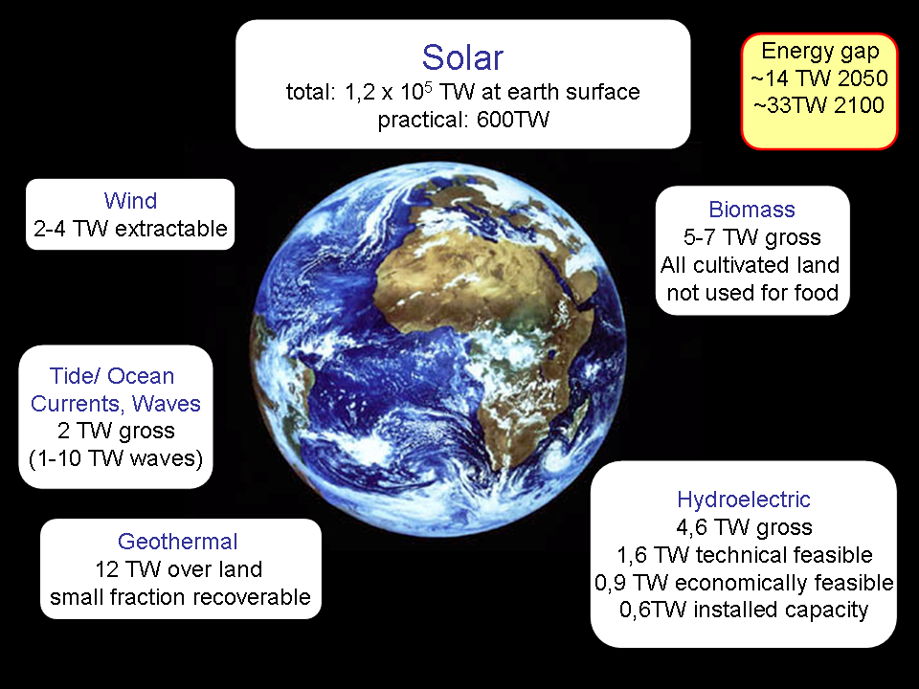
Figure 19: Ways to fill the world energy gap. In 2006 worldwide 14 TW were utilized. Data and analogous figure from Professor Kilner (picture earth from ESA)

Wind energy
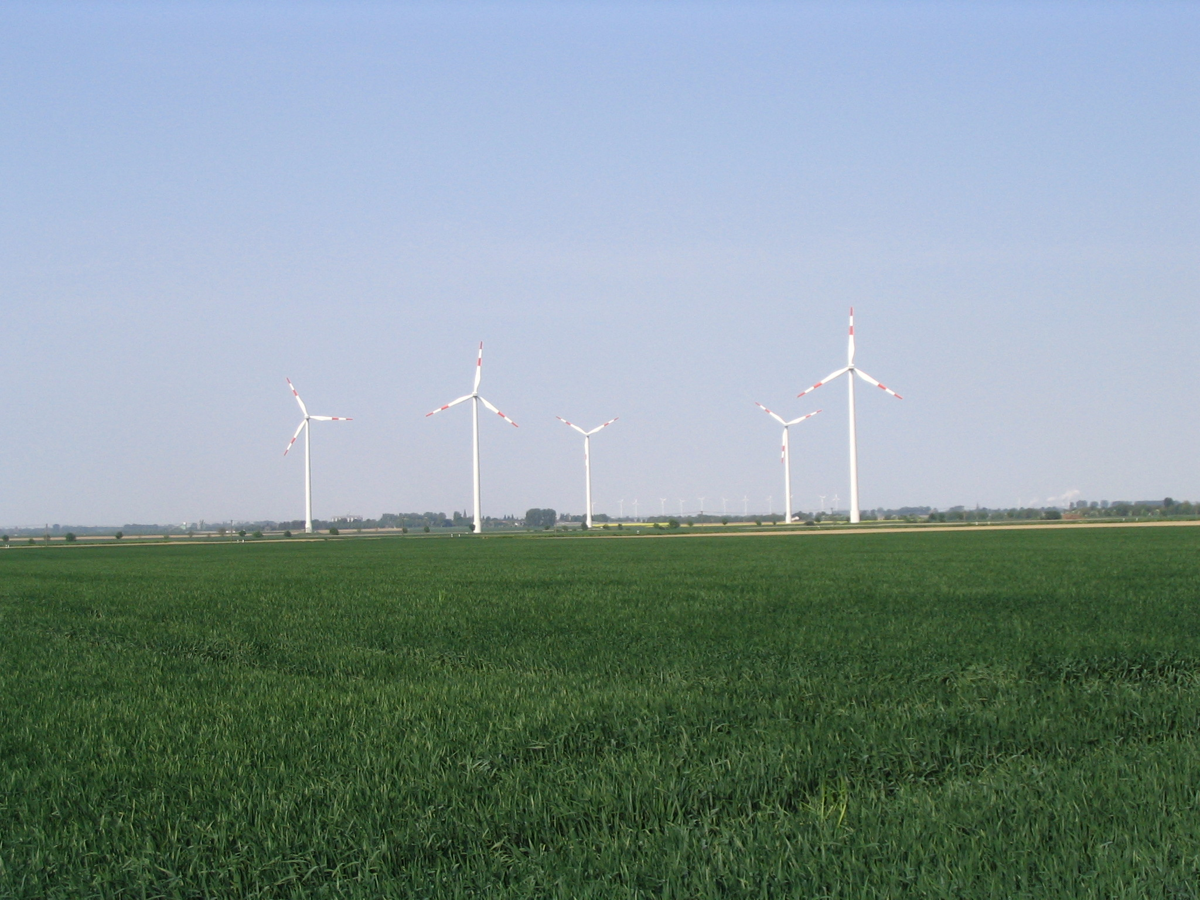
Figure 20: Wind generators (photo: Gerd Schumacher)

As shown wind power can only deliver a small fraction of the global energy demand. Wind turbines convert kinetic energy into electric energy. The characteristics of a 5 MW wind turbine machine are that it has a rotor diameter of 120m, which require high strength and weight ratio. There are even installations with 200m rotor diameter in discussion, in which case blades would weight 50 tons. In principle a wind turbine consists of a rotor that has wing shaped blades attached to a hub. The hub houses a drivetrain consisting of a gearbox, connecting shafts and the generator. The hub-rotor system is positioned on a tower, which is ground-mounted. However, although the generated power increases with the square of the rotor diameter, the mass of the blades increases to the third power of the rotor diameter if the dimensions are simply scaled up (square-cube-law). Therefore rotor design, new materials and modelling of materials behaviour are critical factors in the development of advanced wind turbines.

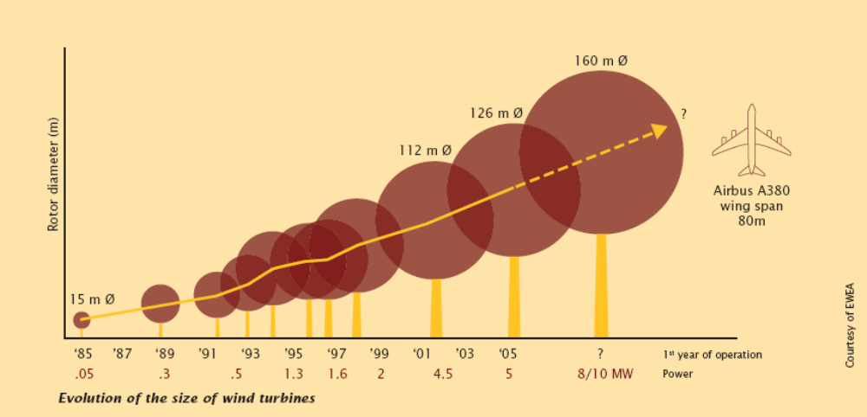
Figure 21: growth in the rotor diameter of wind turbines (taken from )

Dr. Gooch gave in his presentation an overview about materials that are mainly used today in the construction of wind turbines. Most wind generators are positioned on tubular steel towers, manufactured in 20 to 30 m long sections (alternatively lattice towers or concrete towers are also used). The rotor blades of most wind turbines are made of glass reinforced plastics (GRP, plastics being polyester or epoxy). Other promising materials are carbon fibre reinforced plastics, which are emerging but still expensive. Only in a few rotor types wood / epoxy laminates strengthened by carbon fibre are used (i.e. some 1.5MW machines). Aluminium alloys and steel are only used for blades of very small turbines due to weight and fatigue problemsError: Reference source not found. Furthermore textile researchers hope to develop blades from technical aramide textilesError: Reference source not found.

Developments in glass reinforced plastics are heading for weight and cost reduction. Advanced joining techniques could allow to transport blades for future installations in sections, which would lead into a great cost reduction. Also these techniques could allow the combination of composites with metals, which would widen the opportunities in wind turbine design. Important for the design of future concepts is also the optimization of scaling results from test coupons to full size components. Finally materials degradation and testing is a key issue for which non-destructive examination (NDE) and life assessment are important tools. A better understanding of the effect of spectral loadings on fatigue life is needed. Environmental degradation is another research field covering subjects like the effect of moisture absorption by matrix leading to surface crazing.

Because of the limited capacities for wind power on land (onshore), wind parks are moving now offshore. Offshore installations are a great technical challenge. Stiffness and fatigue strength of the constructions play a key role. Since the environment of offshore installations contains water, salt and there are higher UV emissions also higher corrosion, erosion, stress corrosion resistance can be expected and the resistance to UV exposure and a good impact resistance are issues for materials research.

In 2005 Europe already had an installed capacity of 34 GW. Europe is the leading manufacturer of wind power with a market share of 90%. The United States of America plans to obtain in the future 20% of their electric energy demand through wind energy.

Hydropower, tidal and wave power (David Gooch)

Hydropower is an established technology that already accounts for a significant fraction of global electricity production. Hydropower can be obtained from potential energy (reservoirs) or kinetic energy (e.g. rivers). Hydropower electricity is mainly generated by passing the water through large water turbines. Modern water turbines have more than 90% efficiency. The worldwide hydroelectric capacity in 2005 was 700 GW, with the USA (80) and Canada (67) being the biggest producers. Tidal power is a special form of hydropower that exploits the motion of the tides. Tidal barrage systems trap sea water in a large basin (tidal lagoon) and the water is drained through low-head water turbines. A first large scale tidal power plant was constructed in 1966 in La Range France with a capacity of 240 MW. In recent years, rotors have been developed that can extract the kinetic energy of underwater currents, these underwater rotors work similar to wind turbines. A major problem is to built stable systems that can withstand violent sea conditions. The energy in a surface wave is proportional to the square of the amplitude and typical ocean waves transport about 30–70 kW of power per metre width of wave-front. Therefore also devices that harvest the energy from waves have been invented. Most of the best sites for tidal plants are on the western coastlines of continents between the 40° and 60° latitudes. Greater than 100 years life is a requirement, but concrete steel reinforcement corrosion is a problemError: Reference source not found. Materials barriers that have to be overcome are the chloride attack that destroys the passive layer normally present in alkali conditions. Also carbonation of concrete produces acid conditions. Possible measures are cathodic protection, polymeric coatings, or corrosion inhibitors in concrete.

Hydro turbine materials issues are corrosion mainly caused by stress and fatigue. To enable Hydropower to be used more often worldwide also research for low cost C and C-Mn steel adequate for many components and extensive use of stainless steels for critical components has to be done. To avoid silt erosion and cavitation erosion advanced coatings technology has to be applied.

Similar to nuclear energy technology the hydropower causes often public controversy because of relocation of citizens (dams) in the construction stage (so far more than 30 Mio. people worldwide) and the risk of collapse. Also the cost for construction of dams is much higher than for fossil fuel plants and after its lifetime similar to nuclear power high costs for decommissioning arise.

Biomass and waste to energy

Every EU citizen produces 500kg of waste per year, so that in the entire EU 225 mio. Tons of waste are produced per year. There are several different ways of waste management like landfill, recycling and conversion to energy. Due to regulations in most developed countries landfill is more and more reduced. Some fractions of the waste can be successfully recycled such as aluminium cans, glass, paper and fibres. Waste to energy is a strategy to convert waste to energy. Experts in the SMART project tended more towards realizing a zero waste society (see better life chapter) by enabling biodegradable packaging materials. Waste to energy can be sustainable, if a high amount of waste is from renewable bio-based products, since the amount of CO₂ set free by combustion will be consumed by the renewable source. However, the waste to energy technology is today a high sophisticated technology and an important alternative to landfill which causes methane release, a greenhouse gas 23 times more dangerous than carbon dioxide.
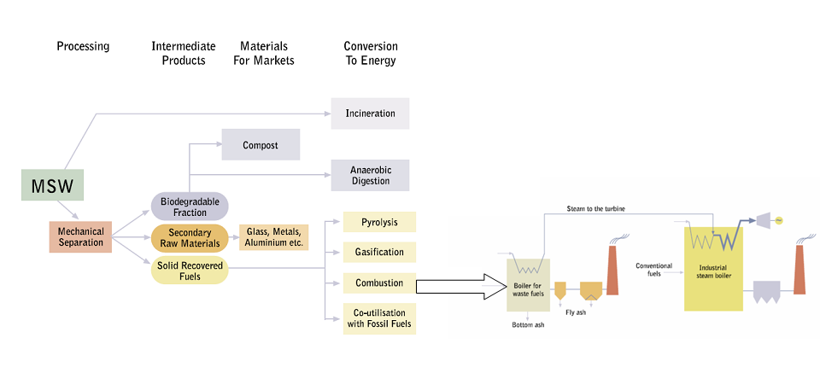
Figure 22: Waste Management; MSW: municipal solid waste (taken from IEA Bioenergy)

Materials issues cover developments in superheater tube corrosion. Currently the efficiency of the combustion process is limited due to the fact that steam conditions above 400°C, 40bar would increase superheater corrosion. Target of superheater materials development are 520°C, 100 bar steam. Low cost tubes are needed for the replacement of carbon steels used today. High Cr, Ni based steels with up to 8% Mo seem to be best. Other candidates are coatings for alloy 625.

Definition of biomass: “….the biodegradable fraction of products, waste and residues from agriculture (including vegetal and animal substances), forestry and related industries, as well as the biodegradable fraction of industrial and municipal waste...”. Biomass is an important part of renewables with a fraction of 65% of all renewables energies in Europe. Europe´s total land area is around 385 million hectar (EU-25). Woodlands cover 140 and crop fields 180 hectars. Biomass from these trees and crops could deliver 11% of todays energy needs. But since the world population is growing these land resources probably have to be used for agriculture of food. Biomass can be used to produce a wide variety of product types like heat, electricity, solid fuels, liquid transport fuels and gaseous fuels. More than 80% of biomass comes from wood, 13% from municipal waste and only 2% from biogas. Recently biomass to fuel (btl) processes are seen as a promising alternative to fossil fuels in the transport sector to overcome shortages in gasoline supply.

To produce electricity (or combined heat and power - CHP) from biomass, the biomass is converted to heat by combustion. The heat is used to produce steam which drives a turbine. In advanced biomass installations the biomass is converted to hydrogen, biogas or methanol and used to operate fuel cells. Usually biomass-based power plants are below a size of 20 MW. In many plants co-combustion with coal in utility boilers becoming favoured option for wood fuels. Corrosion in such plants is highly fuel specific, eg alkali chlorides from straw. There is no consistent correlation of corrosion rates with Cr, Ni content of alloys being used. The corrosion rates can be reduced by co-firing, since sulphur in coal produces sulphates, which are less corrosive than chlorides. Also reduction by injection of ammonium sulphate is possible, which converts alkali chlorides to the less corrosive sulphates.

Other processes besides combustion to convert biomass to products and energy are other thermomechanical processes like gasification and pyrolysis (high temperature process in absence of oil producing bio-oil) or biological methods like anaerobic digestion. Gasification is a high-temperature process which is carried out under conditions that lead to a combustible gasError: Reference source not found. In the process part of the biomass is combusted under restricted air/ oxygen supply taking place between 1200 and 1400°C. By this process a gas consisting of carbon monoxide, hydrogen, methane and carbon dioxide is obtained. This gas can be directly burned to produce heat or electricity or to feed a gasturbine. Materials corrosions problems are in gasification plants more severe than for combustion plants because of highly reducing conditionsError: Reference source not found. Also trace elements, tars, ash etc could cause potential corrosion problems in gasturbines, so that (hot) gas cleaning is needed.

Geothermal

No details were given in view of the limited opportunities in Europe.

Solar

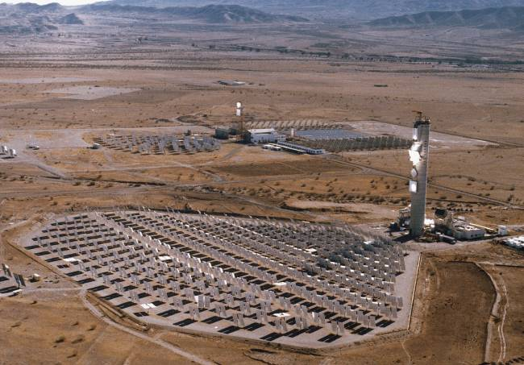
Figure 23: Solar Thermal Central Receiver Systems (SIREC): In this plant in Andalusia, Spain a high flux receiver (2 MW/m2) has been installed, with has a compact design and a ceramic matrix. This device operates at temperatures of 1000 ºC and has a selfregulation system to adjust air recirculation flowrate.

Solar energy reaches the Earth's upper atmosphere at a rate of 1366 watts per square meter. The radiation is used for different technologies like solar hot water systems, photovoltaics and solar thermal electric power plants. In Figure 23 such a solar thermal electric power plant using a solar power tower is shown, which uses an array of flat, movable mirrors (heliostats) to focus the sun's rays upon a collector tower. The high energy at this point of concentrated sunlight is transferred to a working fluid for conversion to electrical energy in a heat engine.
Photovoltaics are seen as one of the most promising ways to produce sustainable energy since the energy produced by the sun seems to be almost inexhaustible. The best way to convert sun energy for practical uses is to use the photovoltaic effect. This effect is known since 1839 and was discovered by Becquerel. A photovoltaic device (solar cell) converts adsorbed photons into electric charges that are used to energize an external circuit. The most important role in today’s market of photovoltaics play silicon solar cells. The drivers in the photovoltaics market are the search for new and better materials, the lowering of production costs and higher efficiency. Materials research focuses on new inorganic materials for thin film solar cells, organic based photovoltaics, multispectrum cells and dyes.

Today’s solar cells are produced from crystalline Silicon, which is doped to set up a p-n junction. On the one side an excess of positive charges (p-side, holes) is implanted to the material and the opposite side an excess of negative charges (n-side, electrons). In the region in between at the junction an electric field is created. Light produces electrons and holes in the Si-bulk material. These charges are then diffusing through the silicon towards the electrodes. Photovoltaic devices used today are solar cells of the first generation having a single junction. The theoretical maximum energy conversion efficiency of first generation cells is 31%. The best performances having been reached so far can be found in Figure 24. Today’s photovoltaic installations have to be improved in the sense of corrosion fouling resistance and abrasion of collectors.

Currently second generation photovoltaics are approaching commercializationError: Reference source not found. These devices are aiming at thin film technologies that do not need to be produced from wafers anymore and therefore have reduced costs. These devices are based on materials systems like CdS/CdTe, Cu(In,Ga)Se2 (CIGS), and multijunction a-Si/a-SiGe. Second generation devices are fabricated using techniques such as sputtering, physical vapour deposition, and plasma-enhanced chemical vapor deposition. Multijunction cells based on a-Si/a-SiGe have been the most successful second-generation technology to date because of their relatively low production cost. Some companies are producing a-Si/a-SiGe devices using roll-to-roll processing on flexible stainless steel and other substrates that allow high-speed productionError: Reference source not found.

The long-term vision is to develop cells with a better efficiency/ cost ratio. According to Figure 25 there are two ways to reach these third generation devices. The first strategy is to use revolutionary physical concepts to develop cells with an ultra high efficiency even above 50%. The second approach is to create solar cells with moderate efficiency but at an extreme low cost. Most experts today believe that the second approach could be realized through organic-based photovoltaics. Organic photovoltaics might play an important role as a power source in using organic electronics for displays, smart packaging and actuators in the future. The advantage of organic solar materials is their low price and the opportunity to use low-cost high trough put manufacturing processes. A major problem is degradation of the conducting polymer. Organic semiconductors are functioning completely different than inorganic semiconductors. In organic semiconductors light produces excitons (electron-hole pairs bound together by coulomb forces). These pairs have to be disconnected at a defect site or an interface leading to an electron transfer from the donor material to the acceptor or a hole transfer from the acceptor to the donor. The organic-based cells still have a long way to go in R&D. Challenges are to increase their efficiency by at least 5% and to enable harvesting a more energetic part of the electromagnetic spectrum by reducing optical bandgaps. Furthermore an improved understanding of carrier transport processes and the recombination at interfaces is needed. Finally higher charge mobilities are needed. The other approach is heading towards ultra high efficient solar cells. Physics and nanotechnology offer a variety of effects that might be used to realize solar cells with an efficiency above 50%. Multi-junction cells are one way to improve the efficiency. Since a single junction cell can only absorb a certain wavelength of the spectrum, the rest of the spectrum gets lost and cannot be converted to usable energy. Therefore in multi-junction cells a stack of cells with different bandgaps is set up. Such multi-junction cells could theoretically have an efficiency of up to 70%. First research results with multi-junction cells have shown improved efficiency of up to 34%. Quantum dots/ nanoparticles have advantageous properties for the development of ultra efficient solar cells, since in nanoparticles the bandgap is a function of the particle size and therefore tuneable. Another advantage of quantum dots is that they can be incorporated into an organic matrix, so that the resulting engineering material can be produced easily and integration into devices is comparable to commonly used technologies. Multiple excitations from one photon are being produced, which happens when the absorbed energy is far greater than the semiconductor bandgap. This phenomenon was only observed in semi-conducting quantum-dot materials. Recently multibandgap materials have been found that can convert several different wavelengths with a single junction.

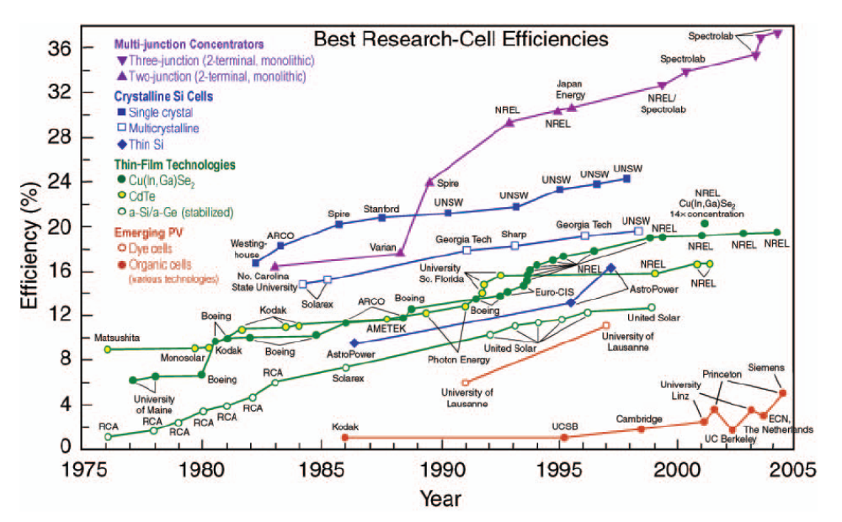
Figure 24: Taken from MRS

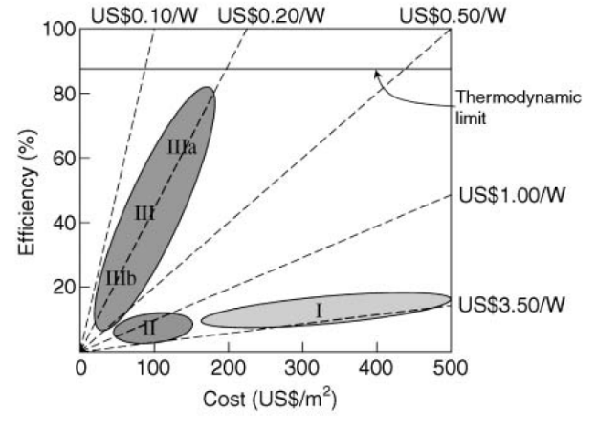
Figure 25: Showing expected efficencies and prices. Taken from MRSError: Reference source not found.

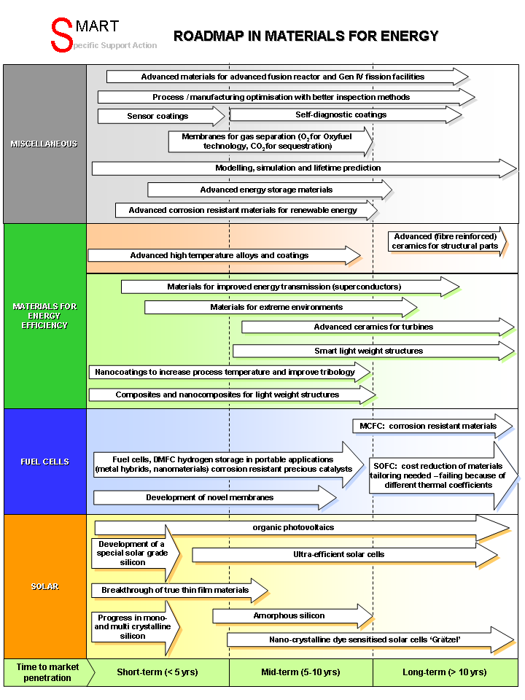
Figure 26: Roadmap Materials for Energy

Energy is a strategic resource for industrialized countries so that the development of future energy technology is of great importance for Europe. Energy safety and CO₂-reduction are the main drivers in this field. The following research priorities have been identified:

- Innovative gas separation membranes for CO₂-capture technology
- Corrosion resistance materials for energy technology in oxyfuel processes
- materials for white light emitting devices
- polymers and materials processing for organic light emitting devices
- ferritic martensic steels, vanadium-based alloys and fibre reinforced composite for future fusion technology
- phase change materials and MOF
- CO₂-reduction in mobility: light weight alloys, nanocomposites and biocomposites
- Materials for superconducting devices
- Advanced corrosion resistant (less degradable) materials for various renewable energy sources
- Corrosion resistant materials for SOFC
- Energy storage materials
- Advanced joining techniques for manufacturing of wind generators
- Ceramics for solar power tower technology
- Materials for 3rd generation solar cells

Roadmaps: Materials for a safe Europe

To identify the innovation potentials in the field of materials for a safe Europe expert interviewing and a roadmapping workshops were carried out. First of all this field of materials for a safe Europe has to be characterized. This field can be divided into personal protection, industrial safety, anti-counterfeiting and protection of the civil infrastructure. A special feature of this safety field is that most information is confidential. Furthermore a paper by Toni Grobstein Marechaux gives an overview about materials technology potentials to reduce the threat of terrorism. In the section Products and Technologies for Citizen Protection in the Strategic Research Agenda of ETP SusChem alarm systems based on stimuli responsive materials, and thermochromic windows as well as innovative textile materials for protective clothing and NBRC sensors have been identified as future research priorities.

Textile materials play an important role in the area of personal protection, but information about this area will be mainly discussed in the section on “better life”. According to the roadmap “Materials for a safe Europe” on page 73 the materials research topics can be categorized into materials for sensors and materials for protection. Therefore in the following two chapters the potentials in these fields will be considered in more detail.

Sensors
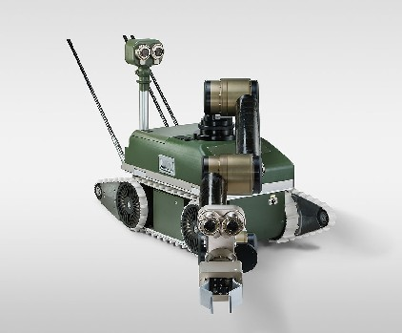
Figure 27: Robot for NBRC detection and mitigation of ammunition (photo from Diehl,

Most experts identified materials research topics for security in the SMART process that are connected to the area of sensors and sensing (see blue topics in figure on page 73). Therefore this important field will be considered here in detail.

For personal protection in households a spectacular innovation would be the application of intelligent carpets for usage in apartments or houses in order to protect the household against undesired visitors (e. g. burglars). After the household members leave the house, a security code is switched on, and the sensor-equipped carpet enters the security system of the houseError: Reference source not found. Similar optical solutions are already commercially available today, but pressure sensitive carpets might be a good complementary device.

Threats in the area of nuclear, biological, radioactive and chemical (NBRC) are very seriously since these substances could cause tremendous destruction and casualties at a large scale. Therefore the development of sensors for these threats has a high priority. For applications in food quality control and environmental monitoring already electronic noses are used based on metal oxide semiconductor (MOS) sensor arrays. These sensor systems are used to evaluate odours and malodours. Many metal oxides show gas sensitivity under suitable conditions, the most widely used material is tin dioxide (SnO2 doped with catalytic metal additives). The target is identified by its effect on the electrical resistance of the semiconductor. SnO2-resistive sensors have been developed for a wide range of applications (like H₂S sensor, ammonia sensor)Error: Reference source not found.

Nanostructured materials play a keyrole in the development of advanced sensors, since the interaction of the target and the site takes place on the nanometer scale. In the engineering of the sensors first an understanding of the target compounds is necessary. Some substances with low molecular weight like chemical agents and toxic industrial compounds are volatile and may not persist for very long in the environment (like sarin). Some of these substances are weaponized by materials modifications, so that their life time is extended. Some biological threats are very large biomolecules (like ricin).

For detection and protection, there are many examples of effective systems in nature. Especially for sensors, nature has numerous examples of detection at extremely low levels. Nanotechnology and lab-on-a-chip techniques will enable fast and more sensitive detection systems. The sensor must be able to detect the presence of the target in difficult backgrounds and at very low concentrations. Nanomaterials play an important role in sensor development, since these sensors need a binding or interaction site. This site could be a molecular imprint, a templated solid or a covalent interaction. The interaction site needs specificity for one certain class of compounds since the chemistry of the environment might be complex. A solution for the interacting site is immobilized enzymes. Enzymes have the advantages of being very specific and their interaction is a lot of times reversible. For the usage of enzymes they have to be immobilized on a platform (silicon or silica coatings). The linking between the enzyme and the surface of the platform is a materials challenge. The detection is made through the enzymatic chemistry (electrode, photoluminescence, spectroscopy).

Figure 28: Mine clearance in Democratic Republic of Congo. Still in many cases the dog sensing nose is superior to artificial sensors today (United Nations Peacekeeping Photo Gallery)

Other approaches for interaction sites in sensors are silicon and polymeric materials. Porous silicon has been used in the detection of explosives. Polymeric materials and silica sol-gels can be used as detection and collection devices by designing an interaction site through molecular imprinting during polymer formation. The target is used for imprinting and removed later on, which leaves an imprint with the complementary structure of the target. Furthermore the identification could take place by optoelectronic signals. In such system an array of multiple dyes would change their colour according to intermolecular interactions, which would be detected by optical sensors.

Besides nano- and chemical sensors another approach are spectroscopic sensors. Electromagnetic waves at the terahertz frequency are in the range of the electromagnetic spectrum between a wavelength under 1mm down to several 100 micrometers. Terahertz radiation is non-ionizing and can penetrate a wide variety of non-conducting materials. Terahertz rays can pass through clothing, paper, wood, plastic and ceramics. While also fog and clouds can be penetrated by Terahertz rays, metal or water are opaque to terahertz systems. Security related application areas for THz systems are the detection of concealed weapons since many non-metallic, non-polar materials are transparent to THz radiation. Many explosives (for example, C-4, HMX, RDX and TNT) and illegal drugs (for example, methamphetamine) have characteristic transmission/reflection spectra in the THz range that could be distinguishable from other materials such as clothing, coins and human skin. THz is a very promising technology since it does not pose health risk for scanning of people. The vast variety of potential applications of terahertz technology in medicine, industry and security is limited today by the lack of the availability of high-power, low-cost, portable room temperature THz sources. A breakthrough in THz technology could be managed through advances in high-speed electronics, lasers and materials research. Photoconduction and optical rectification are two of the most common approaches for generating broadband pulsed THz beams. The photoconductive approach uses high-speed photoconductors as transient current sources for radiating antennas. Typical photoconductors include GaAs, InP and radiation-damaged silicon wafers. Another possibility to produce terahertz rays is the inverse electro-optical effect. For the optimization of THz generation the electro-optic properties of different materials are investigated. Promising materials are semiconductors such as GaAs and ZnTe and organic crystals such as DAST among many others.

Challenges in sensor developments are to simultaneously measure different target components and to increase reliability by monitoring different sensor parameters at the same time. Also different sensor types will be combined in the future (hybrid sensors). Another important challenge is sensor stability over time.

Experts at the “Materials for a safe Europe” workshop addressed self-healing and self-checking detection systems as being needed. Also standards for sensors should be established. In most parts of Europe, R&D in sensors is particularly fragmented today. Because of a high grade of interdisciplinarity, progress relies on a greater collaboration between those working on different types of sensors. Even though cheaper and more reliable sensors are being developed today, major steps forward could be achieved through terahertz technology and through the development of rapid, miniaturised means of detecting DNA, .

Protection

There are new requirements for protection materials, in such a way that the material must have a high elastic modulus compared with the ballistic threat. Therefore low density ceramics are promising materials for protective use. There is a need to replace traditional bullet-proof glass with other transparent materials, which are harder than the threat. Nanotechnology is offering here some promising solutions. New materials in sight for protective use in vehicles cover nanostructured ceramics materials, combinations of metals, hard metals, high tech fibres and elastomers, new constructions of armour sandwiches and transparent armour concepts. New materials for construction play an important role in securing buildings and infrastructure against man made and natural disasters. Fibre reinforced polymer matrix composite materials could be used in the renewal of civil infrastructure ranging from the seismic retrofit of bridge columns and the strengthening of parking garage floor slabs to their use in replacement bridge decks and in new bridge structures, .

There is a need for lighter weight and more easily wearable armour (or clothes generally) that offer protection from piercing, chemicals, impacts, radiation, etc.. Interactive textiles have the potential to decrease risks of security personal and peace keeping forces. Using interactive textiles it will be possible to have a penetration alert (detection of a bullet or shrapnel penetrating the shirt of the security staff). This can be achieved using plastic optical fibers, while penetration is detected by a break in an optical-fiber circuit. Information than can be transmitted to the headquarters of the security unit and medical help send.

Fibres for bullet proof vests must have a number of chemical and physical bonds for transferring the stress along the fibre. The fibres should possess high stiffness and strength to limit their deformation. In fibre-reinforced composites, the fibres are the load-bearing element in the structure, and they must adhere well to the matrix material. An ideal reinforcing fibre must have high tensile and compressive moduli, high tensile and compressive strength, high damage tolerance, low specific weight (grams per square meter), good adhesion to the matrix material, and good temperature resistance. Fibres of significance with these properties include polyethylene, aramid, polybenzobisoxazole (PBO), M5, and carbon fibers. The para-aramids (Kevlar, Twaron, Technora) are the best known examples. M5 is a very promising material that might also find applications in automotive, aerospace and sports. Doetze et al. speculate that the high impact and damage tolerance resistance of M5 is due to the honeycomb-like structure of this polymer. Further protective applications of smart textile materials can be found in the better life chapter.

Special aspects of materials developments for protection
By Dušan Galusek, Slovakian Academy of Science

Ever increasing efficiency of modern firearms represents a significant threat to law enforcement and peacekeeping forces. This threat affects the operability of vehicles and the life/health of individuals. The new types of ammunition (e.g. with tungsten carbide core in small firearms, and kinetic penetrators, RPG’s, chemically driven ammunition etc. in larger calibers) represent a significant threat due to their high kinetic energy, high hardness, and resulting ability to penetrate easily into virtually any material. The attempts to counter such high energy threats usually lead to unacceptable increase of thickness and weight of armours, which is a limiting factor both in body and vehicle protection. The low weight imperative resulted in replacement of steels, as traditional armour materials, by ceramics, leading to layered armour concepts. These consist of a ultra hard ceramic impact layer, which decreases the kinetic energy of a projectile by shattering and eroding it. The underlying plastic (often metallic) layer absorbs the residual kinetic energy of the projectile by plastic deformation. Ceramic materials, like Al₂O₃, SiC, TiC, B₄C, therefore became the materials of choice for modern armour concepts.

Major challenges for protective armour materials of the future could be summarised as follows:
- decrease of thickness and weight at comparable/higher level of ballistic protection and acceptable price;
- increased modularity, protection-on-demand concepts where the armour system is adjusted operatively to expected type of threat, easy-to-replace armours for quick replacement;
- increased multi-hit resistance of ceramic protection;
- floating armours;
- really efficient transparent protection materials.

There are several important obstacles that have to be overcome:
- there will be probably no “miracle” material available in a foreseeable future, and the threats will have to be countered with what materials we have today;
- there is no general agreement on which properties an “ideal” armour material must possess: the uncertainty stems from a very complex nature of interactions between the threat and the armour;
- there are significant gaps in understanding the nature of interactions between threats and targets under dynamic loading conditions.
It has been generally accepted that armour must posses a high hardness, and high elastic modulus, under the conditions of dynamic loading expressed in terms of the so called Hugoniot elastic limit. This simple rule has been challenged recently by Krell and Strassburger, who attempted, on the basis of the analysis of bullet/armour interaction, to establish a hierarchy of key parameters influencing the ballistic strength of ceramic armours. The authors define two periods of the bullet/armour interaction:
  - Short initial phase (< 10 μs), where high dynamic stiffness (determined by Young's modulus) of the impact layer overmatches the impact load and causes the nose of the projectile to dwell on the ceramic surface without penetrating it in the first moments. It is, therefore, expected that Young's modulus is most important in this phase.
  - Penetration period, which starts about 10-15 μs after the first contact with a relatively low penetration velocity. This period involves erosive wear and fragmentation of both the penetrator and the surrounding ceramic armour. In this period the inertia (related to their size) of ceramic fragments and their hardness are believed to play a decisive role in slowing down the penetrator and to erode it, thus robbing it off the major part of the kinetic energy. How to achieve controlled shattering of the ceramic armour material to the fragments of controlled size remains to be answered by the future research.

Some promising solutions are offered by application of nanotechnologies:
    - The use of nano-structures ceramic materials, i.e. monolithic materials with submicrometre grain size prepared by advanced sintering technologies like spark plasma sintering, hot isostatic pressing, sinter-HIP, or microwave-assisted sintering, and their composites reinforced by nanoparticles, or nanofibres, e.g. carbon nanotubes.
    - New concepts of layered armours, and combinations of ceramics with metals, hard metals, high tech fibres, elastomers and liquid polymers (e.g. recently reported concept of liquid armour of polyethylene glycol with dispersed silica nanoparticles, known as shear-thickening fluid, which becomes rigid under applied stress, while being soft and flexible when the stress is removed).

In order to increase the ballistic efficiency of armours a multidisciplinary research effort will have to be focused on:
    - fundamental research leading to ultimate understanding of behaviour of solids under dynamic loading conditions;
    - modelling and computer simulations of interactions of high energy penetrators with high hardness and high moduli substances;
    - optimisation of the properties of existing materials, scaling down to nano-level structures with possible outcome of specific properties, not attainable in micro-scaled structures;
    - development of new methods of joining of fundamentally different materials;
    - development of fundamentally new concepts and constructions of armour sandwiches

Smart materials play an important role in the development of security systems. In this R&D-area engineers are applying bionic concepts for implementing smart materials systems into engines. Smart materials are materials systems that can sense external stimuli and respond with active controls, in real or near-real time, to change their properties. This change in properties allows the structure to dynamically adapt to its environment and to tailor its response. Smart materials function analogous to biological systems, where the brain, senses, and muscles work collectively. Smart materials systems have been used to reduce acoustic emissions in underwater applications and helicopter blades. By applying shape-memory alloys to wing-structures smart wing systems can be constructed which can be used to reduce radar signatures. Certain actuator materials (like PVDF, PZT, SMA, dielectric elastomers) are used for robots and unmanned aerial vehicles. A bottleneck in smart materials developments for security applications is to find an actuation material with similar characteristics to the human muscle. However, to develop a robot that truly moves and acts on biological principles, one needs to fully emulate the dynamics of the muscle. Wax et al.Error: Reference source not found compare this by the example, in which long before a person realizes the terrain has switched from dirt to sand, a person’s legs have reacted and adapted. This is because a significant part of the feedback system for biological locomotion actually occurs in the muscles themselves. Not only do muscles act as actuators, but they also serve as sensors providing local position information. Electroactive polymers (EAP) are a promising material in the development of advanced actuators for robots (further information about EAP on page 103). In the very far future the vision is to obtain a smart material that shows self healing properties.

Radio Frequency Identification (RFID) is a technology for automated identification of objects and people and is foreseen for some security related application areas. An RFID devices are small microchips (some 0,4mm) designed for wireless data transmission. It is generally attached to an antenna in a package that resembles an ordinary adhesive sticker. In contrast to barcodes, RFID tags are readable without line-of-sight contact and without precise positioning. The information they contain is encrypted in electronic product code (EPC) standard. There are two different types of RFID tags: small and inexpensive RFID tags (less than 10cents per unit), which are passive and drive their energy from the scanning signal in the read out process and active RFID tags that contain batteries and can cost up to 15€. Already today RFID is an important application area for printed electronics since antennas are produced this way. However in the future it is predicted that also transistors and batteries for RFID devices are produced by printed electronics. Therefore advanced polymers for printed electronics are a critical research topic for future progress in RFID. Besides household and convenience applications (RFID in clothing optimizing processes in washing machines, medicine avoiding wrong medication and food packaging warning customer after expiration date, toll payment tags and tags at libaries) there are some security related applications like applications in passports for authentification and applications in products to fight counterfeiting. At the SMART workshop experts were amazed by the potentials of such technologies but at the same time concerned about democracy and privacy aspects. However privacy aspects in RFID are strongly related to key management.

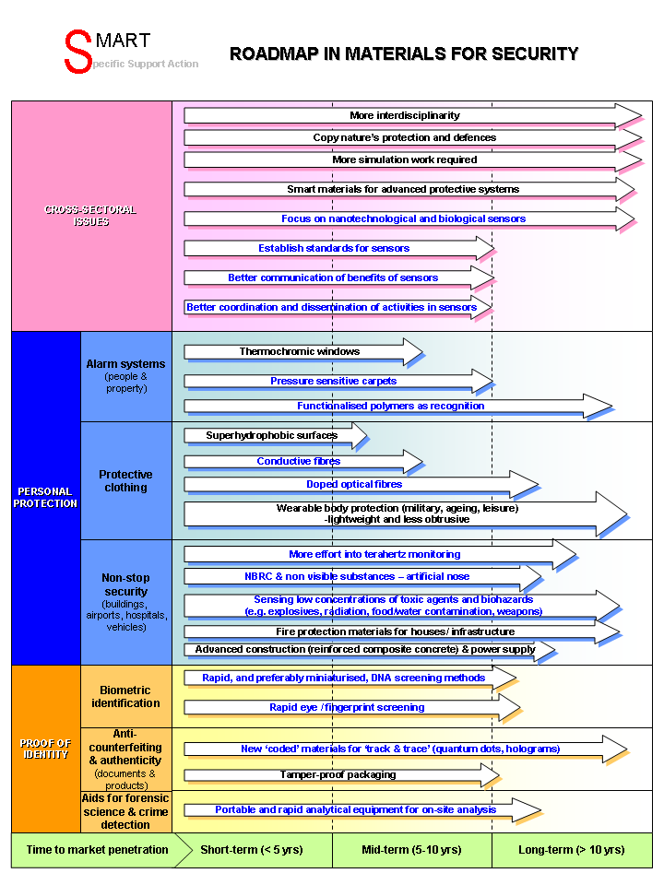
Figure 29: Roadmap „Materials for a Safe Europe“

In conclusion it can be seen, that while materials for security applications are not at the forefront of security research, materials research is a technology enabler in the area of sensors and scanners and at the same time could be an important factor in making these technologies widely available. Smart materials, polymers and nanomaterials are on the way to revolutionizing security technology in the areas of protection by innovative armour and in the field of anti-counterfeiting. Because threats of terrorism, various peace-keeping missions world-wide and anti-counterfeiting of European products are relevant areas for European politics, materials research priorities are:
- smart materials and nanomaterials research for protection as well as for the development of sensors to improve the security of European citizens and peacekeeping forces
- advanced polymers and nanomaterials for anti-counterfeiting systems to secure Europe´s global market position in high added products.

Roadmaps: Materials improving our life

To identify the innovation potentials in the field of materials aiming at improving the life of humans extensive literature research, expert interviewing and a roadmapping workshop were carried out. First of all this field of materials for a better life has to be characterized. In this field biomaterials for medical applications, electronic materials for information, communication and entertainment, textile materials for clothing, construction and medical applications and materials for packaging play an important role. While detailed information about electronic materials for the information and communication sector is available through the International Technology Roadmap for Semiconductors (http://www.itrs.net/) and the Roadmaps of the International Electronics Manufacturing Initiative (www.inemi.org), all other areas were considered in detail in the SMART foresight process.

In 2003 the Materials Panel for the UK Government’s Foresight exercise produced a booklet entitled Smart Materials for the 21st Century. This foresight study is mainly focussing on materials research topics that are relevant for the area of materials for a better life, therefore the study focuses on agriculture, food and consumer packaging, construction, sports and leisure, white goods and domestic products and healthcare. The study Smart Materials for the 21st Century states that materials technology has to be developed that provide pragmatic and cost-effective solutions to smart labelling and packaging. Europe already has expertise in this area, and is well placed to exploit smart materials technology in the implementation of traceability protocols to improve food quality and safety. Barriers to exploitation of smart materials in this sector are given as improving materials properties, system compatibility, availability and cost, better awareness and acceptability of smart materials in traditional engineering sectors, spin-off from other sectors needs to be achieved. Generally the smart materials systems under development cover speciality polymers, coatings, adhesives, composites, inorganic materials, metals, biotechnology and biomaterials. Other key developments are bio-interactive behaviour of materials and the development of bio-compatible components and devices. Important expected developments in the area of healthcare are adjustable stents and catheters, microbial resistance, smart surgical tools and neurosensor prothesis.

In 2005 and 2006 a strategic research plan and an implementation action plan were published by the European Technology Platform SusChem. For this purpose roadmaps for materials for the electronics industry – communications, information, entertainment, materials for medicine, agriculture, nutrition – healthcare and materials for the enhancement of quality of life were developed. In the field of materials for medicine the identified fields are tissue engineering, smart delivery systems, targeted drug delivery, functional textiles and bone reconstruction. New materials for implants, drug delivery, Novel therapeutics, Health protection and care, Diagnostics and sensors for prevention and detection.

In 2004, the Copper Development Centre sponsored a Building Construction Technology Roadmap in Australia. In this roadmap the development of smart windows is foreseen. Such windows would have integrated photovoltaics and OLEDs and could be used for holographic imaging, they also would be switchable between transparent and opaque.

Considering materials for a better life in this study the field was divided into biomaterials (and materials for medical devices), materials for packaging and high tech textiles. Roadmaps were created based on the datascreening, expert interviewing and on discussions and statements at the expert workshop in Lisbon in October of 2006.

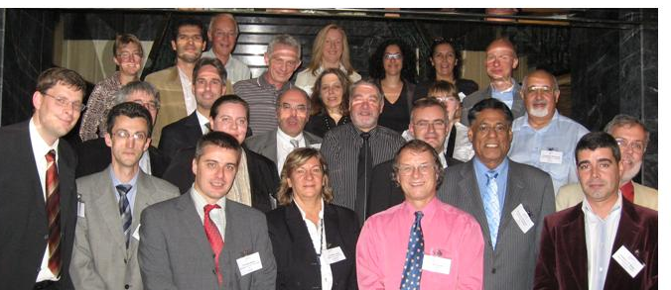
Figure 30: Participants of the roadmapping workshop “materials for a better life”, which took place in October 2006 in Lisbon

Biomaterials and Materials for Medical Applications

In the results of the review analyses on page 27 biomaterials are basically identical with bioconceptional materials and soft matter. Therefore almost 40% of recent review papers deal with this matter and state that this research field is of great potential for the future. In 20% of the interviews of experts the field biomaterials was mentioned as being a hot spot of their research work.

A commonly used definition of biomaterials is, that these are nonviable materials used in a medical device, intended to interact with a biological system. Biomaterials development is mainly linked to medical applications. The healthcare market covers hip and knee prostheses, vascular grafts, heart valves, percutaneous devices, stimulatory electrodes, catheters and stents. Therefore materials innovations are a keyfactor for the competitiveness of medical companies and breakthroughs in healthcare.

A main part of the biomaterials roadmap in Figure 35 describes materials innovations needed for the development of next generation implants. The development of next generation implants can be divided into the improvement of existing implant materials, the medium term development of artificial improved implants by smart materials and the long-term vision of regenerative medicine. However, even though the improvement of existing implants is a priority task, the focus of materials research for biomedical applications is expanding from materials just being inert and passive in the body to materials with a higher functionality, so that these materials can interact with the body in specific and predictable ways. Besides implants also materials innovations for medical devices like smart surgery tools and prostheses are part of foreseen materials relevant future developments.

Improvement of existing implants and medical materials

The human body reacts to today´s implants still by encapsulation and walling off. These implants are identified by the human immune system as foreign intruders. To solve this problem within the next years for today´s implants, improvement of biocompatibility in the development of tailor-made materials for interaction with biological systems is needed. Christian Oehr defined biocompatibility as “the ability of a biomaterial to induce the appropriate answer in a specific application”. To enable progress in existing implant materials technology, antibacterial surface treatments, non-fouling surfaces and controlled drug release strategies have to be developed in the area of materials research. Basic research on protein interaction is needed. The goal is to reach improvements in biocompatibility of implants between the component and the body, in order to reduce rejection or infection.

Polymers for medical applications are already in use since 1937, in particular PMMA (poly(methyl methacrylate)), which was used initially in dental prostheses and later also used for eye surgery (ophthalmics). More and more innovative polymers play an important role in the development of medical devices, today. The global consumption of polymers in medical technology is dominated by PVC, with polyethylene, polypropylene and polystyrene being next in order. Technical polymers such as polyesters, ABS and SAN, polycarbonate and TPE are used in much smaller quantities. In the last years there was a trend to replace glass in medicine and pharmacy by polymeric systems, as seen with contact lenses, membrane modules, and catheters. Christian OehrError: Reference source not found stated that volume properties of polymeric materials have to be chemically and mechanically stable in a biological surrounding. Furthermore these materials should not be allowed to release remaining monomers, additives, or auxiliary materials. Also such polymeric materials must withstand sterilization procedures and in some cases (e.g. diagnostics) should have excellent optical properties.

A relevant research area for improving existing implant materials are surface modification technologies. Surface properties are a keyfactor in implant development, since they control the blood and tissue compatibility of a biomaterial. Surface manipulation can be used to optimize a variety of material characteristics, such as increasing the lubricity of materials, increasing the durability or wear resistance of materials, improving the resistance of materials to clot formation, and decreasing the susceptibility to infection. Relevant surface modification techniques are low-pressure plasma treatment and chemical grafting. Low-pressure plasma treatment is for example used to increase biocompatibility. Chemical grafting is a technique that uses wet chemistry to attach new chemical species to material surfaces (mainly used to improve biocompatibility). Therefore anti-clotting agents (like heparin) are coated to the surface. The coating process itself is a complex chemical process in which a hydrogel is used. Such non-clotting surfaces have been applied to blood-contacting devices such as oxygenators, vascular stents, catheters, and vascular grafts.

Artificial solutions by smart materials

In the mid-term range the development of artificial tissue and organs can be expected. These artificial human body parts might in some cases even have a superior performance compared to the original natural parts. More than 100 million humans carry at least one major internal device today. Even though many new materials are under development for biomedical use, today only a dozen materials are in use to construct artificial organs for internal implantation. The cause of the limited use of innovative materials for medical applications is the availability of materials and to match challenging constraints. Before innovative materials can be introduced to the medical market successful testing of biocompatibility by in vitro studies, in vivo studies and clinical studies is needed. Therefore the development of biocompatible surfaces is a critical bottleneck. Using smart materials, in visionary approaches, even the construction of artificial muscles by electroactive polymers (see on page 103) seems possible.

Smart materials for implants cover stimuli responsive materials, shape memory alloys and materials with high superelasticityError: Reference source not found. Some smart materials applications are already in medical usage today, like endovascular stents, orthopaedic staples and dental braces. Medical applications of smart materials are not limited to the construction of implants. Such alloys can also be used in non-invasive surgery to reach narrow places. The instrument handles can be bent with enormous precision to the proper shape required for surgery, and recover their initial shape after heating (shape memory alloys).

In the area of shape memory alloys most R&D work has been carried out in the field of NiTi-alloys (so called Nitinol), but also CuZn, AuCd, CuSn, TiPd, NiAl as well as NiTiCu and CuZnAl are under investigationError: Reference source not found. The challenge for materials engineers is to predict the behaviour of the shape memory alloy in a specific situation, which is a function of geometry, environmental conditions like temperature and force. This explains the long time for technology transfer. NiTi was already extensively examined in the 1970ties, but it took another 20 years for the first commercial NiTi-stent to be available.

Nickel-titanium alloy is almost a magic material, which has a springback property that is 20 times greater than that of stainless steel and which is very biocompatible at the same time. NiTi can be used for self-expanding and self-compressing medical devices. These alloys are used in wires of braces in dentistry and are used for smart devices in orthopedics such as self-expanding screws and staples. Also nickel-titanium alloys are in development for high sophisticated stents that provide more assurance that the stent will stay open and they can be applied in critical conditions such as an aneurysm of the aorta. Today, NiTi-research and work on other shape memory alloys is considering long-term biological and chemical stability such as biocompatibility and corrosion resistance/ degradation. Long-term corrosion resistance (long-term = life time of patient) is a critical point since it could cause toxic effects and may weaken mechanical properties of the implant.

The “true” shape memory effect is limited to metallic alloys due to crystalline structural changes. Nevertheless, a similar materials property has been observed in polymers, so that these polymers are called shape memory polymers (SMP). Since there is some controvercy about potential toxic behaviour of NiTi-alloy, shape memory polymers might be an alternative implant material and therefore got a lot of attention. However, the principle laws of materials science should be kept in mind when considering potential applications for SMP (see Figure 31). Furthermore, SMP show a completely different shape memory effect compared to SMA, based on their non-crystalline molecular structure. Depending on, if the environmental temperature is above or below the so called glass-transition temperature, the materials properties vary between a rubbery state and a hard, brittle state. Some authors mention the recovery strain, which describes the force needed to stimulate material to undergo transition from temporary stage back to permanent stage, as being fairly low compared to SMAError: Reference source not found. Other researchers do not report such limitations in the materials characteristics of SMP. Also polymer processing without additives is complicated and these additives could cause toxic reactions in the body. Some polymers like PU are known to cause thrombogenic reactions, while other polymers could undergo chemical degradation. A tremendous advantage of SMP is that their properties can be tailored by copolymerisation with other polymers. Furthermore mechanical properties of shape-memory alloys, such as nitinol, can only be varied over a limited range (8% maximum deformation between temporary and permanent shape), while shape memory polymers can be deformed to elongations up to 1100%. Recently, researchers have developed SMPs that are both biocompatible and biodegradable upon external stimulus. These SMPs have been used in stents, which could be compressed and fed through a tiny hole in the body into a blocked artery. The temperature of body would trigger the polymer's expansion into original shape. Instead of requiring a second surgery for removing the SMPs, the polymer would gradually dissolve in the body over time. In some cases, biodegradable polymers are the only solution in applications such as reconstruction and functionality of blood vessels.

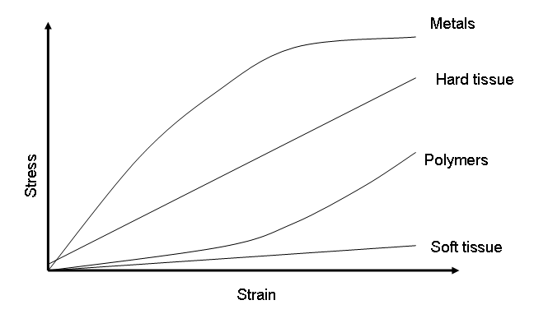
Figure 31: The different mechanical behaviour favours smart alloys and smart polymers for different biomedical applications. Another keyparameter is biocompatibility.

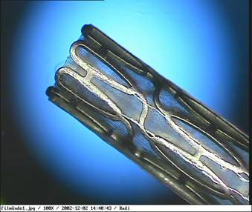
Figure 32: Metal stent covered with a biodegradable polymer, which minimizes the damage and in-growth of tissue (restenosis) (photo by Uppsala University).

As already mentioned in the section about “Improvement of existing implants and medical materials”, surface modification technologies offer a wide variety of opportunities to make implants better biocompatible. At the same time thin film deposition technologies like laser treatment, electropolishing and plasma surface treatment can increase the corrosion resistance of such devices. Also researchers are trying to find anti-adhesive nanocoatings for teeth to reduce plaque formation, which would have a great potential to extend the lifetime of natural teeth. Furthermore these technologies can be used to realize devices in the emerging field of drug-device combinations. Already available today are steroid eluting pacing electrodes, which are part of pacemakers and were released already 20 years ago to help reduce scar tissue, as well as drug eluting stentsError: Reference source not found. An important breakthrough in stent technology has been the addition of a thin coating on the stent wires that contains a small amount of a specific drug. The drug coating is designed to prevent re-narrowing of the coronary artery after stent placement. There are several challenges in this technology, such as to create a coating with the right amount of drug in such a way that the drug is not degenerated. Also the elution profile has to be tailored. Drug therapy with controlled dosing could be used for setting up an in vivo insulin releasing system. Furthermore these approaches have to be combined with self monitoring diagnostic devices and sensors as well as better drug control release through self regulation. Important approaches for both problems are provided by nanotechnology. For realisation advancement in materials systems for sensors, smart materials for electronics and adaptive polymers is needed. For applications such as neuroprostheses, heterogenous materials and interfaces have to be studied and understood better.

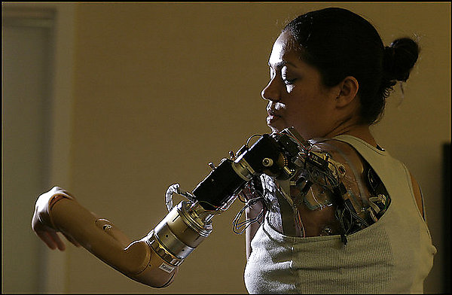
Figure 33: A first-generation bionic arm (photo by Dayna Smith, The Washington Post)

To broaden the application of smart materials systems, progress in mass production technologies for such devices is needed by making them more cost efficient and allowing deformation. Some of these systems could help creating assistance devices for disabled people and elderly people. However, the communication between researchers and interest groups of disabled people could be improved. Although disability aspects of materials development have been recorded, it is recognised that there is a great deal of scope for further developments, to help the disabled and the ageing population.

Materials research for regenerative medicine

Especially to achieve the mid- and long-term goals in the development of biomaterials for next generation implants groundbreaking innovative approaches are needed, which can be found in the area of nanomedicine. According to the ETP Nanomedicine this research area is defined as the application of nanotechnology to achieve breakthroughs in healthcare.

In the long-term range researchers want to enable regenerative medicine. While the aim in the development of traditional artificial implants is a high match of the properties of the replaced organ, in regenerative medicine the goal is to induce the recreation of the organ with identical nanostructure by the body itself. These technologies are expected to enable replacement of tissue and organs by living and functional replacements. To enable these technologies materials innovations are needed in biodegradable polymers, rapid prototyping, drug delivery and biomimetics. Bioactivity is the keyfactor. An artificial matrix that contributes to the technology of regenerative medicine has to be “bioactive” during its early period of contact with the biological environment. One of the key missions in regenerative medicine for materials researchers is to seek for polymers, hydrogels, and other soft materials that can function as bioactive matrices.

Humans who suffer from strokes or heart attacks have tremendous deterioration in quality of life since neurons die and tissue is replaced by scare. Regenerative medicine is a challenge, in which the emerging knowledge in physical sciences like biomaterials science, supramolecular chemistry and self-assembly and life sciences disciplines like stem cell biology and system biology have to be combined with nanotechnology and clinical medicine to learn how to trigger the regeneration of failed human organs and tissues. In regenerative repair of human organs, materials will transition from being providers of mostly mechanical functions to sophisticated regulators of biological activity. As mentioned in the last section about artificial solutions, today, the same metals, ceramics, and polymers used in engineering for technological applications are being used to replace failed blood vessels, heart valves, keep blood vessels open (metal stents), reconstruct joints with parts fixed to bone (hip and knee replacements) and secure artificial teeth in the jawbone (threaded metal posts)Error: Reference source not found.

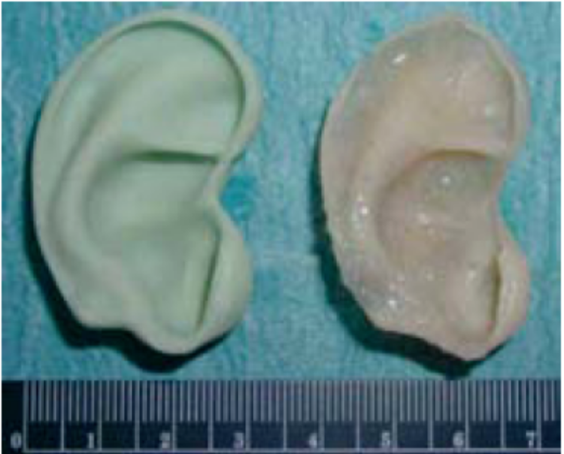
Figure 34: Successful reconstruction of an ear by tissue engineering using biocompatible fibre material as a substrate combined with certain gels (Charité Berlin, )

The most advanced therapeutic option in regenerative medicine is tissue engineering. Tissue engineeringError: Reference source not found is scaffold-guided tissue regeneration and involves the seeding of porous, biodegradable scaffolds with donor cells, which differentiate and mimic naturally occurring tissues. The materials challenge of generating such scaffolds is discussed in the chapter about “High Tech Textile Materials” on page 97. These tissue-engineered constructs are then implanted into the patient to replace damaged tissues, where they will be resorbed and replaced by host tissues. Therefore the generation of viable blood supplies and nerves is a critical point for successful regeneration. Current clinical applications of tissue engineered constructs include engineering of skin, cartilage and in certain cases bone. Recent advancement includes the use of adult stem cells as a source of regenerative cells, and the use of cell-signalling molecules as a source of molecular regeneration messengers.

An important strategy for regenerative medicine is the biomimetic approach. To realize this approach intelligent biomaterials and bioactive signalling molecules are needed. Nanoengineering will enable the creation of biomimetic celluar environments and will induce specific cell responses. The intelligent biomaterials used in regenerative medicine will most likely be resorbable polymers that have been tailored at the molecular level. These intelligent polymers are able the respond to changes in the environment (like change of molecular conformation in response to changes in temperature, pH, electrical or physical stimuli; see more information about stimuli responsive polymers on page 102) and will induce interactions with cells. A challenge in regenerative medicine is to control cell differentiation. Stem and progenitor cells have the ability to differentiate into derivative tissues and have great potential for tissue repair or replacement. Typically, differentiation is controlled by soluble compounds such as growth factors. Recently it has been observed that three-dimensional (3D) macroscopic gel-like solids, consisting of bioactive peptides, are capable of directing differentiation. These highly hydrated 3D gels are formed from peptide amphiphiles, which self-assemble in aqueous media to form nanofibers with diameters of 5 to 8 nm. These gels are able to direct the rapid differentiation of neural progenitors into neurons. Researchers try to identify the chemical fundamentals of the interaction mechanisms by screening of materials libraries using high-through-put techniques.

Researchers are also developing smart biomaterials that respond to specific cellular signals. Such hydrogels containing smart biomaterials will be replaced by cells forming tissueError: Reference source not found. Some of these smart gels also support the infiltration of cells and the formation of mineralized tissue. Implantation is a critical factor in clinical application of these next-generation biomaterials. In solving this challenge biodegradable shape-memory polymers and stimuli sensitive materials play an important part. These materials could lead to new forms of minimal invasive surgeries.

Regarding biomimetics and self-healing structures a better understanding of the mechanisms of structures in natural materials with unique properties is needed as well as about the methods to create self-healing structures. Therefore a new quality of interdisciplinary research combined with an efficient infrastructure would be beneficial. Both research fields are highly complex, so that a virtual network could be a helpful approach. In the development of self-healing structures it should be distinguished between biomaterial (organic) stem cell strategy and inorganic materials such as shape memory alloys, since these are two different approaches. An interesting approach in the area of self-healing structures would be “living polymers” that could be activated on demand. Strong emphasis needs to be placed on biomimetic structural design (evolution has provided the best solutions so far), but as already states in the biomaterials chapter there is a lack of understanding the complexity. It is suggested that a network in biomimetics for Europe could provide information and focus on what is especially multidisciplinary research.

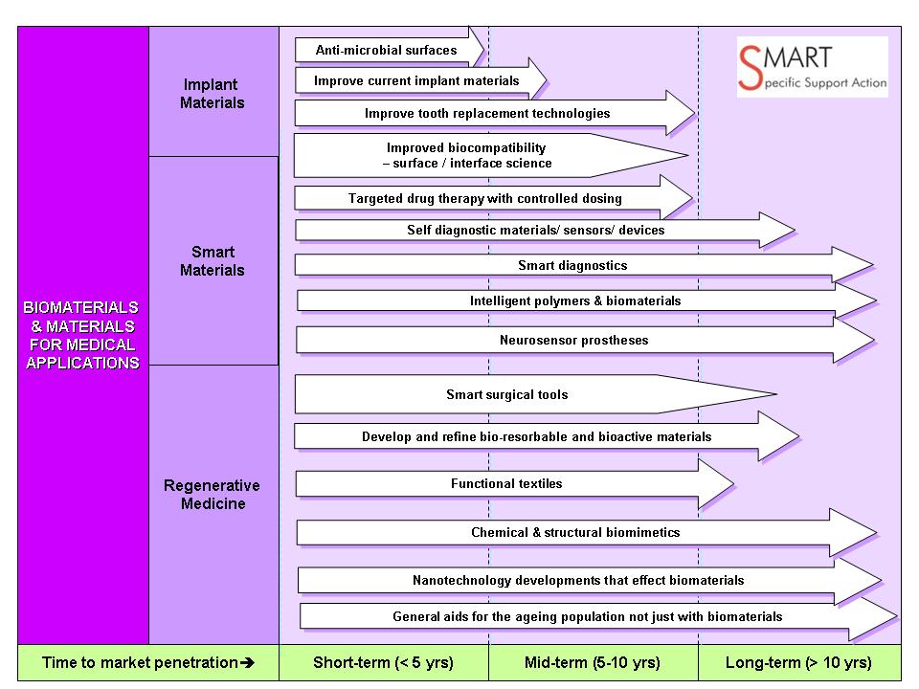
Figure 35: biomaterials roadmap

In the European White Book on Fundamental Research in Materials Science Professor Bill Bonfield gave in a chapter entitled “Biomaterials: Research and Development” an overview about bone and skeletal implants, before looking at the prospects for tissue engineering. For European research the following research priorities are mentioned: develop a distinctive materials science approach to embrace the continuum from gene to protein to cell to biomaterial to medical device; emphasise the innovation of novel biomaterials and tissue-engineered artefacts, based on the biological template, for tissue and organ replacement; develop an understanding of the mechanisms controlling the interaction of cells with second generation biomaterials and third generation tissue engineering scaffolds; encourage the progression of novel biomaterials from the laboratory to distinctive clinical applications in patients by entrepreneurial technology transfer. These identified priorities are in good agreement with the identified research needs by the SMART project. A detailed workplan and strategy for the development of regenerative medicine can be found in the SRA NanomedicineError: Reference source not found.

The identified research SMART priorities in the area of Biomaterials and Materials for Medical Applications are as following:

- Surface modification technologies for producing innovative multifunctional coatings on implants.
- New production technologies for smart materials.
- Stimuli responsive materials (esp. SMP) for smart surgery tools and high-tech artificial implants.
- Materials for adaptive drug-device combinations.
- Fundamental research on heterogenous materials interfaces for prothestics to enable disabled citizens a better participation in social life.
- Identification and characterization of “bioactive” polymers, hydrogels, and other soft materials.
- Research on intelligent polymers and biodegradable materials.
- Improve knowledge management in biomimetics.
- Fundamental research on mechanisms directed differentiation.

Roadmaps: Materials for Packaging

The term packaging is used in this chapter in regard to materials setting up a protective barrier for products. Besides this meaning there are also materials for packaging in the sense of integration of electronic devices, which play an important role for developments in the area of automotive electronics, information and communication technology.

The demands on packaging are for improvements in convenience, safety and error prevention, improved product performance, and easier openability and readability. Novel technologies are under development that will enable safe and sustainable packaging through detectors for oxygen levels, indicators for bacterial toxins and microbial growth, or the integration of time-temperature indicators for detection of improper handling or storage.

According to the roadmap, which has been set up at the workshop in Lisbon, research in materials for packaging can be divided into two major research areas. The first field are all topics connected to the greening in convenient and priceless packaging materials (see Figure 37). The second field is materials for intelligent and safe packaging, which will be an added value to the product (see Figure 37).

Greening in convenient and priceless packaging materials

The greening of convenient and priceless packaging is driven by the reduction of waste. Solutions for a zero waste society are biodegradable materials, innovative interfaces and extending the lifetime and expiration date of products. New efficient barrier solutions are needed. In packaging costs, water sensitivity, opacity and limited mechanical resistance are critical factors. An important economic driver in packaging is the increasing crude oil price. Higher oil pricing are causing the price of packaging materials like polyethylene to increase.

In food packaging there are a number of societal drivers like family changes, ageing demographics, support for healthy and safe lifestyles, design for the environment, and sustainability with easier recycling. Within the next decades there will be an increase in over-65s in most industrialized countries. Elderly people will need easy to read labels. Because of a higher health consciousness of most societies in the industrialized world there is a higher demand for freshness and quality of food. Consumers expect a short time between food production and consumption, while the maximum shelf-life should be extended because of safety aspects. Trends show that consumers expect a high grade of product visiability, which is difficult to realize by metallized coatings materials in packaging technology. Also some property combinations like transparent and heat resistant or transparent and light protective are almost incompatible. Metals are playing in packaging a diminishing role since for a growing number of consumers such materials are seen as environmental unfriendly because of the high energy needed for their production. This growing environmental awareness is also a cause for packaging producers to avoid chlorine containing materials (such as PVC, PVDC) which may lead to toxic dioxines in combustion of waste. Also a trend to convenient packaging has taken place by better opening and re-closing functions and the ability for microwave heating. Convenience and growing environmental awareness are also responsible for the trend away from glass packaging towards more and more polymer packaging materials usage.

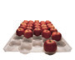
Figure 36: Fruit tray made out of biodegradable polymer. The biopolymer is based on corn, potato or wheat starch (photo taken from NOVAMONT; Zustimmung erbeten)

In today´s business world the time for food consumption is getting shorter and products should be ready to use, like in microwave cooking. Therefore a change might appear with soups that heat up and drinks that cool down, and there are attempts to enable easier opening of packaged items. At this point the greening of packaging products and the addition of intelligent functionality (see also next chapter) will be incompatible developments for some time. However in the very long-term it is likely that materials engineers can develop sustainable materials for sustainable and intelligent packaging concepts.

From the economic point of view a contradictory trend is taking place. On the one hand there is a demand for higher processing speeds in packaging production to increase profits. On the other hand packaging material consumption should be reduced for economic and ecological reasons. For example NestléError: Reference source not found is spending an average of 17% average packaging materials costs on total costs of goods produced. The need for increased line speeds produces stress and strain in material, so that the packaging material has to be thinner AND stronger at the same time.
One of the most important functions of packaging is the barrier function, especially in food packaging. As mentioned before there is a trend to more plastic-based materials in food packaging away from metal and glass packaging. The challenge in enabling more applications with plastic-based packaging materials is the improvement of the barrier function. Key parameters for barrier improvements are the oxygen transmission rate and the water vapour transmission rate. Attempts to set up efficient barrier functions can be divided into thin, transparent vacuum deposited coatings, new barrier polymers as discrete layers, blends of barrier polymers and standard polymers, organic barrier coatings and nanocomposite materials.

In principle packaging materials can be differentiate between flexible and rigid packaging materials. In flexible materials the barrier layer traditionally is realized by aluminium layer on a plastic based material. Recently just a few nanometers thick coatings produced by vacuum deposition are used. Lamination or co-extrusion with a high barrier polymer is another method for realization of the barrier function in plastic-based packaging (high barrier polymers: PVDC, EVOH, PVAL, PA; PVAL, EVOH and PA are only good barriers in the dry state// have to sandwiched with a better water barrier). In rigid packaging the poor barrier function of plastic-based packaging also has to be solved. Therefore a layer approach with co-injection/ again sandwiching needed because of water sensitivity. Another approach is the blending by mixing high barrier material (high barrier polymer or inorganic filler).

Thin glass-like coatings of SiOx have been obtained by PVD since mid 80ies and by PECVD of gaseous organolsilane and oxygen since early 90ies on PET, PP and PA. Such coated bottles have the advantage of being water resistant, microwaveable, transparent and they have a very good barrier (comparable to metallised barriers). The problem with such coatings is their limited flex and crack resistivity and the high production costs. However a variety of such products is on the market (Tetrapack bottles, Alcan Packaging, etc.).

In the mid- and long-term we will move from focussing mainly onto the reduction of weight, improvement of barrier functions and substitution of conventional packaging materials by polymers to a brighter approach towards a zero waste society that also considers the efficient usage of resources in natural cycles. Therefore more and more bio-based materials are being introduced, which will be biodegradable and CO₂-neutral due to their natural origin from renewable resources. As mentioned before the increasing crude oil price is causing alternative bio-based materials already today to be competitive to petroleum-based products in packaging. A significant breakthrough in packaging occurred in 2004 with the introduction of bottled water in a commercially compostable material. These bottles are made from polylactide, a renewable polymer made from corn (trade name PLA).

Biodegradable polymers are polymeric materials in which at least one step in degradation process is happing through metabolism in the presence of naturally occurring organisms. Such biodegradable polymers can be extracted or removed from biomass, like polysaccharides, proteins, polypeptides, polynucleotides. Also biodegradable polymers, like polylactic acid or bio-polyester, could be synthesized from renewable bio-based monomers or a mixture of sources from biomass and petroleum. Finally biodegradable polymers, like cellulose and polyhydroxybutyrate, could be produced by micro-organisms or by genetically modified bacteria. Even though the high oil price is driving developments of bio-based polymers, these materials still have to overcome some bottlenecks. Critical parameters besides costs are performance and processability. Many of these materials are brittle, have a low heat distortion temperature, high gas and vapour permeability and a poor resistance to protracted processing operations. So their applications are still limited and materials research to improve their properties is needed. Nanotechnological modification of such materials might be a good way to improve their properties for various applicationsError: Reference source not found. Investigations have shown that mechanical, thermal and barrier properties can be altered. Most relevant for packaging applications are research studies on biodegradable nanocomposites based on starch and derivates, polylactic acid (PLA), PBS, PHB and PCL. These polymers are mixed with sheet silicates (clay minerals like kaolinite and montmorillonite) to obtain nanocomposites.
An example for the nanocomposite developments are bio-polyesters like PLA and PHB which a high potential for packaging applications in many foods and beverages, but their application is still limited due to low performance. Researchers are trying to improve this performance by adding clay-minerals and therefore using PLA and PHB to form nanocomposites.

Materials are not only used for packaging, but are also used to improve food products itselfError: Reference source not found. Edible films and coatings are thin, continuous layers of edible material used as a barrier between food components to avoid mass transfer. Such coatings might form an integral part of the food itself and are applied as solution (paintbrush, spray, dipping) or as a molten component. Materials used as such edible films and coatings are water-soluble polysaccharides (cellulose, starch, pectin) or lipids (waxes). Polysaccharides play a tremendous role in food industry, since they are responsible to add properties like crispness, compactness, viscosity and mouth-feel to a food product. Waxes are commonly used for the coatings of fruits and vegetables to retard respiration and lessen moisture loss. Researchers are planning to investigate the opportunities of adding new functions to such edible films by incorporation of nanoparticles. For example nanoparticles that are realizing antimicrobial agents in a controlled manner could be incorporated.

Furthermore nanotechnological modifications also offer improvements to pulp/paper and cardboard packaging materials. Recently a nano-hybrid technology has been applied to paper products that will improve gloss and smoothness. A comprehensive overview about ongoing research to obtain sustainable fibre-based packaging materials and the opportunities and risks of applying nanotechnology can be obtained at the website of the EU project Sustainpack: www.sustainpack.com. Further information is available on the website of the forest-based sector technology platform and from the EU project Biorenew.

Materials for intelligent and safe packaging

Drivers for intelligent and safe packaging are the need for high-added products of European companies in international competition and to take anti-counterfeiting steps. Also logistics, consumer trust into food products and improving the safety of products especially for pharmaceutical products are of importance.

Looking at expected developments of packaging materials within the next 15 years the study “Consumer Packaging: Opportunities for Smart Technologies” states that RFID and printed electronics are those two technologies that will have the greatest impact on packaging. RFID already has started to revolutionize logistics worldwide and applications in textile products and shelf products in supermarkets are coming up next. Smart packaging will help to fight counterfeiting and piracy of products, to strengthen the loyalty of consumers to brands and to avoid misuse of products (like medicine). There are visions that printed electronics on packaging will provide screens on products for video clips used for marketing, logistics and education. First applications might be flashing messages on products in different colours. Adding such smart functions to packaging might be the marketing tool for the next decade to make products competitive in a global market with equal technical standards. These electronics will be printed onto the paper or plastic packaging. Developments in conducting polymers and printing technologies are needed to realize this vision.

Due to the ageing population and a stretched health service, the importance of delivering the right medication effectively will increaseError: Reference source not found. Smart Materials Packaging could help to remind patients to take their medicine and help them to take the right medicine with the right dosage. Studies have shown that as many as 50% of patients fail to comply with the terms of their prescriptions. Health and economic consequences of non-adherence include excess hospitalizations and home visits, disease progression, complications, premature disability or even deaths.

While the developments above will head towards interactive functions of packaging in the long-term, in the near future we might see active functions like smart anti-microbial systems and indicators giving the customer information about quality of the product.

An intelligent packaging concept with an active function is the so called “bioswitch”. The bioswitch reacts on external stimulus due to changing environmental conditions like presence of metabolites, pH, temperature and humidity. Therefore such an intelligent system can be more specific and will only be activated on demand. An important application of the bioswitch concept is anti-microbial packaging of food. This packaging material includes a preservative-releasing system, which aims at extending the shelf-life of the packed food. This system only releases its preservative on command, which means that a preservative will be released from the packaging material if bacterial growth occurs, thus inhibiting growth of the emerging bacteria. The bioswitch system is intelligent because the inhibitor is only released if there is bacterial growth, so that levels of antimicrobial agents in the food itself can be reduced. From the materials point of view the bioswitch concept is realized by particles consisting out of an anti-microbial compound which is coated with a natural polymer (like polysaccharide). These particles are coated onto the food packaging. In the case of initial microbial contaminations micro-organisms will start to secrete enzymes, which will hydrolyze the polysaccharides of the bioswitch particles. Partial degradation of the natural polymer will induce release of the anti-microbial compound, resulting in inhibition of microbial growth.

In some European countries there have been big scandals in the past dealing with spoiled food products that have entered the European market. For customers it is often not possible to identify such low quality products. Intelligent packaging could help indicating the freshness and might warn visually, if food is not safe anymore. Monitoring the quality through time-temperature indicators, gas-leakage indicators, toxin indicators and spoilage/ freshness indicators could help to improve the trust of European customers into food products.

As already mentioned RFID is one tool to fight counterfeiting. Also the development of high sophisticated inks is an approach to later distinguish between the original and the fake product. Recently Qinetiq developed a key-lock polymer system. The right colour combination of the product, which contains the lock polymer, can only be obtained if the customer receives the key polymerError: Reference source not found. Researchers at Toronto University have developed a nano-structured polymer that can be used to record biometric features, such as fingerprints, photos and signatures. This technology will be used to identify fraud.

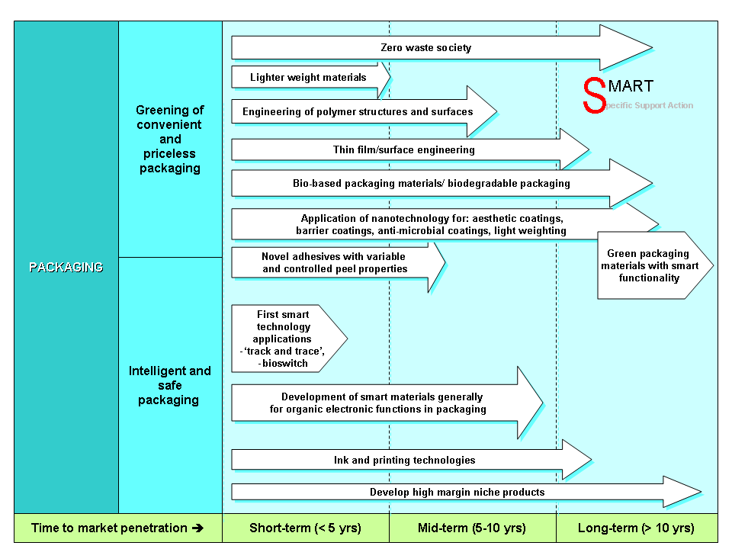
Figure 37: Roadmap for materials for packaging (proceedings of workshop)

Limited resources, a changing lifestyle of European citizens in a globalised world, the growing relevance of anti-counterfeiting for European industry and the aging society are the main drivers for technological innovations in packaging materials. The identified materials research tasks are:

- Nanotechnological improvements of packaging materials
- Improving the materials performance of bio-based polymers
- Intelligent polymers for printed electronics
- Sustainable materials for smart packaging

Roadmaps: Materials for high tech textiles

According to the ETP Textiles the market shares for textile materials used for clothing was 41%, for home and Interior applications 33% and for technical and industrial applications 26% (2005, EU-25).

So far textiles in history have been mainly used for clothing and had passive functions for keeping people warm and to protect them. Also textiles were of cultural importance since they always were an expression of societal trends in terms of fashion and underlined the belonging to certain groups (by uniforms). Because of advances in fibre technology we can expect today, that more and more textiles will have sensing and adaptive functions, so that textiles in clothing could function as a “second skin”. Besides innovations in fibre materials, advances in manufacturing technology by intelligent garment manufacturing, automated spherical sewing systems, RFID technology, 3D CAD technology, online-retail and 3 D human body scanners play an important role in the transformation of traditional textile industry towards a high tech industry. Textiles also play an important role for house interiors. Even though there are alternative materials the textiles are favoured for interior applications by properties like flexibility, softness, light weight, durability and easy production in all possible shapes, forms, colours and designs.

Innovations in textile materials can be divided into new garments, technical textiles and fabric-based composites. In the field of new garments innovations in fibre materials are aiming towards smart textiles and bio-based products. The SMART roadmap for high tech textile materials in Figure 40 has been divided into a technical textile section and a smart materials section. Technical textiles are defined as textile products manufactured primarily for their technical performance and functional properties. The end-uses range from simple products such as dental floss and sutures, to heart valves and vascular prostheses; from air filters to heat and flame barriers; and from car seat covers to load bearing composite materials. Smart textile related research topics are the use of electronics in fabrics as well as new conductive, electrochromic and luminescent polymers in fibres. Further more research is going on in chemical sensing and garments that monitor physiological status (i.e. blood pressure). Finally research is aiming at new developments in chemical and biological protective fabrics, engineering considerations for environmental control within fabrics and new high-strength fibres for protective armour. However, such additional protection often has a negative effect upon the exchange functionality of the human skin, in certain cases very severely like in the case of full body armour, fire-fighters, uniforms or diving suits. Functional and even smart or intelligent clothing are the innovative response to such limitations.

Smart textiles

While all types of clothing have some basic decorative or protective effects, functional clothing refers to products in which one or several specific functionalities are emphasised. Smart garments can for instance adapt to their insulation function according to temperature changes, detect vital signals of the wearer’s body and react to them, change colour or emit light upon defined stimuli and detect and signal significant changes in the wearer’s environment.

An already commercialized example of smart textiles is the integration of wearable computers and wireless communications with textile substrates to produce clothing that can monitor heart and respiration rates as well as body temperature. However, these health monitoring functions as well as today’s available protective clothing are still based on incorporating current device technologies onto common fabric substrates. A future goal is to build devices into the fibre itself. Recently Cartysse et. al. reported about successful testing of textile sensors for the equipment of a wireless monitoring suit monitoring of electrocardiogram (ECG) and respiration rate of children in a hospital environment. This suit is used for long-term monitoring of children and should avoid skin irritation problems and allergies caused by conventional sensor technologies. The sensors, which are entirely fabricated out of textile, are integrated in a prototype belt of the monitoring suit (see Figure 38). The complete suit will not contain only the sensors, but also the interface, data handling, storage and transmission electronics. Therefore, distributed, miniaturized circuitry, textile interconnections, a textile antenna and hermetic packaging have been developed. A bottleneck of such smart suits is their durability and washability.

Figure 38: pedriatic application of wireless monitoring suit (photo K.U. Leuven; )

Smart suits will in the future not be limited to medical applications of infants but will also be used to help elderly people, ill persons and disabled people.

Further progress in developing smart suits is needed for protecting firefighters, law enforcement, medical personnel and peacekeepers when dealing with chemical and biological threats in many environments such as urban, agricultural, and industrial. full barrier protection, such as hazardous materials suits, or permeable adsorptive protective overgarments. It can be expected that we will see in the future protective smart suits with the capability to selectively block toxic chemicals, to chemically destroy toxic materials that contact the fabric, and to detect hazardous agents on the surface of the fabric. Such smart protective suits with enhanced chemical and biological protection rely on materials developments such as selectively permeable membranes, reactive nanoparticles (esp. nanometal oxides), reactive nanofibers, biocidal fabric treatments, and intelligent polymers as well as optical fibres. Selectively permeable membranes exhibit a high level of water-vapor permeability, but are resistant to the permeation of organic molecules. These membranes provide protection from hazardous organic chemicals while allowing a mechanism for water vapour transport and evaporation so that the fabric is comfortable to wear.

Optical sensors could be used for internal stress monitoring in textile composites. Such fibre-optic sensors could be woven into the uniforms of law-enforcement personal, in which the sensing function is based on the ability to change the light-propagation properties of optical fibres with various cladding materials. Such next-generation fibre-optic sensors might be even used to warn the wearer of the exposure to biological or chemical agents. A further step in the development of high-tech textiles would be fabrics being adaptive to the environment. Therefore a shift from electronic-textiles to interactive textiles is needed. Assuming a shift to i-textiles the fabric materials will not just be designed to warn the wearer of threats such as the presence of chemicals or biological contaminants, but also ultimately adapt electronically to protect the wearer.

The protective functionality of fabrics play a keyrole in security applications of textile materials. Such applications are not just aiming at a certain strength of fibres, so that the fabric will be impact resistant (i.e. ballistic protection), but also aim at additional functionalities like camouflage and protective/ sensor clothing. This area has been addressed in the roadmap on page 112 by the topic of smart textiles with tuneable properties. There has also been an interest in developing “chameleon” fibre systems that reversibly change colour and appearance for both commercial and military applications. Electrochromism and electroluminescence are two general approaches for achieving controlled colour-changing fibres. Materials development has a keyrole in both. For the electrochromics approach reversible switching between redox states is a critical factor, while in the case of electroluminescent materials, a high-efficiency emitter is needed. Integration of such systems with the fibre substrate is complicated and additional developments like transparent conductive electrodes are required. Further problems in the development of chameleon fibres are lifetime, ionic transport to electrochromic materials, flexibility and strength of the material and environmental stability. A critical step in the development of chameleon fibres is finding the right substrate fibre, which has to be a conductive and flexible material with a high strength. First materials that have been used in research were wet spinned flexible polyaniline fibres having good electrical conductivity. Lately formation of polyaniline hollow-fibre membranes is envisaged.

Breakthroughs in the development of smart textiles are depending on advances in the research field of intelligent polymers. Intelligent polymers can be divided into stimuli responsive polymers in general and shape memory polymers as well as piezoelectric polymers in particular.

Stimuli-responsive polymers alter their characteristics in response to changes in their environment. A responsive macromolecule is one that changes its conformation and/or properties in a controllable, reproducible, and reversible manner in response to an external stimulus (e.g. solvent, pH, or temperature). One of their most important applications is the controlled drug delivery system. The pH range of fluids in various segments of the gastrointestinal tract may provide environmental stimuli for responsive drug release. Stimuli-responsive polymers can also find application in intelligent textiles. Some thermo-responsive macromolecules could be attached to the nanotube fibres that run along the fabric in the outer part of the cloth. The polymer would shrink when the fibres detect cold conditions from the surrounding environment, keeping the inside layers protected. Some conducting polymers changed their resistance in presence of chemical contaminants and could be used therefore as sensorsError: Reference source not found. Thermally induced shape-memory effects can be observed in multiblock copolymers, mainly polyurethanes. The mechanism of the thermally induced shape-memory effect of linear block copolymers is based on the formation of a phase-separated morphology with one phase acting as a molecular switch. Possible applications for shape-memory polymers cover for example applications in non-invasive surgery.

The properties of piezoelectric polymers are very different from those of ceramic materials. PVDF [poly(vinylidene fluoride)] and certain copolymers exhibit the best electromechanical performances. Typical applications of the piezoelectric polymers cover sensing and actuating devices in medical instrumentation, robotics, optics, computers and also ultrasonic, underwater and electroacoustic transducers and microphones. Future potential applications of piezoelectric polymers cover artificial muscles, bio-inspired robotics, active pump applications, sensors to monitor intracellular conditions, and actuators as valves for controlled drug delivery.
Electroactive polymers (EAP) respond to electrical stimulation with a significant change in shape or size. They are lightweight and easy to control. EAP materials can easily be formed in various shapes and their properties can be engineered. Available EAP materials can be divided into two distinct groups. The first group are electronic EAPs (driven by an electric field or Coulomb forces) such as electrostrictive, dielectric, ferroelectric and liquid crystals and the second group are ionic EAPs (involving mobility or diffusion of ions) such as conductive polymers, ionic gels and polymer-carbon nanotube composites. Various applications are being explored in such fields as medical (i.e. for sensor arrays, artificial muscles), aerospace (i.e. for MEMS), entertainment and consumer products.

An important pre-requisite for approaching interactive smart textiles is the availability of energy. Therefore energy interactive textiles have to be developed for energy conversion, storage and energy management. For energy conversion developments are needed in materials research fields such as piezoelectric polymers for mechanical to electrical energy conversion, photoadaptive polymers that change their mechanical properties at the presence of electromagnetic radiation, photoelectrical materials (i.e. such materials might be used in fibres of tents for solar cells) as well as chemomechanical fibres and magnetorheological polymers. In many fabric applications of smart textiles the harvested energy will also have to be stored intermediately before used for the smart application. In energy storage the following materials developments are important: heat absorbing fabrics (ie. phase change polymers), electret fibres that can store electrical charges (polyolefin-based fabrics), shape memory polymers (see above) and electroluminescent fibres. For energy management polymeric fibre materials have to developed that will allow energy (photons, electrons) to be transported from one point to another. Promising materials research areas are optical fibres, bioresponsive polymers, conductive polymers and nanotubes.

Technical Textiles

Antimicrobial attacks of fibres in textiles are a serious problem. The problem with textiles in hygiene and medical applications is that they are an excellent medium for growing microorganisms if there are the right conditions like moisture, nutrients, oxygen level and appropriate temperature. Natural fibres are more susceptible to microbial attack than synthetic fibres, which are mostly hydrophobic. Problems of microorganisms in textiles are fabric deterioration (discolour, stains, eat up fabric), metabolism of nutrients cause odour and skin irritation. Protein fibres act as nutrient for many types of worms. Cellulose fibres are not a direct nutrient for microorganism. But some fungi convert cellulose to glucose, which is a good nutrient for microorganisms. Also soil, dust and some textile finishes act as nutrients.

Polypropylene (PP) is one of the most widely used synthetic fibers in textile industry, which is cheaper and stronger than the other synthetic fibres. PP is widely used in carpets, automotive interiors, packages, cover stocks, cables and napkins. Also PP is used for sanitary applications such as surgical masks, diapers, filter, hygienic bands, etc. For hygienic and medical applications PP needs antibacterial activity Usage of some organic antibacterial agents has been evaded up to now, since the unsafe some halogen compounds of having aromatic group becomes a serious problem. A very good antibacterial agent is silver because it is non-toxic and a natural inorganic metal. Recently researchers developed an organic-inorganic nanocomposite fibre which has a permanent antibacterial effect. Therefore nanocomposite fiber of sheath-core type using PP chips and PP/Ag master-batches were prepared with varying the concentration of silver nanoparticles.

The antibacterial property of textiles is an essential feature in fabrics used in prophylaxis, medical treatment and hygiene. A significant part of medical, fibre-based materials are antibacterial textile fabrics which can be obtained by various advanced technologies. The application of new nano-technologies offers the possibilities of producing and implementing such products. Typical antimicrobial agents are heavy metals like mercury, silver, copper and metal salts, azo disperse dyes, ammonium salts, chitosan, magnesium peroxides and triclosan.

Many properties of textiles can be altered by nanostructuring of the surfaces of textile fibres. Such nanostructures are usually ultrathin coatings on the surface of the textile fibres, which can be obtained by plasma processes. These plasma coatings can increase hydrophilic properties or can make surfaces hydrophobic and can improve the dyeing behaviour. By using silver-targets in the sputtering process, Ag-nanoparticles can be obtained on the fibres and therefore anti-microbial properties added to the fabric. Plasma processes have proven to be successful in shrink-resist treatment of wool with a simultaneously positive effect on dyeing and printing, . Highly hydrophobic surfaces are produced, which in contact with water are extremely dust- and dirt-repellent and hence should be also repellent to bacteria and fungi. Even multifunctional textiles can be tailored by adjusting plasma chemistry and plasma physics. Regarding agglomeration of particles, toxicity and mechanical durability processing of nano coatings by plasma processes is advantageous compared to other coating processes like wet chemical processes (also wastewater is avoided by plasma technology). Recently a German research consortium investigated systematicly plasma modified surfaces for technical applications in a project within the German WING materials research funding programme, . Even coatings were produced that were not compact but had an island structure. While nanocoatings in principle allow combining bulk properties with coating properties, these island structures offer completely new functions.

Textiles are an essential part of interior design, but they are also the main source of ignition in house fires. Since textiles are highly ignitable they cause fires to rapidly spread all over places. Therefore there is a high interest to drastically reduce ignitibility of fabrics. However, since in the last decades environmental issues, toxicology and cost efficiency were in the focus of developers most flame retardant inventions are for the 60ties to the 80ties of the last century. In principle flame retardancy can be improved substitution of frequently used fibre materials with inorganic materials, but materials like asbestos are not an option. Also chemical treatment with an flame retardant chemical is an option, but the durability is problem at least if the textile might be mechanically cleaned using solvents. Also chemical modification of the polymer it self is possible and is carried out using organic phosphorous compounds. Finally, it has been found recently that inclusion of functionalised nanoclays in polymers can lower the peak heat release rates.

Composite materials are a class of multiphase engineering materials in which the phase distribution and geometry has been deliberately tailored to optimise one or more propertiesError: Reference source not found. In textile-reinforced composites one phase, called matrix, is reinforced by a fibrous reinforcement in the form of a textile material. Thanks to better performance characteristics of fibre and textile-based engineered materials in terms of their strength-weight ratio, durability, flexibility, insulating and absorption properties, and fire and heat resistance, textiles are increasingly becoming part of the construction of buildings and infrastructure. Textile-reinforced composites are in a position to replace more traditional construction materials such as steel and other metals, wood and plasticsError: Reference source not found. Examples of ongoing replacements are light-weight textile roofing, textile-reinforced concrete, fibre- and textile-based bridging cables, erosion and landslide protection systems, textile reinforcement of water management systems, fibre-based pipes and canalisation as well as artificial islands and floating platforms. Besides these ongoing replacements in the construction sector textile-based composites are predicted to replace in the near future many of today’s metallic and plastic materials used in the automotive industry, ship building or aeronautics, in the machinery and machine tools industry, in the electronics and medical devices sector. Tremendous research is ongoing to develop cementitious composites reinforced with frabrics out of glass, aramid or carbon.

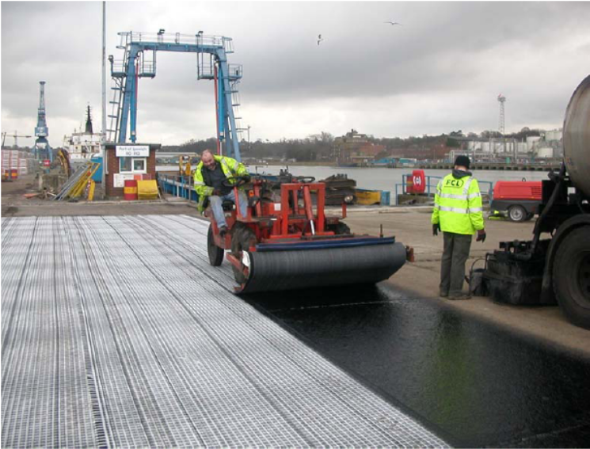
Figure 39: Reinforced asphalt overlay (glass reinforced fibres) at Ipswich Docks, RoRo Ramp, (copy taken from www.asphalt-geotextiles.co.uk)

A trend in the last two decades has been that mankind is not just adapting through nature but also started to change landscapes, so called terraforming. For terraforming geotextiles play an important role. Geotrextiles refers to textiles related to earth or soil. This class of textiles can be divided into woven and non-woven types. The woven type has a better strength. Geotextiles can be formed of synthetic fibres, natural fibers or combination of the two. In the past geotextiles were made of natural plant fibres while today are usually formed of synthetic polymers such as polyester, polypropylene (PP), polyamides (PA) and polyamides (PA). Geotextiles made from natural fibers are less durable as they get decomposed with passage of time.

With the inevitable trend towards an aging society in European and most other industrialised countries, health care and enhancement of quality of life for elderly and (chronically) ill people is becoming a more and more dominating societal priority. Textile products are omnipresent in the field of human hygiene and medical practice. Traditional applications include wound care products, diapers, braces, protheses and orthoses, wipes, breathing masks, bedding and covers, ropes and belts etc. Innovative textile products can both add significantly to effectiveness of medical treatments as well as patient comfort during active medical care or recovery. At the same time, new medical textiles, while not being responsible for a large share of overall health care costs, may contribute to cost containment. Such innovative products: Provide new treatment options (textile based implants instead of scarce donor organs; artificial tissues, joints and ligaments),Speed up recovery after medical treatment (innovative wound dressings; light, breathable orthoses/ prostheses), Enhance quality of life of chronically ill people (functional clothing for people suffering from neurodermitis or psoriasis, anti-dust mite bedding for asthmatics etc.), Facilitate and secure the life of the elderly (adaptive compressing stockings, functional diapers, customised clothing for easy use and functionalities adapted to special needs).

The major requirements from a modern advanced wound dressing are that they should remove excess exudates and toxic component and maintain a high humidity at wound/dressing interface. They also have to allow gaseous exchange and provide thermal insulation. Furthermore they have to be impermeable to microorganisms and the product has to be free from particulate and toxic wound contaminates as well as be removable without causing trauma at dressing changeError: Reference source not found. Therefore Prof. Anand stated at the SMART better life workshop that further improvements in the development of advanced wound dressings have to be made.

Recent progress in nanotechnology will have an impact on the development of sterile wound dressings. Textile industry is already an important player in the development and production of nanomaterials, such as fibre containing metal oxide and nanoparticles with antimicrobial properties. The advantage of nanomaterials is that beneficial properties can be added to the product without diminishing the aesthetic properties. However besides these perspectives the risks of nanoparticles to health and environment have to be considered. Also nanotechnology will allow the development of wound dressings, in which the fibres can provide controlled drug release through self regulation.

The importance of tissue engineering in regenerative medicine has been already outlined in the biomaterials section of the better life chapter. This technology is a combination of biological and engineering disciplines in order to culture viable human tissues outside the body. Tissue engineering provides surgeons with the possibility of implanting living tissue which will eventually integrate fully with the patients own tissue. A keyfactor in tissue engineering is scaffolds and this is also the point were textile materials come into play. The scaffold defines the overall size and shape of the implant. Scaffolds also provide the correct internal structure which allows cells to enter the scaffold, attach and grow. The scaffolds are a framework of appropriate surfaces on which the cells will attach onto. Using biocompatible textile materials as scaffolds in tissue engineering has the advantage that the fibres may be bioresorbable so that eventually the entire scaffold is replaced by living tissue. Textiles scaffolds have mechanical properties which sufficient support the developing tissue and could give the neo-tissue structural reinforcement (at least temporarely)Error: Reference source not found.
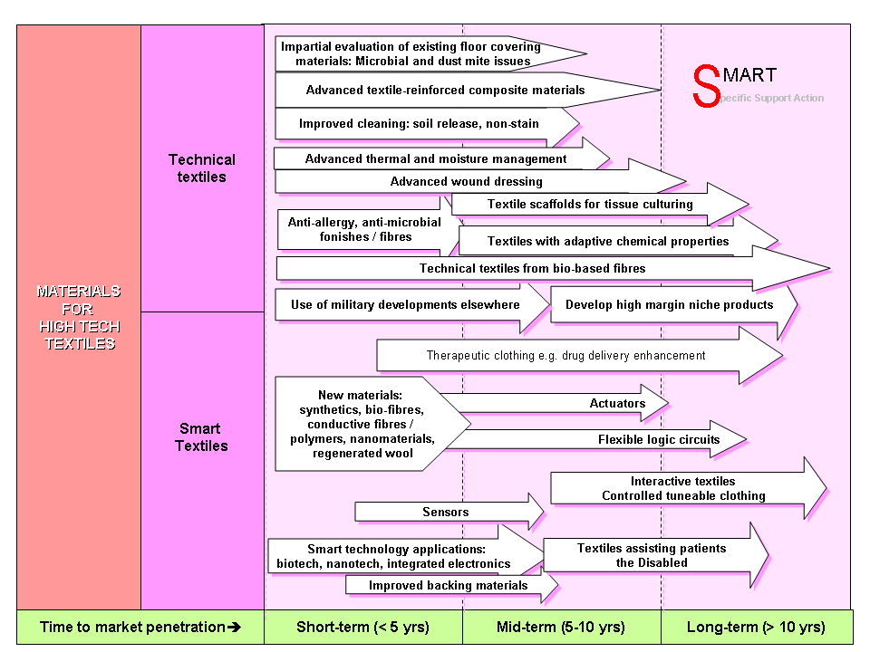
Figure 40: Roadmap for high tech textile materials

In conclusion it can be seen, that many high tech textile materials breakthroughs might be just around the corner. High tech textiles offer solutions for relevant societal and ecological needs. Smart textiles might offer in the midterm perspective disabled persons and ill people a new quality of life and more privacy. The bottleneck in smart textiles is to produce materials cost efficient and make them sustainable. Technical textiles are an important factor in improving medical heathcare and making medicine in an aging society affordable. Also will technical textiles like geotextiles be an important factor in the terraforming to adapt today’s landscapes and infrastructures to a changing environment. Therefore materials research priorities in the area of high tech textile materials are:
- Intelligent polymers for smart textiles
- Nanotechnological improvement of technical textiles

Strategies to keep Europe´s strong position in materials technology

Data screening, interviewing and the workshops in the SMART project have shown that Europe has a strong and internationally competitive position in materials research. Bibliometric analyses showed a high output rate of scientific publications. A specific strength of the European materials science community is their research activity in all areas of materials technology. This is due to a portfolio of complementary funding programmes on regional, national and European level. Established and living networks between industry and academia are a great advantage of the European materials innovation system and an important success of European funding as well as federal funding of many European countries. Another cause of the competitiveness of the European materials innovation system is a high grade of internationalisation. The dialogue about technological trends and scientific developments through European Technology Platforms and roadmapping activities is an important

However, even though materials technology is in a good position today, some weaknesses of the European materials innovation system identified in the SMART could develop to a threat for future, if no action is taken. While many funding action have a high visibility on the internet through websites and free available studies of high quality, the European research is weakly present in publication databases especially in overarching publications like review papers. This leads to the impression even of experts that research abroad is of higher quality and more activities been carried out. The citation rate of most European materials science papers is weak compared to other regions in the world. These impressions could make oversees research positions more attractive, so that a higher visibility in raking relevant databases is a matter to act against brain drain. Therefore scientific marketing strategies have to be developed. A traditional problem of European materials research is the fact, that Europe is excellent in fundamental science but that that technology transfer rates and time to market have to be improved. The transfer of many industrial R&D activities to Asia as well as counterfeiting of innovative developments is a real threat to the European materials innovation system. Also Europe seldomly takes leadership in technology transfer processes. Many experts complained about bureaucracy hindering their research progress or at least slowing progress down. Also researchers were missing predictable long-term funding strategies. By summarizing these critical points risks for the European materials innovation system are seen in a further brain drain and less attractivity of Europe for foreign excellent scientists because of low visibility of European materials research excellence, a loss of innovative industrial capability by movement of materials R&D to Asia and finally an inefficient return-on-invest of European research funding because of technology transfer weakness and failed counterfeiting strategies. A specific weakness of the European materials innovation system is that there are many different strategic activities to set up roadmaps and define priority for future funding.

The 7th European Framework Research Programme with a budget of 54 billion € and a duration of seven years is an important step towards predictable long-term developments. Since materials are taking up an adequate part in the 7th FRP in the Specific Programme Cooperation within the topic Nanoscience Materials and Production, excellent conditions for a continued successful development of European materials technology are given. For the first time the European Commission will also support fundamental science in the 7th Framework Programme and therefore established the so called European Research Foundation (ERC). The ERC could give excellent researchers a European perspective and therefore help to fight brain gain of European scientists and attract foreign researchers. Recently the European Commission started activities to reduce bureaucracy by simplification. Simplification actions have been taken in all political sectors and therefore also in the area of research and innovation. It is still unclear, if the right steps to reduce bureaucracy have been taken and a lot more effort is needed. In the area of European materials research funding the Commission introduced a two stage proposal submission system and reduced the number of funding instruments. This should help to minimize oversubscription and give applicants a clear orientation.
Crucial for the success of the European materials innovation systems are the right decisions about relevant up-coming research topics and actions to improve technology transfer. There are many relevant European foresight activities in materials science. Cooperation between different strategic materials activities such as European Technology platforms EUMAT, SUSCHEM, Forestry Platform, the Steel platform and materials relevant ERANETs like MATERA, Chemistry and ACENET should be improved to obtain a dialogue process about the future of European materials R&D. First attempts have been made by setting up the network MaterialsEuroRoads, a dialogue platform for materials foresight experts, and the MATERA Outlook Conferences. A positive development is that the Commission, federal ministries of European member states and funding agencies are involved in this dialogue, since foresight is only useful if some of the greatest identified potentials will be converted into research projects. Another very crucial question for the future development of the European materials innovation system is how to improve the number of successful technology transfers, the time to market and how to ensure that legal rights are not violated outside Europe. Many different actions have been started in the past in this area, but so far no silver bullet has been found. Promising approaches are patent marketing agencies that have been established in the last five years in Germany, and the Cordis technology market place, , in which by the search term “materials” more than 120 technology offers can be found.

Summary

SMART is a Specific Support Action funded by the European Commission within the 6th Framework Programme in Priority 3 “Nanotechnology and Nanosciences, l knowledge based multifunctional materials, new production processes and devices”. The objective of the SMART project is to give the scientific community and the European Commission important information about specific strengths and weaknesses in European materials technology as well as to draw a picture of materials research in the future. The SMART process can be divided into several different stages. The first stage involved data screening on the forecast side and identification of relevant studies on the foresight side. In the second stage interviewing of experts and analysis of studies led to further progress. Materials relevant foresight scenarios were used to identify the thematic focus areas for the workshops. In the third and final stage roadmapping exercises were carried out which combined the forecast and foresight results from three thematic workshops.

Bibliometric studies prove that Europe’s position is competitive in all areas of materials science. By analysing the number of publications in different materials research areas per year it was found that Germany, Italy, France and United Kingdom have a high output of scientific materials science publications in all research areas. Poland and Spain have a significant publication number per year in the field of macroscale materials. Spain has also a high output in bio-, smart- and nanomaterials publications. Sweden has a significant activity in modelling. Excellence in materials research was measured through the impact of materials research publications and by surveys taken from materials experts. For example high impact numbers were measured for publications from Germany, Great Britain, Switzerland, the Netherlands, Belgium and France.

The evaluation of recent foresight studies led to the identification of the long-term focus fields of energy/ environment, better life and security.

Energy is a strategic resource for industrialized countries so the development of future energy technology is of great importance for Europe. Energy safety and CO₂-reduction are the main drivers in this field. Identified research priorities are innovative gas separation membranes for CO₂-capture technology, corrosion resistance materials for various energy technologies, advanced materials for future fusion technology, energy storage materials, light-weight materials for energy efficiency and materials for advanced solar cells.

While materials for security applications are not at the forefront of security research, materials research is a technology enabler in the area of sensors and scanners, and at the same time could be an important factor in making these technologies widely available. Smart materials, polymers and nanomaterials are beginning to revolutionize security technology in the areas of protection by innovative armour and in the field of anti-counterfeiting.

The identified research SMART priorities in the area of biomaterials and materials for medical applications are surface modification technologies for producing innovative multifunctional coatings on implants, stimuli-responsive materials for smart surgery tools and high-tech artificial implants. Research on intelligent polymers and biodegradable materials is a top priority.

Limited resources, a changing lifestyle of European citizens in a globalised world, the growing relevance of anti-counterfeiting for European industry, and the aging society are the main drivers for technological innovations in packaging materials. Nanomaterials, intelligent polymers and bio-based polymers will play a keyrole for innovations in packaging.

Finally, in the area of high-tech textile materials, intelligent polymers for smart textiles and nanotechnological improvement of technical textiles are important innovations for transforming this traditional industry into a high-tech sector with a growing European future.

Materials innovations are an important enabler for anticipated future scenarios. The 7th European Framework Programme is a great opportunity to further strengthen the competitive role of Europe in materials technology. Visibility of excellent activities, technology transfer and strategies for brain-gain will be crucial points for success. Platforms like EUMAT, SusChem and MaterialsEuroRoads will together with the ERANET on Materials be forums for further strategic development and at the same time tools for implementation.

Index of figures & tables
Figure 1: SMART process 7
Figure 2: Structure of modern materials research area 8
Figure 3: Stages in the roadmapping process 10
Figure 4: Participants clustering topics for SWOT anaylsis at SMART workshop 10
Figure 5: Development of all SMART Topics. number of publications 12
Figure 6: Mapping of materials activities in Europe 19
Figure 7: Distribution of foresight studies 21
Figure 8: Relevance of materials innovations for selected foresight scenarios. 23
Figure 9: Comparison of foresight priorities and materials relevance, 23
Figure 10. Data screening: Distribution of the review papers by affiliated country of the institute of the corresponding author. 25
Figure 11. Relevance of materials research fields identified by review analysis. Allocation of hot spot topics, mentioned in review papers as highly relevant for the future, to Level-1 topics (multiple allocation was allowed). 27
Figure 12: World Energy Outlook, Energy Trends 2005 29
Figure 13: World Energy Outlook, Energy Trends 2005 29
Figure 14: World Energy Outlook, Energy Trends 2005 32
Figure 15:light weight materials 36
Figure 16: Energy losses in power transmission are about 8 to 10%. 37
Figure 17: fuel cell principle 43
Figure 18: Volkswagen high temperature fuel cell (photo taken at Hannover Fair 2007). 46
Figure 19: Ways to fill the world energy gap. 48
Figure 20: Wind generators 49
Figure 21: growth in the rotor diameter of wind turbines 50
Figure 22: Waste Management; MSW: municipal solid waste 53
Figure 23: Solar Thermal Central Receiver Systems (SIREC): In this plant in Andalusia, Spain a high flux receiver (2 MW/m2) has been installed, with has a compact design and a ceramic matrix. This device operates at temperatures of 1000 ºC and has a selfregulation system to adjust air recirculation flowrate. 55
Figure 24: Taken from MRS 58
Figure 25: Showing expected efficencies and prices. Taken from MRS⁶¹. 58
Figure 26: Roadmap Materials for Energy 59
Figure 27: Robot for NBRC detection and mitigation of ammunition 61
Figure 28: Mine clearance in Democratic Republic of Congo. Still in many cases the dog sensing nose is superior to artificial sensors today 63
Figure 29: Roadmap „Materials for a Safe Europe“ 71
Figure 30: Participants of the roadmapping workshop “materials for a better life”, which took place in October 2006 in Lisbon 74
Figure 31: The different mechanical behaviour favours smart alloys and smart polymers for different biomedical applications. Another keyparameter is biocompatibility. 80
Figure 32: Metal stent covered with a biodegradable polymer, which minimizes the damage and in-growth of tissue (restenosis) (photo by Uppsala University). 80
Figure 33: A first-generation bionic arm 81
Figure 34: Successful reconstruction of an ear by tissue engineering using biocompatible fibre material as a substrate combined with certain gels 83
Figure 35: biomaterials roadmap 85
Figure 36: Fruit tray made out of biodegradable polymer.) 88
Figure 37: Roadmap for materials for packaging (proceedings of workshop) 94
Figure 38: pedriatic application of wireless monitoring suit 97
Figure 39: Reinforced asphalt overlay (glass reinforced fibres) at Ipswich Docks, RoRo Ramp, (copy taken from www.asphalt-geotextiles.co.uk) 103
Figure 40: Roadmap for high tech textile materials 106

Table 1: Comparison of global publication activity in the area of biomaterials. 15
Table 2: Comparison of global publication activity in the area of macroscale materials. 16
Table 3: Comparison of global publication activity in the area of modelling. 16
Table 4: Comparison of global publication activity in the area of nanomaterials. 16
Table 5: Comparison of global publication activity in the area of smart materials 17
Table 6. Review paper analysis, statistics on corresponding author's research field 26

References

SWOT Analysis, is a strategic planning tool used to evaluate the Strengths, Weaknesses, Opportunities, and Threats involved in a project or in a business venture. It involves specifying the objective of the business venture or project and identifying the internal and external factors that are favorable and unfavorable to achieving that objective (source: wikipedia).
A comprehensive list of European foresight actions can be found at: http://www.efmn.info
Contrary to Figure 7, here column “Total” represents the number of all mentioned material subgroups in the studied foresights.
combustion product that goes up the smokestack, other substances are mainly nitrogen that does not participate in the combustion process
Superconducting Quantum Interference Device. Sensor to measure extreme small changes in magnetic fields.
Type of gasoline: btl = biomass to liquid
ionic salt 4-dimethylamino-Nmethylstilbazoliumtosylate
Poly{2,6-diimidazo[4,5-b-4’,5’-e]pyridinylene-1,4(2,5-dihydroxy)phenylene}, known as PIPD or M5.
A vascular graft is a man-made tube which replaces or bypasses part of a blood vessel, most commonly an artery (source: www.terumo.co.jp).
The percutaneous approach is commonly used in vascular procedures. This involves a needle catheter getting access to a blood vessel, followed by the introduction of a wire through the lumen of the needle. It is over this wire that other catheters can be placed into the blood vessel (source: www.wikipedia.org).
Stents are very small wire scaffolds that are placed in the coronary arteries of patients with narrowed blood vessels.
Oxygenators are devices which mechanically oxygenate venous blood extracorporeally. They are used in combination with one or more pumps for maintaining circulation during open heart surgery and for assisting the circulation in patients seriously ill with some cardiac and pulmonary disorders (source: http://cancerweb.ncl.ac.uk).
Shape memory alloys are a certain class of stimuli responsive materials.
Based animal testing cytotoxic, carcinogenic and eventually mutagenic effects are in discussion.
Neuroprosthetics is a discipline related to neuroscience and biomedical engineering concerned with developing neural prostheses, artificial devices to replace or improve the function of an impaired nervous system. The best know device is the heart pacemaker. Other motor prosthetics are bladder control implants and motor prosthetics for conscious control of movement. Furthermore sensory devices like the bionic ear and bionic eye are under development. Even the replacement of damaged brain regions seems possible in the very far future.
Much information about biopolymers is available under: www.biopolymer.net
In electrochromism, a reversible and visible change in the absorption and reflection behavior is observed in a material as a result of electrochemical oxidation or reduction.
Electroluminescence is the principle behind light-emitting diodes, in which a fluorescent material is electrically excited, generating the emission of light as the molecule returns to the ground state.
Shape Memory Polymers are a special type of stimuli responsive polymers.
Further expected SMP applications: self-repairing auto bodies, smart kitchen utensils, switches for sensors, intelligent packaging to smart tools.
Funded by German Federal Ministry of Education and Research; FKZ: 03N8022%
An orthosis is a device that is applied externally to a part of the body to correct deformity, improve function, or relieve symptoms of a disease by supporting or assisting the musculo-neuro-skeletal system. (source: wikipedia)
Martin Möhrle, Ralf Isenmann, Technologie Roadmapping, Zukunftsstrategien für Technologieunternehmen, 2. Auflage, Springer 2005.
Dirk Holtmannspötter, Sylvie Rijkers-Defrasne, Christoph Glauner, Sabine Korte, Axel Zweck, Aktuelle Technologieprognosen im internationalen Vergleich, Zukünftige Technologien Nr. 58, Düsseldorf, Juni 2006
Loew, H.-C. (2003). Frühwarnung, Früherkennung, Frühaufklärung: Entwicklungsgeschichte und theoretische Grundlagen. Frühwarnsysteme. R. Schatz. Fribourg, InnovatioVerlag: 19-47.
CARS 21, a competitive automotive regulatory system for the 21st century, EU COM 2006, final report.
European Commission 2002
www.CEFIC.org
www.eicta.org
Isak Karabegović, Darko Ujević, Applying Intelligent Systems as a Basis for Improving the Position and Competitiveness of the European Textile Industry, FIBRES & TEXTILES in Eastern Europe January / March 2006, Vol. 14, No. 1 (55)
http://www.in-cites.com/institutions/mat-sci_1996-2006.html
Anthony van Raan and Thed van Leeuwen, CWTS, 2001 (www.cwts.leidenuniv.nl).
Globalization of Materials R&D, National Research Council, The National Academies Press, Washington, 2005 (http://www.nap.edu/catatlog/11395.html)
http://cordis.europa.eu/foresight/definition.htm
Source: Handelsblatt, 20th of March 2007.
A Technology Roadmap for Generation IV Nuclear Energy Systems, December 2002, http://nuclear.energy.gov/genIV/neGenIV2.html.
Energies for future centuries, J. Ongena, G. van Oost.
Information, fusion, European fusion development agreement, March 2002, www.efda.org.
MIT Study: “The Future of Coal”, 2007, http://web.mit.edu/coal/.
Professor Lorenz Singheiser, Director of the Institute for Materials and Processes in Energy Systems, at the Forschungszentrum Jülich in Germany, presentation ate te roadmapping workshop “materials powering Europe”; April 2006, London, UK.
Broschure of German Ministry of Economics, Turbomaschinen, December 2006, www.bmwi.de.
Information from Schlumberger, www.seed.slb.com
Kranzmann, Hünert, Technologien für den Klimaschutz únd ihre Anforderungen an Werkstoffe, Chemie Ingenieur Technik, 2006, 78, No. 12.
Capacity Building for the Deployment of CO₂ Capture and Storage (CCS), UNFCC Meetings, Bonn, presentation of Bill Reynen, 20 May 2006.
A study by the German Physical Society, Climate Protection and Energy Supply 1990 – 2020, September 2005.
Kilner presentation at “Materials Powering Europe” workshop, London, UK, 2006.
R. Stanley Williams, The Evolution of Technology for Electronic Materials over the Last 50 Years, JOM, February 2007.
Direan Apelian, Looking Beyond the last 50 Years: The Future of Materials Science and Engineering, JOM February 2007.
http://www.fz-juelich.de/ptj/nanomobil
Vineet Veer Tyagi, D. Buddhi: PCM thermal storage in buildings, Renewable and sustainable energy reviews, 11, 2007, 1146-1166.
Photo taken at Hannover Fair 2007: technical data: Loremo GS (GT), less than 11k€ (15k€), 20 HP (50 HP), max speed: 160 km/h (220 km/h).
Strategic Research Agenda for Europe´s Electricity Networks of the Future. European Technology Platform SmartGrids, 2007, EUR 22580.
Power-Cables in the 21st Century, T.J. Hammons, Electric Power Components and Systems, 31, 967-994.
K. Kishio, JSAP International, No. 6, July 2002.
Information on the webpage of the Consortium of European Companies Determined to the Use of Superconductivity (Conectus).
Handelsblatt, January 2007.
Physics News 744, September 6, 2005
R. E. Smalley: Future Global Energy Prosperity: The TeraWatt Challenge; MRS Bulletin, 2005.
Kilner, Presentation at SMART workshop Materials powering Europe.
I. Gurrappa, A. Rao, Thermal Barrier Coatings for enhanced efficiency of gas turbine engines, Surface Coatings and Technology, 201, 2006, pp 3016
L. Singheiser, Research Center Juelich, SMART Presentation at Materials Powering Europe Workshop
L. Singheiser, Research Center Juelich, SMART Presentation at Materials Powering Europe Workshop
Gil, Shemet, Quadakkers, Singheiser et al., Effect of surface condition on the oxidation behaviour of MCrAlY coatings, Surface and Coatings Technology, Vol. 201, Issue 7, 2006, pp 3824.
Ulrich Brill, Hochtemperaturwerkstoffe in der Prozesstechnik, Konstruktion, 5- 2003.
D. Oertel, T. Fleischer; Fuel Cells; Impact and Consequences of fuel cells technology on sustainable development; Institute for Prospective Technological Studies; March 2003, EUR 20681 EN.
European Hydrogen and Fuel Cell technology Platform, “Implementation Plan – Status 2006”, www.HFpeurope.org
An overview of advanced materials for hydrogen storage, Elena David, Journal of Materials Processing Technology, 162-163, 2005, 169-177.
Adressing Grand Energy Challenges through Advanced Materials, M.S. Dresselhaus, G.W. Crabtree, M.V. Buchanan, MRS Bulletin, Vol. 30, July 2005.
http://www.greencarcongress.com/2005/11/new_rigid_polym.html
Dr David Gooch gave a presentation on Materials Issues in Renewable Energy Power Plants
Fraunhofer CWMT, Technische Zuverlässigkeit durch vereinte Kompetenz, broschure.
European wind energy at the dawn of the 21st century, European Commission, 2005, EUR 21351.
Renewable Energy Newsletter, European Commission, May 2006, Issue 5.
Danish wind industry association, www.windpower.org.
The wind energy goes offshore, presentation from Fraunhofer CWMT, 2006.
American Wind Energy Association, Wind Energy Basics, February 2007.
Energy Science: Principles, Technologies and Impacts, John Andrews & Nick Jelley, ISBN-10: 0-19-928112-2.
Municipal Solid Waste and its role in Sustainability, IEA Bioenergy, 2003, www.ieabioenergy.com
Biomass, Green Energy for Europe, 2005, EUR 21350.
http://www.esi2.us.es/~rubio/proyec_i.html
Presentation from Dr. David Gooch “Materials Issues in Renewable Energy Power Plants” at the SMART workshop Materials for a Better Life.
Einblicke Nr. 40, Universität Oldenburg, Herbst 2004.
Photovoltaic and photoelectrochemical conversion of solar energy, Phil. Trans R. Soc., 2007, 365, 993-1005.
Website of the Institute of Science in Society.
MRS-Bulletin, Organic-based photovoltaics: Towards low cost power generation, Volume 30, January 2005.
Toni Marechaux, Better Materials Can Reduce the Threat from Terrorism, JOM, December 2001.
Electronic olfactory systems based on metal oxide semiconductor sensor arrays, Matteo Pardo and Giorgio Sberveglieri, MRS Bulletin, October 2004.
Presentation of Stefan Kaskel (University of Dresden) at the SMART workshop “Materials for Safe Europe” in Munich in October of 2006.
J. G. Reynolds, B. R. Hart, Nanomaterials and their Application to Defense and Homeland Security, JOM, January 2004, page 36-39.
An optoelectronic nose: “Seeing” Smells by Means of Colorimetric Sensor Arrays, Kenneth S. Suslick, MRS Bulletin, October 2004.
John F Federici, Brian Schulkin, Feng Huang, Dale Gary, Robert Barat, Filipe Oliveira and David Zimdars, THz imaging and sensing for security applications—explosives, weapons and drugs, Semicond. Sci. Technol. 20 (2005) S266–S280
Materials for terahertz science and technology, BRADLEY FERGUSON AND XI-CHENG ZHANG, nature materials | VOL 1 | SEPTEMBER 2002.
Presentation of Mark Benecke at the SMART workshop “Materials for Safe Europe” in Munich in October of 2006: http://www.benecke.com/
DNA typing in forensic medicine and in criminal investigations: a current survey, Naturwissenschaften 84, 181–188 (1997)
Dusan Gallusek, Materials for a Safe Europe, 2006.
Strategic Research Agenda of the European Construction Sector, December 2005, www.ectp.org.
V. M. Karbhari, F. Seible, Fiber Reinforced Composites – Advanced Materials for the Renewal of Civil Infrastructure, Vol7, No. 2-3, 2000.
C. M. Pastore, Opportunities and Challenges for the Textile Reinforced Composites, Vol. 36, No. 2, 2000.
Doetze J. Sikkema, Maurits G. Northolt, and Behnam Pourdeyhimi, Assessment of New High-Performance Fibers for Advanced Applications, MRS BULLETIN/AUGUST 2003
Krell A., Strassburger E., Ballistic Strength of Opaque and Transparent Armor, Am.Ceram.Soc.Bull., 86 [4] (2007)
N. Wagner, Liquid Body Amor, Am.Ceram.Soc.Bull., 86 [3] (2007)
S.G. Wax, G.M. Fischer, and R.R. Sands, The Past, Present, and Future of DARPA’s Investment Strategy in Smart Materials, JOM, December 2003.
Ari Juels, RFID Security and Privacy, IEEE JOURNAL ON SELECTED AREAS IN COMMUNICATIONS, VOL. 24, NO. 2, FEBRUARY 2006.
http://www.iom3.org/foresight/Smart%20materials%20web.pdf
http://www.suschem.org/media.php?mId=2678
Ratner, Bryant
Dr. Christian Oehr, Fraunhofer IGB, Stuttgart, presentation at the workshop „Materials for a better life“, October 2006, Lisbon.
Innovations in Biomaterials: Achievements and Opportunities Rebecca M. Bergman, MRS BULLETIN • VOLUME 30 • JULY 2005.
Shape Memory Materials for Biomedical Applications, Fatiha El Feninat, Gaetan Laroche,Michel Fiset, andDiego Mantovani, ADVANCED ENGINEERING MATERIALS 2002, 4, No. 3, pp 91.
Shape-Memory Polymers, Andreas Lendlein* and Steffen Kelch, Angew. Chem. Int. Ed. 2002, 41, pages 2034 to 2057.
German Project ZOVAN, financed by the WING funding programme of the German Federal of Education and Research (BMBF), further information available at: broschure “Hochleistungsschichten im Werkstoffprogramm des BMBF – Trends und Potentiale”, published by Madeleine Dietrich, PTJ (www.werkstoffinnovationen.de), page 34.
Materials Science and Technology: Challenges for the Chemical Sciences in the 21st Century, ISBN: 0-309-08512-8, 98 pages, 6 x 9, (2003), http://www.nap.edu/catalog/10694.html
SRA Nanomedicine, 2006.
Samuel I. Stupp, Biomaterials for regenerative medicine, MRS Bulletin, Vol. 30, July 2005
Broschure “Regenerative Medizin” of the Federal Ministry of Education and Research http://www.bmbf.de/pub/regenerative_medizin_biologie.pdf.
Smart Biomaterials, Daniel G. Anderson, Jason A. Burdick, Robert Langer, SCIENCE VOL 305 24 SEPTEMBER 2004.
Dr. Paul Butler, presentation at the workshop “Materials for a better life”, October 2006, Lisbon.
Microbial Control by Packaging: A Review, Catherine Nettles Cutter, Critical Reviews in Food Science and Nutrition, 42(2):151–161 (2002).
J. Lange, Y. Wyser, Packaging and Technology Science, Vol. 16, No. 4, 2003
S.J. Eilert, New packaging technologies for the 21st century, Meat Science, 71, 2005, 122-127.
Andrea, Sorrentino, Giuliana Gorrasi, Vittoria Vitorria, Potential perspectives of bio-nanocomposites for food packaging, Trends in Food Science & Technology, 18, 2007, 84-95.
Smart.mat, Materials Knowledge Transfer Network, Consumer Packaging: Opportunities for Smart Technologies, Paul LeGood and Wavell Coulson, February 2007.
Electrochromic conducting polymers and packaging products: Polymer selection and methods of application, Priya Subramanian, Noel B. Clark, Richard J.N. Helmer, Joseph N. Barisci, Byung Chul Kim, Gordon Wallace, Leone Spiccia, Douglas MacFarlane, Appita Journal, Vol 59, No. 6.
A, R, DE JONG, H. BOUMANS, T. SLAGHEK, J. VAN VEEN, R. RIJK, VAN ZANDVOORT, Active and intelligent packaging for food: Is it the future?, Food Additives and Contaminants, October 2005; 22(10): 975-979.
Advanced Fabrics, Heidi L. Schreuder-Gibson and Mary Lynn Realff, Guest Editors, MRS BULLETIN/AUGUST 2003.
Prof. Anand (University of Bolton), “Technical Textiles their social and economic impact”, presentation at Better Life Workshop, 2006 Lisbon.
M. Catrysse, R. Puers, C. Hertleer, L. Van Langenhove, H. van Egmond, D. Matthys, Towards the integration of textile sensors in a wireless monitoring suit, Sensors and Actuators A 114 (2004) 302–311.
Sungmee Park and Sundaresan Jayaraman, Smart Textiles: Wearable Electronic Systems, MRS BULLETIN/ AUGUST 2003.
Heidi L. Schreuder-Gibson, Quoc Truong, John E.Walker, Jeffery R.Owens, Joseph D.Wander, and Wayne E. Jones Jr., Biological Protection and Detection in Fabrics for Protective Clothing, MRS BULLETIN/AUGUST 2003.
Progress toward Dynamic Color-Responsive “Chameleon” Fiber Systems Stephen S. Hardaker and Richard V. Gregory, MRS BULLETIN/AUGUST 2003.
Anna Boczkowska, Marcin Leonowicz, “Intelligent Materials for Intelligent Textiles”, FIBRES & TEXTILES in Eastern Europe January / December 2006, Vol. 14, No. 5 (59)
Concepts for Energy-Interactive Textiles, Yong K. Kim and Armand F. Lewis, MRS BULLETIN/ AUGUST 2003.
R. Purwar, M. Joshi, Recent developments in antimicrobial finishing of textiles a review, AATCC Review, March 2004.
SANG YOUNG YEO, HOON JOO LEE, SUNG HOON JEONG, Preparation of nanocomposite fibers for permanent antibacterial effect, JOURNAL OF MATERIALS SCIENCE 38 (2003) 2143 – 2147.
Bogna Goetzendorf-Grabowska, Halina Królikowska, Mariusz Gadzinowski, Polymer Microspheres as Carriers of Antibacterial Properties of Textiles: A Preliminary Study; FIBRES & TEXTILES in Eastern Europe October / December 2004, Vol. 12, No. 4 (48)
Nanostructured plasma coatings to obtain multifunctional textile surfaces, Dirk Hegemann, M. M. Hossain et al., Progress in organic coatings, 58, 2007, 237 – 240.
Plasma treatment of textile fibers, Hartwig Höcker, Pure Appl. Chem., Vol. 74, No. 3, pp. 423–427, 2002.
Textile Plasma Treatment Review – Natural Polymer-based Textiles, Ji-Yun Kang, Maijid Sarmadi, AATCC Review, October 2004, pages 28-32.
Charakterisierung von plasmafunktionalisierten Oberflächen mittels ToF-SIMS und multivariaten Analysemethoden, Marc von Gradowski, Dissertation, 2006: http://ubm.opus.hbz-nrw.de/volltexte/2007/1292/pdf/diss.pdf
Development in flame retardant textiles – a review, A. R. Horrocks, B. Kandola, P. Davies, S. Zhang, S. Padbury, Polymer Degradation and Stability, 88, 2005, 3-12.
Textile reinforced concrete (TRC), Wolfgang Brameshuber, Materials and Structures 2006, 739-740.
www.fibre2fashion.com
“The future is textiles”, ETP for the future of textiles and clothing, Strategic Research Agenda, EURATEX, June 2006.
Potential advantages and risks of nanotechnology for textiles by David Karst & Yiqi Yang, AATCC review, March 2006.
http://www.technologieallianz.de/
http://cordis.europa.eu/aoi/home.cfm
http://cordis.europa.eu/marketplace/home.html

