Grant Report (Appendix)

## Photoreactor design

To facilitate the reactions we constructed two photoreactors, these are shown in **Figure** . Both photoreactors are made up of the same basic setup, a stirrer plate under a simple glass cylinder with a strip of green LED lights. The first photoreactor had a cylinder of a height of approximately 30 cm, this enclosed the latent heat of the LED’s, and therefore, a fan was placed on top to return the temperature in the reactor to room temperature (21-25oC). The subsequently constructed reactors were formed using approximately 8 cm tall cylinders, which did not suffer from the same drawback allowing the reaction to proceed at room temperature. The reactions were then run in closed glass vials placed evenly within the cylinder with no more than four reaction vessels per reactor.



**Figure 1** - Schematic and photo of the constructed photoreactor for the methodology used in the projects outlined

### Transitioning into flow reactions



**Figure 1** - Schematic of the flow set up

**Figure 2** - Schematic of the flow set up

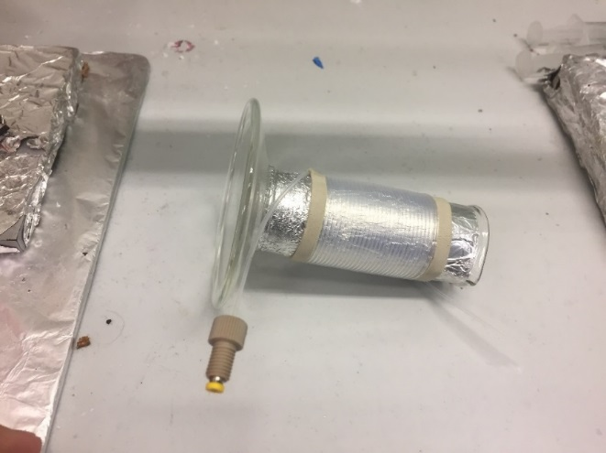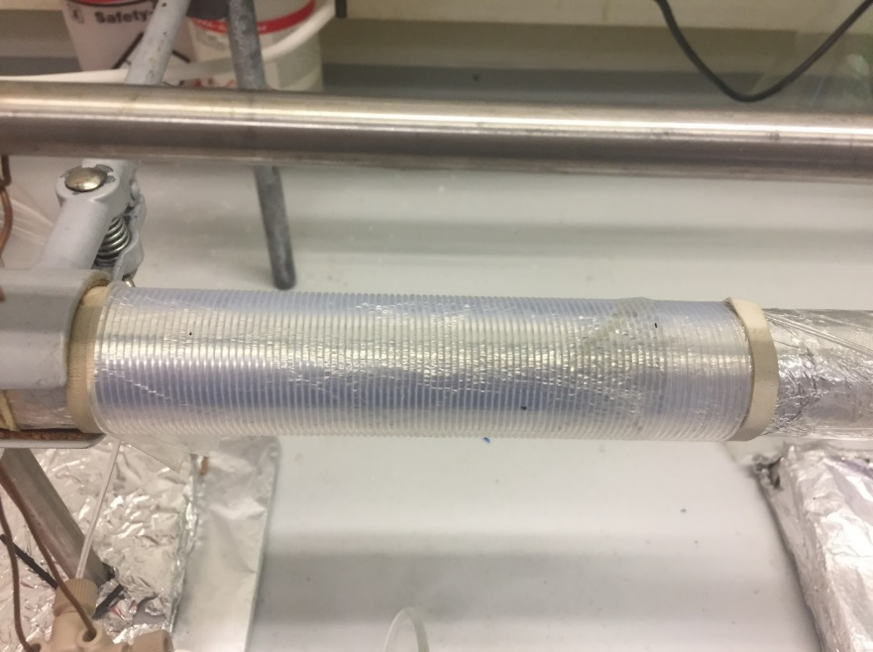  
  
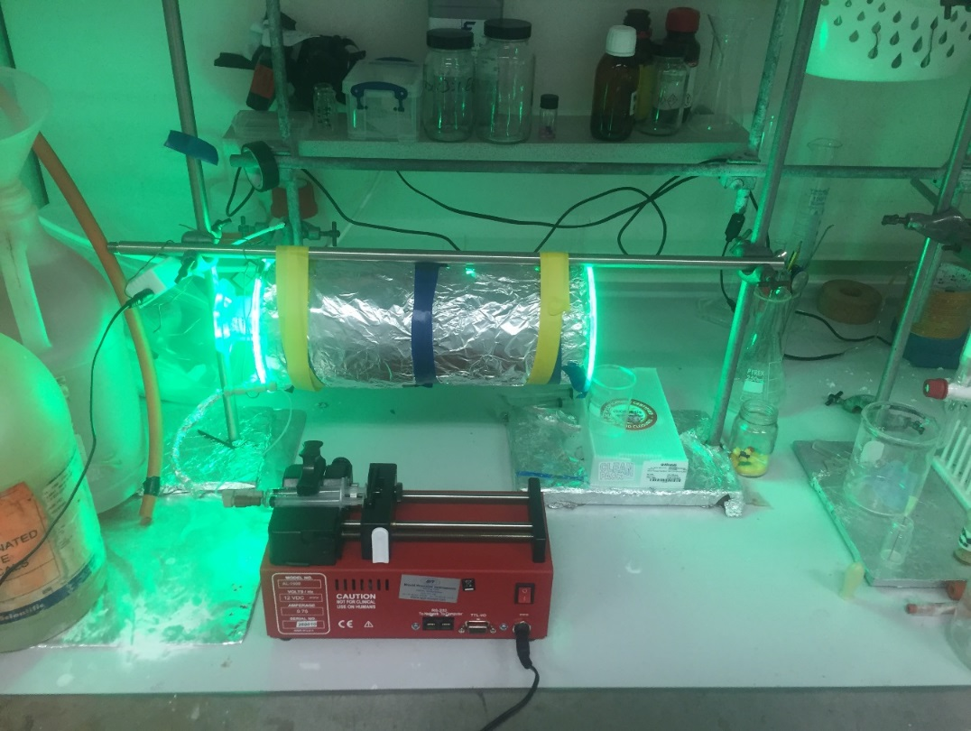

b)

a)

c)

**Figure 3** - a) 590 μl reactor b) 1.6 ml reactor c) fully constructed photoredox flow setup