**Figure 1.**

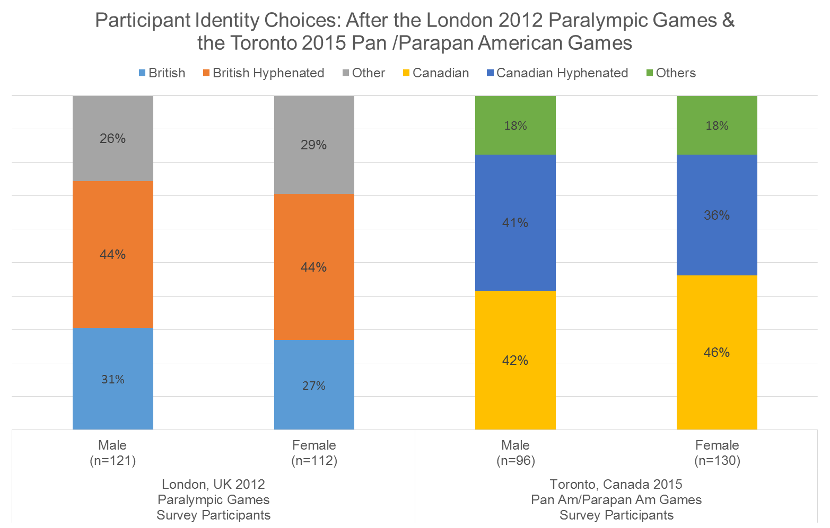

**Figure 2.**

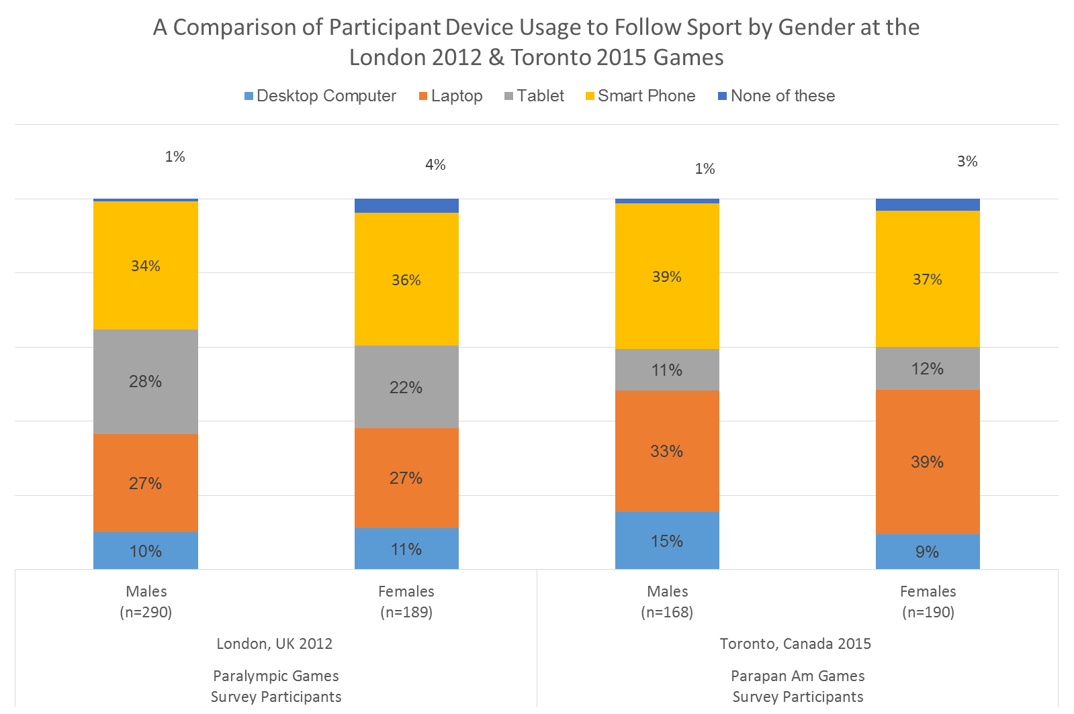

**Figure 3.**

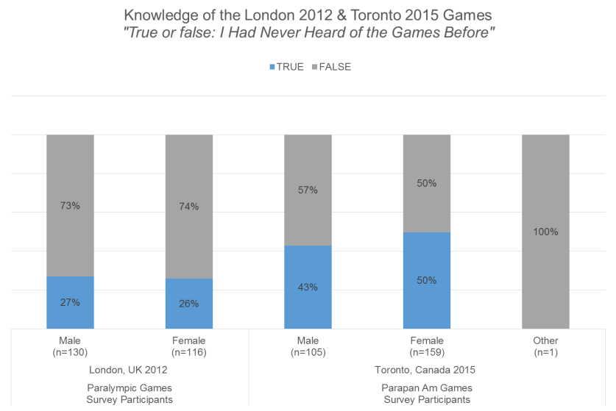

**Figure 4.**

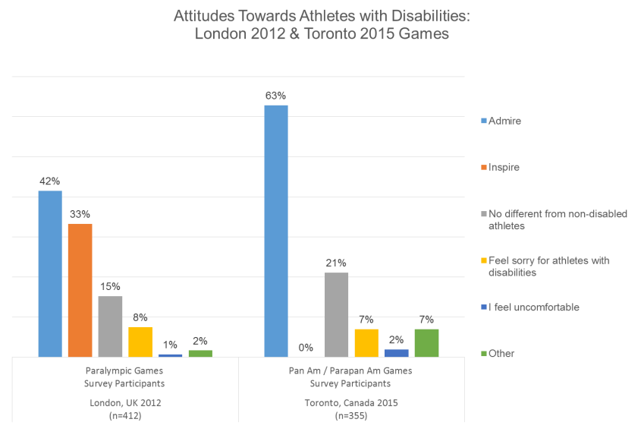

**Table 1.**

Recognition of Athletes and Their Sport: London 2012 & Toronto 2015 Games

