EUROPEAN COMISSION
Research Executive Agency
Marie Curie Actions-International Incoming Fellowship (IIF) Programme

Grant Agreement No: PIIF-GA-2013-624609
Project No: 624609
Project Acronym: VALOWASTE
Project Title: Valorisation of Agro-food Industrial Wastes

Marie Curie Actions

Final Report

- FINAL PUBLISHABLE SUMMARY REPORT
Cultivation of grapes is a major agro-economic activity in the European Union (EU) because of the large scale consumption and demand for wine. Wine production entails the generation of large volumes of organic waste/by-products in the form of grape pomace and wastewaters. The peculiar characteristics of such wastes are not only their large scale generation which leads to problems regarding their efficient management, but also their physico-chemical characteristics which create environmental pollution. Reducing the environmental impact associated with wine production is a key relevance to the EU as well to the VALOWASTE project. Also, keeping in focus the antioxidant and health benefits associated with the polyphenols, as well as a possibility of recovery of useful resources present in the organic fraction of wine wastewaters, VALOWASTE was conceived based on the biorefinery concept in adding value to the winery wastes as well as to eliminate environmental issues. The activities outlined in the project include application of different low cost, eco-efficient valorisation steps
- to recover bioactive polyphenols both from winery solids and waste water,
- to recover bioenergy products like the bio-fuels from the wine wastewaters and simultaneously to remediate the wastewater effluents as per discharge standards.
- to develop bio based activated carbons/biochars from the exhausted winery solids for use in wastewater treatment
The project activities can be summarized in the logo below which was developed for dissemination activities.
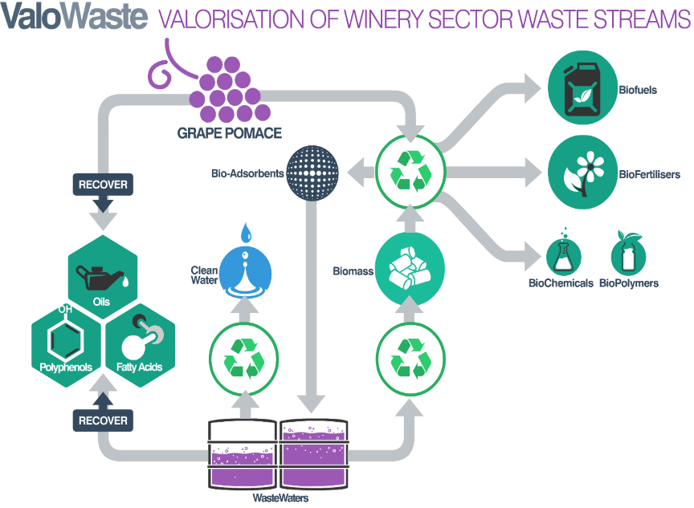
The overall work which is in line with the objectives was divided into various work packages.
In Work Package 1, a detailed compositional analysis was carried out on grape pomace and wine wastewaters procured from the Experimental winery at Tarragona in Spain. Different extraction methods were undertaken and their parameters were optimised so as to recover highest polyphenol yields.
Keeping in view the high biodegradability of the wine wasters, anaerobic digestion (AD) techniques were undertaken in laboratory batch methanogenic test vials for an initial assessment of process viability (Work Package 2) and a further upscaling of the process via the ASBR (anaerobic sequencing batch reactor) was performed in Work Package 3. The process parameters were optimised so as to achieve reactor stability, maximize biogas yields and achieve high efficiency in the biodegradation of the winery contaminants. Also, keeping in view the toxicity and inhibitory effect of the high polyphenolic content in the wine waters towards the microbial activity, the polyphenols were recovered by activated carbon adsorption technique and the final effluents was subjected to the AD technique. In Work Package 4, novel activated carbon was developed from the exhausted grape pomace (after the extraction of polyphenols) and the same was used to recover polyphenols from wine wastewater. Both batch tests and column operations were carried out in the laboratory for optimisation of process parameters for maximizing the adsorption efficiency.
Results on the compositional analysis reveals that the pomace of the red grape variety Cabernet Sauvignon has a high dietary fibre, protein, polyphenols and a mineralogical content. The wine wastewater revealed a high COD of 182.45g/L and an acidic pH of 3.8. The presence of 28.6% of organic matter reveals the organic nature of the substrate. Significant proportions of carbohydrates (20.36%), ethanol (7.5%), fatty acids and polyphenols are contributory to the high COD of the wine wastewaters. Results on the extraction efficiency of polyphenols from grape pomace reveal that conventional solvent extraction with 10 mins of ultrasonication using 1:1 aqueous ethanol as the extraction solvent resulted in best yields of polyphenols (2079.33 mg/100g) and are also in agreement with the green chemistry principles. The biodegradability results (work package 2) obtained from the batch methanogenesis assay of the wine wastewaters was >70%; with a significant amount of COD input (85%) being converted to methane thereby indicating the suitability of the anaerobic digestion for degradation of the wine wastewaters. The upscaling experiments (Work package 3) on the digestion process using a sequencing batch reactor (ASBR) reveal methane yields of 221 mL/g-COD-input representing a bio-methanization ability of 63% at digestion temperatures of 30⁰C. The final effluent demonstrated a COD reduction of 93%.
In Work package 4, a novel mesoporous (GPMAC-1) activated carbon was developed from exhausted grape pomace. Application of GPMAC-1 (8g/L) as an adsorbent to the real wine wastewater (initial polyphenol content of 856ppm) revealed a removal efficiency of 39.54% under 2hrs of contact. Increase in the adsorbent dosage resulted in 95% polyphenols removal from the wastewater; the performance was found to be comparable to a commercial activated carbon. Laboratory scale column loaded with GPMAC-1 demonstrated a polyphenols removal performance of 71.3%. The final outcome of the project are:
- Recovery of polyphenols using green solvents and processes from grape pomace
- Anaerobic digestion is an innovative technology that has resulted in high biodegradability of the wine wastewaters.
- Low environmental impact separation technologies like adsorption in the recovery of phenolic compounds from winery wastewaters. The novelty of the proposed method lies in the use of the exhausted grape pomace in preparing highly effective low cost activated carbons.
The VALOWASTE project has identified great potential in the wastes generated from the wineries. Considering the growing demand for the use of natural antioxidants, grape pomace can be a cheap source of polyphenols which are known for their antioxidant activity. Also, cheap, eco-efficient activated carbons prepared from the exhausted grape pomace can easily replace the costly commercial carbons for use as adsorbents for wastewater treatment. The project has not only important environmental implication in reducing the organic pollutants present in wine wastewaters, but also the recycling of the organic fraction to significant yields of bio-fuels serves as an important valorization strategy especially in light of rapidly rising costs associated with energy supply from the ever depleting fossil resources. At a time when the world population is increasing and fossil resources are dwindling, the VALOWASTE project adopting novel bio-based technologies for sustainable waste management has great significance to the EU food industry along with the EU bio economy strategies. The untapped potential for agro-food production wastewaters to produce various renewable energies and high added value by-products is enormous and is in line with the current zero waste sustainability concept. The VALOWASTE research activities thus supports the sustainable management of resources and wastes embedded in the EU waste framework directive (Directive 2008/98/EC) which established that waste management can be improved via the life-cycle of the resources.

