Publishable Summary
AVATAR (624969)
Introduction
In the last decade, modern technologies of imaging and analysis have revolutionized the study of fossils and opened up exciting new avenues of investigation. For instance, µCT and synchrotron-CT scanning allow fossils to be characterized in three dimensions and with unprecedented resolution. This has enabled palaeontologists to gain important insights into the anatomy, growth patterns, and biomechanics of extinct organisms. New protocols allow more objective reconstructions of fossil organisms, including soft tissues, from incomplete remains. Very recently, the development of Synchrotron Rapid Scanning X-ray Fluorescence (SRS-XRF) and its application to the mapping of fossils has taken palaeontology a step further. By identifying, quantifying, and spatially resolving the chemical composition of the bone, shell, and soft tissues, together with that of embedding matrix, this technique has the potential to provide great insight into the composition, preservation, and biochemistry of ancient life. Furthermore, mapping the chemistry of fossils while still embedded within their matrix opens a window onto the transfer of elements between the original organisms and the sedimentary rocks in which they have been entombed. Therefore, it helps distinguish the parts of the chemical patterns of specimens that are due to taphonomy from those that are the remnant of the biochemical processes related to physiology.
This project aimed at applying a range of newly developed techniques to exceptionally preserved fossils.

Results
Two fossils were studied in the framework of this project: a diminutive bird (MPCM-LH-26189) from the Cretaceous of Las Hoyas (Spain) and a rodent (EDS-1) with visible soft tissue preservation from the Miocene of Elche de la Sierra (Spain).
-Bird
The specimen was subjected to propagation phase contrast X-ray synchrotron radiation microtomography at European Synchrotron Radiation Facility (ESRF; Grenoble, France; Fig. 1). Propagation-based phase contrast on microradiographs enhances edge detection. This helped to examine the inside of the matrix. The specimen was scanned several times, corresponding to scans at various resolutions. We used this to search for parts that were not visible on the bedding plane. For example, no scapula was visible on the surface of the slab, and we were able to verify that the scapulae are not present since there was none detectable within the matrix. However, synchrotron tomography did suggest the presence of at least five teeth, which were not visible on the fossil optically, even via detailed microscopy. Faint ribbing in a geochemical precipitate visible in a yellowish stain close to the tail made us suspect the presence of plumage remains in MPCM-LH-26189. However, synchrotron tomography showed it to correspond to ribbon-like structures more consistent in their morphology with vegetal material than with feathers.
Virtual thin sections (Fig. 2) were made in the shaft of the left tibia and right radius of MPCM-LH-26189 using VGStudio MAX 2.2. Each virtual thin section was 10μm thick. They showed the presence of an irregular surface in the inner region of the cortical bone of the tibia, which suggested internal erosion. This explained the thinness of the primary bone and the large extension of the free medullary cavity. There was no evidence of secondary deposition on the inner surface of the cortical bone. The cortical bone was pierced by primary vascular canals and exhibited a large number of globular-shaped osteocyte lacunae. These cell lacunae were relatively large (7-13 μm). No lines of arrested growth could be observed. Although flattened, the radius displayed a similar microstructural organisation with an obvious longitudinal orientation of vascularisation.
The absence of lines of arrested growth in the cortex of the tibia and the radius of MPCM-LH-26189 indicated that the bony tissue was deposited during a relatively fast growing period. This, together with the primary nature of the vascularisation, the plump shape of the osteocytes lacunae, and the uneven peripheral margin of the medullary cavity (with no endosteal bone) strongly suggested that the bone was growing at an active pace, characteristic of an early stage of development, when the bird died. The resorption front bore testimony to an ongoing intensive restructuring of the bone, progressively integrating the vascular canals into the medullary cavity.
The exceptional preservation of MPCM-LH-26189 meant that there was a possibility of soft tissue/biochemical information preservation that, whilst not visible to the naked eye, could be detectable as a chemical “ghost”. SRS-XRF elemental imaging has previously shown the ability to detect dilute chemical remnants of soft tissues in many fossil specimens, even when no visible evidence of such tissues remained. We, therefore, undertook SRS-XRF imaging of the specimen at the Stanford Synchrotron Radiation Lightsource (SSRL) wiggler beam line 6-2 at the Stanford Linear Accelerator Centre (SLAC, CA; USA; Fig. 7). Experiments were operated with an incident beam energy of either 13.5 keV and a 50 micron pinhole or 3.15 keV and 25 micron pinhole. X-rays were detected using a single element Vortex silicon drift detector. For point quantification analyses, a full energy dispersive spectrum was collected for 100 live seconds. Energy dispersive spectra obtained from SSRL were fit using the PyMCA freeware from fundamental parameters of the experiment using a Durango apatite (fluoroapatite) mineral standard with known element concentrations for calibration. SRS-XRF maps from SSRL were processed from the raw detector count raster files using a custom MATLAB computer script that converted the data array into viewable 8 bit tiff images clipped at various contrast percentiles.
The resulting elemental maps showed that Al, Si, P, Fe, Cu, and Zn were associated with fossilised tissue, but were mostly constrained by the skeletal components thus indicating that little remained of the original soft tissues. P was clearly elevated in the bones as would be expected (Fig. 3) and resolved the bone morphology in extremely high fidelity, even in areas where the fossil specimen was hardly visible optically. Notably, P was present in concentrations that were almost identical to that seen in extant avian bone, suggesting that there has been minimal loss of this element into the surrounding matrix. However, Fe and Si did appear elevated in a diffuse pattern on the bottom half of the organism. A false colour composite image of Fe (red), Si (green), and P (blue) (Fig. 4) showed that Fe and Si were highly correlated (yellow). P also appeared to be weakly correlated with Fe and Si in this region. The distribution of these elements was somewhat similar to what the body outline would have been in life.
This diffuse distribution of Fe and P was consistent with the known mode of preservation of soft-tissue at the Las Hoyas site, which has been interpreted to be due to microbial/biofilm iron carbonate mineralisation and phosphatisation. The distribution of silica was also consistent with mineralisation associated with microbial mats. Unlike a wide range of other exceptionally preserved fossils studied via SRS-XRF, little organic sulfur was associated with this fossil integument. Sulfur X-ray absorption spectroscopy showed no difference in sulfur speciation between matrix and fossil, consisting predominantly of sulfate, although a minute amount of reduced sulfur may have been resolved. This indicated that the soft tissues, in this case, were almost entirely replaced, such that some details of integument distribution were still visible, but remnants of original biochemistry were at the limits of detection for the techniques applied here.
-Rodent
The specimen, EDS-1, is a 6 million years old, exceptionally well-preserved murine discovered in Spain near Albacete. It was unique in that it shows not only a nearly complete skeleton in articulation but also remnants of soft tissues, such as hairs and viscera. We performed tomography so as to be able to observe the skeleton in three dimensions. Because the specimen lies on a slab of rock, it was indeed very difficult to study its anatomy satisfactorily and, of course, physical preparation was not only impossible in this case but also unwanted as it would have destroyed the thin remnants of soft tissue as well as disarticulated the skeleton. So, we CT scanned it at the Henry Moseley X-ray Imaging Facility at the University of Manchester (MXIF) on a Nikon XTH225 with a voltage of 100 kV and a current of 100 µA. We did this twice at different resolution, initally for the full skeleton and a second time for the skull only. Because there was an important difference of attenuation coefficients between the matrix (siliceous) and the skeleton (phosphatic), the dataset we obtained was very high contrast. This made the digital preparation of the fragile skeleton, currently under progress, easier than it was expected to be. The 3D reconstruction eventually obtained will allow characterization of this possibly new species, enabled via a thorough anatomical study of the teeth and bones.
We wanted to add to the tomographic data from the skeleton with information about the soft tissues. The SRS-XRF maps (Fig. 6) showed that Zn was concentrated in discrete small regions mainly proximate to the caudal part of the mandible and the pelvis. Within these regions, there were numerous small bright spots that would be consistent with fine-grained mineral precipitates rich in Zn. The distribution of Cu was more extensive than that of Zn. Cu did not show discrete bright spots, but rather maintained a diffuse pattern that defined the cadaveric decay island, with elevated concentrations across almost the entire body of the specimen and especially bright areas in the body cavity and along the caudal-most part of the body. The map of total sulfur showed there was a great amount of it around the fossil. The mapping of reduced (organic) sulfur revealed the outline of soft tissue residue, which correlated largely with the distribution of Cu. As expected, Ca and P were mostly constrained within the skeleton, while Si was mostly found in the matrix.
The concentrations of Cu and Zn in both the skull and gut area were elevated. The Zn XANES spectroscopy was consistent with Zn being coordinated in a mineral precipitate, while the Cu XANES spectra indicated that the Cu in the fossil body was organically bound. We interpreted this as the soft tissue partially oxidising to release Zn and form mineralised regions rich in Zn, while the more stable Cu complexes remained bound to residual organic material. This was further supported by the correlation between Cu and the distribution of organic S. It is entirely plausible that the Zn and Cu distribution at least in part reflected the original distribution of melanin pigments in the organism. In the point analysis of the mandible, the concentrations of Ca were low in the three analyses, presumably because of the presence of a thin film of sulfate, probably under the form of magnesium sulfate, that attenuated the Ca X-rays more efficiently than the higher characteristic energy fluoresced X-rays from the transition metals (Fe, Cu, Zn, As…). Cu and Zn showed normal concentrations in bone, which meant that there has been little post-burial geochemical alteration of the bone itself. The bone did show high concentrations of Fe, however. The matrix had some carbonate minerals, possibly acting as cement. Infrared spectroscopy confirmed the preservation of soft tissue in the body of the fossil mouse.

Impact
The results of the project added to the growing, yet small, data that have been obtained over the last few years about the chemical mapping of fossils. They confirmed that SRS-XRF is a powerful tool with prodigious promises for palaeontology and beyond and contributed to the foundation of our ability to combine non-destructive chemical mapping and quantitative chemical analyses. The use of synchrotron radiation to map and quantify the biochemical pathways and taphonomy of fossils should not only improve our understanding of the living world, past and present, but also fuel research across a broad array of disciplines.

Figures

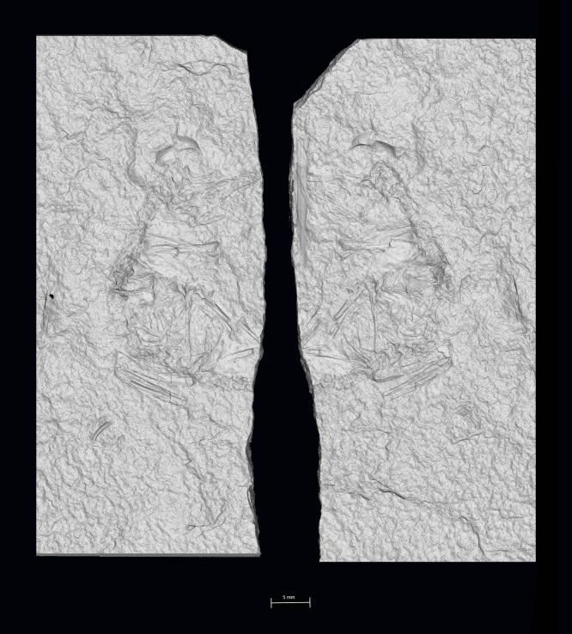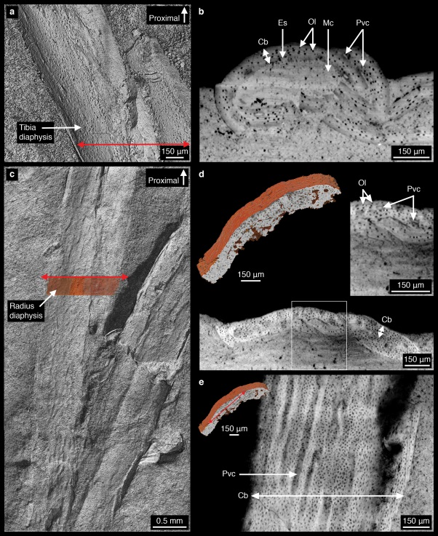

Figure 1 (left). 3D rendering of the two slabs of MPCM-LH-26189.

Figure 2 (right). Virtual long-bone histology of MPCM-LH-26189. a, 3D model of the tibia diaphysis; b, transverse section of the tibia showing a thin poorly vascularised cortex, eroded in its inner region, and a large medullary cavity; c, 3D model of the radius diaphysis; d, transverse section of the radius showing a microstructure similar to that of the tibia, although with a slightly more vascularised cortex; e, longitudinal section showing the longitudinal orientation of the vascularisation. Abbreviations: Cb, cortical bone; Es, erosion surface; Mc, medullary cavity; Ol, osteocyte lacunae; Pvc, primary vascular canals.

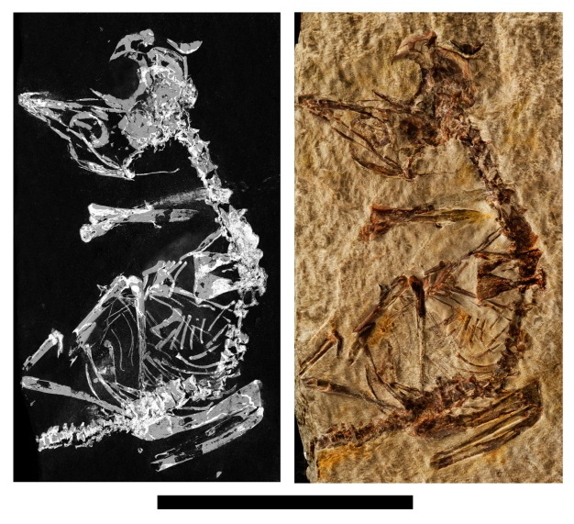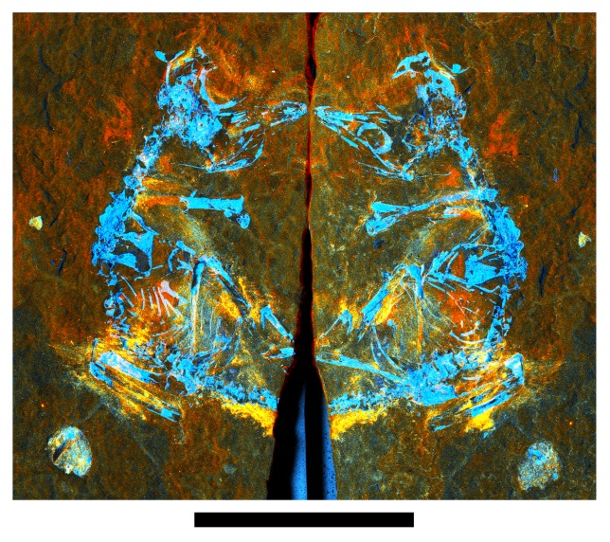

Figure 3 (left). Overlay of the phosphorus SRS-XRF maps (left) and optical photographs (right) of the slab and counterslab of MPCM-LH-26189. This provides a visual representation of the combined preserved skeletal elements. Scale bar = 20 mm.

Figure 4 (right). False colour composite image of SRS-XRF elemental maps of MPCM-LH-26189. Red=Fe, Green=Si, Blue=P. This image is not representative of true relative concentrations but is designed to best illustrate the distributions of these elements. Fe and Si correlate in some areas (yellow regions) potentially representing remnant soft tissue. Scale bar = 20 mm.

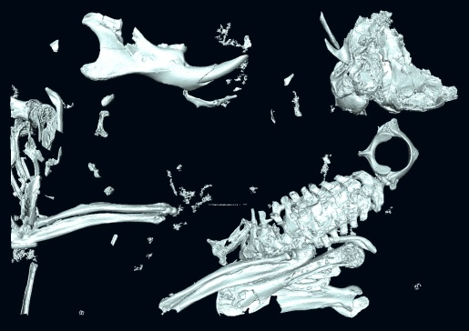

Figure 5. Partial CT-scan of EDS-1 showing the braincase, mandible, neck, and forelimb.

Figure 6. False colour composite image of the exceptionally preserved murine. Red=Cu, Green=Zn, Blue=Ca. This image is not representative of true relative concentrations but is designed to best illustrate the distributions of these elements.

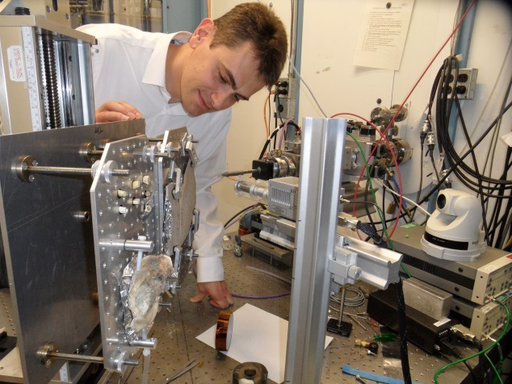

Figure 7. The fellow at the Stanford Synchrotron Radiation Lightsource (SSRL). The specimen MPCM-LH-26189 is placed on the stage, ready for scanning (December 2014).

Figure 8. The fellow at the University of Manchester Postgraduate Summer Research Showcase 2016 (June 2016).

