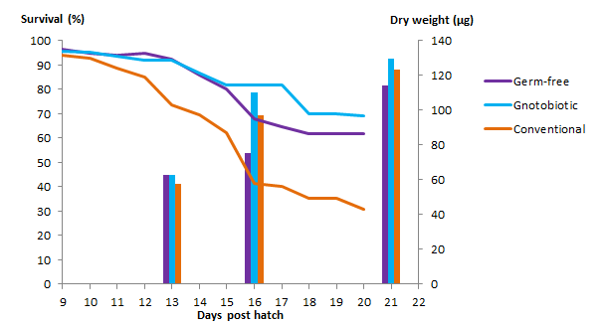

**Figure1**. Survival and weight of cod larvae exposed to different microbial conditions throughout the long-time experiment. Lines represent the average of survived fish of three replicate fish tanks. Chart bars represent the average weight of larvae per sampling day of three replicate fish tanks.