PUBLISHABLE SUMMARY
The project has realized its two main objectives:
- Detection of individual biological material, ‘tagged’ with nanoparticles.
- Detection of single redox protein activity.
Initially, the researcher gained theoretical and experimental experience with single nanoparticle (NP) electrochemistry. Knowledge transfer of the lab experience was established as planned. Electrochemical detection of individual NP’s randomly colliding with a potentially biased microelectrode was achieved. Next, the researcher and the scientist in charge turned to the two proposed scientific objectives.
For the first objective, detection of single E. Coli bacteria, ‘tagged’ with silver NP was demonstrated. In a brief, the electrochemical activity and the known ability of NPs to adhere to bacteria was exploited. After UV-Vis and electrochemical characterization of the system (of the bacteria and the silver NPs), we turned to a single cell detection. Individual E. coli, coated with silver NPs, where detected within 10 minutes from a pM solution of bacteria and KCl electrolyte. Each random collision of a ‘tagged’ single cell with a microelectrode, produced burst of charge, expressed as a current spike (See figure 1.a,b).
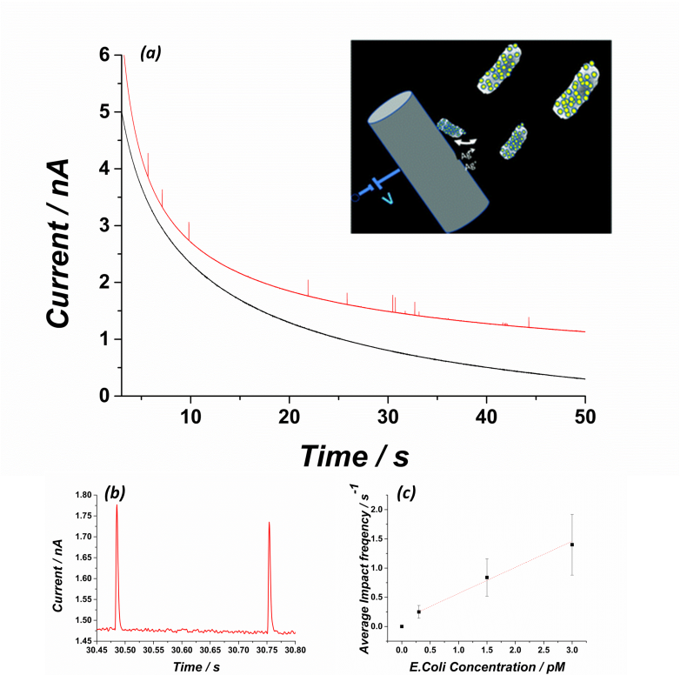
Fig. 1. Representative chronoamperometric responses for a carbon fibre electrode held at +1.3 V vs. SCE in 0.1 M KCl and AgNPs. (a) Reference (‘blank’) chronoamperometric measurement of 1 nM AgNPs without E. coli cells (black curve) and with approximately 0.3 pM E. coli (red curve). The ‘blank’ plot was offset in y-axis, for clarity. (b) Current spikes seen with expanded time scale. (c) Average spike frequency (number of spikes per s) as a function of cell concentration with a constant AgNP:E. coli ratio of 3000:1
The frequency of the current spikes was linearly proportional to the bacterial concentration in the solution (figure 1.c). Hence, from this in-situ technique, we can gain fast information on the concentration of the bacteria in a solution.
Next, we showed that a similar concept can be established for viral detection. A proof of concept for a new biosensor that can rapidly distinguish between bacteria and a virus solution was demonstrated. The technique may have medical applications in the growing need for fast, cheap and reliable tools for bacterial diagnosis (and other biomaterials).
Subsequently, we were also able to show that single red blood cells can be detected, without any labeling, by their electrocatalytic activity towards hydrogen peroxide.
The work was published in:
- Biomaterials Science (2015, 3, 816-820):“Electrochemical detection of single E. coli bacteria labeled with silver nanoparticles” by: Lior Sepunaru, Kristina Tschulik, Christopher Batchelor-McAuley, Rachel Gavish and Richard G. Compton.
- Chemical Science (2016, 7, 3892-3899): “Rapid electrochemical detection of single influenza viruses tagged with silver nanoparticles” by: Lior Sepunaru, Blake J. Plowman, Stanislav V. Sokolov, Neil P. Young and Richard G. Compton.
- Angewandte chemie (2016, 128, 9920-9923): “Electrochemical Red Blood Cell Counting: One at a Time” by: Lior Sepunaru,Stanislav V. Sokolov, Jennifer Holter, Neil P. Young and Richard G. Compton. (VIP and highlight in the same journal)
For the second objective, we have achieved the following goals:
- Redox proteins were immobilized on a microelectrode surface, while their catalytic activity was preserved.
- Electrochemical quantification of the protein’s redox activity in solution and on the surface.
- Feasibility of single enzyme electrochemistry was investigated theoretically and experimentally.
- Demonstration of the ability to electrochemically detect single nanoparticle modified with enzymes
The work was published in:
- Chem. Eur. J. (2016, 22, 5904 – 5908): “Catalase-Modified Carbon Electrodes: Persuading Oxygen To Accept Four Electrons Rather Than Two” by: Lior Sepunaru, Eduardo Laborda and Richard G. Compton. (VIP)
We are now at a stage of finalizing three more publications dealing with single and ensemble enzyme activities. We are confident that via these reports we will contribute to the current understanding of electrochemical detection of enzymatic activities and to which extent can we use cutting edge electrochemical techniques to detect biological catalytic activity.

