How does Nitric Oxide (NO) regulate crop pathogen virulence? “NO CROP PATHOGEN”

Fungal pathogens cause disease in important crop plants including cereals, dramatically reducing yields and quality. Preventing fungal disease in crop plants such as wheat, would ensure global food security and reduce agricultural inputs with respect to fungicide application.
Following the recognition of microbial attack both plants and animals produce a nitric oxide (NO) burst which is part of plant immunity and is directly antimicrobial.

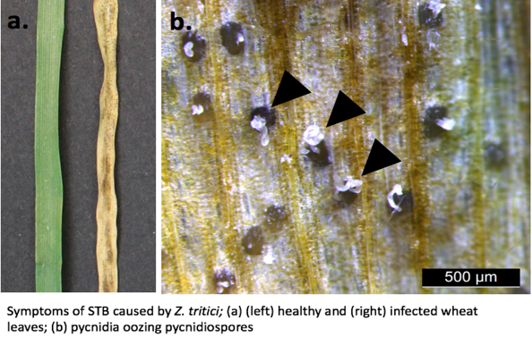
Zymoseptoria tritici (Synonym Mycosphaerella graminicola) is a devastating fungal pathogen of wheat causing the disease Septoria tritici Blotch (STB) (Fig.1). Currently 70% of the fungicides used in the EU are applied to control this disease on wheat.
Understanding the role that NO has on pathogenic fungi during attempted colonisation and infection of the plant host may allow new resistance strategies to be developed to control important crop pathogens.
Overall this study has found an important role for NO in controlling fungal disease in wheat.
Fig. 1

Mechanisms to counteract NO stress and control S-nitrosothiol levels in plant pathogenic fungi
We identified the Nitrosoglutathione Reductase (GSNOR) homolog from the fungal pathogen of wheat Z. tritici. In plants, bacteria and animals this GSNOR enzyme plays a critical role in NO signalling and is a source of bioavailable NO.
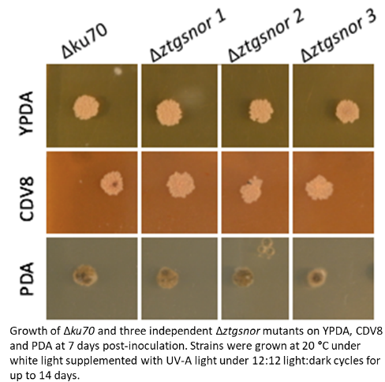
To assess the role of GSNOR in this cereal pathogen the ZtGSNOR was cloned and three independent knock-out mutants (Δztgsnor) were created using Agrobacterium-mediated transformation. The knockout of ZtGSNOR expression and the loss of function of the enzyme was confirmed using RT-qPCR and an enzyme activity assay. The level of S-nitrosothiols was also analysed using an NO analyser. The effects of different stresses and growth media were investigated (Fig.2.) on the Δztgsnor mutants as was any developmental defects which may occur following the knock-out of this gene. Similar studies in plants for example, found that the knockout of this GNSOR gene has impacts on development and growth. In fact the hyphal growth of the Δztgsnor fungal mutants was impacted. To further assess if the fungal GSNOR has similar properties to that found in other organisms Arabidopsis gsnor mutant plants were transformed with the Z. tritici homolog. Finally, the aggressiveness and virulence of these Δztgsnor lines while infecting wheat was investigated. This work revealed the importance of GSNOR and levels of S-nitrosothiols to this pathogenic fungal pathogen and its role in STB disease of wheat. This work is in preparation for publication.
Fig. 2

S-nitrosylation during Z. tritici infection of wheat the effect on virulence
To identify virulence factors that have may be targeted by NO and consequently S-nitrosylated GPS-SNO was used to identify candidates in silico with were predicted to have targeted cysteines. Five candidates were selected. These were cloned and over-expressed in E. Coli for protein purification. Following purification, the proteins were analysed by a Biotin Switch Method (which is a modified version of western blotting). The proteins were also analysed using an NO analyser at UCD to asses S-nitrosylation.

Impact:
This CIG has had a pivotal role in my career progression. Following the CIG I have secured other funding such as a Science Foundation Ireland (SFI) Career Development Award and led a successful SFI bid for “Phenotyping Infrastructure for Crop Stress” at UCD worth €1.2 million. I am also CoPI on other projects such as the CerealPath, EU MC ITN as well as working on industry funded projects for example by Alltech Crop Science. My groups research has economic and environmental impacts via our work on cereal disease control and we have patent application in this area.
I have a been integrated into UCD as a tenured lecturer and a PI with a group of eight researchers focussed on fungal cereal pathogens. My links with the EU community of researchers has increased since returning to Europe for example via the CerealPath ITN and the Zymoseptoria tritici community.
The project has also had a positive impact on the career of Dr. A. Tiley (right in image) who was employed as a post-doc on this project and subsequently went on to secure her own Irish Research Council Fellowship to investigate circadian clock components in Z. tritici pathogen.

Contact: angela.feechan@ucd.ie
Left-Angela Feechan https://people.ucd.ie/angela.feechan
Right - Anna Tiley: https://people.ucd.ie/anna.tiley

