PEOPLE
MARIE CURIE ACTIONS

Marie Curie Career Integration Grants (CIG)
Call: FP7-PEOPLE-2013-CIG: FINAL PUBLISHABLE SUMMARY REPORT

The role of visuospatial working memory in quantities representation and arithmetic: Neuroanatomical and behavioral evidence from typical and atypical development.

VisuoQuant

Over the last two decades, converging evidence has indicated that human infant and primates are born with innate abilities to represent quantities. However, the relation between these innate representations and the cognitive mechanisms that underlie typical and atypical school arithmetic abilities is still largely unknown.
The present research will point to the critical role of primitive spatial representation of quantities (a mental model of quantities or representation of quantities on the mental number line) in numerical cognition, supported by the mechanism of visuospatial working memory (VSWM). The present work would like to examine the role of VSWM memory in typical and atypical development of number processing, from several novel perspectives.
(1) Development: How are the spatial representations of numbers built? What is the role of VSWM in the development of spatial representations of numbers? Here, we are currently testing second, third and fifth grade children in three tasks: a VSWM task (the Corsi block tapping task), the number line estimation task, which tests the mapping between space and quantities, and an arithmetic task (addition problems and solution strategies).
(2) Neuroanatomy: What are the neuro-cognitive mechanisms related to VSWM that underlie numerical processing? We took two groups of participants with high or low VSWM capacity. During a functional magnetic resonance imaging scan (fMRI), participants performed the number line estimation task, two additional VSWM tasks and a numerical comparison task.
(3) Learning disabilities: Understanding the role of VSWM in the etiology of developmental dyscalculia (DD): evidence from training in DD. Here we would like to train VSWM, using a computer program developed for the current study, and test the effect of VSWM training on numerical abilities in a group of participants with DD.
Neuroscience and education are two fields that are disconnected; the aim of the present work is to close the gap between the classroom and cognitive neuroscience. Here I would like to present the idea that mathematics and numerical processing are directly based on primitive VSWM representations. Math abilities is a new cultural invention; hence, it is not hardwired into the brain. Alternatively, I propose that it is built based on a VSWM representation. Therefore, we should examine connections between VSWM and math ability from the initial stages of elementary school and we should also expect to find shared neural mechanisms.
Examples for the results of the project
Here is an example for the results from the developmental perspective of the project. Several previous studies report correlations between a tendency towards mature number line representations (linear tendency) and improvement in school-like math skills. These correlations, however, do not imply causation. Hence, in the present experiment we examined, directly, the effect of VSWM on strategy use during the solution of addition problems. Children in the initial stages of elementary school primarily use four strategies to solve addition problems: (a) counting fingers, (b) verbal counting, (c) retrieval, and (d) decomposition (e.g. 6 + 7 = 6 + (6 +1) = 12 + 1 = 13). When children first learn to solve addition problems, they rely heavily on effortful and time-consuming counting procedures (such as figure counting). Repeated use of counting strategies results in the formation of associations between problems and solutions, resulting in the implicit use of the retrieval strategy. Children with math difficulties, tend to continue to use the strategy counting fingers long after their peers; this tendency can be related to VSWM weakness. Those children would continue to use finger counting due to deficits in building a mental model of the problem and using their fingers as an actual model. Hence, in the present study I expected to fine relation between individual VSWM ability and tendency to use a specific strategy. To test this hypothesis, a three-way analysis of covariance (ANCOVA) was performed on the percentage of use of advanced strategies (The addition of the percentage of usage of direct retrieval and decomposition) with problem type (small or large) as the within subject factor and mathematical anxiety group (low or high), and grade as the between subject factor. Individual memory span served as a covariance. The main effect of memory span reached significant F(1, 87) = 4.14, partial η2 = .07, p < .05, observed power= .52. There was a positive correlation between the usage of advanced strategies and memory span r (92) = .30, p < .01 (See figure 1). The main effect of group also reached significant (1, 87) = 3.32, partial η2 = .07, p < .05, observed power= .61. The percentage of usage of advanced strategies increased between the second (M = 68.32%, SD = 30.48%) and third grade (M = 87.17%, SD = 23.83%), t(60) = -2.71 p < .01. However, the percentage of usage of advanced strategies stayed high and stable between the third and fifth grades (M = 89.17%, SD = 20.07%), t(61) = -.36, p = .72. The main effect of anxiety also reached significant F(1, 87) = 9.58, partial η2 = .10, p < .01, observed power= .86. Across ages the percentage of usage of advanced strategies was much higher in the low MA group (M = 91.4%, SD = 20.11%) compared to the high MA group (M = 74.4%, SD = 28.57%). None of the other interactions reached significant values. However, the interaction between anxiety group and problem type was marginally significant F(1, 87) = 3.92, partial η2 = .04, p = .05, observed power= .49. While low MA used advanced strategies similarly in small (M = 91.96%, SD = 20.34%) and large problems (M = 90.83%, SD = 21.67%) t(39) = .59 p = .56. High MA used advance strategies more in the small problems (M = 79.37%, SD = 26.71%) compared to large problems (M = 69.44%, SD = 34.83%) t(53) = 3.00, p < .01 (See figure 2).

Figure 1. Correlation between VSWM (visual spatial working memory) span tested by the CORSI tapping task and percentage of usage of advanced strategy (sum of percentages of usage of direct retrieval and decomposition). There was a positive correlation between the usage of advanced strategies and memory span r (92)= .30, p< .01, as the memory span increases the usage of advanced strategies increases as well.
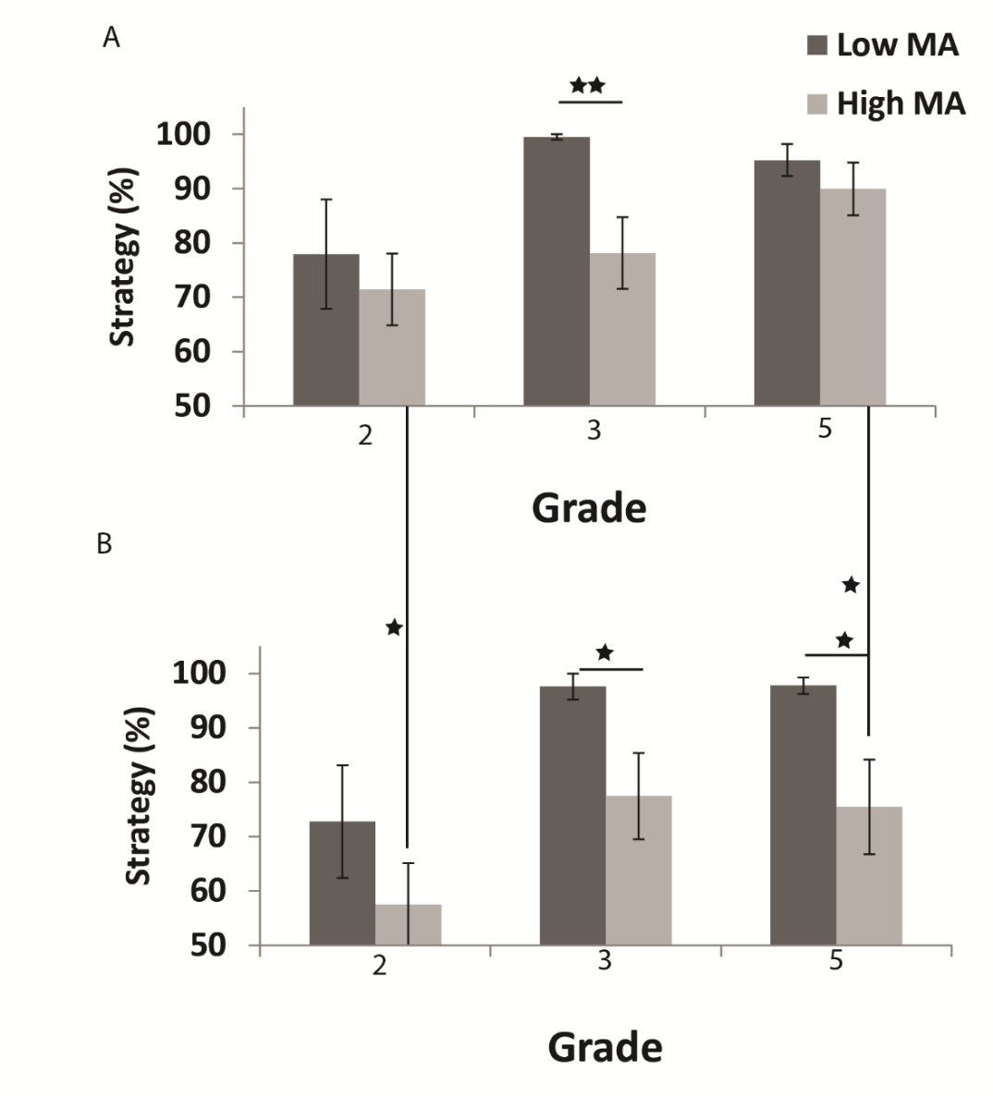

Figure 2.
Mean usage of advanced strategies (sum of percentage of usage of direct retrieval and decomposition) as a function of grade and mathematical anxiety in small problem (A) or large problem (B). As can be seen, the usage of finger counting was similar between anxiety groups in the second grade, however, only the high anxiety group show a decrease in the usage for larger problems compared to smaller problems. Note- * p < .05, ** p < .01.

Additional goal of the present project is to understand the neuroanatomy aspect of the relation between VSWM and numerical processing. Interestingly, neuroanatomical evidence indicates that both arithmetic and VSWM are supported by activation of the intraparietal sulcus (IPS).
We ran few tests in the scanner of the fMRI. First the participant preformed the number line main task for two runs. A number line was presented with 1 and 1000 in each of its sides. A number appeared above the number line and a vertical line was presented on the number line. The participants had to judge whether the position of the number line matched the presented number or not. The two next blocks were the brightness control task. In that task a line was presented with white and black squares presented at the end of the line. A gray square appeared above the line and the participants had to judge whether the position of the line matched the presented color or not. We contrasted the brain results from these two tasks. Example of some of the results are presented in figure 3.
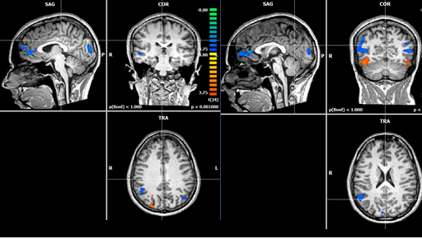
Figure 3. Brain activation for the contrast estimation of a number on the number line compared to estimation of brightness. The red to yellow colored brain areas were more active during the number task, whereas the blue to green colored brain areas were more active during the brightness task, compared to the number task.

Contact details:

Dr. Sarit Ashkenazi, Learning Disabilities,
The Seymour Fox School of Education
The Hebrew University of Jerusalem,
Mount Scopus
Jerusalem 91905
Room 469, 972-2-5882058
sarit.ashkenazi@mail.huji.ac.il
Lab: 972-2-5880088
http://saritashkenazi.wix.com/sarit-ashkenazi

