Overview:
The goal of this project was to develop advanced driving behaviour models that explicitly account for the effects of driver characteristics in his/her decisions alongside the effects of path-plan, network topography and traffic conditions. Special focus was on quantifying how the stress levels of the drivers affect their driving decisions. In a novel approach, the driving behaviour models have been calibrated by combining experimental data collected from the University of Leeds Driving Simulator (UoLDS) and actual traffic data collected using video recordings.
Background:
Driving behaviour models, which provide mathematical representations of how the drivers make decisions involving acceleration-deceleration, lane-changing, overtaking, etc., are increasingly being used for evaluation and prediction of road safety parameters and formulating remedial measures.
Reliable driving behaviour models are also critical for accurate prediction of congestion levels in microscopic traffic simulation tools and analyses of emissions. While research in human factors and safety has confirmed that driving behaviour is significantly affected by drivers’ characteristics (such as age, gender, education level and experience); individual traits (such as aggressiveness, emotional instability) and their mental states/mood (such as anger, tension, depression, cognitive workload and distraction), the existing driving behaviour models being used in the leading microscopic simulators capture only the effects of the network and traffic conditions and tend to overlook the effect of these driver-specific factors on the decision framework. Ignoring the underlying heterogeneity in the decision making of different drivers as well as the same driver in different contexts can lead to significant noise because of the models’ structural inability to uncover underlying causal mechanisms. Implemention of models failing to capture the full diversity of driving behaviour in traffic micro- simulation tools can lead to unrealistic traffic flow characteristics and incorrect representation of con gestion.
The proposed project, therefore, addressed the current research gaps in driving behaviour modelling and develop next-generation driving behaviour models which account for driver demographics, attitudes/traits and moods as well as effects of path-plan, network topography and traffic conditions in a single model framework.
Data and Methodology:
The project relied on data from two different settings:
(i) Experimental data collected from the University of Leeds Driving Simulator (UoLDS) and
(ii) Detailed trajectory data from the field.
UoLDS is one of the most advanced driving simulators in Europe (Figure 1). It has a Jaguar S-type vehicle cab with all driver controls fully operational. The vehicle’s internal Control Area Network (CAN) is used to transmit driver control information between the Jaguar and a network of nine high-performance computers that manage the complete simulation. Control feedback is generated so that the driver seated in the cab feels, sees and hears an appropriate simulation of the driving environment. As part of this project, 40 participant drivers have been asked to drive a motorway and an urban scenario. In each case, the detailed driving decisions are recorded alongside the speed and positions of the ambient simulated traffic in a fully controlled setting. Given the aim to capture the effect of the mental state of the driver on their observed decisions, the driving scenarios are designed to have a variation in levels of workload and stress levels. The physiological indicators of the mental state of the driver (e.g. skin conductance, blood pressure, heart rate variability, eye blinking rate, eye gaze, etc.) are collected using non-intrusive sensors (e.g. wearable wristbands and dashboard cameras) alongside their socio-demographics, experience levels and risk-taking attitudes.
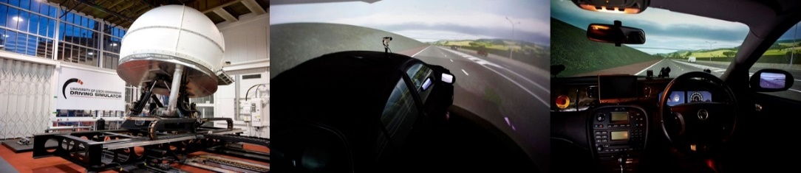
Figure 1: The University of Leeds Driving Simulator
[source: University of Leeds, University of Leeds Driving Simulator]

Statistical analyses of the data collected from the urban task indicated that under time pressure, participants significantly increase their speed and completed specific scenarios much faster. Moreover, significant associations have been found between observed behaviour and sociodemographic characteristics and traits. The analysis of the data collected from the motorway setting indicate that participants change their behaviour depending on the traffic conditions and time pressure. Moreover, physiological responses are found to be significantly correlated with observed behaviour such as speeding, braking etc. though the correlations with the traits are less significant. The insights from the results (presented in C2) have guided the model formulations.
The two specific behaviour modelled as part of the project are as follows:
1. Gap acceptance at an urban intersection
2. Car-following behaviour in a motorway

In the gap-acceptance component, discrete choice models have been developed to link the accept-reject choices of a driver with the driver demographics, traffic conditions and stress levels. The results of the models indicate that increased stress levels significantly increase the probabilities of accepting a gap. The improvement in model fit and safety implications derived from model estimates have also been discussed (see J2 for details).
In the car-following model, an extension of the GM stimulus-response model framework has been proposed where stress is treated as a latent (unobserved) variable. The proposed hybrid models have been calibrated using data collected with the University of Leeds Driving Simulator where participants have been deliberately subjected to stress in the form of aggressive surrounding vehicles, slow leaders and/or time pressure while driving in a motorway setting. Alongside commonly used variables, physiological measures of stress (i.e. heart rate, blood volume pulse, skin conductance) have been collected with a non-intrusive wristband. These measurements have been used as indicators of the latent stress level in a hybrid model framework and the model parameters have been estimated using Maximum Likelihood Technique. Estimation results indicate that car-following behaviour is significantly influenced by stress alongside speed, headway and drivers’ characteristics (see Figure 2 & C2 for details).
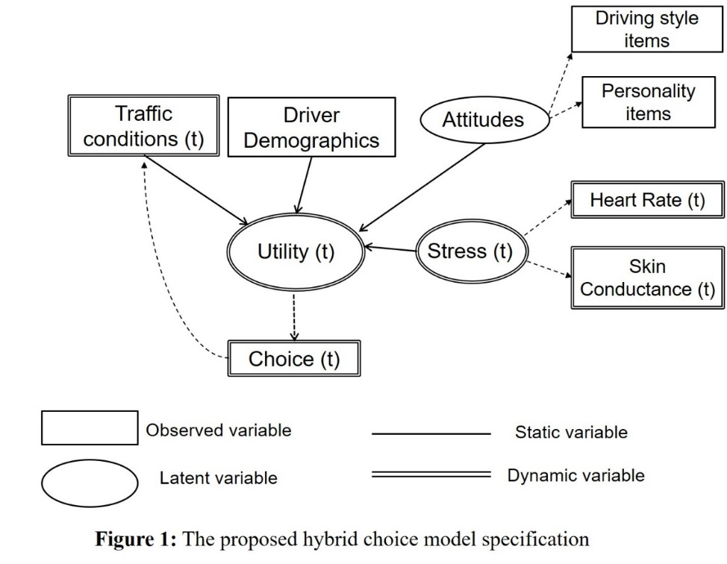
Figure 2: Hybrid choice model of driving behaviour
The findings of both the models can be used to improve the fidelity of simulation tools and designing interventions to improve safety. Comparison of the effects of socio-demographics, personality, trait and state stress on driving choices reveal that considering the trait and state stress is critical for predicting the driving decisions (see C1 for details).
While the simulator data offers the opportunity to fully control the driving scenarios and collect de tailed data from the participant drivers, such data may lack behavioural realism. This prompted us to first investigate the driving behaviour data from video recordings in great details (see J4 & J5 for de tails). As a follow-up, transferability of the car-following models between UoLDS and two comparable real-life traffic motorway scenarios, one from the UK (Motorway 1 near Leeds) and the other one from the US (Interstate 80 near California) have been investigated. In this regard, stimulus-response based car-following models have been estimated using the Maximum Likelihood Estimation technique and the transferability of the models have been investigated using statistical tests of para meter equivalence and Transferability Test Statistics. Estimation results indicate transferability in the model level but not fully in the parameter level for both pairs of scenarios (see J3 for details).
Further, two different approaches of combining the driving simulator and the real-world data sources have been investigated: 1) econometric approaches for increasing model transferability: Bayesian up dating and Combined Transfer Estimation 2) joint estimation using both data sources simultaneously. Performances of the proposed approaches for improving transferability have been evaluated using t- tests for individual parameter equivalence and Transferability Test Statistic (TTS). The results indicate that the transferability can be improved after parameter updating and Combined Transfer Estimation is found to outperform the other approaches. The findings of this study will enable more effective usage of driving simulator data for the estimation of mainstream mathematical models of driving behaviour (see C6).
Practical applications:
The developed models demonstrate that incorporating for the full range of behavioural factors increase the behavioural realism of the models. Improving the driving behaviour algorithms will ultimately lead to more reliable and valid transportation decisions, which is critical in the current environment of both shrinking transportation budgets and growing demand for accountable and efficient transportation investments. Further, quantification of the stress effects enable auto-manufacturers and road designers to contribute to enhancing safety.
Project website:
https://environment.leeds.ac.uk/faculty/dir-record/research-projects/739/next-generation-driving-behaviour-models
List of publications:
Journal papers (accepted)
J1. Paschalidis E, Choudhury CF, Hess S. 2019. Combining driving simulator and physiological sensor data in a latent variable model to incorporate the effect of stress in car-following behaviour. Analytic Methods in Accident Research (in Press) Link
J2. Paschalidis E, Choudhury CF, Hess S. 2018. Modelling the effects of stress on gap-acceptance decisions combining data from driving simulator and physiological sensors. Transportation Research Part F: Traffic Psychology and Behaviour. 59(Part A), pp. 418-435 Link
J3. Papadimitriou S, Choudhury CF. 2017. Transferability of Car-Following Models Between Driving Simulator and Field Traffic. Transportation Research Record. 2623, pp. 60-72 Link
Journal papers (under review):
J4. Kusuma A, Liu R, Choudhury CF. Modelling lane-changing mechanisms on motorway weaving sections, Under re-review in Transportmetrica B: Transport Dynamics
J5. Bwambale A, Choudhury CF, Hess S. Getting the best of both worlds - a framework for combining disaggregate travel survey data and aggregate mobile phone data for trip generation modelling, Under review in Transportation
J6. Haque MB, Choudhury CF, Hess S, dit Sourd RC. Modelling residential mobility decision and its impact on car ownership and commute mode, Under review in Travel Behaviour and Society
Conference papers (accepted):
C1. Paschalidis E, Enam A, Choudhury CF (2019) Unravelling the effects of socio-demographics, personality, trait and state stress on driving choices, accepted for presentation at the International Choice Modelling Conference, Japan, August 2019 (forthcoming)
C2. Paschalidis E, Choudhury CF, Hibberd D (2019) Investigating the effects of traits, stress and situational factors on driving performance, accepted for presentation at the World Conference on Transport Research, Mumbai, May 2019 (forthcoming)
C3. Bwambale A, Choudhury CF, Hess S. Getting the best of both worlds - a framework for combining disaggregate travel survey data and aggregate mobile phone data for trip generation modelling, , accepted for presentation at the World Conference on Transport Research, Mumbai, May 2019 (forthcoming)
C4. Paschalidis, E., Choudhury, C. & Hess, S. (2019) Modelling the effects of stress in the car- following model using driving simulator and physiological sensor data, Proceedings of the 98th An nual Meeting of the Transportation Research Board, Washington DC, USA.
C5. Paschalidis, E., Choudhury, C., Hess, S. (2018), Incorporating the effects of stress in a traditional car-following model framework using driving simulator data and physiological sensors, 15th International Conference on Travel Behaviour Research, Santa Barbara
C6. Paschalidis, E., Choudhury, C. & Hess, S. (2018), Improving the transferability of car-following models between the driving simulator and field traffic, Proceedings of the 97th Annual Meeting of the Transportation Research Board, Washington DC, USA.
C7. Paschalidis, E., Choudhury, C. & Hess, S. (2018), Investigating the effects of stress on choices - Evidence from gap acceptance decisions of drivers in a simulator experiment, Proceedings of the 96th Annual Meeting of the Transportation Research Board, Washington DC, USA.
C8. Kusuma A., Liu R., Choudhury C (2017) Car-following model for motorway weaving sections, East Asia Society for Transportation Studies Conference, Vietnam.
C9. Paschalidis, E., Choudhury, C. & Hess, S. (2017), Investigating the effects of stress on driving decisions, Road Safety and Simulation 2017, Netherlands.
C10. Papadimitriou S. and Choudhury C. (2017) Transferability of Car-Following Models between Driving Simulator and Field Traffic, Proceedings of the 96th Annual Meeting of the Transportation Research Board, Washington DC, USA.
C11. Paschalidis, E., Choudhury, C. & Hess, S. (2016), Investigating the transferability of car- following models between the driving simulator and field traffic, 5th Annual Symposium of the European Association of Researchers in Transport (hEART), Delft, Netherlands.
C12. Kusuma, A., Liu, R., Choudhury, C. (2016) Lane-changing Models for Weaving Sections, Proceedings of the 95th Annual Meeting of the Transportation Research Board, Washington DC, USA.
C13. Ahmed N., Iftekhar L., Ahmed S., Rahman R., Reza T., Shoilee S. and Choudhury C. (2015) Bap re Bap! Driving Experiences through Multimodal Unruly Traffic on Bumpy Roads, Sixth Annual Symposium on Computing for Development, London, UK.

