

*Project no. 2005-7224*

***Phagevet-P***

*Veterinary phage therapies as alternatives to antibiotics in poultry production*

**SIXTH FRAMEWORK PROGRAMME**

**PRIORITY [5]**

**[**FOOD QUALITY AND SAFETY**]**

**Final Report**

Period covered: 1st May 2005 – 31st October 2008

Date of preparation: December 2008

Start date of project: 1st May 2005 Duration: 42 months

Project Coordinator Name: Joana Azeredo

Project coordinator organisation name: University of Minho

**Introduction- PHAGEVET-P objectives and structure**

PHAGEVET-P is a 42 months STREP Project within the EU Sixth Framework Research Programme. The project started in May 2005 and has a total amount of eligible costs of 750,515 €. The maximum Community contribution to the project was 674,026 €.

The PHAGEVET-P project aimed at evaluating the potential use of phages as alternatives to antibiotics in poultry production and to characterize the efficacy of phages from *farm-to-fork.*

The numbers of reported outbreaks of food-borne diseases and pathogen presence in foodstuffs, continues to climb to unlikely figures, considering the general improvement in food safety knowledge and good practices. The two major important pathogens involved in food-outbreaks and surveys are *Salmonella* and *Campylobacter*.

A study by the Department of Environment, Food & Rural Affairs pointed out the growing resistance of food-borne pathogens to antimicrobials used during animal production and warns processors about the risks of these resistant pathogens passing through the food chain to consumers.

Bacteriophages have proven their efficacy as therapeutic agents, in both human clinical settings and animal disease research models. Actual and productive research on this matter strongly supports the concept that bacteriophage therapy can be developed as an alternative to antibiotics. The number of works published, including some reviews, clearly shows that the scientific community finally opened its mind to the tremendous potential of bacteriophages in the control of pathogenic or undesirable bacteria.

Stated targets of PHAGEVET-P are the characterization of the efficacy of phages from *farm-to-fork* and input in poultry food safety, including the promotion of knowledge transfer on phage use as alternatives to antibiotics from Eastern Europe, allowing the establishment of an industry-based project follow-up framework.

The main scientific objectives were to establish that in live poultry, treatment with specific phages can reduce or eliminate the occurrence of the two pathogens responsible for the majority of human food-borne illness, namely *Salmonella* and *Campylobacter* spp. and to establish that this protection of the live birds from infection provides poultry products for human consumption that have greatly reduced contamination levels with these two pathogens.

Some of the innovative aspects in the objectives of Phagevet-P are the concerns related to the safety of phages and respective hosts in the administration process and to the possibility of occurrence and multiplication of resistant strains of pathogens in the rearing environment. This includes the confirmation of using non-temperate phages, the characterization of phages comprising the study of homologies between phages and host bacteria to ensure the absence of bacterial toxin-encoding genes and the monitoring of phage-resistant mutants in the environment.

Six workpackages were defined in order to attain the scientific and technical objectives:

* WP01: **MANAGEMENT** - project management and development
* WP02: **SELECTION** - choice of selective bacteriophages
* WP03: **MODELLING** – experimental design for modeling phage production and poultry trials
* WP04: **PRODUCTION** –establish production protocols and produce selective phages in a pilot scale
* WP05: **EXPERIMENTS** - poultry experiments
* WP06: **EVALUATION** – quality and safety evaluation

Summarising, the project was focussed on trials in live poultry to evaluate the importance of the following factors on safety and quality (WP06): phage choice and production (WP02 and WP04); route of administration and timing of administration (WP05); quantity of phages administered (WP05); modelling of the infection and curing process (WP03).

**Partners involved**

Phagevet-P is a multidisciplinary project involving expertise only available at the European level: the University of Minho, Braga, Portugal (the Project Coordinator); the School of Biotechnology of the Catholic University of Oporto, Portugal; the School of Veterinary Science of the University of Bristol, United Kingdom; the Faculty of Pharmacy of the University of Santiago de Compostela, Spain; State Institute for Genetics and Selection of Industrial Microorganisms, Russia; Leatherhead Food International Ltd., United Kingdom; The project brought together a unique set of fragmented knowledge in different areas related to the use of phages as alternatives to antibiotics for poultry.

**Work performed and main results achieved**

Several phages active against *Salmonella* and *Campylobacter* were isolated from sewage water and poultry carcasses. These phages were tested against a pool of food and clinical isolates of *Salmonella enterica* Enteritidis and *Campylobacter coli* and *Campylobacter jejuni* (total of 200 strains), which enabled the characterisation of their lytic spectra. Phages having the broader lytic spectrum were fully characterised and used in the *in vivo* trials and production experiments. Characterisation involved Scanning Electron Microscope (SEM) analysis for morphology; DNA restriction profile for DNA size; hybridisation with host pathogens, for DNA homology; *in vitro* activity under simulated GI tract conditions; susceptibility to GI tract conditions and phage-host bacteria interaction, phage infection parameter (burst size and latency period). It must be stressed that the phages selected are strictly lytic and do not encode toxins. One of the Campylobacter phages was sequenced being the first *Campylobacter coli* phage to be sequenced and the data will be deposited in GenBank.

The methodology used in phage isolation and characterization is presented in Figure 1. A model for phage-host interaction was developed and used to predict the *in vivo* phage efficiency and productivity in batch and fed-batch modes of operation. *Salmonella* phages were produced in 5 L fermentors with optimised production conditions and using a non-pathogenic *E.coli* host. Parallel to these experiments methods of production, purification and storage to ensure the quality of the bacteriophage preparations were developed, as well as a new method of phage detection.

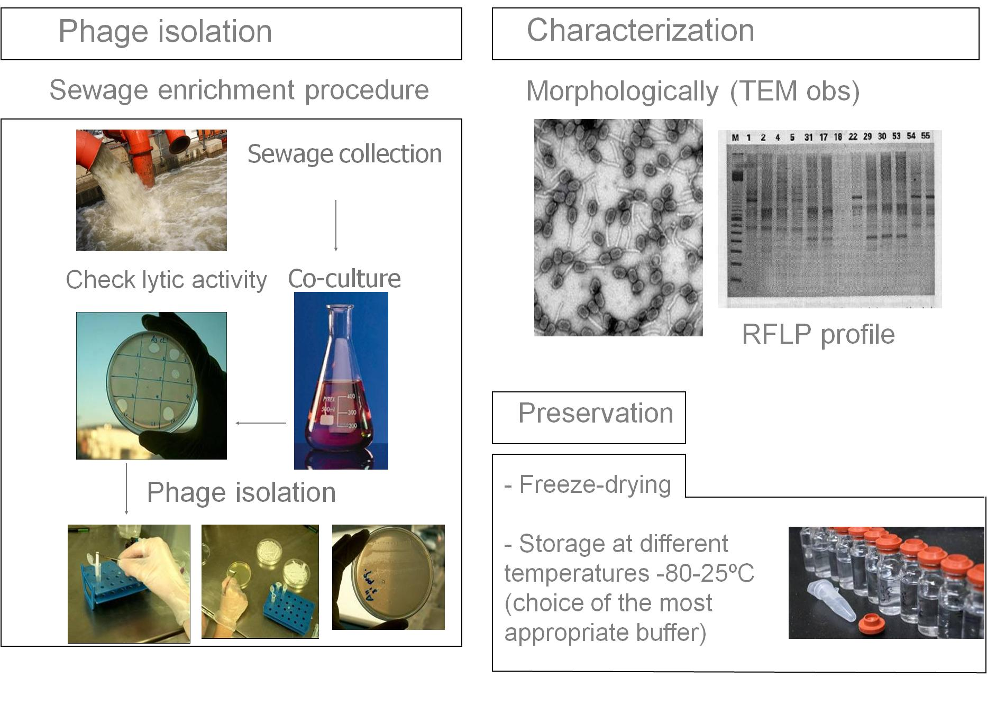

Figure 1: Schematic representation of the steps involved in phage isolation and characterisation.

Two Salmonella and two Campylobacter phages presenting the broadest lytic spectra were selected for in vivo trials. These phages were named phi PVP-SE-2, phi-PVP-SE-3 (both for Salmonella), phi-PVP-CC1 and Phi-PCP CC2. SEM images of these phages are presented in Figures 2 and 3

Figure 2: Phages phi PVP-CC1 (A) and phi PVP-CC2 (B) are Campylobacter phages and belong to the *Myoviridae* family, possess an icosahedral head (diameter 100nm) and a contractile tail with tail fibers at their distal end.

A

B

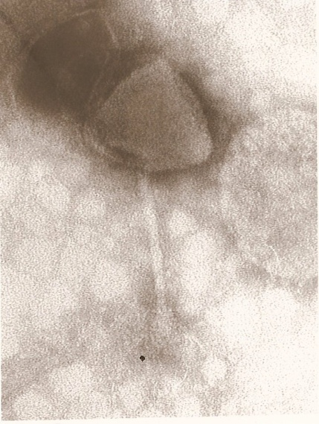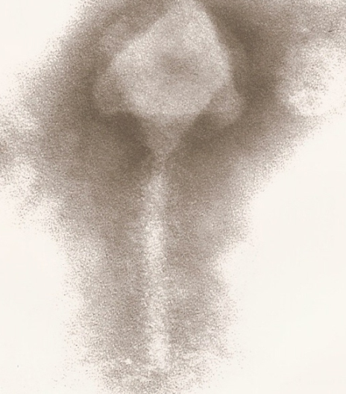

Figure 3: Phages phi PVP SE-1 (C) and PVP-SE 2 (D) are Jersey-like *Siphoviridae* Salmonella phages, head 57 nm, tail 125 x 8 nm, base plate with 3 or more spikes.

D

C

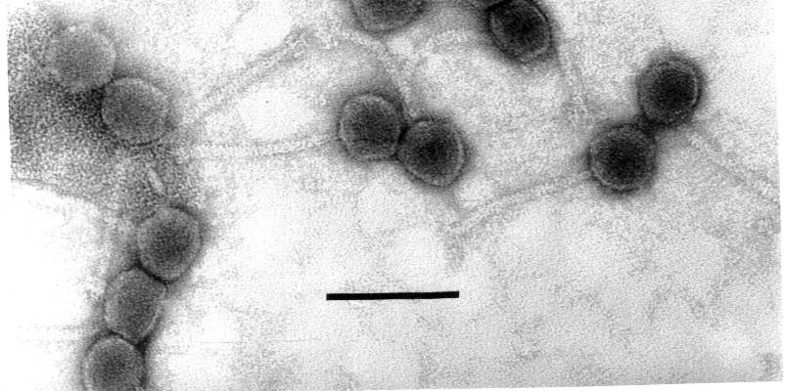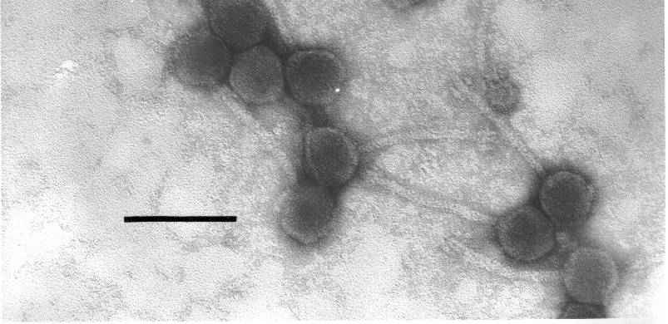

The majority of the experiments undertaken during Phagevet-P to evaluate the efficacy of phage therapy used oral gavage as the administration route. The reason for this was to deliver known doses directly into the GI tract of the poultry thus providing a reproducible scientific method which would produce results that could be compared directly to each other.

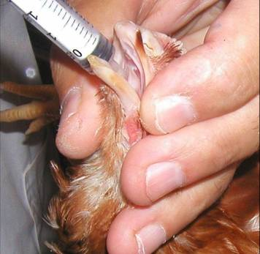

One simple method of administering an oral dose would be to deliver the phage in food or water. For Phagevet-P delivery of phage in food was tested as well as aerosol administration.

*In vivo* trials demonstrated that phage therapy of poultry can dramatically reduce the numbers of colonising campylobacters and salmonellas. An average **3.1 log** and **1.98** log reductions in *Salmonella* and *Campylobacter* numbers were achieved, respectively. Oral gavage or incorporation in food are two feasible and effect routes of phage administration, conversely aerosolised phage had no effect on the numbers of campylobacter colonising the chickens. In addition there was no phage detected in the faeces at any point post administration.

Based on the *in vivo* results, it is recommended that the phages are administered 1 day pre-slaughter in order to achieve the best phage efficacy and to minimise the risk of resistance developing, e.g. in the rearing environment. This recommendation is based on the large but short-lived reduction in pathogen numbers within 1 day of phage administration, therefore maximising the reduction in pathogen load. Moreover, 1 day pre-slaughter administration would reduce the time that the pathogen has in contact with the phage and therefore reduce the time for resistance to phage to emerge.

**Use and dissemination of knowledge**

A website was designed for public access and also an intranet for partners in Phagevet-P; the website address is (www.ceb.uminho.pt/projectos/phagevet) .The intranet can be used by all partners with a password. In the intranet, information such as news, alerts, PowerPoint files of the meeting presentations, meetings minutes, articles of interest, seminars and workshops alerts, and other important documents can be made available and accessed by all partners.

Five meetings were organized with the main goal of communicating main achievements of partners; discussing difficulties and planning future work. The results of the project were presented in four international conferences, the best way to fast disseminate the scientific work: a total of 15 communications were presented and 6 scientific papers were published in international journals. A “book of protocols” (33 pages) was issued summarising all the methods implemented and developed under the scope of Phagevet-P.